Florian Cramer  
Prince #304  
University of Massachusetts  
Amherst, MA 01003  
(413)546-2561

# Autonomy and Space - Hans Haacke’s systems aesthetics

Final paper for Art History 625, Nature in Contemporary Art  
Instructor: Anne Mochon  
December 10, 1992

# 1. Haacke in the 1960s and since the 1970s

When preparing this paper, I was interested in the relation of Hans Haacke’s sculptural ‘real-time systems’ from the 1960s and the political-educational installations for which he is known today and which a critic called his “mature” work.[1] Was there a radical rupture in his aesthetics around 1970, likely under the impression of the left-wing protests of that time and in which Haacke participate ? Haacke himself seems to back up such a reading, since he avoids to comment upon his early work and did not even show it in his 1987 retrospective.[2] The earliest piece included was “Nachrichten” (“News”) from 1970, a teletype machine which, by constantly printing news agency messages, puts political and media reality back into the museum space.

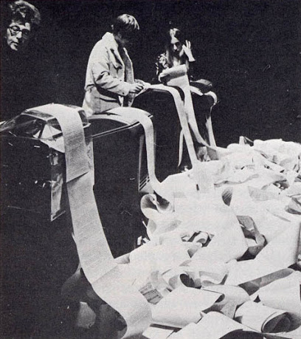

Hans Haacke, News (1970)

Haacke’s didactic depictions of interrelated political and economic power and cultural representation in later text-image installations like “The Chocolate Master” from 1982 seem to have little in common with Haacke’s early ‘real-time systems’ like the “Condensation Cube” from 1965 which, in its minimalist appearance, resembles sculptures made around the same time by Robert Morris,[3] Sol LeWitt and the German ‘Zero’ group of Heinz Mack, Guenther Uecker and Otto Piene to which Haacke had been loosely associated in the early 1960s.[4]

Echoing the visual language of his early work, Haacke’s “U.S. Isolation Box, Grenada, 1983”, a wooden box used by the U.S. Army to jail prisoners at Point Salines airport, however suggests a more complex relation between the two periods of his work. Haacke explain that “when I read about the isolation boxes in the New York Times, I immediately recognized their striking similarity to the standard minimal cube. As you see, one can recycle ‘minimalism’ and put it to a contemporary use”.[5]

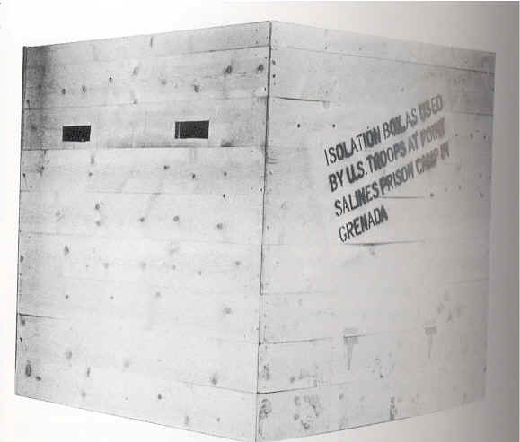

Hans Haacke, U.S. Isolation Box, Grenada (1983)

Beyond such seemingly parodistic references, both periods seem to be connected through a set of common concepts and either explicit or implicit notions of system, context and autonomy, as well as reality and truth. These notions have been addressed and made problematic throughout Haacke’s work, and also suggest a specific approach to the “nature” and “art” dichotomy.[6]

# 2. The “Condensation Cube” as a paradigmatic ‘real-time system’

In its interrogation of space, Haacke’s “condensation cube” of 1965 is prototypical for most of his sculptural work before 1970. The cube contains water that condenses and produces patterns on the glass surface whenever spectators enter the gallery space and thereby raise the room temperature. Next to minimalism, this seemingly simple piece reflects, through the dynamic of the water within the cube, another major current of 1960s art, kinetic sculpture, as it had been developed by the Zero group. But at the same time, it goes beyond both of the two aesthetics: The hard-edge minimalist form exists in a tension with the fluid, amorphous contents of the cube and its processual state. As opposed to classical kinetic sculpture, its dynamism is natural and not mechanical.[7] As a hybrid of ‘natural’ and ‘artificial’ form, function, and material, the cube represents - as a critic wrote - an “alternative kinetic tradition” where “[t]he environment took precedence over the object”.[8]

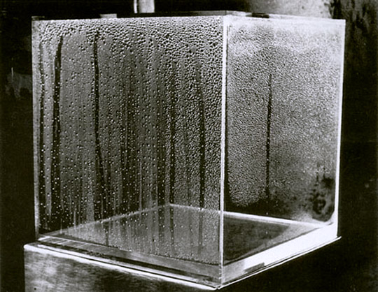

Hans Haacke, Condensation Cube (1965)

For analyzing the communicative function of the “Condensation Cube”, four sculptural dimensions and their interrelatedness could be described: form, inherent process, gallery space and spectator. The form of the cube harmonizes with the gallery space and the context of a modern art exhibition, but contrasts both with spectators in their nature as human organisms and with its internal, organic condensation process.

Spectator and process do not only exist as parallels, but they directly interact with each other, in a double structure: water and cube relate to each other in the same way as spectator and gallery space while spectator and space contrast with each other in the same way as water and cube.

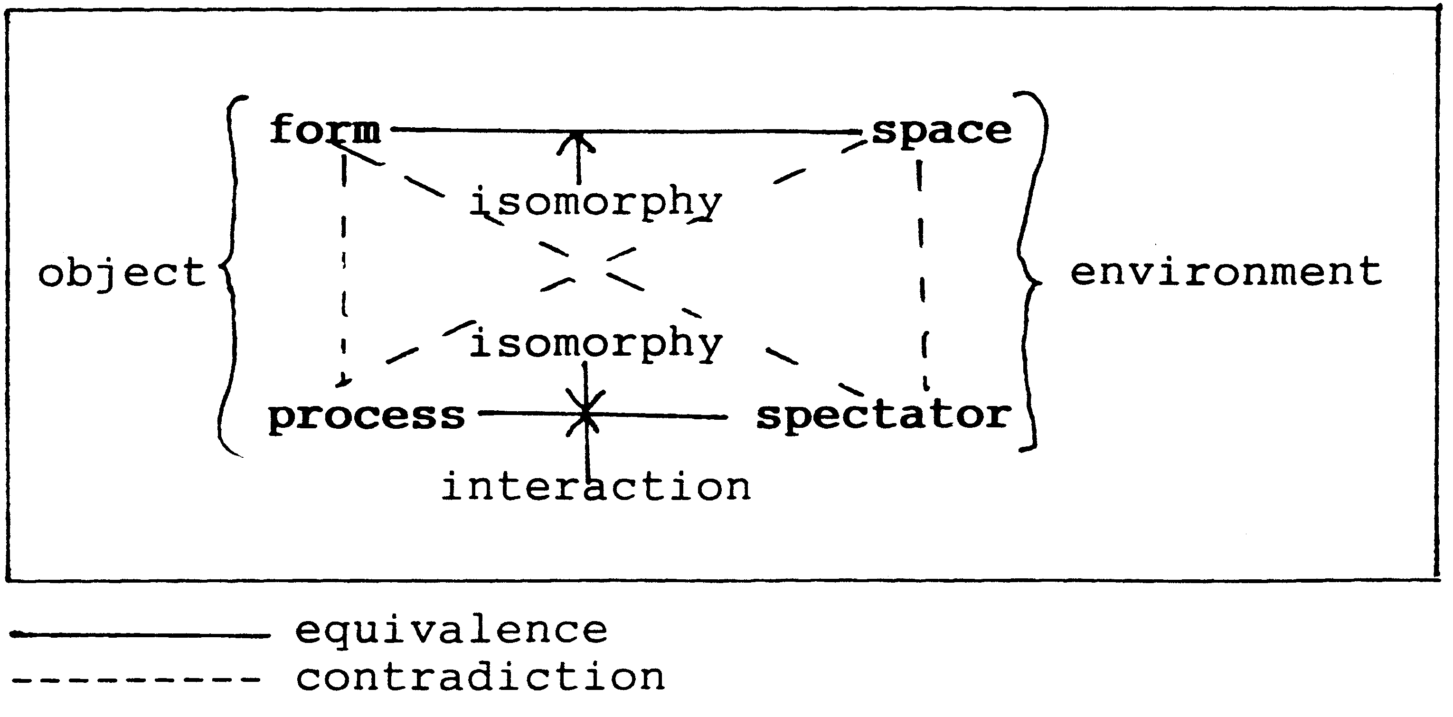

diagram

[Material entities, the cube versus the spectator in the room, are juxtaposed to formal entities, cubic form and gallery space, versus spectator and internal process.]

The object thus draws its surrounding space into question and makes the context “art” problematic.

Haacke confirms these observations in a manifesto written in the same year:

make something, which experiences, reacts to its environment, changes, is nonstable… …make something indeterminate, which always looks different, the shape of which cannot be predicted precisely…

…make something, which cannot ‘perform’ without the assistance of its environment…. …make something which reacts to light and temperature changes, is subject to air currents and depends, in its functioning, on the forces of gravity…

…make something, which the ‘spectator’ handles, with which he plays and thus animates it….

…make something, which lives in time and make the ‘spectator’ experience time…

…articulate something natural…"[9]

The notions of indeterminacy and interactivity combined with Haacke’s desire to articulate “something natural”, point to additional aspects of the “Condensation Cube”: Indeterminacy is conceptualized here, unlike in the music of John Cage or the Fluxus ‘events’ of the 1960s, rather as a natural property than as an intellectual or compositional concept. The organic interaction of spectator and cube thus supersedes more constructed attempts of including the audience. Nature therefore is a fifth, implicit dimension of the condensation cube’s aesthetics, as a space beyond the gallery space.

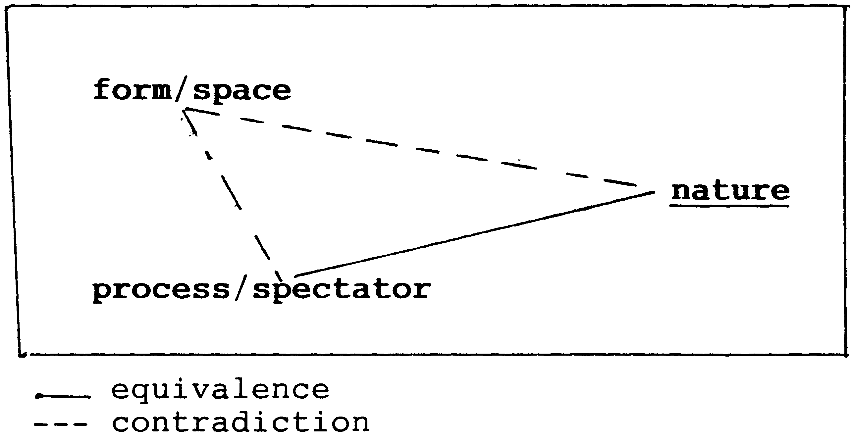

diagram

An equivalence of spectator, process and nature is juxtaposed to form and space, and questions the unity of the artwork whose form does not correspond to its internal process. By articulating “something natural”, the context ‘art’ collapses; the object dissolves, the space is being put into question.

# 3. A ‘Real Time Systems’ Aesthetic?

Haacke’s “Ice Stick” from 1966 continues the “Condensation Cube”’s discourse. Simply consisting of a refrigerator tube, the object interacts with the spectator’s breath. Moisture condenses to random, processual ice formations.[10] As in the “Condensation Cube”, there is a tension between the tube as a linear-shaped, artificial means that formally corresponds with the gallery space and the organic interaction between spectators and the object: spectators receive coldness for the moisture they provide. Since it is not form which limits this process, but the surrounding space, the museum context is even more obviously being questioned in this piece.

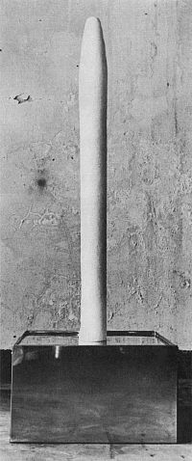

Hans Haacke, Ice Stick (1966)

Although the “Photo-electric viewer-controlled coordinate system” from 1968 is, in its technological character, closer to Zero aesthetics, its actual performance is based on organic processes: optic sensors transform the spectator’s movements into light patterns, human activity is necessary to activate the system.[11]

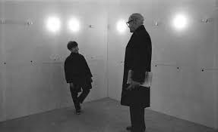

Hans Haacke, Photo-electric viewer-controlled coordinate system (1968)

In contrast, “Spray of Ithaca Falls: Freezing and Melting on a Rope” from 1969, which simply consists of a rope attached above a water fall in winter,[12] excludes the spectator from its material constitution. There is no artificial surrounding space to be problematized, and the implanted-artificial object vanishes under the constantly changing ice formations on its surface.

Despite their differences, Haacke’s early ‘real-time systems’ share a set of common characteristics:

1. They exceed visual experience, or, as Burnham explains, “since the early 1960s Hans Haacke has depended upon the invisible components of systems. In a systems context, invisibility, or invisible parts, share equal importance with things seen.”[13]
2. Their dynamic is organic, even in the photo-electric system.
3. They are not symbolic, or at least avoid symbolism: “they are what they are”.[14]
4. Despite their processual and interactive character, they are stable entities by themselves. Through their time dimension, they subvert the dimension of space. Still, their processual character never threatens the object in its functioning and integrity.
5. Therefore, the gallery space as a static and artificial environment alienates the piece, which conversely alienates this space.

These observations match with what Haacke writes in a statement from January 1968: “A ‘sculpture’ that physically reacts to its environment is no longer to be regarded as an object. [It is a process; see point 1 - F.C.] The range of outside factors affecting it, as well as its own radius of action, reaches beyond the space it occupies [beyond art as the institutional context; point 4, F.C.]. It thus merges with the environment in a relationship that is better understood as a”system’ of interdependent processes. These processes evolve without the viewer’s empathy. [They are not perceived like classical art works, they do not aim for a psychological effect, point 3] He becomes a witness. A system is not imagined, it is real."[15]

It is real and not symbolic; and despite its indeterminacy and openness, it remains stable, regulating itself through a metabolism. It is remarkable that Haacke speaks of ‘systems’ in his statement, not of ‘sculpture’ or ‘art’, thus pointing to the significance of General Systems Theory for his early work. My analysis of the “Condensation Cube” could be more or less conclusive because it was applied Systems Theory, like Haacke’s cube itself. A detailed account of this influence is given in the writings of Jack Burnham, a sculptor, critic and, according to his own testimony, close friend of Haacke since 1962.[16]

# 4. General Systems Theory: A Brief Outline

First efforts of formulating comprehensive theories of systems were done by scientists in the 1920s and 1930s, but with the publication of the book “General System Theory” in 1949, the Austrian biologist Ludwig von Bertalanffy established it as comprehensive theory and discipline.[17] As he explains in his essay “The History and Status of General Systems Theory”, systems theory departs from Aristotle’s observation that the whole is more than the sum of its parts.[18] General Systems Theory thus promotes a holistic approach to science, rejecting the atomistic, specialized disciplines and methods of modern sciences. Bertalanffy insists that this holism is strictly scientific, unlike occult holisms (such as, for example, alchemy, Neoplatonist philosophy or Kabbalah).[19] Drawing on the Greek word “systema” (“collection”), General Systems Theory regards every phenomenon as a system and investigates its organization instead of its single parts by describing relations, hierarchies and interactions of parts within a system.[20]

As opposed to cybernetics, which investigates interaction in human-machine systems, and systems analysis, which looks for practical solutions of structural problems, General Systems Theory is an interdisciplinary all-purpose discipline whose scope includes hard sciences as well as social sciences and humanities.[21]

According to General Systems Theory, a system can be principally investigated and classified as natural or cultural, dynamic or static, indeterminate or deterministic, temporal or fixed, complex or simple, stable or unstable, autonomous or dependent, open or closed;[22] the same criteria and polarities that I described above as being constitutive for Haacke’s “real-time systems”.

An central concept of General Systems Theory that also reverberates in Haacke’s early works is that of the open system. It was coined and defined by Bertalanffy in 1950.[23] For Bertalanffy, all organisms are open systems, since they change their components and interact with their environment.[24] This metabolic interaction maintains and stabilizes the object, because it reverses entropy.[25] According to the second thermodynamic law, entropy occurs only in closed systems. Open systems are therefore self-regulating, they can be time-independent, and their initial state does not predetermine their final state.[26]

Haacke’s cube is an open and a closed system at the same time: it interacts with the room temperature, but its contents is limited by the cubic frame. The cubic form and the gallery space thus act as closed, entropic systems.

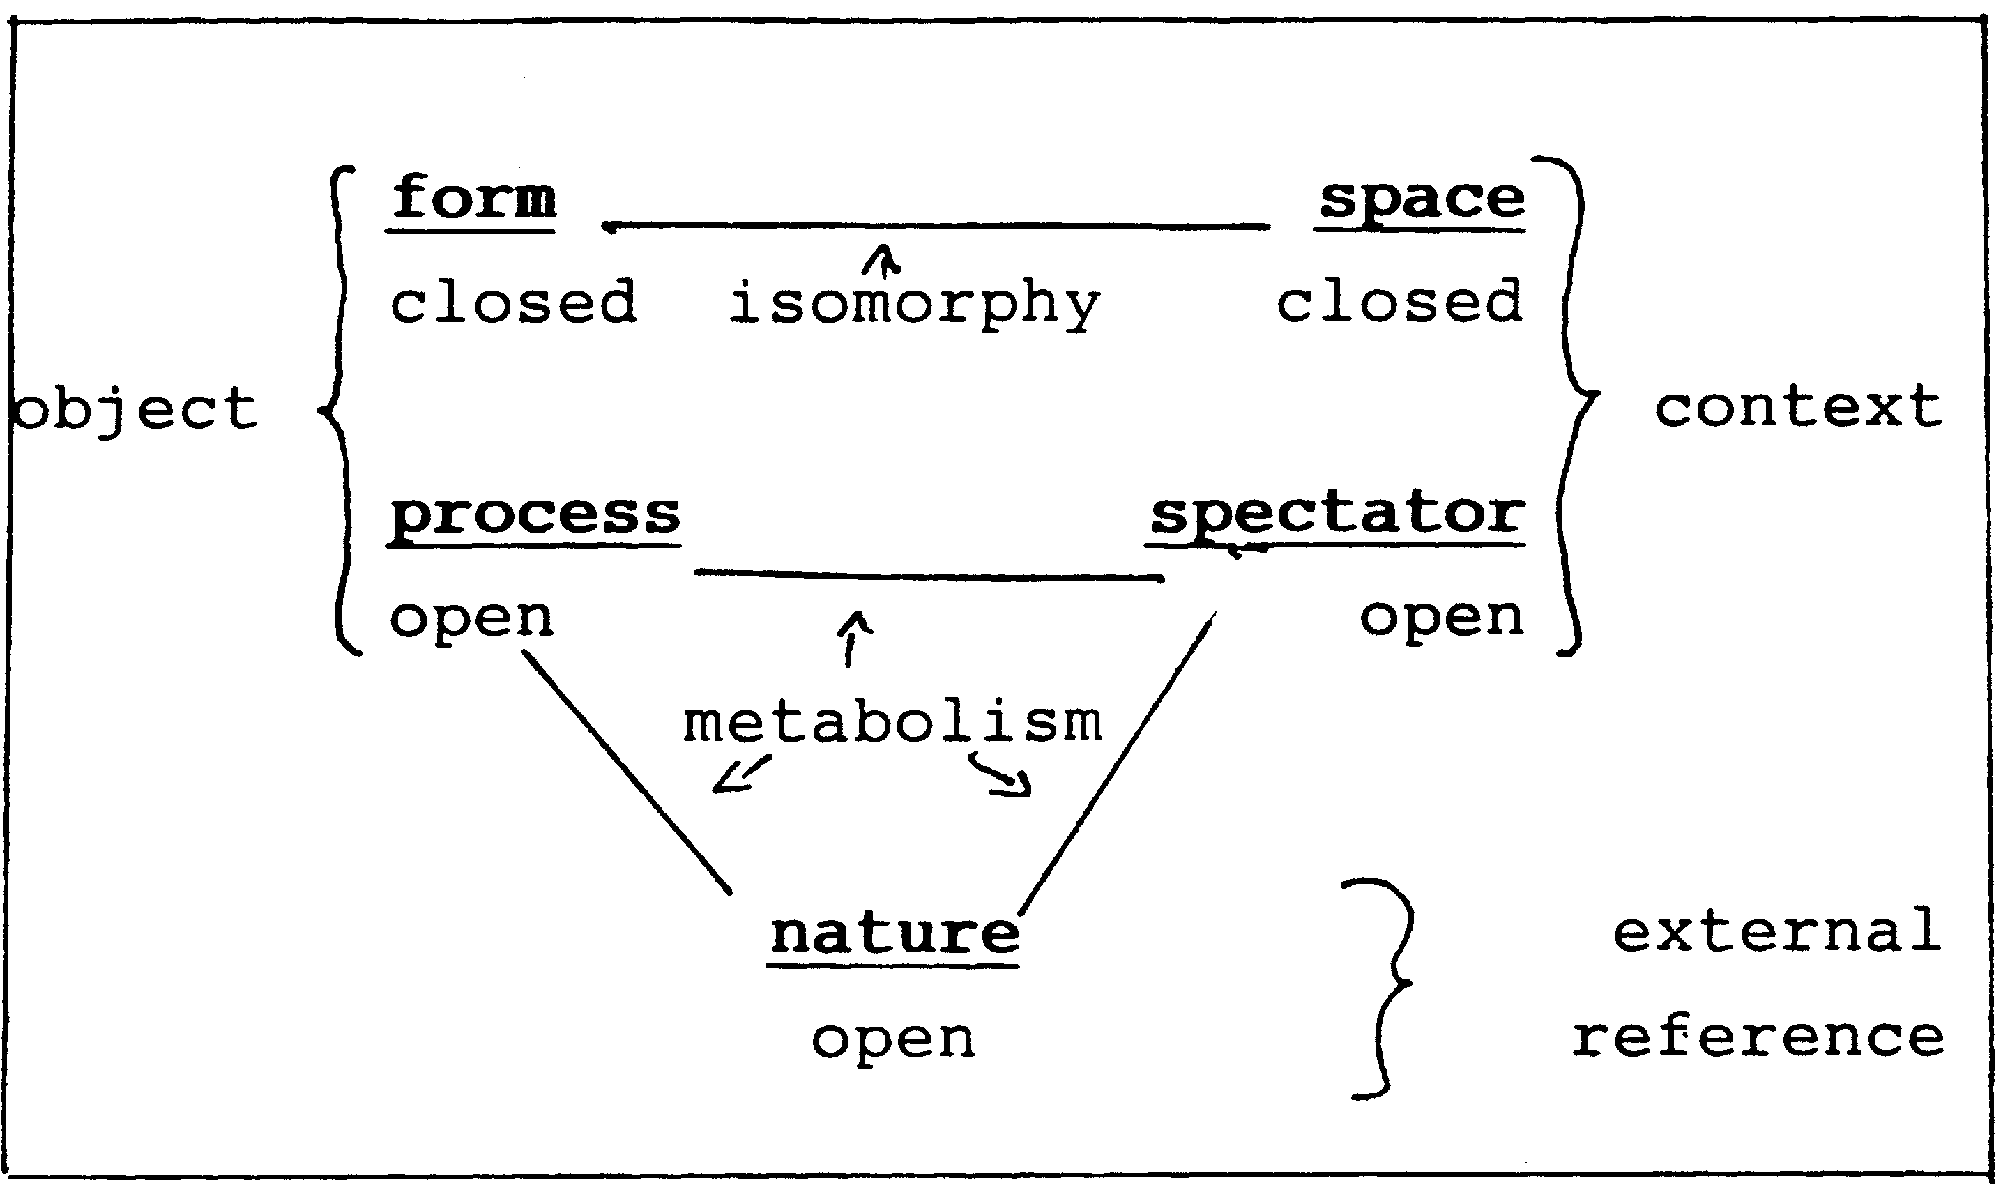

diagram

With its very general categories of analysis and description, General Systems Theory clearly aims to be a universal theory, a model that can be applied to and explain virtually anything.[27] This has provoked criticism, particularly in the social sciences where the idea of societies as “self-regulating” and “self-stabilizing” systems caused discomfort.[28]

Both in Bertalanffy’s and in other early system theoretical writings, there is a strong implicit claim for scientific objectivity and truth. This is echoed in Haacke’s statements that “a system is not imagined, it is real”[29] and that “the working premise is to think in terms of systems. [….] In all cases, verifiable processes are referred to”.[30]

# 5. Haacke’s Paradigm Shift

In the later General Systems Theory known among others as radical constructivism, the earlier objective truth claims were radically revised. It defines all systems as constructions. Even the act of considering something a system, is a construction.[31]. System analysis then acts as a tool and does not tell the objective truth about a thing.[32]

Haacke might have had taken a similar turn when he radically changed his art. Perhaps this was motivated by the temporary contradiction between his political engagement in the Art Workers’ Coalition in 1969, which focused on the complicity of art establishment and political establishment,[33] and his system sculptures implying truth, stability and spaces that construct autonomy from their surrounding.



diagram

The “condensation cube” is open, self-regulating and autonomous as a system in particular, but not in regard to its closed context, the art space as the super-system it depends on. Referring to nature as a utopia or non-space, the cube subverts its space perhaps symbolically, but not in reality, thus undermining Haacke’s program. We could thus read Haacke’s later work as the attempt to address this space itself, directly and not metaphorically, in order to make the inherent critique of the piece succeed. This however affects the supposed ‘autonomy’ of the art object. Autonomy is no longer possible, because there is no object outside a space and no space outside institutions. The object thus needed to be re-conceptualized from scratch.[34]

There is an eclectic fusion of Systems Theory, the Marxist concept of the politically engaged artist and the [German] romanticist notion of art as a continuously expanding universal system[35] in Haacke’s statement that “the artist’s business requires his involvement in practically everything. […] An artist is not an isolated system. In order to survive […] he has to continuously interact with the world around him. Theoretically, there are no limits to his involvement”.[36] Haacke points towards a shift here to the larger super-system of politics and economy while still clinging to his earlier holistic systems approach to art.

By investigating the structure of complex organizations and opposing atomistic alienation, both General Systems Theory and Marxism could be described as holistic. Their fundamental difference however lies in Marxism’s categorical refusal to project biological onto social structures, or nature onto culture. On the contrary, “biology” and “nature” can be described as social and ideological constructs from a Marxist perspective. Haacke might have drawn a similar conclusion when he broke with his early art.

From the 1970s on, his works appear so radically different, because “nature” as the larger context or superstructure has been replaced with political and economical superstructures. Apart from that, the structures of Haacke’s works in both periods remain similar. “The Chocolate Master”, for example, can be analyzed with basically the same model as the one that I used for the “Condensation Cube”, by describing the systemic interrelations of its dimensions of form, text, spectator and (art) space.

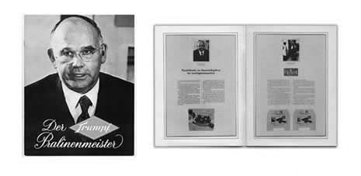

Hans Haacke, The Chocolate Master (1982)

In the “Chocolate Master”, the form of the piece is no longer isomorphic to the art space, since the object does not look like a contemporary artwork, but like an advertising campaign: a piece of everyday communication familiar to the spectator, and - at the same time - speaking the language of those who economically own and rule the space. The contrast of form and space, mediated through the text, thus replaces the previous contrast of form and process. Process, and the dimension of time, has been removed or frozen to stress the dominance of space, the idea that there is no outside of the institution.[37] Subversion of the space no longer occurs in a process, but in the text that ties the codes of power (advertisement) to the space of the museum. Since the form of the piece makes use of accessible everyday visual language, it alienates the spectator from the museum space. The space “does not fit’, the spectator is made aware of the contradiction between the space of the museum and its suggestions of an ‘autonomous’ or ‘free’ sphere, and the political and economic superstructure behind it. The space of the museum is thus unmasked as being highly dependent and drawn into question by the object. The effectiveness of Haacke’s critique is proven by Benjamin Buchloh observation that”the reception of Haacke’s work does prove is that the supposedly all-embracing liberalism of high-cultural institutions and of the market may be far more selective than is generally believed".[38]

# 6. Concluding Remarks

In my analysis of the “Condensation Cube”, I drew the conclusion that *the object draws the whole space into question and makes the context ‘art’ problematic*. In Haacke’s later work, nature as the seemingly necessary counterpart for creating this opposition, has been relinquished - as it seems, as a fiction and construction like the art space itself. On top of this, the art object no longer pretends to be autonomous and transgressing the institutional space in which it is shown. On the contrary, the object imitates the codes of the institution to turn them against itself and show up its contradictions. This strategy strongly resembles the estrangement method in Brecht’s epic theatre as well as the Situationist “détournement”.[39]

When once more comparing the “Condensation Cube” and the “Isolation Box”, a similar critique of the art space can be observed, with the difference that the “Isolation Box” insists on the signature that every space puts on an object, and the ideological character of any visual language. In its attempted subversion of its museum space, the “Condensation Cube” relies on its supposed autonomy and self-regulation while the “Isolation Box” describes both itself and its surrounding space as constructs, as being dependent, and controlled by institutions and political and economical superstructures.

# Postscript:

This dependency also means that the even the critical art object can always be incorporated and appropriated by the institution, ‘contained in the box“, so to speak. Arthur C. Danto wrote that Haacke’s documentation of the Shapolsky real estate trust may today be read as a glorifying homage to economic”visionaries" (because their property chiefly consists of houses in SoHo and the Lower East Side that were cheaply bought as slum houses in that time): “One might almost expect Shapolsky et al. to acquire ‘Shapolsky et al.’ as evidence of its founder’s sagacity”.[40] In an interview, Haacke stated that he is well aware of such risks,[41] arguing that his works are meant to be site- and time-specific and thus limited in their validity. This also means that his work cannot challenge superstructures at large.

# Bibliography

## 1. Exhibition catalogues

“Framing and Being Framed”, New York University Press, 1975

“Unfinished Business”, Cambridge, Ma.: MIT Press, 1987

## 2. Haacke on his systems aesthetic

in: Peter Selz, “Directions in Kinetic Sculpture”, Berkeley: University of California Press, 1966, p. 36

in: Lucy Lippard (ed.), “Six Years”, New York: Prager Publishers, 1973, p. 37 & 123

in: Ursula Meyer, “Conceptual Art”, New York: E.P. Dutton&Co, 1972, p. 132

## 3. General literature on Haacke

Jack Burnham, “Steps in the Formulation of Real-Time Political Art”, in: “Framed and Being Framed”, p. 127-141

Benjamin H.D. Buchloh, “Hans Haacke: Memory and Instrumental Reason”, in: Art in America, vol.76, Feb.1988, p. 97-108 & 157-159

Arthur C. Danto, “Hans Haacke: Unfinished Business” (review), in: The Nation, February 14, 1987, p. 190-195

## 4. On Haacke’s early works

### Condensation Boxes (in the context of Earth Art):

Nicholas J. Capasso, “Environmental Art: Strategies for Reorientation in Nature”, in: Arts Magazine, vol. 59, January 1985, p. 73-777

### Condensation Boxes, Grass Cube:

Jack Burnham, “Beyond Modern Sculpture”, New York: George Braziller, [year of publication not mentioned], p. 279, 347-348

### Rain Tree, Sky Line, Photo-Electric Viewer Programmed Coordinate System, Spray of Ithaca Falls, Wind Room:

Jack Burnham, “Great Western Salt Works”, New York: George Braziller, 1974, p. 22-3, 32-3

### Photo-Electric Viewer Programmed Coordinate System:

Jack Burnham, The Aesthetics of Intelligent Systems, in: Edward F. Fry (ed.), On the Future of Art, New York: The Viking Press, 1970

### Chicken’s Hatching:

Jack Burnham, “The Structure of Art”, New York: George Braziller 1971, p. 142-143

## 5. Hans Haacke’s re-orientation in 1969: Political activism, Art Workers’ Coalition, Art Strikes

David Craven, “Hans Haacke and the Aesthetics of Dependency Theory”, in: Arts Magazine, vol. 61, March 1987, p. 56-58

Lucy R. Lippard, “Get the Message: a decade of art for social change”, New York: E.P. Dutton, 1984

Adrian Henri, “Total Art”, New York & Washington: Praeger Publishers, 1974 [notably the section “Art and Politics”, p. 174-186 and the Art Workers’ Coalition document in the appendix, p. 195-197]

## 6. The Situationist International

Ken Knabb (ed.), “Situationist Anthology”, Berkeley: Bureau of Public Secrets, 1981 [includes a selection of articles from the “Internationale Situationniste”, the official periodical of the S.I.]

Guy Debord, “The Society of Spectacle”, Detroit: Black and Red, 1977

Sadie Plant, “The Most Radical Gesture”, London and New York: Routledge, 1992

Stewart Home, “The Assault on Culture”, London: Aporia Press and Unpopular Books, 1988

Roberto Ohrt, “Phantom Avantgarde”, Hamburg: Edition Nautilus, 1990 [in German] .

## 7. Politics and Haacke’s later work

Frederick Jameson, “Hans Haacke and the Cultural Logic of Postmodernism”, in: “Unfinished Business”, p. 38-50

Yve-Alain Bois, Douglas Crimp, Rosalind Krauss, “A Conversation with Hans Haacke”, in: October 30, Fall 1984, Cambridge, Mass.: MIT Press, p. 23-48

## 8. Haacke in the context of postmodern art

Benjamin H.D. Buchloh: “Allegorical Procedures: Appropriation and Montage in Contemporary Art”, in: Artforum, vol. 21, Sept. 1982 (without pagination)

## 9. Haacke and Brecht’s estrangement method

Yve-Alain Bois, “The Antidote”, in: October 39, Winter 1986, p. 128-144

## 10. General Systems Theory

Ludwig von Bertalanffy, “The Theory of Open Systems in Physics and Biology” (1950), reprinted in: F.E. Emery, “Systems Thinking”, Harmondsworth, England: Penguin Books, 1969, p. 7085

Ludwig von Bertalanffy, “The History and Status of General Systems Theory”, in: George J. Klir (ed.), Trends in General Systems Theory, New York: Interscience, 1972, p. 21-41

Ludwig von Bertalanffy, “General Systems Theory”, New York: George Braziller, 1968

Ervin Laszlo, “The Systems View of the World”, New York: George Braziller, 1972

Guenter Ropohl, “Einfuehrung in die allgemeine Systemtheorie”, in: Hans Lenk, Guenter Ropohl (ed.), “Systemtheorie als Wissenschaftsprogramm”, Koenigstein/Ts.: Athenaeum Verlag, 1978, p. 9-49

1. Benjamin H.D. Buchloh, “Hans Haacke: Memory and Instrumental Reason”, in: Art in America, vol.76, Feb. 1988, p. 157.
2. “Unfinished Business”, Cambridge, Mass.: MIT Press, 1987.
3. “there are obvious structural, material, and morphological similarities between a work like Haacke’s ‘Conden sation Cube’ […] and, for example, Robert Morris’s ‘Mirrored Cubes’ (1965)”, Buchloh p. 106.
4. Aside from ‘Zero’, David Craven mentions the French “Group de récherche visuel” as a major influence on the young Haacke who studied in Paris in 1960 and 1961. Although it promoted a formalist Op Art aesthetic, the GRAV shifted towards radical political critique in the late 1960s, according to David Craven, “Hans Haacke and the Aesthetics of Dependency Theory”, in: Arts Magazine, vol. 61, March 1987, p. 56-7.
5. Quoted from: Yve-Alain Bois, Douglas Crimp, Rosalind Krauss, “A Conversation with Hans Haacke”, in: October 30, Fall 1984, Cambridge, Mass.: MIT Press, p. 26.
6. I found few critical texts supporting this hypothesis. Craven observes the importance of ‘systematic thinking’ for Haacke throughout his career and suggests a relatedness to General Systems Theory, but rather argues with biographical and political circumstances than through an actual analysis of Haacke’s work (Craven, p. 57). Buchloh states that “Haacke seems to have recognized by 1969 that the aesthetic object was constituted as both a discursive and a material object whose possible reading emerged at the intersection of several determining factors: artistic (linguistic) conventions, the practices of institutional power, the ideological investment and economic needs of a shifting audience” (p. 106). Buchloh also observes a demasking of ‘autonomy’ in Haacke’s work. However, I will try to point out that autonomy and institutional space have already been addressed as being problematic in Haacke’s early ‘real-time systems’, so that the shift in his aesthetic was less a question of the target, but of the approach. Jack Burnham’s “Steps in the Formulation of Real-Time Political Art” (in: "Framing and Being Framed, New York: New York University Press, 1975, p. 127-141) is close to my attempt by reconstructing a continuity within Haacke’s work through General System Theory. However, I missed a discussion of how Haacke’s revised or structurally modified his systems approach in the 1970s (since at least some kind of rupture occurred in his work).
7. On the distinctiveness of ‘natural’ movement in Haacke’s cube: Jack Burnham, “Beyond Modern Sculpture”, New York: George Braziller, [year of issue not mentioned], p. 279.
8. Nicholas J. Capasso, “Environmental Art: Strategies for Reorientation in Nature”, in: Arts Magazine, vol.59, January 1985, p. 74.
9. in: Peter Selz, “Directions in Kinetic Sculpture”, Berkeley: University of California Press, 1966, p. 37
10. As explained by Burnham in “Beyond Modern Sculpture”, p. 347.
11. Technical explanation in Jack Burnham, “The Aesthetics of Intelligent Systems”, in: Edward F. Fry (ed.), “On the Future of Art”, New York: The Viking Press, 1970, p. 108. (As a curator at Guggenheim Museum and responsible for the cancelled Haacke exhibition in 1971, Fry was subsequently fired by the direction.)
12. Jack Burnham, “Great Western Salt Works”, New York: George Braziller, 1974, p. 32.
13. Burnham, Saltworks, p. 22.
14. Burnham, Beyond Modern Sculpture, p. 34/7.
15. Lucy R. Lippard, “Six Years”, New York: Praeger Publishers, 1973, p. 37
16. Burnham, Real-Time Political Art, p. 128. On page 131, Burnham states that “from 1965 to the present [1975, F.C.] Haacke has identified his art with ideas implicit in General Systems Theory” and gives extensive comments on page 132 and 133. (The close relationship of Haacke and Burnham and the sheer quantity of Burnham’s writing in the late 1960s and early 1970s creates the temptation of considering their thinking identical and to read Burnham’s statements about Haacke and Systems Theory as ‘official’ explications. Burnham’s failure of fully recognizing Haacke’s paradigm shift however is reason enough for caution. My section on General Systems Theory is therefore based on my own readings.)
17. According to Ervin Laszlo, “The Systems View of the World”, New York: George Braziller, 1972, p. 10.
18. In: George J. Klir (ed.), “Trends in General Systems Theory”, New York: Interscience, 1972, p. 21.
19. Laszlo, p. 19, History & Status, p. 21, and Guenter Ropohl, “Einfuehrung in die allgemeine Systemtheorie”, p. 10 (in: Hans Lenk, Guenter Ropohl [ed.], “Systemtheorie als Wissenschaftsprogramm”, Koenigstein/Ts., Athenaeum-Verlag, 1978, p. 9-49).
20. Ropohl, p. 9 & p. 14.
21. Ropohl, p. 11-13.
22. Ropohl, p. 34, History & Status, p. 24.
23. Ludwig von Bertalanffy, “The Theory of Open Systems in Physics and Biology”, reprinted in: F.E. Emery, “Systems Thinking”, Harmondsworth, England: Penguin Books, 1969, p. 70-85.
24. Open Systems, p. 70.
25. Open Systems, p. 71-72, Laszlo, p. 42-43.
26. Bertalanffy calls the latter characteristic “equifinality”, Open Systems, p. 73-77, Laszlo, p. 46.
27. History & Status, p. 25, Laszlo, p. 79.
28. Laszlo, p. 120.
29. In: Lippard, Six Years, p. 3/7.
30. In: Lippard, “Six Years”, p. 123.
31. Ropohl, p. 32.
32. Burnham ends with the same conclusion, “Real-Time Political Art”, p. 133.
33. Lucy Lippard and Adrian Henri give detailed accounts of political activism in the art world of the early 1970s, including the Art Workers’ Coalition and the Guerilla Art Action Group. Only Henri, however, notices the striking similarities with the activities of the Paris-based Situationist International. Lacking any mention of the S.I., Lippard’s text suggests that Situationism was largely unknown to New York artists at that time, including, I suppose, Haacke himself. Lucy R. Lippard, “Get the Message”, New York: E.P. Dutton, 1984; Adrian Henri, “Total Art”, New York & Washington: Praeger Publishers, 1974.
34. “It is important to recognize that artists who nevertheless continue to reject the idea of aesthetic autonomy have also had to abandon traditional procedures of artistic production”; Buchloh, p. 101.
35. Friedrich Schlegel, “Athenaeums-Fragmente”, Jena 1798.
36. Burnham, Salt Works, p. 32-3.
37. Buchloh, p. 98.
38. Buchloh, p. 98.
39. On Haacke and Brecht’s estrangement method: Yves-Alain Bois, “The Antidote”, in: October no. 39, Winter 1986, p. 128-144.
40. Arthur C. Danto, “Hans Haacke, Unfinished Business”, in: The Nation, Feb. 14, 87, p. 192.
41. Yve-Alain Bois, Douglas Crimp and Rosalind Krauss, A Conversation with Hans Haacke, in: October no. 30, Fall 1984, p. 47.