art = trap
Boekie Woekie describes itself as an “artist-run bookstore for books by artists.” There is a subtle but significant difference between (a) “art books”, (b) “artists’ books” and (c) “books by artists.” Art books, such as exhibition catalogs, artist monographs, coffee table books, and art history books published by small and large publishers, are what is sold in museum shops, specialty bookstores (not run by artists), or in the art sections of mainstream bookstores; they are almost always books about art, not books as art.
Artists’ books are made and often published by artists as works of art or art projects. Boekie Woekie’s unofficial predecessor, Ulises Carrión’s “Other Books and So,” which existed only a few blocks away at Herengracht from 1975 to 1979, called itself a place for “other books, non books, anti books, pseudo books, quasi books, concrete books, conceptual books, structural books, project books, plain books,” thus expressing Carrion’s research interest in an experimental poetics of the book form, less in a community.
Printed Matter was founded in New York in 1976 by Lucy Lippard, Sol LeWitt, and others as a store for “artists’ books,” which, according to Lippard, “got no respect; dealers used them as freebies – bait to get collectors to buy the big stuff.” This perspective is as artwork- and medium-centric as Carrion’s, yet without the explicit interest in a new poetics. The motivation to give space to an otherwise marginalized form of contemporary art also drives today’s artists’ bookstores, which have become a global phenomenon at the time of writing and can be found in almost every major city. Printed Matter gave birth to this phenomenon when its former artistic director AA Bronson founded the NY Art Book Fair in 2009. As its name suggests, it blurred the line between artists and art books, placing their various forms of publication firmly within the art system. Logically, it first took place at the contemporary art museum MoMA PS1.
Boekie Woekie differs from Other Books and So and Printed Matter in two ways: It was founded and is still run by an artists’ collective that also uses the space as a studio or production facility. This is expressed in its self-description as “artist-run.” And its goal is not to end up in a museum, nor to promote or develop a particular form or genre of artwork, but to serve a particular community. Hence “books by artists.”
In contrast to “art books” and even, to a certain extent, “artists’ books,” it doesn’t matter whether these books themselves have the status of works of art, but who made them for whom. By selling them in an inconspicuous, non-white cube that resembles a neighborhood bookstore more than an art space, the goal for the books is not to end up in the art world, and the goal for Boekie Woekie is not to end up as or in a gallery or museum in any form. As a result, Boekie Woekie may be the only [so-called] “project space” in the Netherlands that has never received or sought art funding or recognition in the art system during its entire existence from 1986 to 2023.
Or, as Jan put it when he briefed me for this essay: “not dreaming of [the] Stedelijk [Museum].”

don’t be pretentious
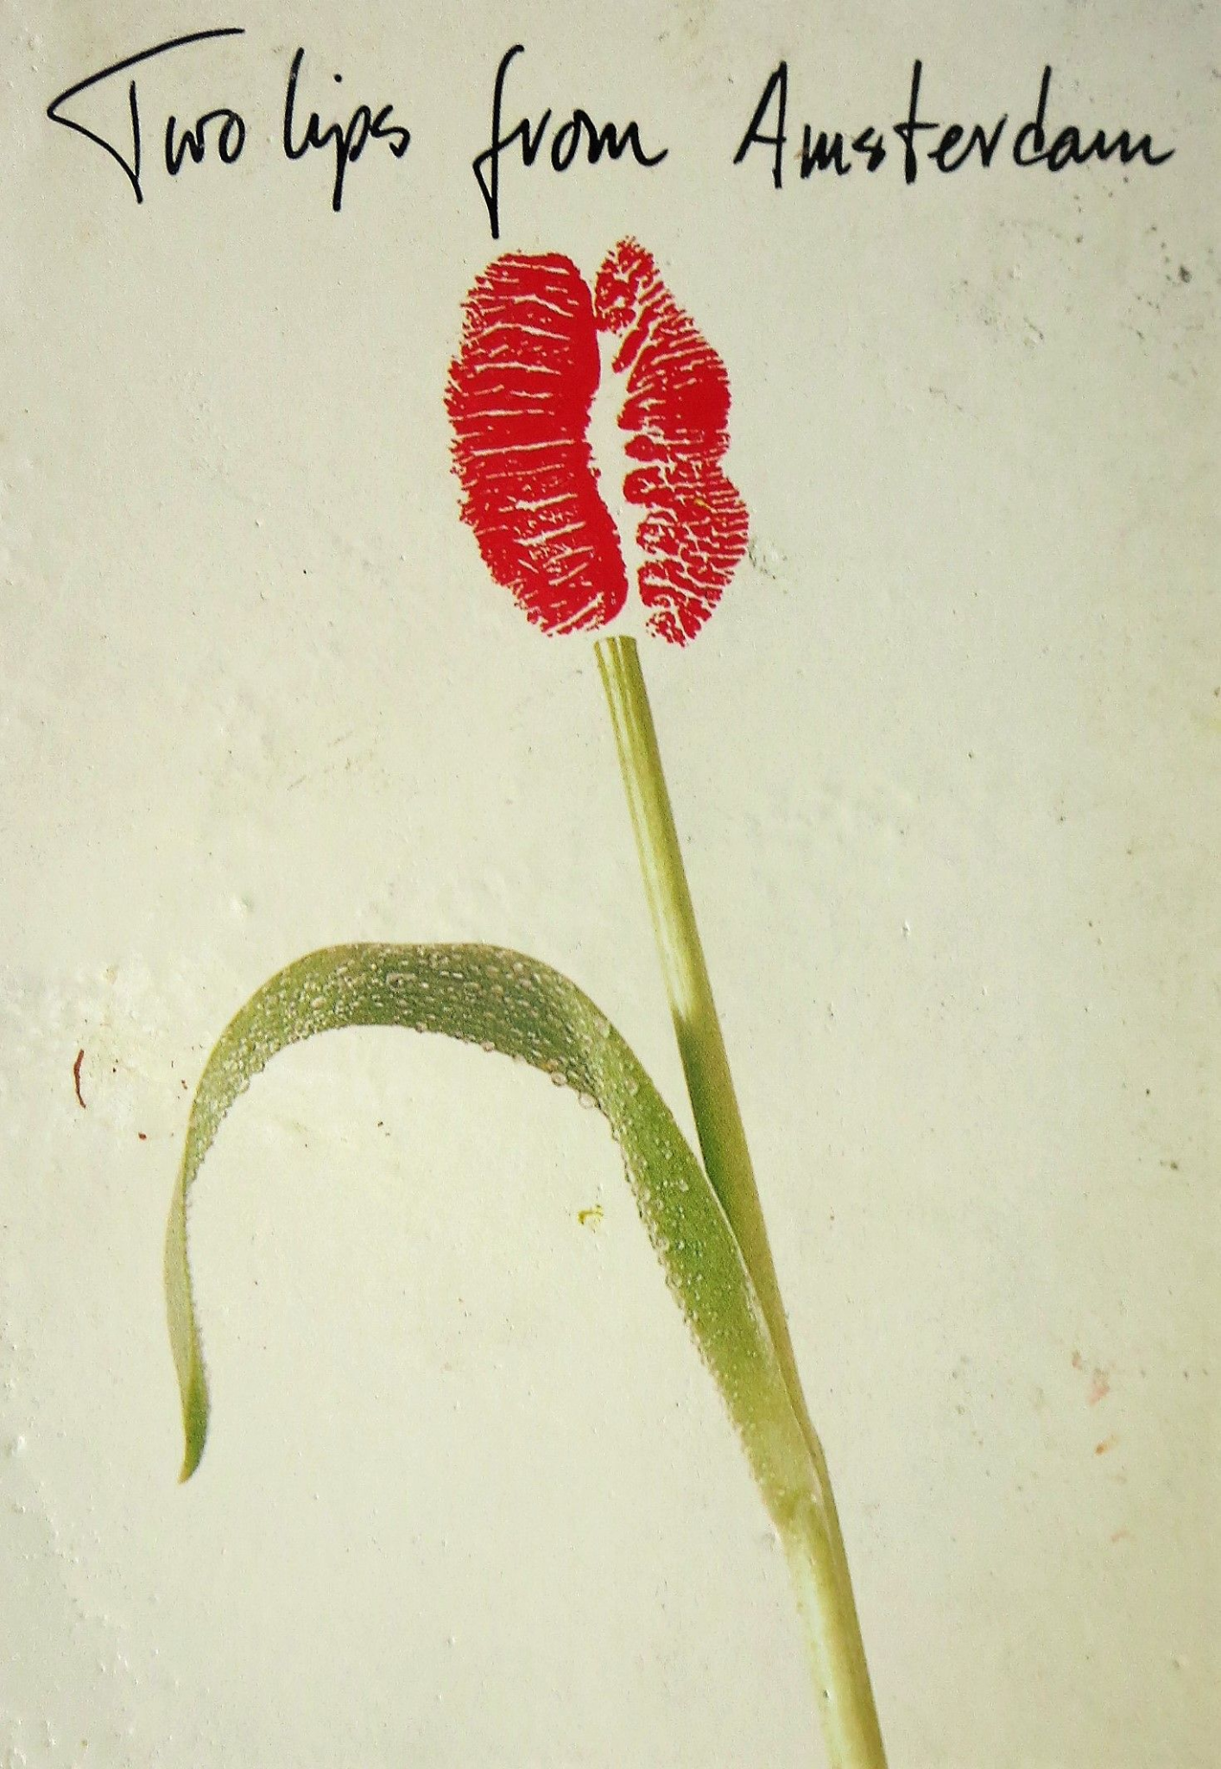
This (seemingly corny) postcard embodies, in my perception, the philosophy of Boekie Woekie. Displayed in front of the store on Amsterdam’s now very popular Berenstraat, it not only looks like a tourist souvenir, but also makes Boekie Woekie look like a souvenir shop. Probably more than half of the customers in Boekie Woekie are not art book buyers, but tourists, lured into the shop by this and similar self-printed postcards and paraphernalia. This is not accidental or unwanted, but deliberate.
Depending on one’s point of view, one could say that Boekie Woekie operates either in semi-disguise, not appearing to be an art space, or simply in non-disguise: not actually being an art space in any conventional sense, but blending into the everyday. It’s a program to democratize art by democratizing not only its poetics (= its making, as in most contemporary artists’ bookstores) but also its aesthetics (= its perception).
This follows a longer, often overlooked tradition of making art quotidian. In non-Western countries, including East Asia, this is still the norm for art. In the West, John Dewey wrote a first program of art as part of everyday life in “Art as Experience” (1934). It later informed the Black Mountain School, its student Allan Kaprow, and, directly or indirectly, Fluxus, and thus a tradition of art that also influenced Boekie Woekie and, at some point, merged with non-Western approaches to everyday art, such as ruangrupa’s.
One might be tempted to call this approach “post-autonomy” art, following a recent coinage by German art historian Wolfgang Ullrich, and thus declare Boekie Woekie an early example of it. But contrary to what Ullrich suggests in his book, Boekie Woekie does not seek an exit, a solution, or salvation by becoming a gift shop. On the contrary, Boekie Woekie’s refusal of aesthetic autonomy (in the sense of l’art pour l’art and white cube art) is done in order to gain personal and collective autonomy, for the Boekie Woekie artist collective (including material autonomy from running the shop), and for the people around it.

your best friends are the ones you may not even know
Having been a zine-maker since the age of 13 in 1982, and having returned to zine-making some time ago, a personal Walhalla of mine has been the Sticky Institute in Melbourne, Australia: a small, volunteer-run space for zine-makers where zines are made and sold, and where people can meet other zine-makers, centrally located in the city (when I visited in 2013) in a small space in a pedestrian underpass right next to the central train station. My dream was to create a Sticky Institute in Rotterdam, preferably in the similarly central and crowded underpass of the Beurs metro station, near its (seemingly) haunted eastern exit, where shops, fast-food joints and hairdressers never stay in business for more than a few months.
It took me almost ten years to find out that the Sticky Institute, with its principle of not being an art institution, of being self-organized, unassuming, and embedded in its everyday environment, was actually modeled on Boekie Woekie. As the Sydney Morning Herald wrote in 2015, “Luke Sinclair co-founded Sticky, as it is known by its inner circle, in 2001. It was inspired by Amsterdam’s Boekie Woekie, and while it was the first shop of its kind in the country, it’s now one of many. Sydney has Take Care zine distro, Perth has Aunty Mabel’s, Adelaide has Co-West.” Jan Voss still remembers Luke Sinclair as a visitor and customer in Amsterdam, but didn’t know this history.
The Beijing-based artist-run space HomeShop, which existed from 2008 to 2013, defined itself as “a storefront residence and artist initiative [...n]estled in the centre of the city on one of its old hutong alleyways, the space and its window front were used as the beginning points from which to examine ways of relaying amidst public and private, the commercial, and pure exchange as such. [...] Here, daily life, work and the community served as explorations of micropolitical possibility, and of being in common.”
Not only is there a shared spirit with Boekie Woekie’s quotidian art practice, but HomeShop’s (now archived) website even linked to Boekie Woekie in the headers of all its pages, and its magazines were for sale there. HomeShop’s founder, Elaine W. Ho, had studied in the Netherlands, worked in Amsterdam, and frequented Boekie Woekie. She later initiated and now leads the project 後勤慢遞 LIGHT LOGISTICS, a “person-to-person distribution network” for DIY publications and everyday items, which operates as a social experiment of a self-organized volunteer courier service and psychogeographic logistics enterprise. The delivery of its shipment no. HQL-453 (containing 11 publications) from Hong Kong to Amsterdam took place in Boekie Woekie.
The two examples show that Boekie Woekie has influenced initiatives, communities, and practices in places one wouldn’t conventionally expect; less because of their geographic locations, but more in terms of the art concepts (“Kunstbegriffe”) being practiced. They are all experiments in forms of publication and distribution, experiments in practiced and lived autonomy, and experiments outside the white cube.
don’t be gezellig
With everything that has been written on the other four pages, one could wrongly conclude that Boekie Woekie is a community art initiative. However, the disadvantages of community art dialectically mirror white cube art.
But first a digression: With Peter Fengler, artistic director of Rotterdam’s former sound performance art space and small experimental book and vinyl record publisher De Player/De Layer (whose work is also on display at Boekie Woekie), I once came to the conclusion that the difference between an artist-run initiative and an institution is that in an institution, everyone must always be replaceable in their job function; so that the same institution could be run by completely different people without any major disruption, ideally at any time; while an initiative is fundamentally based on the subjectivities, personal knowledge, and backgrounds of the people who run it, and who are not simply replaceable. Therefore, an initiative or an artist-run space usually ends when the people decide to leave. We came to this conclusion when we ended De Player. Boekie Woekie proves this equation because it has been run by practically the same group of people for 36 years – in contrast to other artist-run spaces in Amsterdam and the Netherlands that institutionalized at some point, changed their staff multiple times, and are now zombies kept alive for the sake of their own survival.
So is community art the antidote to institutions?
In the early 1990s, the American anarchist theorist Bob Black characterized this dialectic more specifically for Mail Art (which is also represented in Boekie Woekie, and which could be called a more specific form of community art because of its open participation). He likened high-brow art in galleries and museums to the Olympics and Mail Art to the Paralympics, pointing out that their systems aren’t structurally different in any way, only based on different reward criteria. The high-brow art Olympics reward “excellence,” while the Mail Art Paralympics – much like membership clubs and nonprofit organizations – reward participation.
Community art and art pedagogy are also based on maximizing participation and thus lowering the threshold of entry. This kind of communality has its popular expression in the Dutch term “gezelligheid,” which is considered untranslatable (although it’s closely related to the German word “Geselligkeit,” “sociability”). When something is “gezellig,” it doesn’t create obstacles, it is pleasantly sociable, perhaps cozy, but in any case it amounts to a positive communal experience. To borrow from Adorno (whose aesthetic program is in many ways the opposite of Boekie Woekie’s – he would have even despised the name “Boekie Woekie”), gezelligheid is a performance of the “identical.” It has no space for the “non-identical,” no space for aesthetic, social, political or other disagreements.
Boekie Woekie, however, has both: the (seeming) gezelligheid of “Two Lips from Amsterdam” and an attitude of open disagreement – with the conventions of today’s artists’ bookstores, with the art system, with the real estate business that ultimately drove it out of its space, with politics, with just “gezellig” art and books.

the medium is overrated
When I visited Boekie Woekie a few years ago, Jan (Voss), who was sitting behind the counter, referred to it as a “used paper storage” in a semi-disparaging and self-critical way. I have always perceived Boekie Woekie as operating both inside and outside its medium, the book. This is also embodied in its name: “Boekie” [pronounced “bookie”] means “little book” (in Dutch: “boekje,” which can also be pronounced “boekie” in colloquial language and in some Dutch dialects), “Woekie” [pronounced “wookie”] means nothing per se (although it recalls the furry humanoid creatures called Wookies in “Star Wars”), while “Boekie Woekie” sounds like a nursery rhyme alluding to boogie-woogie, the early 20th century blues music genre. Meanwhile, Dutch “street language” (“straattaal”), the vernacular spoken by immigrant youth that is gradually overtaking traditional Dutch working-class dialects, includes the phrase “woekiki” (pronounced “woo-kiki”) for “hello, how are you.”
In other words, while the medium of the book is centrally present in Boekie Woekie’s name, it is simultaneously dissolved into sound. This is reminiscent of the Fluxus concept of intermedia (first proposed by Dick Higgins in 1966), and of visual and sonic poetry, but in a deliberately low-brow, quotidian language, without the pretension of a word like “intermedia.” At the same time, Boekie Woekie’s signature postcard and t-shirt “Two Lips from Amsterdam” is itself an example of visual and phonetic intermedia poetry. It has only an implicit disinterest in book culture as anything other than part of a larger vernacular, everyday culture (which includes postcards and t-shirts). It also contradicts the idealization of print in recent artists' bookstores and their focus on well-designed books and “beautiful” neo-artisanal printing techniques.
A collaborator of mine, the Croatian ex-web designer, ex-journalist, (ex-?) artist and queer sports activist Z. Blace, once called Dutch artists’ books “over-designed and under-edited.” In contrast, Boekie Woekie has a pronounced disinterest in the book as a design object, including its own publications such as the demonstratively low-tech and sometimes crude “André Behr Pamflet” series.
A community hosted by Boekie Woekie is the Dieter Roth Academy, and Dieter Roth’s books form a secret library and archive within the store. In 1973, a major German publishing house published selected writings by Roth in the paperback “Typische Scheiße” (“Typical Shit”). A few years later, the book was picked up by Berlin’s emerging punk and post-punk scene, because it could have been the title of a punk record or zine. In 2006, survivors of that scene (including musicians from the bands Tödliche Doris and Stereo Total) formed a “Dieter Roth Orchestra” and recorded an album with lyrics from the book.
I am not sure if the members of the Boekie Woekie collective would also call their inventory “typical shit,” but their irreverence (but not ignorance) of craft and media seems to be related and has made Boekie Woekie close in spirit to the original zine and punk DIY culture, despite being run by an older generation of people.

Julie Ault, Interview with Lucy R. Lippard on Printed Matter, 2006.

