autonomy zinedraft
#2: takeaways on autonomy

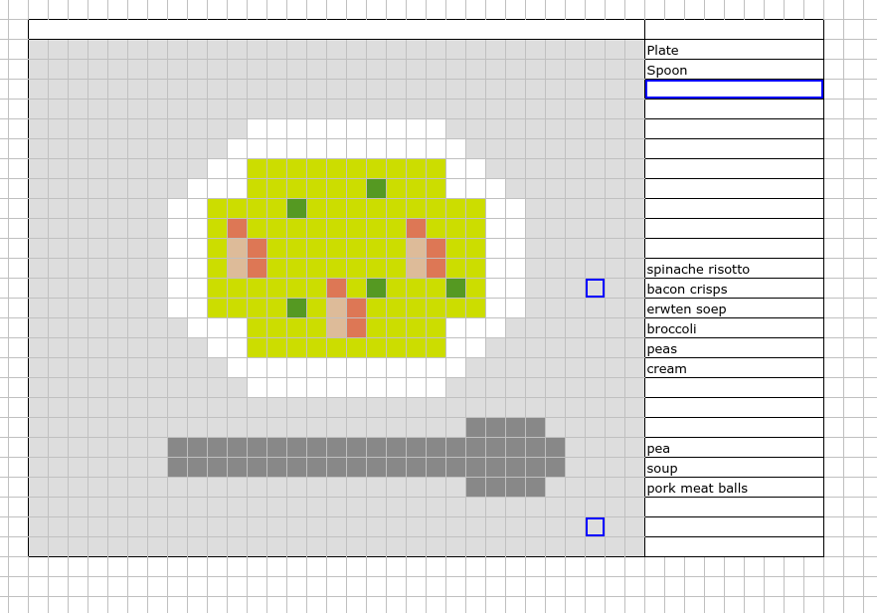[note: we don’t know who of the 2nd year student group Autonomous Practices/Hacking made this – can you help us out? We will credit you in the non-draft edition of this zine!]

based on workshops by & with Judith Westerveld, Timoteus Anggawan Kusno, KAJET, Karl Moubarak, Maike Hemmers in
WdKA Autonomous Practices.
autonomy zine grew out of WdKA's Autonomous Practices. It is a zine that can be made by anyone: an experiment in & about autonomy. Feel free to make & spread your own issue of autonomy zine.
This edition was made by Florian Cramer, Natalia Sorzano & Weronika Zielinska as part of Autonomy Lab, WdKA's research program on Autonomous Practices.
- edited & designed on Hogeschool Rotterdam's web-based Microsoft Office 365 environment, with its available typefaces, as an experiment in our dependencies and autonomies.
Cover illustration made by 2nd year Autonomous Practices/Digital Craft students in Ethercalc, an Open Source, Web-based, collaborative spreadsheet editor, during Karl Moubarak's workshop.

[autonomy as politics]

autonomy = political concept
autonomy as democracy and liberation; vs. dictatorship and authoritarianism; artmaking as a moment/subjective experience of autonomy

[autonomy vs. social systems]

autonomy = in relation to societal dependencies

how can a squatter claim autonomy when they are dependent on public infrastructures (healthcare, transport...)?

one can be simultaneously autonomous and dependent on an institution

you can stretch what is allowed and expected but have to exist within a system

[cultural autonomy]

conceptual understanding of autonomy: can one maintain an autonomous position in constant struggles over power and cultural hegemony?

having to write and speak in English means to compromise one's autonomy

all works needs to come with a disclaimer: autonomy has been compromised, a second skin is worn

[institutional autonomy]

institutional autonomy: to realize projects with minimum interference by others

funding can allow or compromise autonomy

structural dependence on funding means to lose autonomy

[public vs. private art]

arts and culture are a public service in the Netherlands. This means: you have to create joy, you are not allowed to be angry. Your art is meant for the middle-class, suburban Dutch household - or otherwise it's private market art

the question is: who can afford to be autonomous?

[individual and collective art]
autonomy shifts from individual to collective work after feeling alone in one's autonomous practice; it moved to larger contexts

broadening one's autonomous practice by making more connections

artistic research helps in learning to work collaboratively where multiple voices and perspectives are important

using open frameworks to collaborate on equal footing

the new experience how quickly one can create in a group of people

[bodies, spaces, objects]

an attitude of “Being in relation with…”: autonomy exists in the relationships between bodies, objects and spaces.

And there is autonomy of objects and spaces themselves

What does it mean to understand something we consider non-living as autonomous? - ecological autonomy.

Animals have been treated as objects, women have been treated as objects, people have been treated as objects and these things continue to happen.

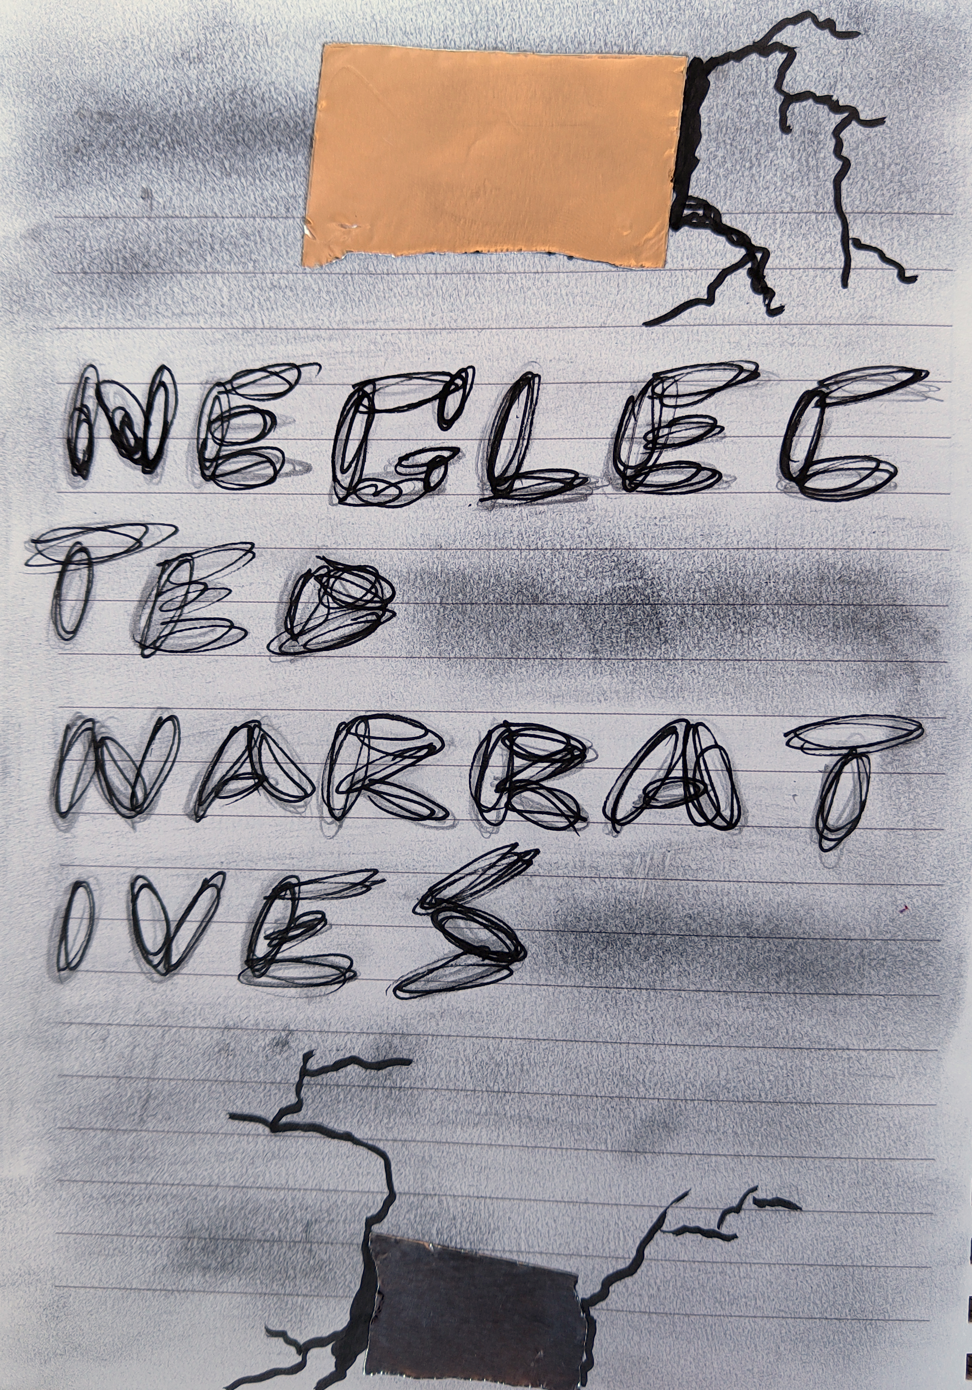

Timoteus Anggawan Kusno
Timoteus Anggawan Kusno's films and installations explore Indonesia's colonial history to "unsettle the colonial matrix of power", using fiction (such as creation of made-up historical materials) as artistic research methods. His work combines research (he's a PhD candidate in media studies) and artistic practice. Among others, he's contributed to the "Revolusi!" exhibition at Rijkmuseum where he worked with its colonial collection.
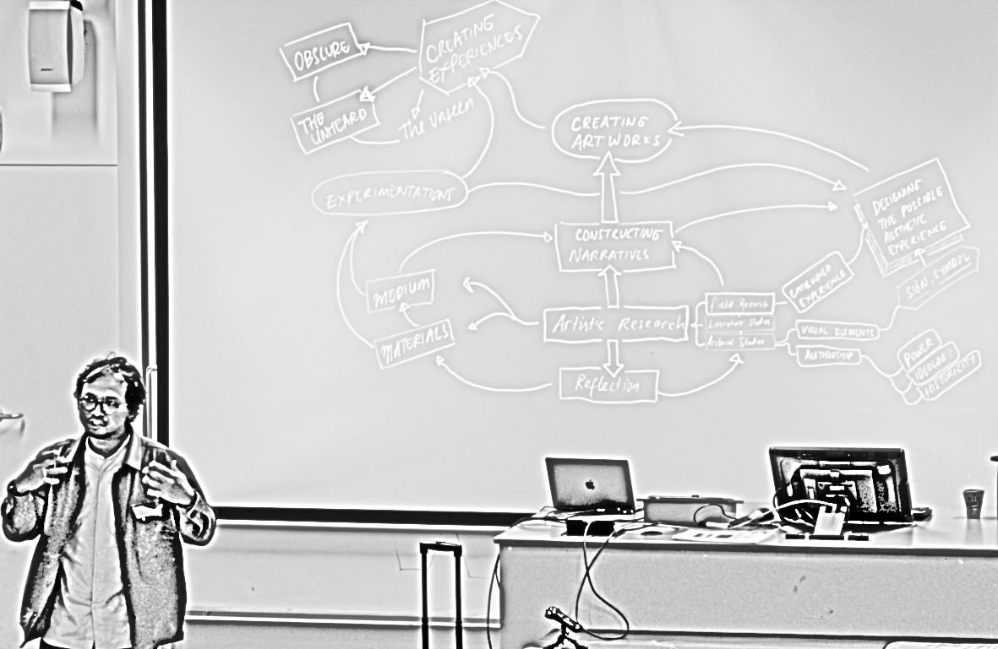autonomy as liberation
The notion of autonomy is very significant for Timoteus Anggawan Kusno and his work. It is motivated by having grown up under a dictatorship and been subjected to the strong protocols of being taught during authoritarianism.
For him, autonomy is a political concept, in the sense of not being subjected to authoritarian rule. It is closely tied to democracy. In the time of the dictatorship, democracy and autonomy were illusions. After the fall of the regime, autonomy was “what we were collectively searching for”. Timoteus tried to find the meaning of autonomy and found it in creating art: “When I come into artmaking, this creates a moment of autonomy”.

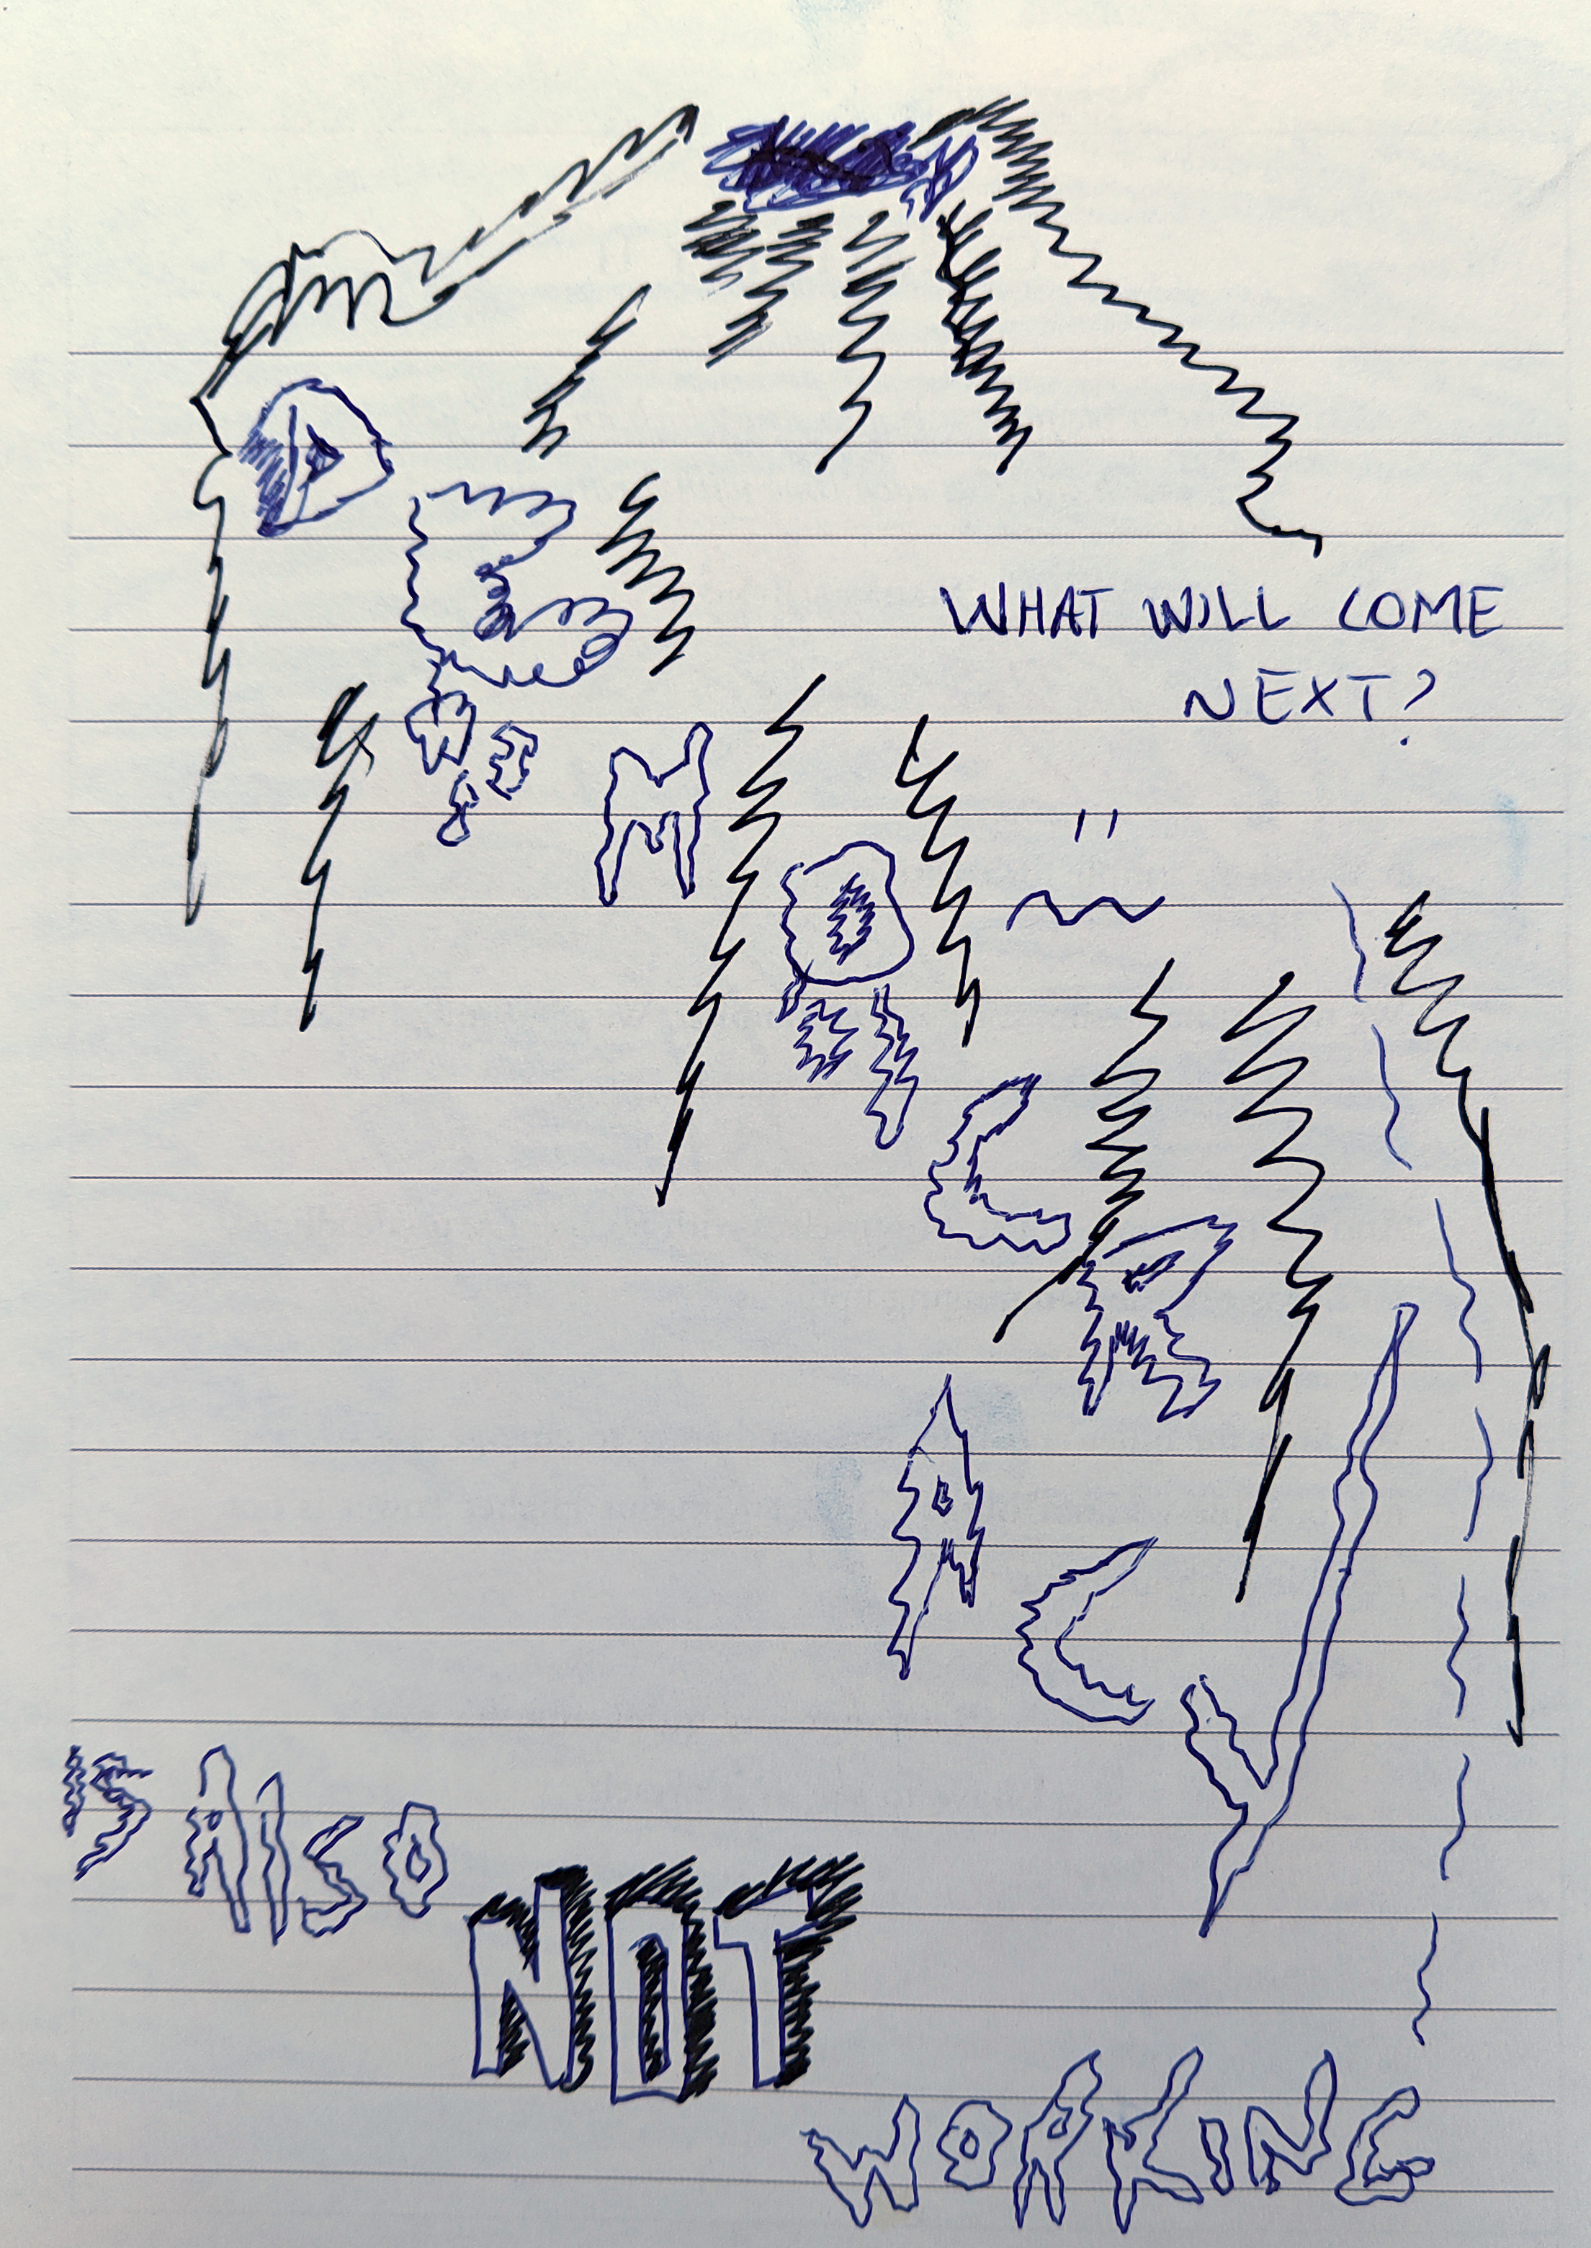

Karl Moubarak
Karl works with art, culture, software/computers. He rarely works alone, but in groups, networks and collaborations. These include the Office of Queer Affairs (a collective that queers Van Abbe Museum Eindhoven), Cell for Digital Discomfort (a project for BAK Utrecht Digital addressing discomfort with existing digital systems and internet platforms, and the use of Open-Source alternatives) and Hackers & Designers (a "non-profit workshop initiative organizing activities at the intersection of technology, design and art").
autonomy in relation to societal dependencies
Autonomy has been an interesting concept particularly in the context of squatting. There is now a discrepancy between the older, legalized and economically settled squatters and the younger, more economically precarious generation of squatters: How can one, as a squatter, claim autonomy when one has multiple dependencies on public infrastructures, such as social security (healthcare etc.)?

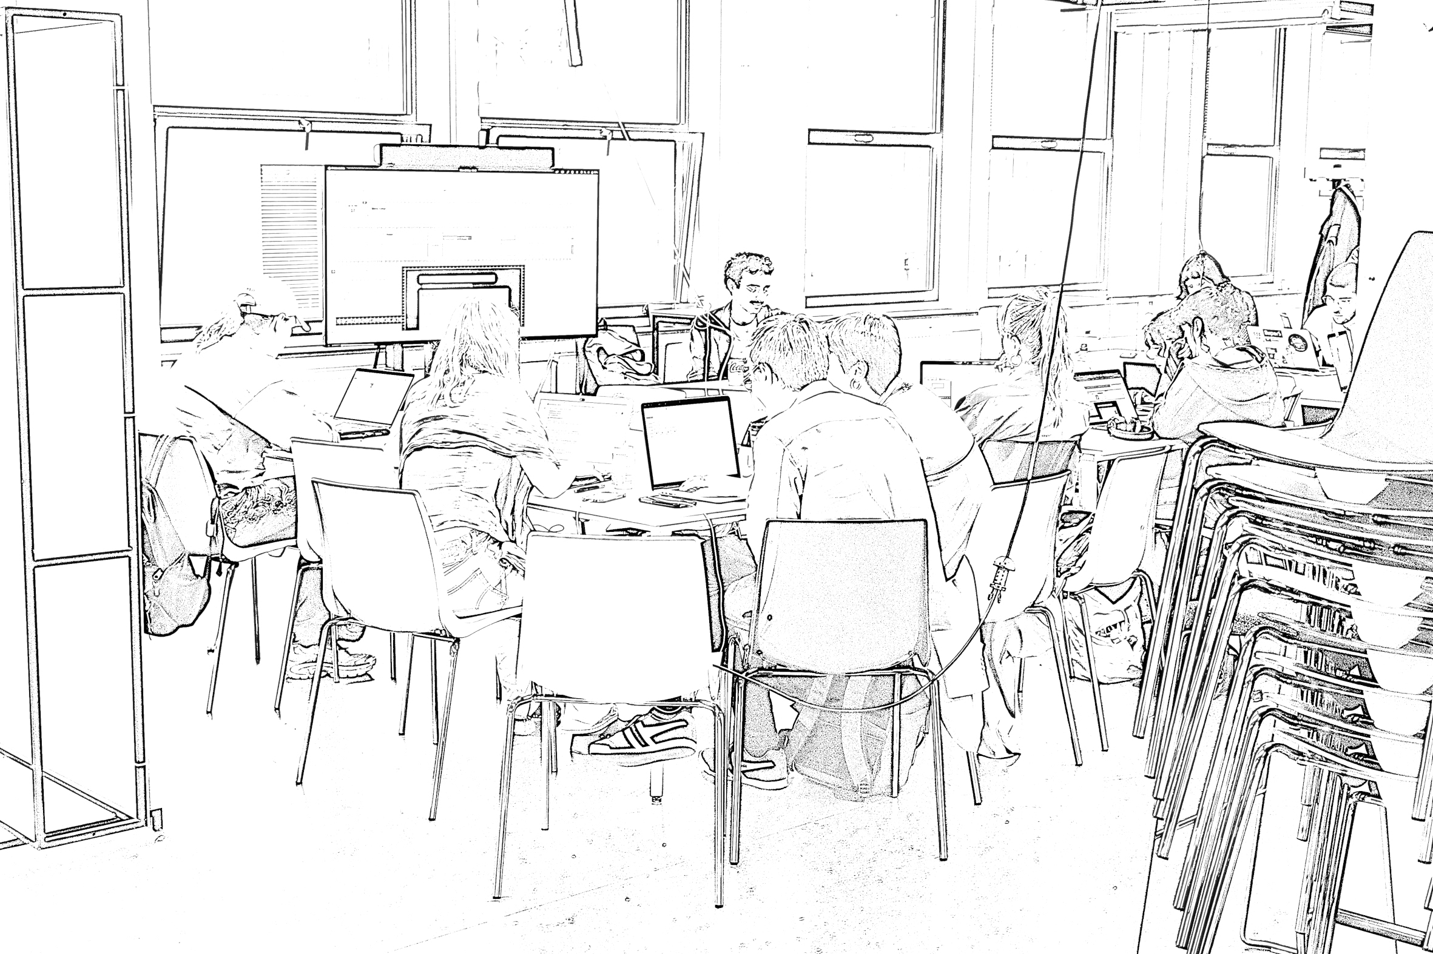

This question also relates to the collectives in which Karl was involved: The Office of Queer Affairs was both autonomous and dependent on an institution (of the Van Abbe Museum Eindhoven). Hackers & Designers are both autonomous and dependent on the Stimuleringsfonds Creative Industrie as its main source of funding. The practice of the collective stretches what is allowed and expected within the cultural funding system but has to exist within that system.
In the Netherlands, arts and culture are a public service. This means your work is funded by taxpayers’ money and you must report and justify your practice as a public service. This can be problematic because you always have to end on a positive note: you have to create joy, you are not allowed to be angry. After all, culture as a public service is meant for a nuclear, middle-class, suburban Dutch household. The only other model is the private market art world.
So autonomy is contested, and the question is who can afford to be autonomous. We often want to call ourselves autonomous, but we must constantly justify our practice.

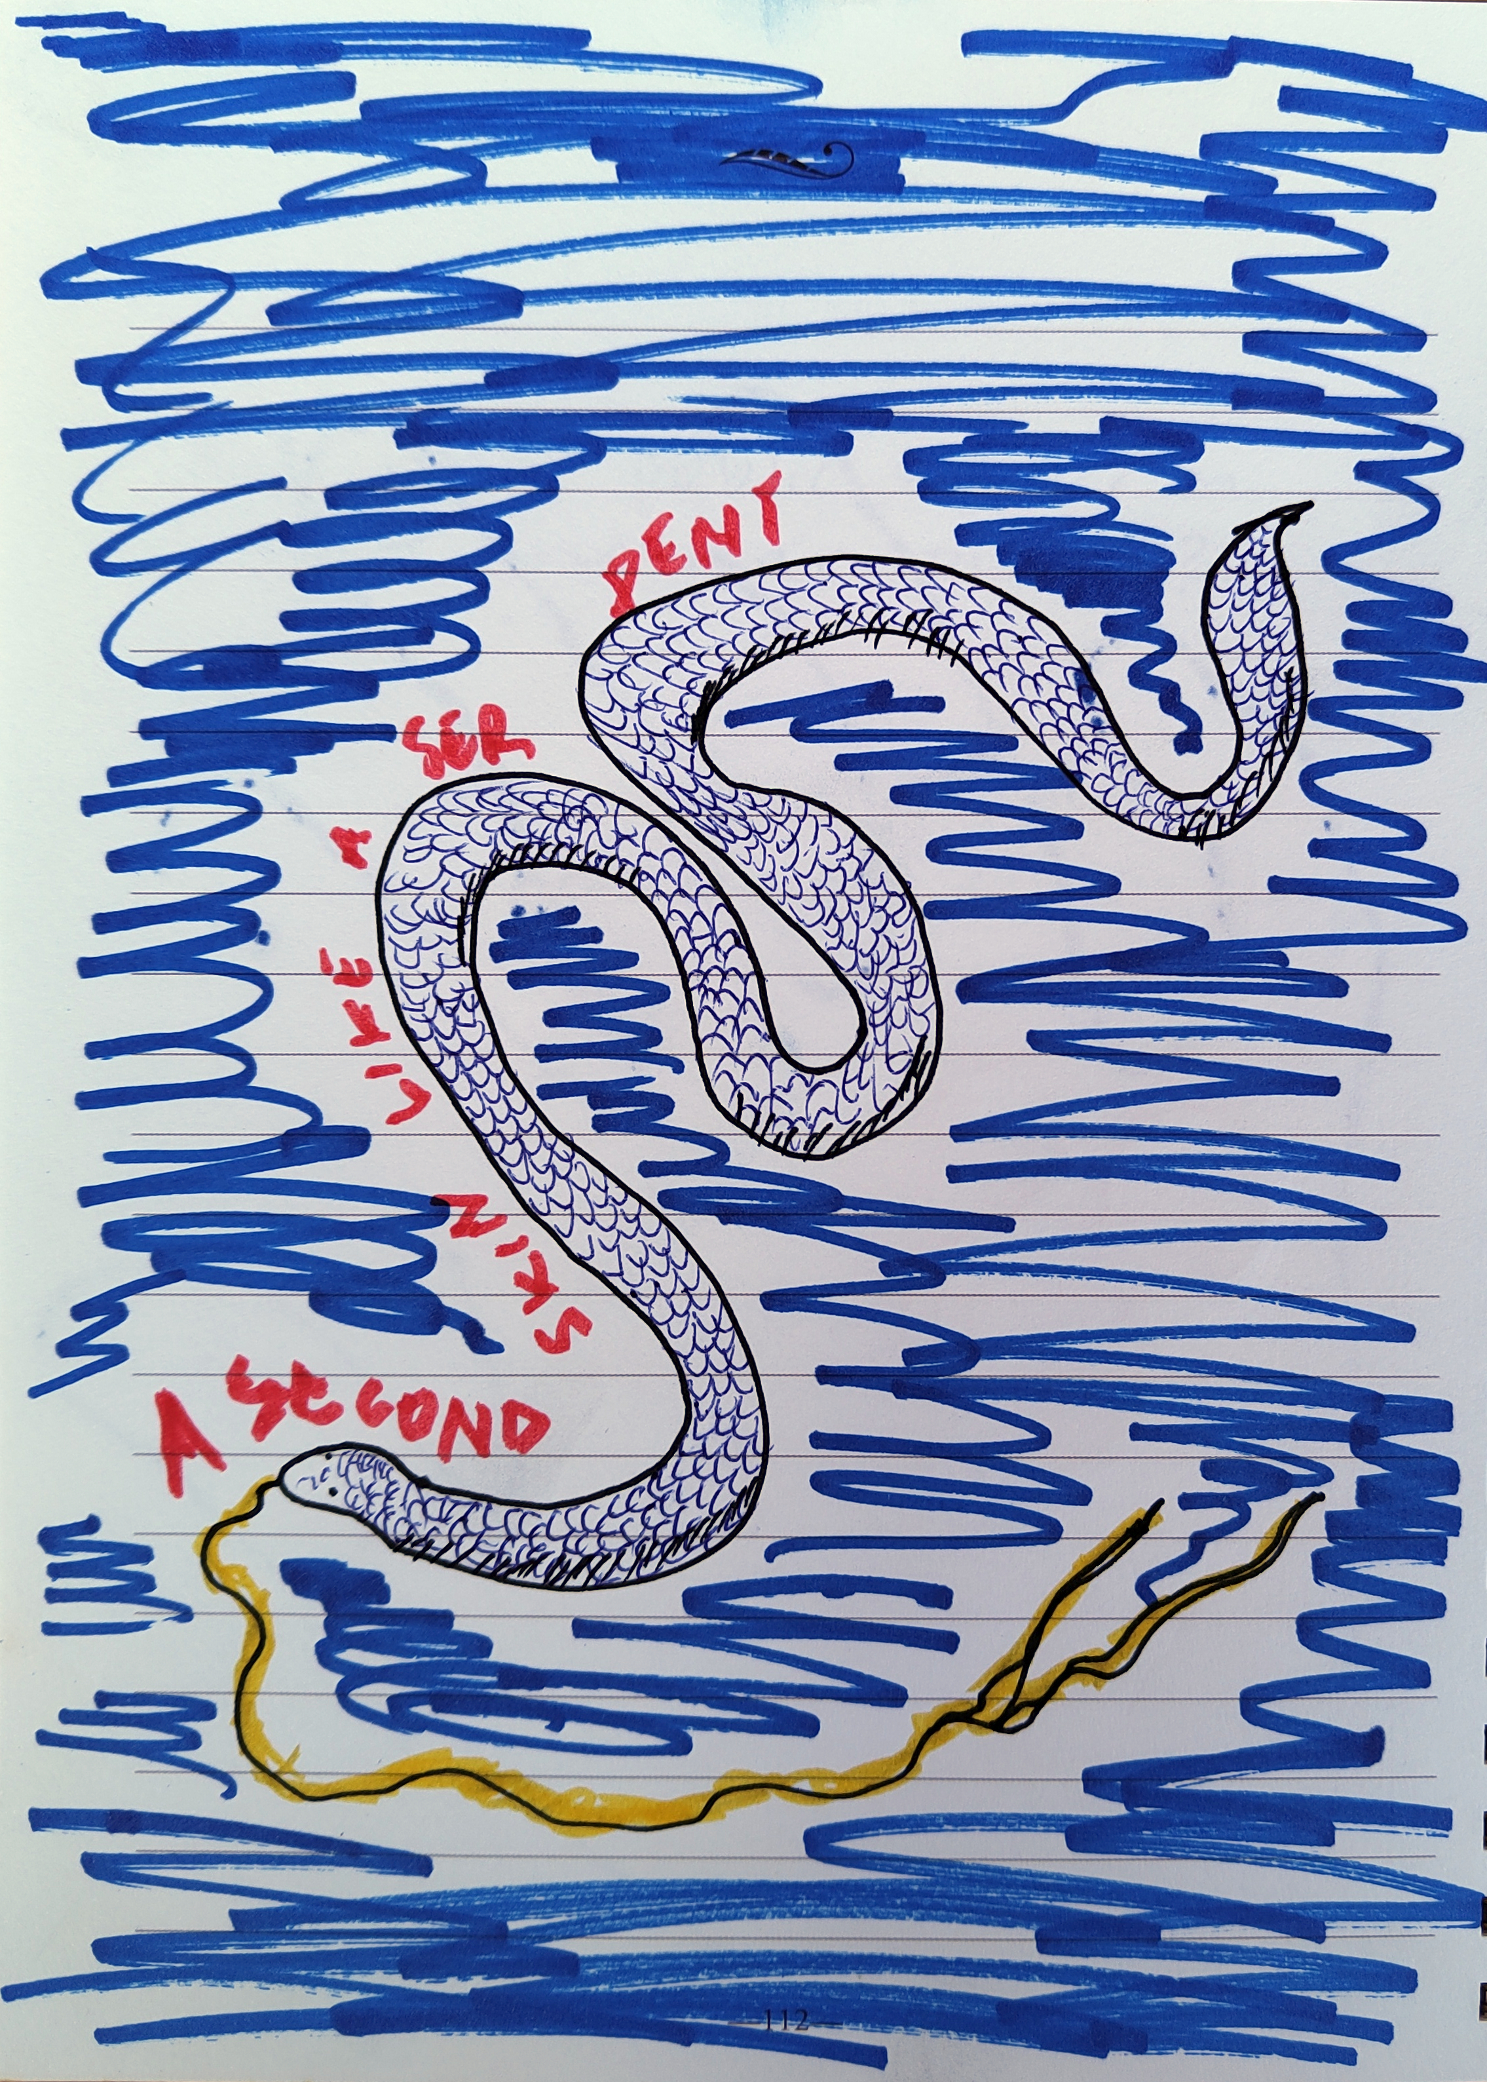

Judith Westerveld
Judith Westerveld is an artist and filmmaker who studied Fine Art at Rietveld Academy and completed a Master Artistic Research at University of Amsterdam. She grew up and lives both in the Netherlands and South Africa. Her work concerns the common violent colonial past of South Africa and the Netherlands and reflects on how the colonial past impacts the present. This past is very present in South Africa, but largely unknown or misconstrued in the Netherlands. Her works concern the question of whose voices are being heard in a post-colonial world, and whose are missing, erased and silenced.
Her works and projects include a series of video works on Jan van Riebeeck’s hedge, a planting of wild almond trees in South Africa to form a physical boundary of Dutch colonial settlement which today is seen as the first apartheid structure; the live performance and audio installation “Mukalap” (2018) and film “Message from Mukalap” (2021, 14:41 min) based on an ethnographic sound recording of a man speaking the now-extinct language !ora, whose identity got otherwise erased. Judith learned fragments of !ora to develop her spoken live performance and its still spoken sister language Khoekhoegowab.
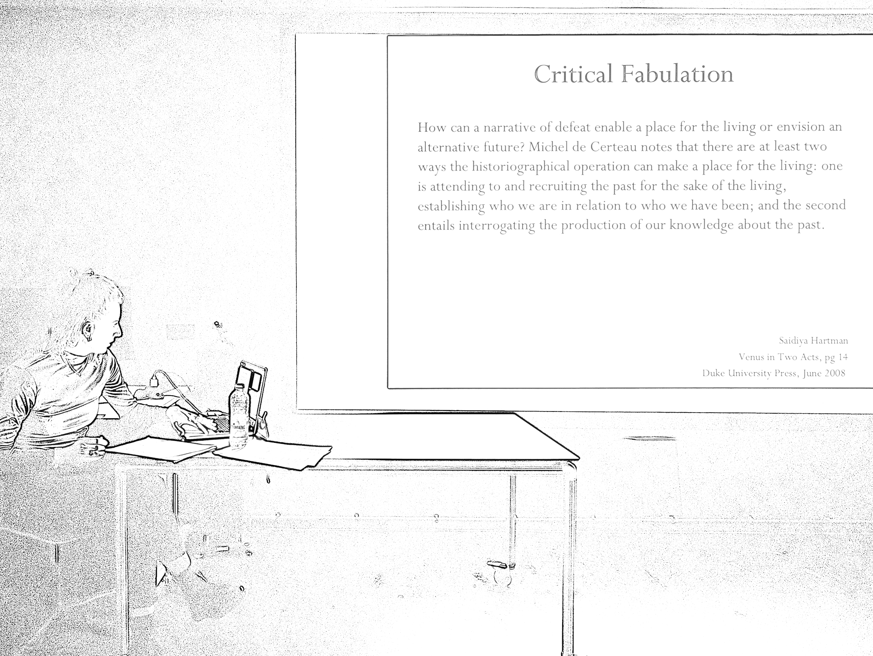
Presently, much of her work is done as a member of the collective Sites of Memory that develops a site-specific performance in one Dutch city every year, as “history theater”. It addresses histories of slavery and colonialism, based on extensive historical research in collaboration with historians and archivists, including the research project “Mapping Slavery” at Vrije Universiteit Amsterdam. The performances are based on the concept of Critical Fabulation by Saidiya Hartman (published in Venus in Two Acts, Duke University Press, 2008) which in turn references Octavia Butler’s Afrofuturist time travel novel Kindred as a model for imaging alternative futures. Sites of Memory puts Critical Fabulation into practice.
autonomy shifting from individual to collective work
Judith Westerveld finds the concept of autonomy still relevant for her art practice. While it began as an individual work trajectory [very much like "autonomous art" is being understood in the Dutch art and art school system], it later became important for her to situate autonomy in larger contexts. She felt alone in her autonomous practice, lacking tools such as: art history, philosophy, film and sound. As a result, she broadened her autonomous practice by making more connections. First, this happened in a more intuitive and personal way. Later, her Master study in artistic research taught her to put her work in a larger context.
She now often works collaboratively where multiple voices and perspectives are extremely important, even if the project still remains hers. She learned through collaboration (such as: learning new languages). In this process, she realized that she needs an open framework while collaborating on equal footing. This means to learn to make decisions together with her collaborators, for example: learning things from collaborators/performers while shooting a film. This almost became a method, to work with a loose framework and fill in gaps collaboratively in the making process.
Sites of Memory was the first collective she was a part of. It therefore meant a shift from her previous individual studio art practice. This was a welcome shift. It was a new experience for her to experience how quickly one can create in a group of people when participants contribute their own perspectives, languages and cultural backgrounds. It is beautiful to have these expressions in the final piece. As a result, she opened up the idea to work collectively, also in projects that are more autonomous, and to give more consideration to collective ways of working and thinking.

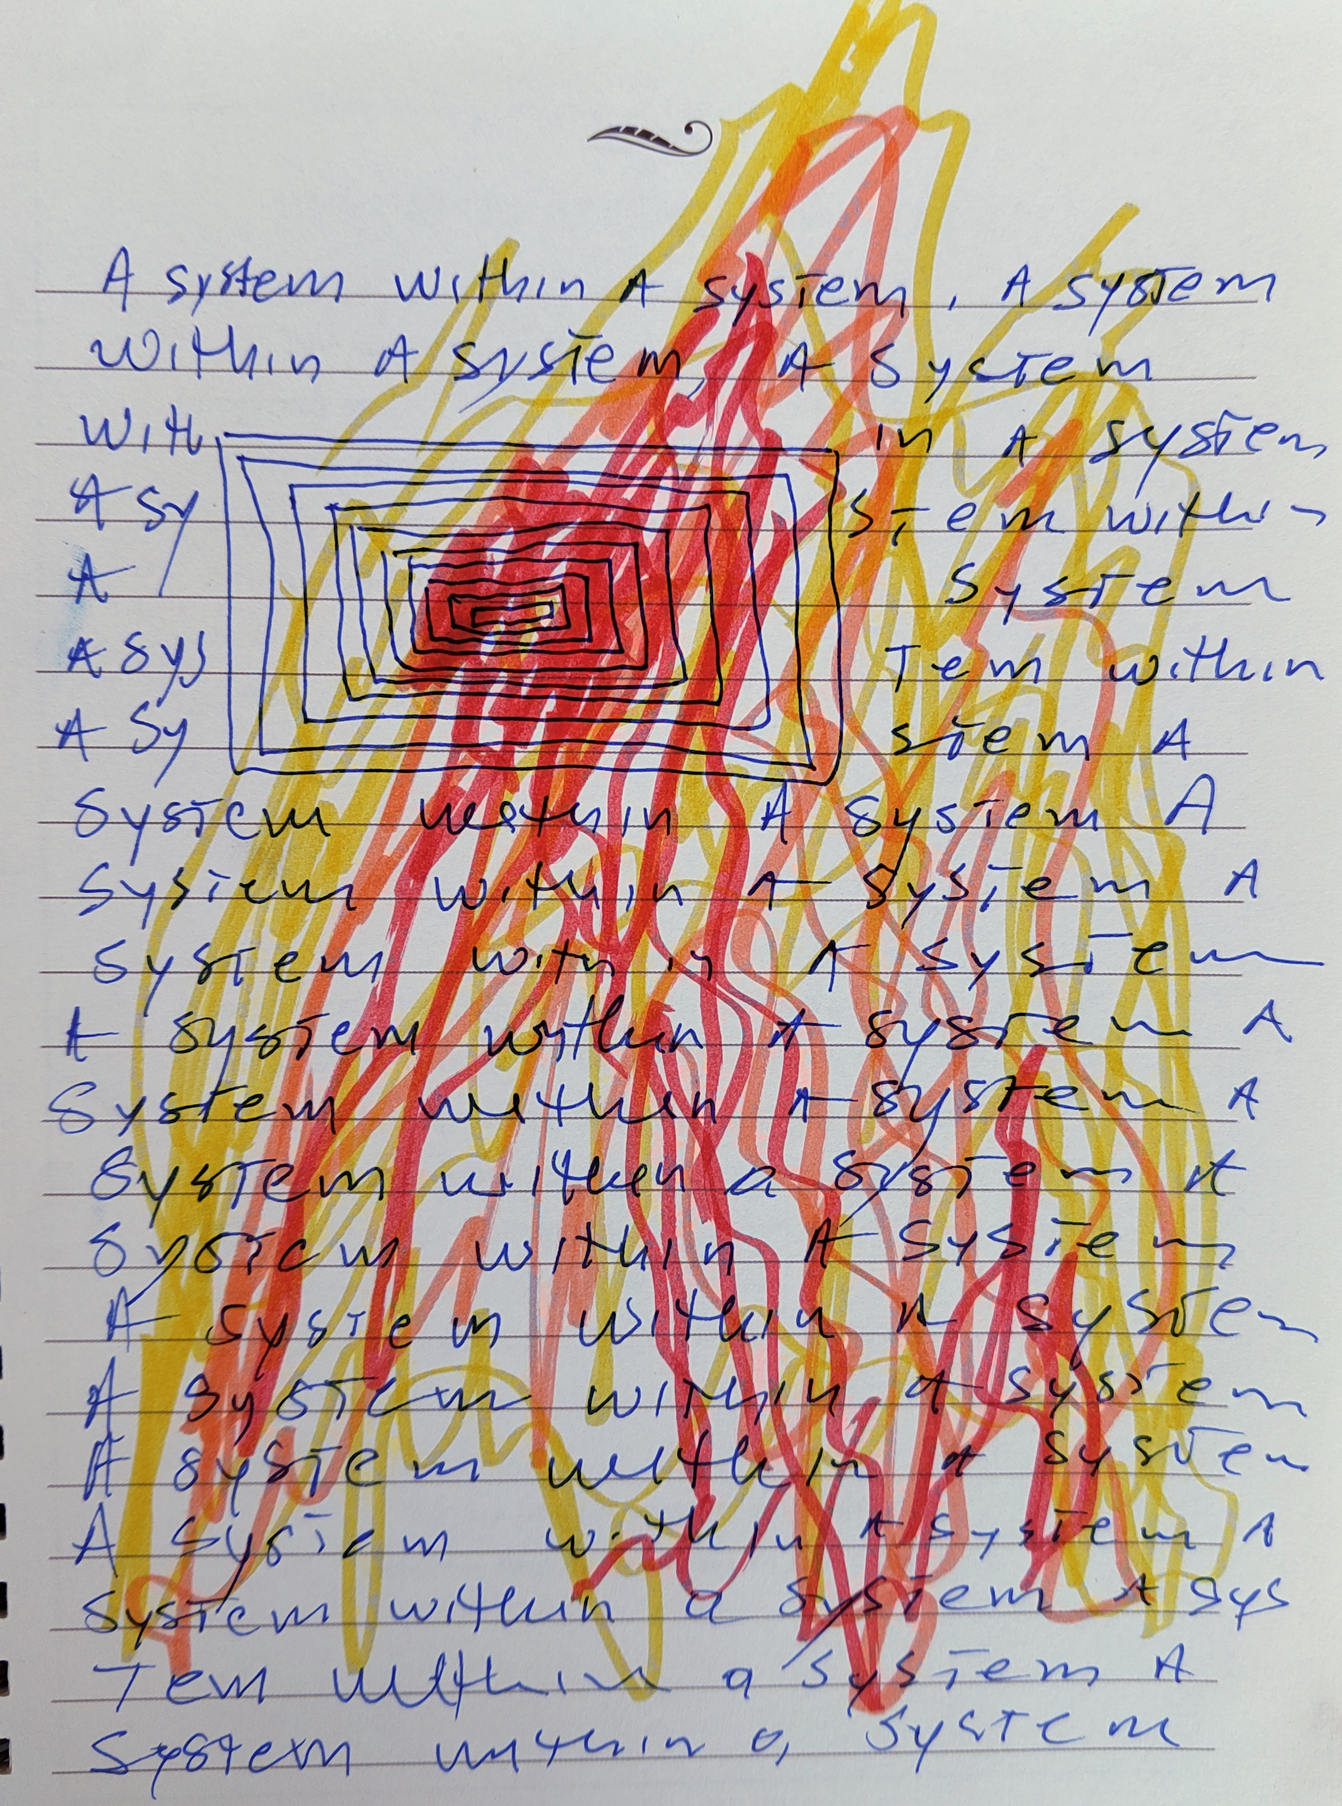

Maike Hemmers
Maike Hemmers is a Rotterdam-based artist whose research reflects on intuitive material relations, shaped by feminism and architecture and what she terms “queer and soft resistance”. She obtained a Master of Fine Art in 2017 from the Dutch Art Institute (DAI). Her project "No Kitchen Ever Belongs to Me" investigates how the Kiefhoek building complex, designed in 1929 by De Stijl architect J.J.P. Oud, implemented normative ideas of how the working class should live and be disciplined (among others, with only four square meter kitchens).
autonomy in the relationships between bodies, objects and spaces.
Maike Hemmers is interested in a feminist critique of architecture, looking at architecture as a structure that forms us, influences us, and determines how we are in space. “Being in relation with…” is central to her practice because her explorations depart from her own subjective experience. So it is crucial to find moments to open her practice for other experiences to come in. During her presentation, we spoke about autonomy in relation to how we, as subjective beings, are affected by objects and spaces. In her work, she explores her own intuitive relation to physical materials and those of invited guests who contribute as collaborators or workshop participants. This conversation led Maike to wonder about the autonomy of objects and spaces themselves. What does it mean to understand something we consider non-living as autonomous? We detach desire, movement or agenda from objects and spaces, but they do have these attributes. Maike finds it fascinating "to think about this relationship and mutual influence between subject and object, what it means to understanding something (an object) as having its own world. It’s easier for us with our human perspective to see it in nature because there is life and we can see movement and transformation. It connects to topics around ecological autonomy, but also to subject and object. Animals have been treated as objects, women have been treated as objects, people have been treated as object and these things continue to happen."

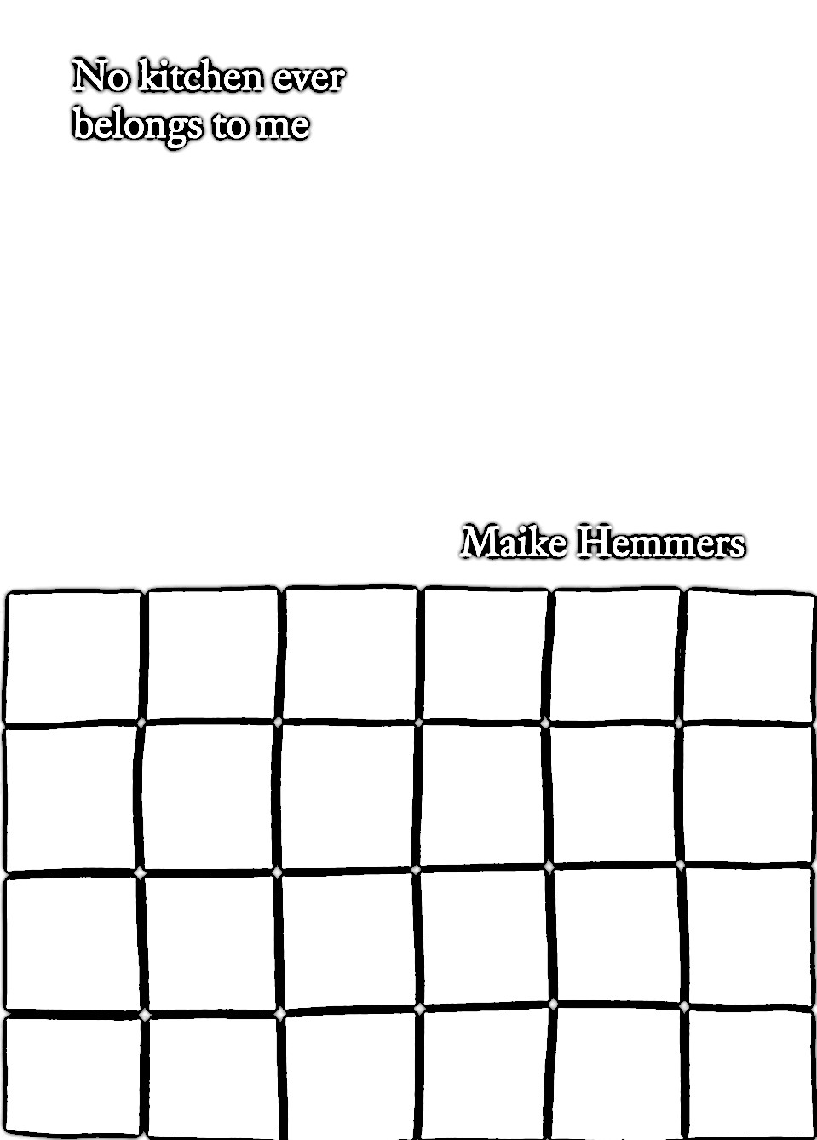

Maike told an anecdote on how she has funded her own practice. For the publication piece No Kitchen Ever Belonged To Me, Maike reached out to Woonstad, the housing corporation that manages large parts of social housing in Rotterdam. She knew that Woonstad used to fund art before the financial crisis, so she contacted the corporation without an open call, just to see if they would support the project with a little money for the publication and if she could work there in the first place. They said yes to her project, gave her a key to stay in the museum house and €500 to make the publication. "That was a good experience of just trying to reach out and get support, and it worked".

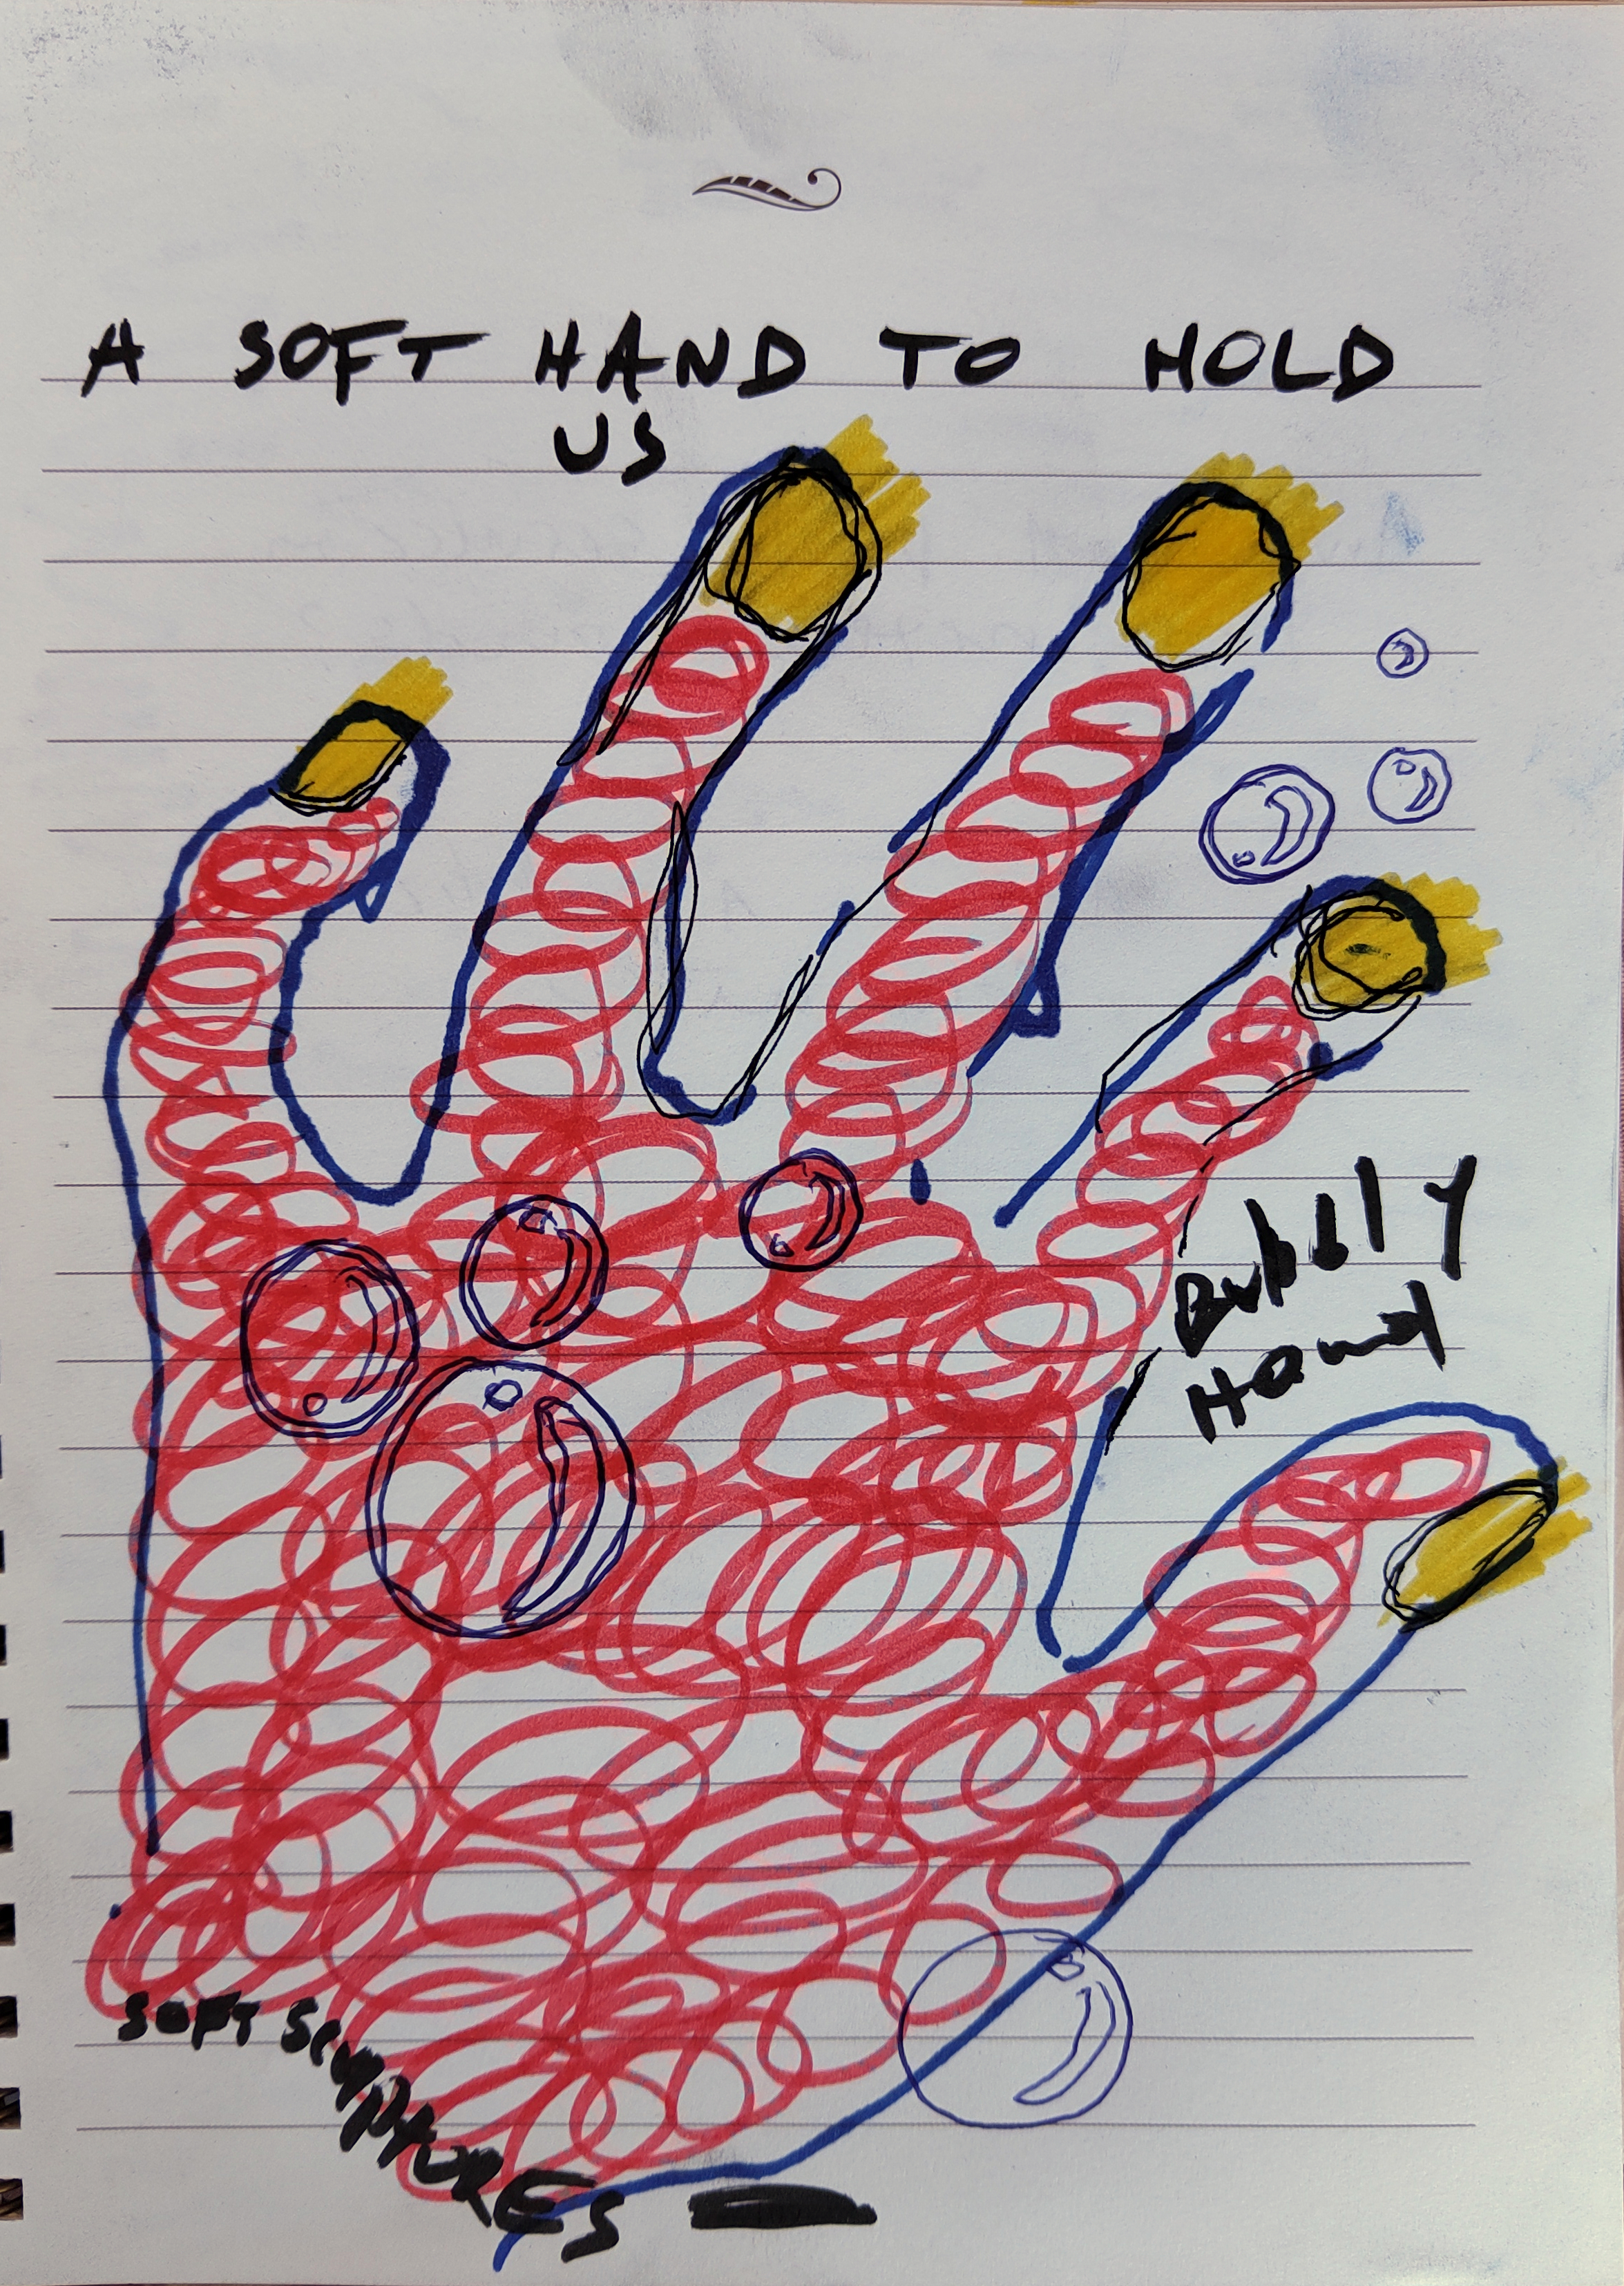

KAJET
KAJET, which appears yearly as a printed periodical, “emanated out of an urgent need to provide a platform for Eastern European narratives. Aiming to become a timeless archival document, KAJET gets its name from the Easternised version of the French cahier, meaning notebook. It embodies the ethos of KAJET: a textual & visual collection of thoughts, an assemblage of neglected narratives, a self-expanding string of reflections & perspectives, a perpetual work in progress of a history that keeps re-writing itself; essentially, a journal of Eastern European encounters”. https://kajetjournal.com/about/
KAJET emphasizes alternative forms of knowing in a situation of ruling misconceptions on Eastern Europe, reimagining the configuration of the region. It is published by Dispozitiv Books, a publishing house and book shop in Bucharest (https://dispozitivbooks.com/shop/imagined-exchanges-2/) that offers publications on critical theory, contemporary art and politics. Sister projects are the publication The Future of and the archive Camera Arhiva [cameraarhiva.com] that collects and documents Romanian printed matters from the communist period. These projects deal with utopias and speculative thinking, imagining other futures as well as canceled futures that need to be reclaimed. This is why the nostalgic project of Camera Arhiva corresponds to the utopian thinking in KAJET’s other publications.

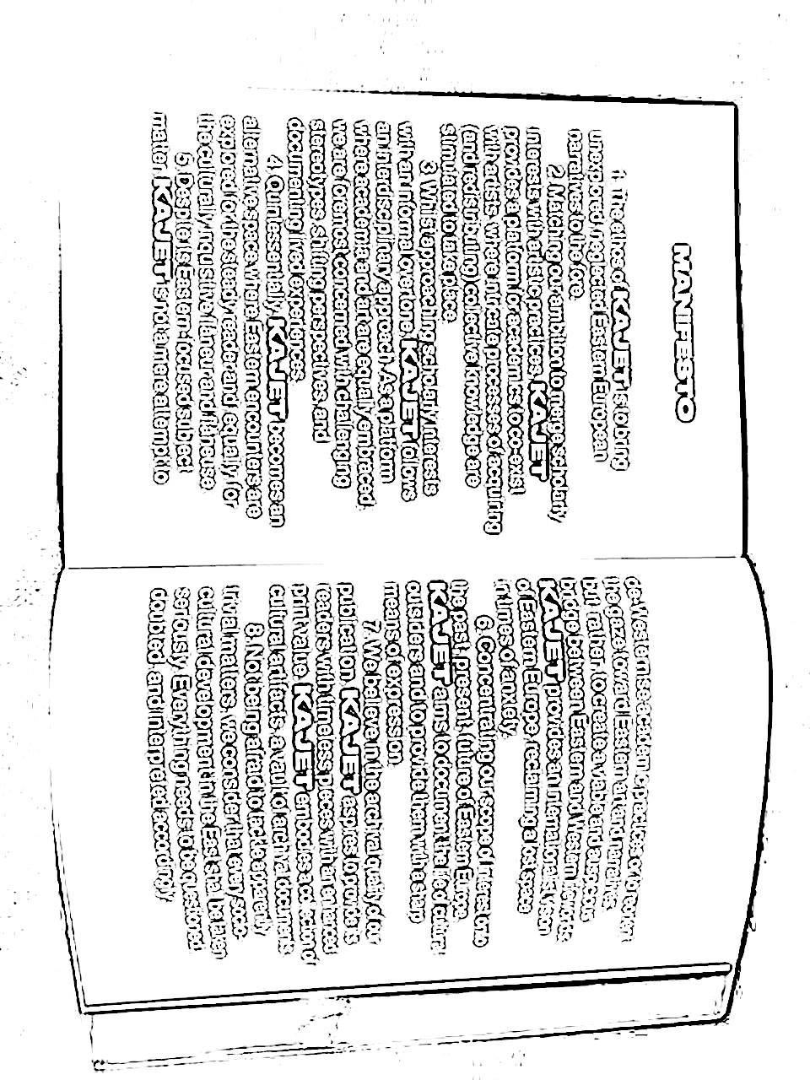institutional and conceptual autonomy
KAJET and its sister projects deal with two types of autonomy: institutional autonomy and a conceptual understanding of autonomy. It tries to navigate both, which always entails compromises.
Institutional autonomy concerns the very practical question of how to be able to realize projects with minimum interference by institutions and other outside parties. This concerns funding in particular: How to develop a practice, a publishing program, exhibitions, and other forms of cultural production through which you can speak and stay on your own path, while at the same time making sure that there are the necessary funds to do this?
KAJET only occasionally applies for funding, depending on the degree to which the particular funding program allows or compromises the autonomy of the project: "How can we do our own thing without the pressure of changing our content by being influenced by external factors?" In Romania, there is a cultural funds financed by alcohol and cigarette taxes. Cultural organizations fight for it three times a year, but it has the advantage that it is known where the money comes from, and that it grants a comparatively high degree of autonomy to the projects that receive it. A counter-example is a publishing funds that dictates the sales prices of magazines and books, which ultimately means that publishers will not be able to sell them at self-sustaining prices and become structurally dependent on the funding.
KAJET's conceptual understanding of autonomy concerns its position in and in relation to Eastern Europe. While it is a heterogeneous space, it is also one that has been conquered, appropriated and whose knowledge has been marginalized after the fall of communism.
The question is whether one can maintain an autonomous position when one is in a constant struggle that concerns power/cultural hegemony, for attention, for funding? KAJET has to compromise its autonomy, for example, by having to write in English and speak in English even now in front of the class. Does that invalidate the project? It never invalidates it completely. But it also means that KAJET's activities always need to come with a disclaimer: autonomy is always affected to some extent when you are not speaking your own language, but figuratively putting on a second skin.

autonomy zine is a zine that can be made by anyone: an experiment in & about autonomy
feel free to make &
spread your own issue of autonomy zine

