Autonomy Lab

ACKnowledge
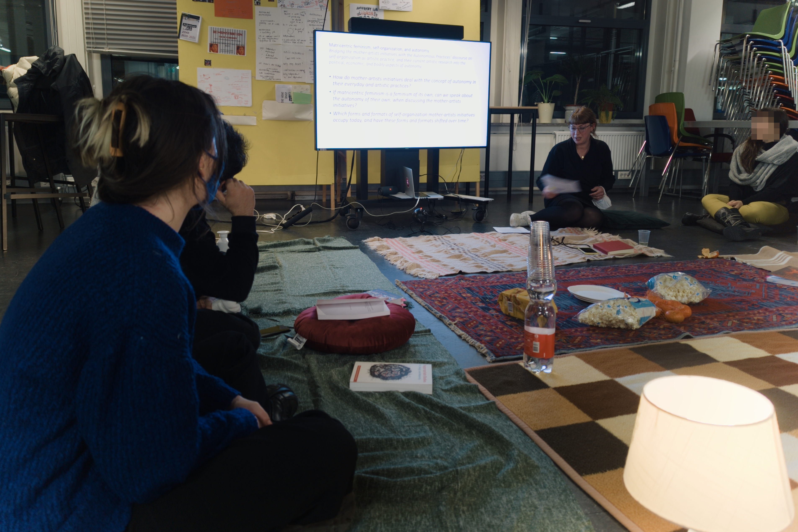
AUTONOMY LAB

How to read a Library

Autonomy Lab

Crafted
Autonomy Lab was conducted by the Autonomous Practices research program of Willem de Kooning Academy Rotterdam, in a research group consisting of teachers and students of the school: Ailie Gieseler, Alice Strete, Anna-Maria Psyllou, Arvand Pourabbasi, Anika van der Meulen, Carla Arcos, carlota garcia, Eugi Manenti, Fenna van Breda, Florian Cramer, Francis Belte, Julia Wilhelm, Lara de Poorter, Leslie Hildering, Linn Doornaar, Luna Bongers, Natalia Sorzano, Noami van Kleef, Nikki Giesen, Pragya Jain, Sam Niehorster, Santiago Pinyol, Simon Kentgens, Sten Heijster, WdKA Haven, Weronika Zielinska, Yunjoo Kwak.
Autonomy Lab investigated new ways of understanding and creating autonomy, particularly in multidisciplinary artist collectives and self-organizations in diverse world regions.
Autonomy Lab included workshops with more than a dozen of artist collectives:
- Eat Art Collective (Rotterdam, Netherlands)
- 展銷場 Display Distribute and Autonomous-8 (Hong Kong)
- Woodbine Collective (New York, USA)
- BananSkolen (Copenhagen, Denmark)
- The Bureau of Care (Athens, Greece & Rotterdam, Netherlands)
- Amigas (Bogotá, Colombia)
- Arahmaiani (Yogyakarta, Indonesia)
- CONSTANT (Brussels, Belgium)
- Take-A-Way collective (Rotterdam, Netherlands)
- Linksinhetnieuws (Amsterdam, Netherlands)
- Baan Noorg & OCAC (Nong Pho, Thailand & Taipei, Taiwan)
- Wok the Rock (Yogyakarta, Indoensia)
- Arts Collaboratory (international)
- Jatiwangi art Factory (Jatiwangi, Indonesia)
- Varia/Lumbung.space (international)
(Summaries of the individual workshops have been published in a separate research zine.)
Autonomy Lab also participated in documenta fifteen (Kassel, Germany, 2022) where it helped running the ‘Apamart’ of the Indonesian artist collective Jatiwangi art Factory.
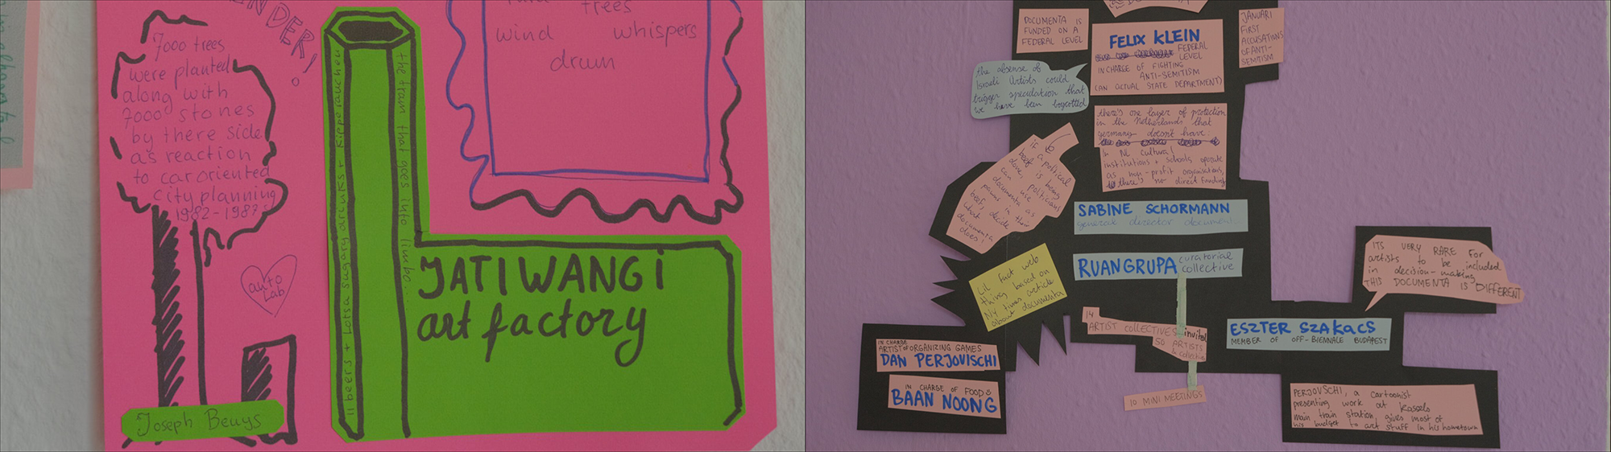

Research questions
…for Autonomy Lab were:
Which concepts of autonomy do collective, self-organized art practices embody and represent?
How do they differ from established concepts of artistic autonomy?
What can other societal actors learn from them?

Types of autonomy identified in the course of the project:

political autonomy
- creation of autonomous spaces - for political activist intervention, community building and mutual aid: among others in BananSkolen’s activist performance tools, in the community practices of Italian Autonomists (introduced in a guest lecture by University of Amsterdam researcher Joost de Bloois), Woodbine Collective and Wok the Rock (who used the Indonesian term Gotong Rojong as an equivalent of mutual aid, Mandiri for self-sufficiency and Merdeka for institutional independence);
- rethinking political autonomy as (a) a human and civil right and (b) something to be nuanced and relativized as interdependency (展銷場 Display Distribute /Autonomous-8 which used the Cantonese and Mandarin word 自治 [zìzhì] to describe a type of autonomy that takes dependency on others into account; in the case of Hong Kong, its basic resource dependency on Mainland China], chosen dependency (CONSTANT, who introduced it as a feminist concept), and even voluntary surrender (Take-A-Way, who introduced it in the context of addiction recovery).
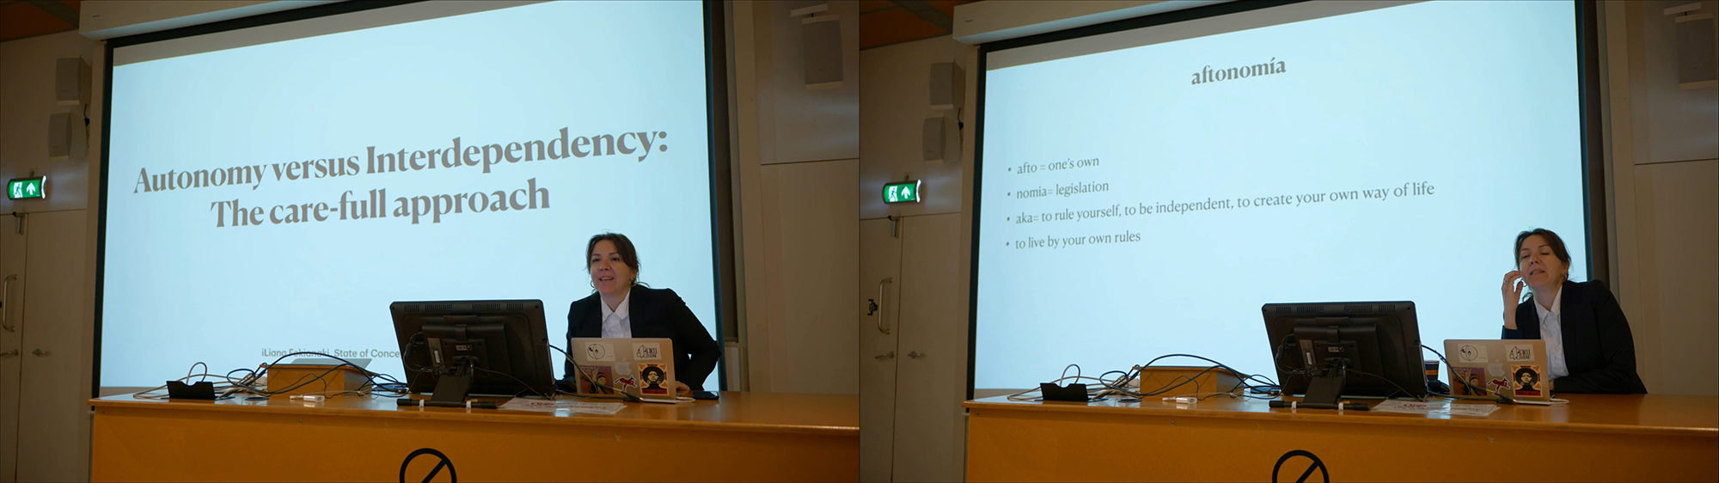

bodily / biopolitical autonomy
- abortion rights/reproductive autonomy (addressed among others by the Feminist Healthcare Research Collective, Mother Art, an in autonomist feminism);
- migration/freedom of physical movement (Take-A-Way, BananSkolen; two artist collectives who collaborate with undocumented refugees);
- body normativity and rethinking biology in relation to technology (CONSTANT): prosthetics, medical treatment, digital and physical-spatial-architectural control.

autonomy of choosing one’s own way of life and work
- autonomy of integrating care work and reproductive labor into one’s life and work practice, including ‘autonomous’ artistic practice (Mother Art, Italian feminist autonomism, The Bureau of Care).

technological autonomy
- self-organized platforms: Free and Open Source, self-developed technological infrastructures as alternatives to corporate Internet/social media platforms and their monopolistic, extractivist business models (CONSTANT, Lumbung_Space, 展銷場 Display Distribute);
- rethinking dependency while creating and supporting technological alternatives: any type of technology, as an infrastructure or platform, creates dependency. But rather than (pure) autonomy or (pure) dependency, technology creates interdependency. (CONSTANT, 展銷場 Display Distribute). Stating that this interdependency does exist, however, does not obsolete the question of who is (or is not) in control of technological infrastructures. The question of technological autonomy thus boils down to a chosen dependency (CONSTANT);
- taking use of resources into consideration: cost, care, environmental impact. This also concerns the imagining and developing of alternative technologies and tools (CONSTANT, The Bureau of Care, lumbung.space).
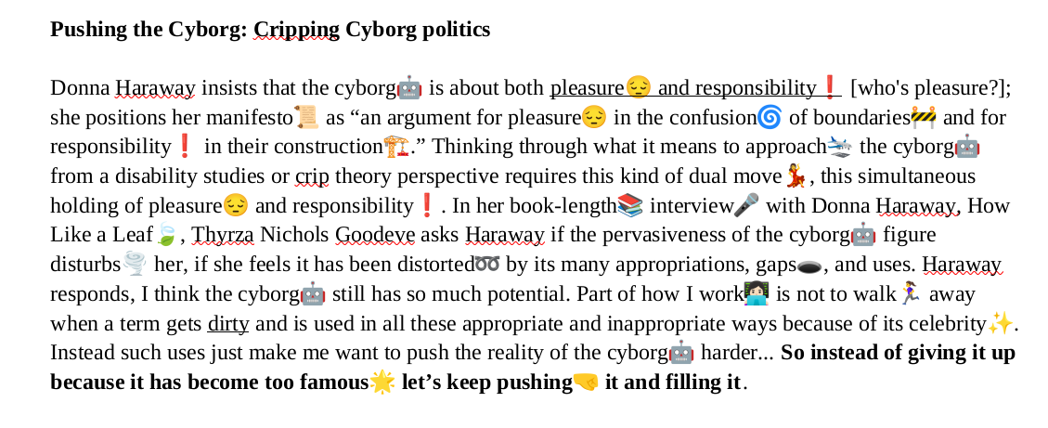

economic autonomy: alternative systems of value and exchange
- local, small-scale, self-organized economies that sustain a community and create independence from third parties (Amigas, Wok the Rock, Jatiwangi art Factory);
- creation of alternative systems of exchange and finance (Jatiwangi art Factory).
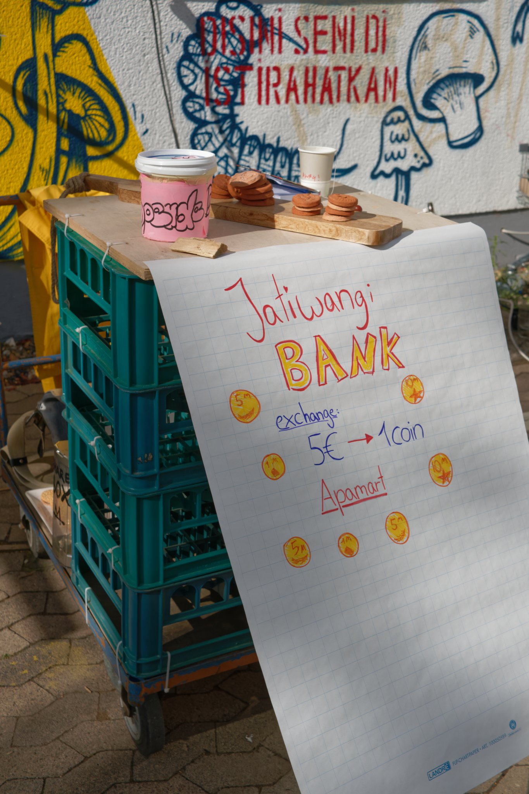

communal/collective autonomy; autonomy as interdependency
- as an alternative to, or a nuancing of, traditional Western individualistic concepts of autonomy (展銷場 Display Distribute/Autonomous-8, CONSTANT, Wok the Rock, Woodbine Collective, Take-A-Way);
- as commons : ruangrupa’s & Jatiwangi art Factory’s Lumbung, Woodbine Collective’s mutual aid practice, Varia/lumbung.space’s and CONSTANT’s digital commons practices. All these concepts overcome a relatively recent - and arguably: problematic - dichotomy in Western contemporary art discourse between “care” (as communal and sustainable) versus “autonomy” (as hyper-individualistic, libertarian, capitalist, destructive). (iLiana Foukianaki/The Bureau of Care used this binary opposition.)
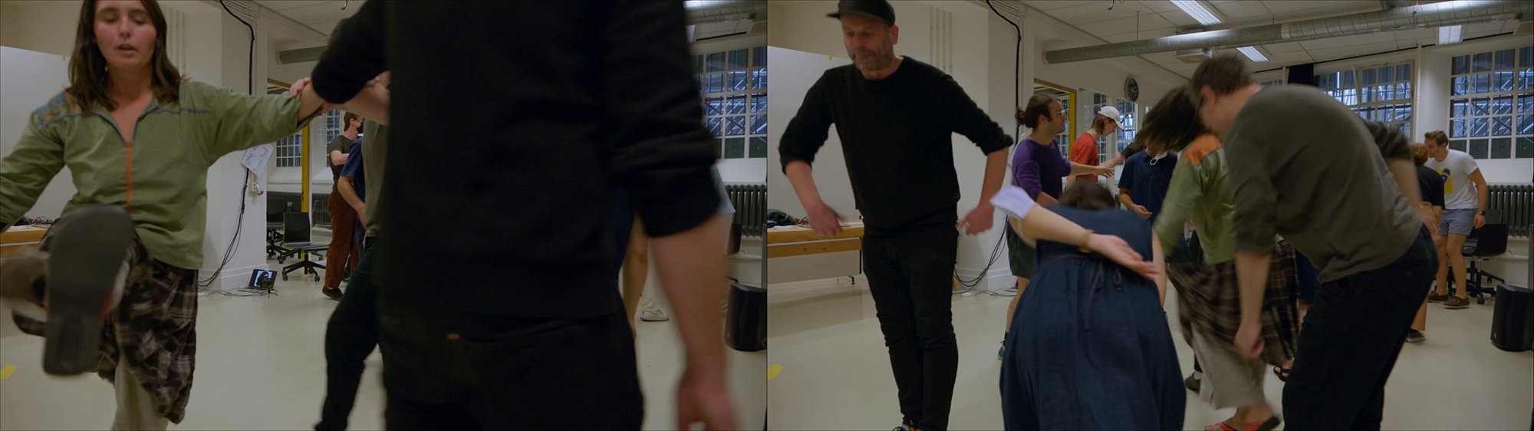

institutional & non-/anti-institutional autonomy
- autonomy granted by a supporting institution (such as an art institution). With its failure to grant sufficient autonomy and protection for its artists and their communal practices (in the light of - controversial - political accusations and threats against them), documenta fifteen became a negative example for the continued necessity of institutional autonomy;
- autonomy gained by creating one’s own institution (Woodbine, Jatiwangi art Factory, Mother Art);
- Both types of autonomy - granted by an external or a self-created institution - are conceptually related to the traditional, post-enlightenment concept of aesthetic and artistic autonomy (that was part of Western art’s emancipation from clerical and ruling class control). In the contexts of the collective, communal and commons-oriented art practices mentioned here, institutional autonomy effectively gets repurposed and redesigned to support different, non-fine art practices;
- autonomy as independence from institutions, respectively the creation of alternative, self-organized institutions (Amigas, BananSkolen, Wok the Rock);
- absence of hierarchies, radically democractic decisionmaking, voluntary participation (BananSkolen, Lumbung/documenta fifteen), commons resource sharing (documenta fifteen, lumbung.space, Jatiwangi art Factory, Woodbine Collective, 展銷場 Display Distribute).
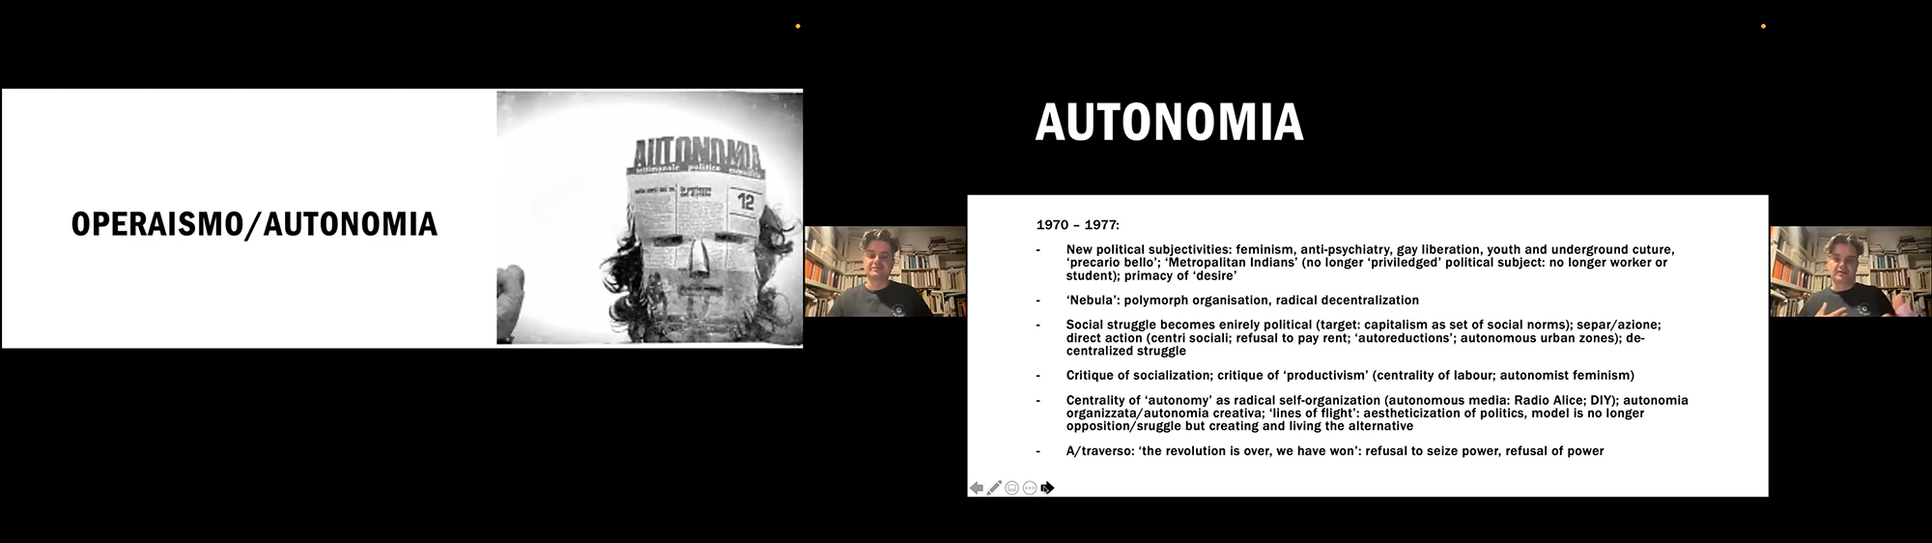

“post-autonomy” (outside this research project)
This term was coined by art critics around the same time as the ACKnowledge/Autonomy Lab research project (most prominently in Ullrich, Wolfgang. Die Kunst nach dem Ende ihrer Autonomie. Wagenbach, 2021). From our research perspective, this terminology still takes a traditional Western aesthetic autonomy concept as its fixed point of reference, and therefore does not do justice to the new and diverse ways in which autonomy is being understood and practiced in today’s multidisciplinary artist collectives and self-organizations.
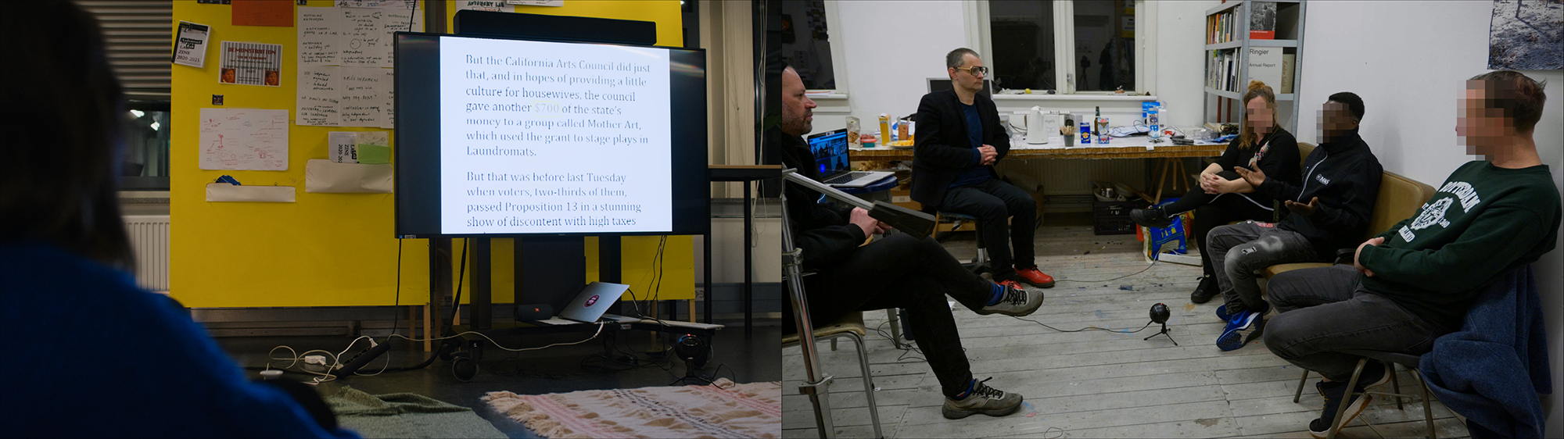

broadening/localizing/decentering terminology/notions:
Mandiri (‘independent’, ‘self-sufficient’, not depending on institutions)
Merdeka (independence)
self-organization, collective organization
self-/collectively organized infrastructure
self-sufficiency, self-reliance
mutual aid
Gotong Rojong (mutual aid, working together collectively)
volunteer collectives
自治 (zìzhì)
post-autonomy [with question marks]
interdependency
chosen dependency


