Position Paper WdKA Autonomous Practices

January 2018

Authors: Simon Kentgens, Florian Cramer

The main focus of the Willem de Kooning Academy’s (WdKA) Autonomous Practices is the shift from the traditional autonomy of fine art toward critical self-organisation.

The concept of autonomy has gained various new meanings in philosophical, political, scientific and technical contexts, particularly with regard to social independence and self-operating systems.[1] At the same time, the traditional concept of artistic autonomy - in its specific Dutch meaning - is being increasingly challenged, and has become untenable within the context of cultural globalisation.

* In the 19th and 20th centuries, the concept of autonomy within the Western European art context was related to non-applied visual art.[2] The broader art-philosophical meaning of aesthetic autonomy is that art should not be defined by a client’s assignment or be made for purposes of propaganda.
* Outside of the Netherlands (where “autonomous art” [“autonome beeldende kunst”] is synonymous with “fine art”), the concept of autonomy is not necessarily linked to the arts.[3] In non-Western cultures, there is traditionally no distinction between fine art and applied art.[4]

Aesthetic autonomy is still regularly discussed in the context of critical theory. This position paper examines the question of what exactly should be understood as contemporary autonomous art and design practices. This question in turn provides the incentive for a long-term research project focusing on five specific questions:

**1:**

What is the meaning of the term “autonomy” in relation to contemporary artistic and social developments? In which:

* Self-organisation is expected to play an increasingly important role; as bottom-up practices that position themselves as independent, self-directed, non-product-oriented and often without predefined goals.
* These self-organised practices necessitate methods of working and interacting with the public that are not yet clearly delineated, and that will have to be (re)invented and tested in practice.
* Systems that operate in an increasingly autonomous fashion are expected to have a tremendous impact on future developments within the labour market.
* Autonomy is a drive for activist practices.

**2:**

Who are today's autonomous makers?

Within the visual arts, the concept of autonomy is no longer the exclusive domain of fine art, but can be applied to any artistic discipline: autonomous fashion makers, autonomous graphic designers, autonomous product designers, autonomous cooks / food designers, etc. The concept of autonomy also includes other critically driven, self-organised activities including non-institutional education, autonomous political activism, and critical engagement with technology (for example in hacker culture).

From the 1960s onwards there have been a variety of artist-run initiatives including schools, restaurants, shops, venues, day-care centres, etc.[5] These should be seen as an essential component of autonomous practices, and not merely as a side job or failed artistic career.

The WdKA’s Autonomous Practices are based on the understanding that art and culture no longer take place exclusively in recognised cultural institutions (museums, art galleries, art centres, etc.), but that the most interesting contemporary developments are now to be found in the capillaries of society, often in informal and underground settings. This is where experimentation takes place and where new initiatives arise; this is where new audiences can be reached, who have little or no access to the established system of cultural institutions.

Rotterdam is an ideal case study for this development. For some thirty years now, the city has played a pioneering role in self-organised artists’ initiatives and activist practices. These have developed throughout the years into an active, extensive and intricate network. The WdKA’s Autonomous Practices explicitly aim to play an active and connecting role within this network.

A component of this research is a cartography of current autonomous practices in the city of Rotterdam (see: [www.autonomousfabric.org](http://www.autonomousfabric.org)):

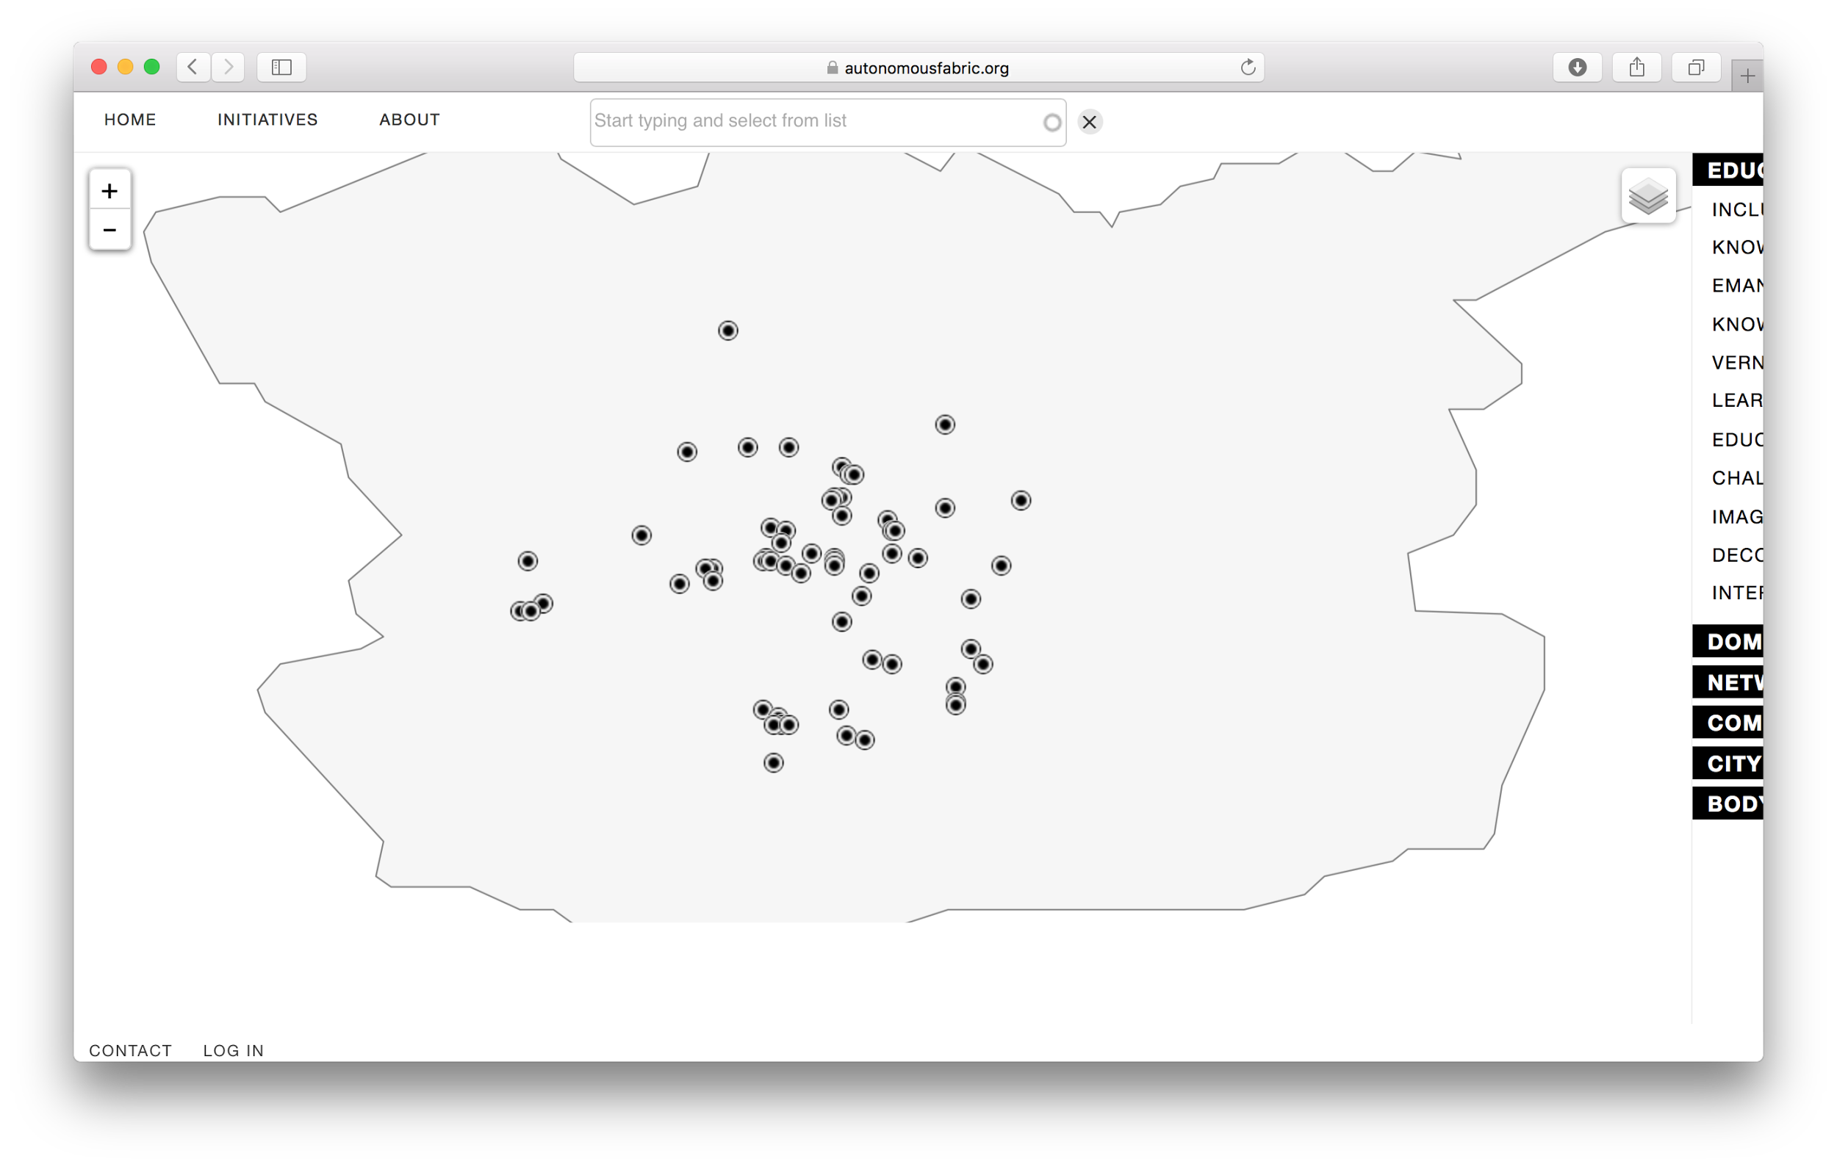

**3:**

What does self-organisation mean within the Autonomous Practices curriculum, in which the 19th- and 20th-century concept of artistic autonomy has been left behind?[6]

* Self-organisation is a subject of ongoing critical artistic reflection.
* Self-organisation does not mean hyper-individualism, but is instead based on cooperation and solidarity.
* Self-organisation does not mean retreating from one's environment, but is rather embodied, and takes place within an integrated context, an ecology in which everything is connected: people, nature, materials, techniques.
* Self-organisation is open-ended and not necessarily focused on problem-solving.

**4:**

Key questions for autonomous practices are:

* How can one initiate an autonomous practice based upon a critical attitude?
* How can one develop an autonomous practice, in such a way that it can sustainably operate on economic, social and ecological levels while also remaining artistically relevant in the long term?
* How can artistic self-organisation and economic self-organisation be understood not as disconnected factors, but rather as one integrated process? How can autonomy be experienced as a way of experimenting with alternative economies and alternative models of living and working together?
* How can self-organised practices function within broader frameworks, locally as well as globally?
* How can autonomy be defined as being embedded, embodied, implicated? How can autonomous makers negotiate the contradictions between engagement and independence?
* Autonomous practices are first and foremost directed by the artists, designers or activists who initiate them. How do these practices relate to the social or economic challenges that exist in society?
* What is the status of production processes and making processes in autonomous practices that are not necessarily focused on generating art objects?
* How important is the “art” label for autonomous practices?
* How do self-organised artistic practices relate to activist practices?

**5:**

How can the WdKA serve as a university for the autonomous initiatives of tomorrow?

* The WdKA’s Autonomous Practices operate from the perspective of art and design, based upon the vision that education increasingly takes place outside the walls of the academy.
* The WdKA’s Autonomous Practices focus on critical self-guidance and artistic self-organisation. WdKA students learn to expand their artistic practice beyond their traditional studio work. Already during their Bachelor study, they research and experiment with creating non-institutional, self-directed initiatives.
* The WdKA’s Autonomous Practices require students to develop organisational abilities and communicative competencies, since the success or failure of all self-organised initiatives relies on day-to-day interaction with their public.
* The WdKA’s Autonomous Practices must reflect upon self-organised practices, not only in the *educational content* but also in the *form* of its curriculum.

The above questions will be applied to new curricula for the Willem de Kooning Academy’s Autonomous Practices, with an increased focus on self-organisation and engagement with the existing network of initiatives in Rotterdam.

1. Examples of this development cover a broad range of subjects, from activist squats (political autonomy) to life sciences (autopoiesis in systems theory) and self-driving cars (autonomous systems in computer science).
2. This concept was first established during the Enlightenment and was further refined in the 19th century in the context of aesthetic theory as well as public policy (in the Netherlands by Johan Rudolph Thorbecke).
3. In English-speaking and French-speaking countries, the terms generally used for this type of art often emphasise its supposed higher aesthetic qualities (“fine art”, “beaux-arts”).
4. For example, “seni rupa” (Indonesian) which simply means “visual arts”.
5. Examples include the restaurant *Food,* founded in 1971 by the artists Carol Goodden, Tina Girouard and Gordon Matta-Clark, and, in Rotterdam, the venue WORM (of which the co-founder and former artistic director is a WdKA alumnus).
6. Etymologically, the terms “autonomy” (auto = self, nomos = law, direction) and “self-organisation” are closely related.