Presentation Autonomous Fabric,   
NWO Smart Culture 24-6-2019

# Slide 1: map autonomousfabric.org

# 

This is a recent snapshot of the website autonomousfabric.org in which we mapped over 100 artist-run, self-organized spaces and initiatives in Rotterdam.

# Slide 2: map with photos

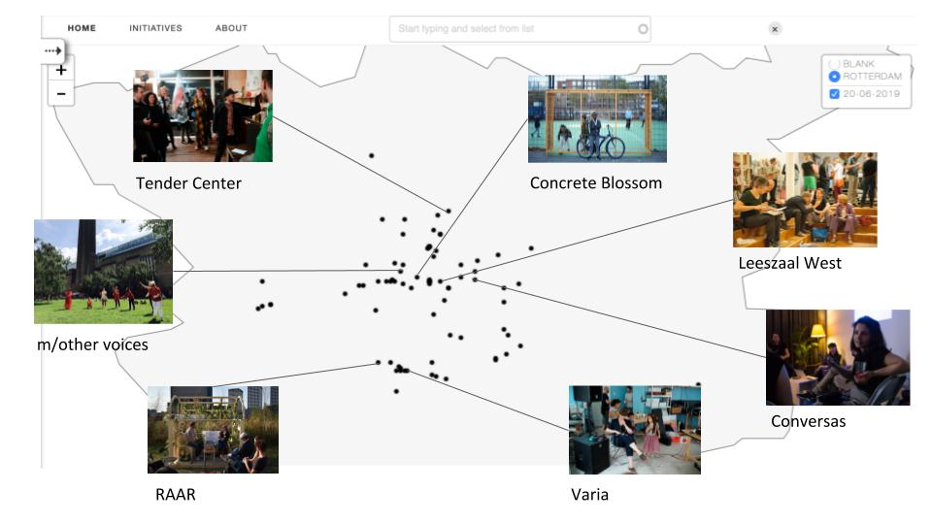

What we observe is a new type of self-organized artistic practice that doesn’t operate in traditional white-cube spaces but is instead based on collective participation. These initiatives manifest themselves - among others - as public libraries, copy shops, radio stations and are often hardly recognizable as art projects at all. Running them has become an art practice in its own right. This is why we call this phenomenon “*self-organization-as-contemporary-art*”.

Our first and foremost research question - called *re:autonomy* - concerns the changing concept of artists’ autonomy in these practices.

# Slide 3: old vs. new artist-run spaces

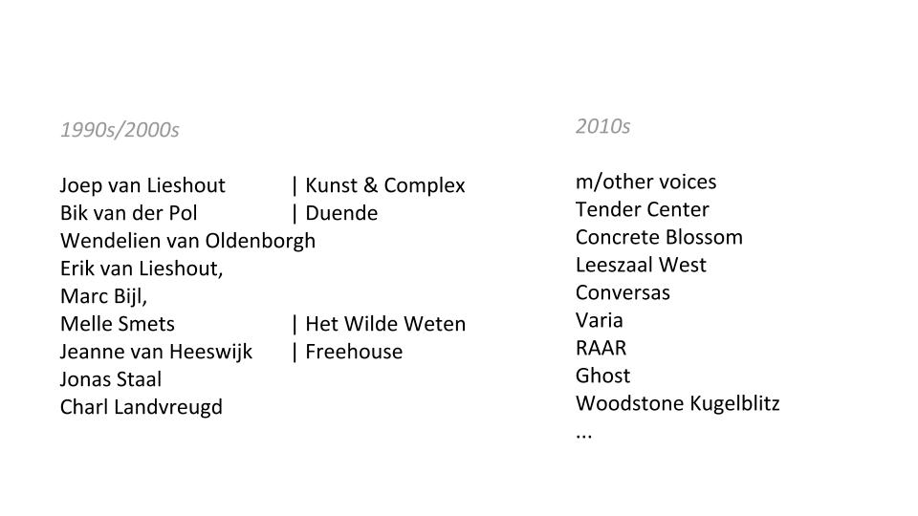

Due to affordable spaces, Rotterdam grew to become a center of contemporary art production. Many renowned Dutch artists have been involved in artist-run spaces since the 1990s. Those spaces, however, were rarely open to the public, but facilitated art shown in galleries and museums.

The more recent *self-organization-as-contemporary-art* initiatives do not produce art objects, but collective-participatory activities around diverse subjects, including queerness, technology, maternity, and migration.

Established art and culture institutions have difficulties accommodating them, as they cannot be easily shown as exhibitions. Art schools and funding bodies, too, normally deal with individual artists’ work portfolios. Adapting to *self-organization-as-contemporary-art* is seen as an urgent issue by our project partners Witte de With, CBK, Het Nieuwe Instituut, Kunsthal, too.

# Slide 4 & 5: International context

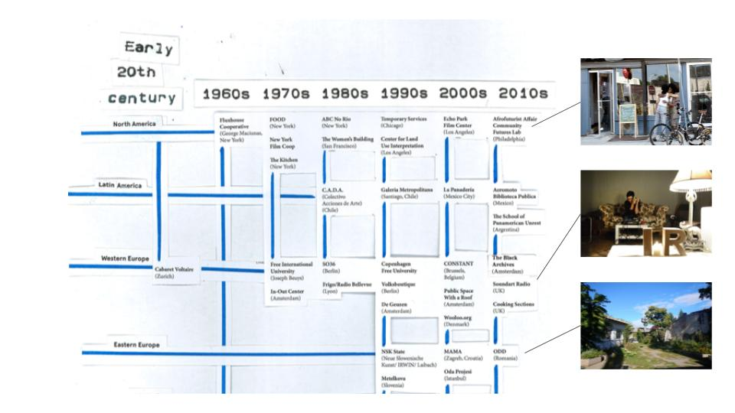

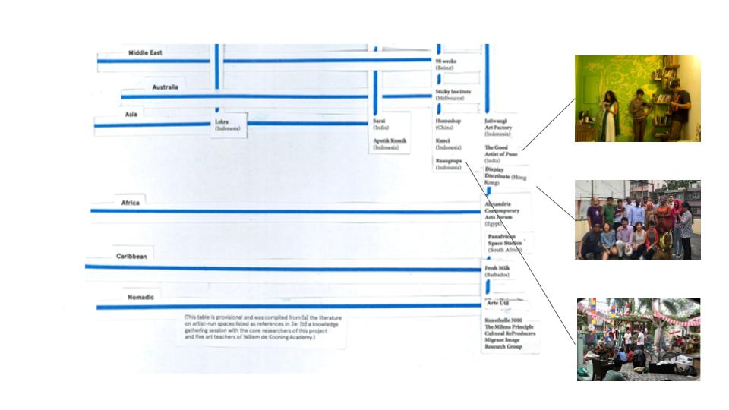This diagram shows that *self-organization-as-contemporary-art* has become increasingly international, and is nowadays lead by Non-Western regions and artists. They influence Western artists such as in Rotterdam. However, this learning process does not necessarily result in more diverse participation. Therefore, intersectionality in *self-organization-as-contemporary-art* remains an issue and is the second major research question in this project, called *inter:sections*.

To quote the second review of our project, we need to research more thoroughly “who these contemporary artists are; […] and how the marginalized and diverse populations mentioned […] are characterized”.

Closely related to *re:autonomy* and *inter:sections* is the issue of *re:placement* that concerns gentrification of cities. With Rotterdam as an example of art practice under rapid urban transformation, we need to study all three - autonomy, intersectionality and gentrification - as interlinked phenomena.

# Slide 6: ruangrupa

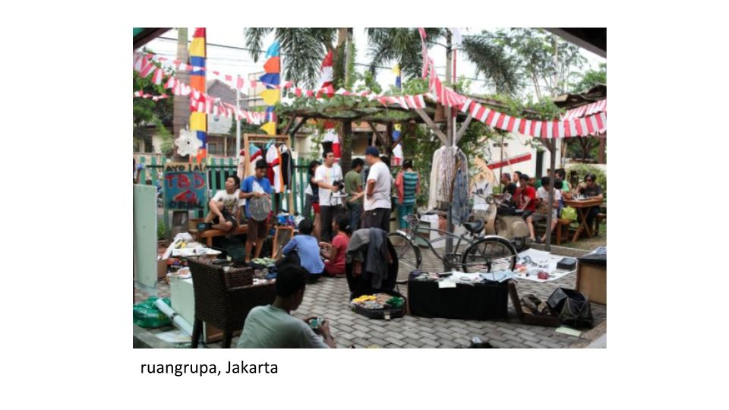

This research project will be carried out with Autonomous Fabric initiatives, by means of workshops. The resulting knowledge will flow back into the fabric, and into institutions that want to learn from it.

The artist-in-residencies are an essential part of this research, in which the knowledge created by postdocs, the artistic research workshops with Autonomous Fabric initiatives, and the artistic research of international artist-in-resident collectives will be combined.

We didn’t know during our proposal submission that the Jakarta-based ruangrupa collective would be chosen as the main curator for the next *Documenta*. This decision affirms the relevance of these practices in contemporary art. Ruangrupa is a collective of over 40 artists, musicians, writers and researchers, with an open, participatory practice since the year 2000. We are closely in touch with ruangrupa, and a member of our research team wrote the first and still only book on the group.

We will investigate gentrification and intersectionality as university postdoc research at Erasmus University. The question of shifting autonomy will be mainly investigated through artistic research conducted by Willem de Kooning Academy and Codarts, with major input from international artist-research collectives. Actually, we had ruangrupa in mind as a possible artist-in-resident collective - but Kassel was faster.