A Near-sighted Falling into Technology — Through the Looking Glass of Art Practice as Human Self-Experimentation, Accidents and Coincidence
Florian Cramer & Elaine W. Ho
Originally published in: Joke Brouwer & Sjoerd van Tuinen (eds.), Technological Accidents, Accidental Technologies, Rotterdam: V2_ Publishing, 2023, ISBN 978-90-828935-8-8, pp. 60-80, 2023

An Astigmatic Prologue
Several diffracting lenses offer a productive distortion by which to view accidental technologies in the arts. We shall attempt a kaleidoscope of thought here, in the words of “accidental” inventor of the kaleidoscope Sir David Brewster, in the name of “the highest service in all the ornamental arts, ... for the purposes of rational amusement.”

Lens 1: Aestheticization
Ever since the Western Enlightenment episteme divided the Latin ars (plural: artes) and its Greek predecessor technē into the separate domains of “art,” “science,” “technology,” “craft,” and “skill,” investigations of accidental technical invention, especially within the sphere of the arts, seem to be imbued with a modern-era sort of spirituality, if not a moot sense of romanticism.
Following former conceptions of artes, Athanasius Kircher’s fantastic contraptions, such as the Katzenklavier (cat piano), were still part of mainstream science and technology in the seventeenth century. Some of them, such as the megaphone, even became common devices in the centuries that followed. “Art” in its present-day meaning has provided a refuge for non-empirical, speculative, and even irrational practices and knowledge, but it has also quarantined them in the domain of the aesthetic. Accidental, random, absurdist, pataphysical, and haunted technologies have been effectively sanitized in this way.
In the twentieth and twenty-first centuries, a great deal of objects, devices, and technologies created by artists (including social technologies such as pataphysics, psychogeography, durational performance, deep listening, and nongkrong) have occurred accidentally or coincidentally. Often existing outside of established institutions of science and technology, the artistic accident makes for an underlying poetics of the accident itself. Such a poetics is at work in Hans Arp’s Collage with Squares Arranged According to the Laws of Accident (1916) — also notably in the cracks of The Large Glass, caused by transportation workers in 1927 after which (pataphysician) Marcel Duchamp embraced as the completion of the piece. Coincidence also plays a part in aesthetic processes, such as the inadvertent creation of artist Lai Yu Tong’s sound work Problems in the World (1) by virtue of a coincidental mixing of an auto-played audio download. Nina Schuiki’s series of fleshy “Hand” photographs are unintentionally captured by the artist’s mobile phone while being carried in transit.
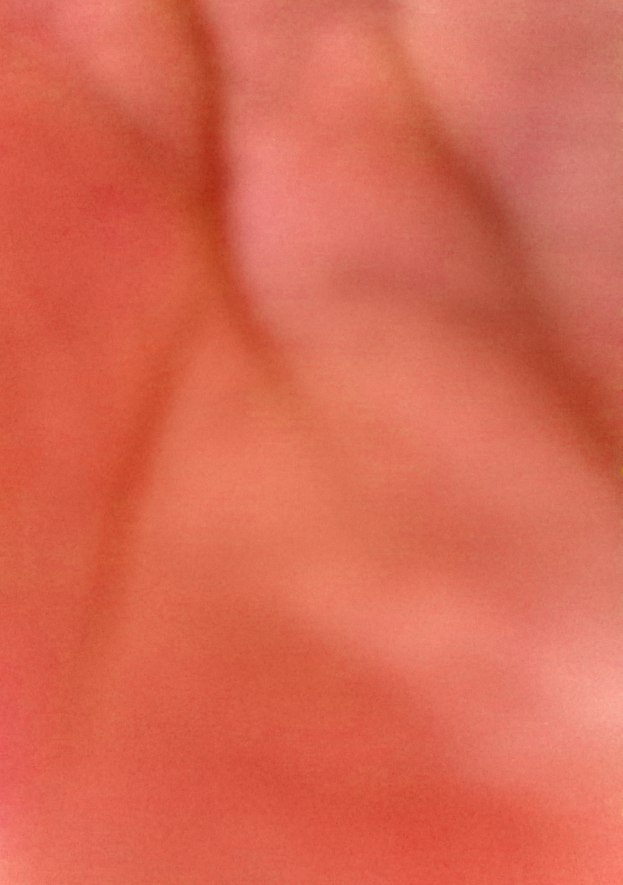
Hand, Nr. 3, 2017. direct print on glass. 21.0 x 14,5 cm. Courtesy of Nina Schuiki.
In all these examples and practices, the aesthetic is a double-edged sword; or, more precisely, it calls attention to a negative dialectic that constrains life practice. On the one hand, the aesthetic regime allows art to open literal and epistemological spaces for experimentation that — after the modern differentiation of arts, science, technology, craft and skill — no longer had space elsewhere. On the other hand, the aesthetic is, to use a software engineering term, a “sandbox”: a quarantined system running in a safeguarded and isolated environment so that it cannot infect the larger underlying operating system with viruses or other dangerous code. The seclusion of art from artes into an aesthetic domain (which included the subjugation of poetics under aesthetics) was, effectively, sandboxing. The question is whether such seclusion and sandboxing need to be at least partly undone — as suggested by concepts like “artistic research” and “commons/commoning” — or whether the sandbox was not leaky from the start.

Lens 2: Art as Design Prototyping
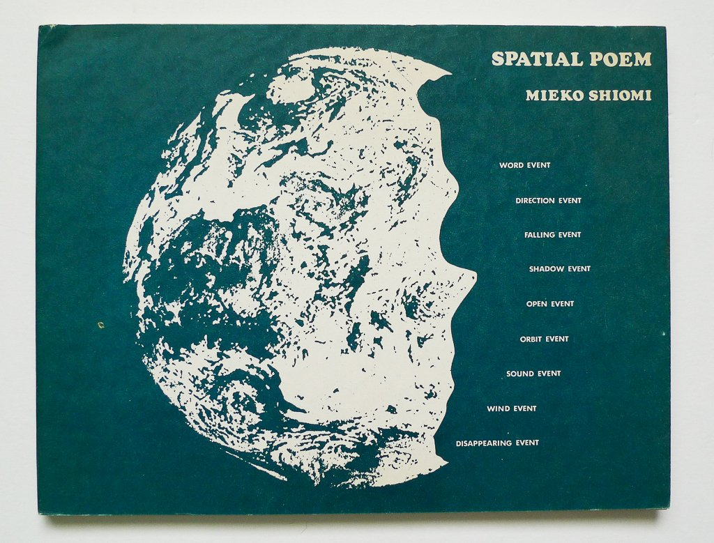
From 1965 to 1975, Japanese Fluxus artist Mieko Shiomi created a series of nine spatial poems that consisted of prompts for simple actions, like the following:
SPATIAL POEM no. 3 will be the record of your intentional effort to make something fall, occurring as it would, simultaneously with all the countless and incessant falling events. Please write to me how and when you performed it, as we are going to edit them chronologically.
These instructions were sent to Shiomi’s network of friends and fellow artists, and she then compiled their responses — that is, the executed prompt — and assembled them into poem objects. It was her way of keeping in touch with other Fluxus artists after her visa had expired in 1965, and she had to leave New York for her home country.
With this work, Shiomi is often credited with having co-initiated Mail Art. In the 1970s and ’80s, Mail Art developed into a global communication ecosystem that, in the coinage of Fluxus artist Robert Filliou, called itself The Eternal Network. The extent to which it anticipated the Internet and its social networks by way of the medium of postal mail can be seen in a 1983 diagram by Italian mail artist Vittore Baroni — effectively a schematic for a distributed, peer-to-peer network architecture:
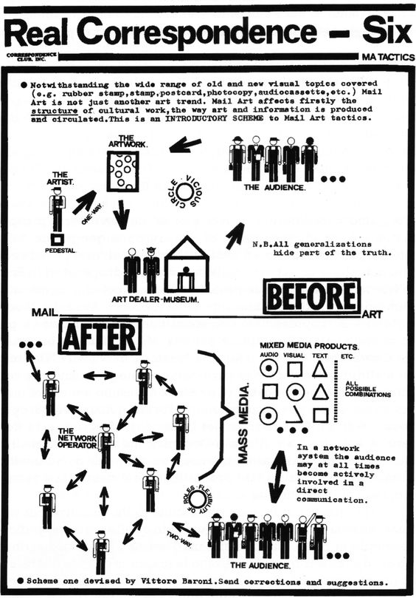
For visual comparison, this is an often-used diagram of today’s digital network architectures:
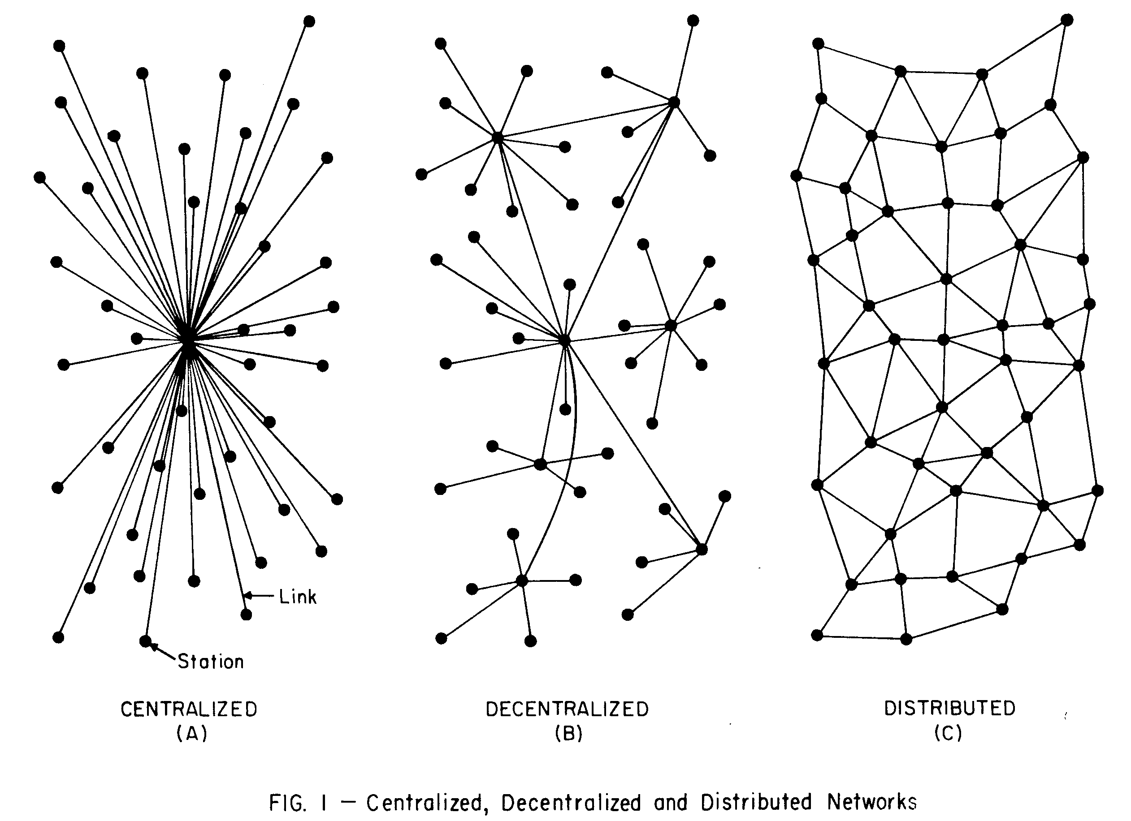
From today’s perspective, Shiomi’s Spatial Poems also constitute what could be called a “small” data operation: networked data mining, mapping, and data visualization.
Moreover, there is a striking similarity between Shiomi’s prompts and minimalism with a social medium that is wildly popular at the time of writing this essay (to the point of being considered the defining audio-visual and social medium of contemporary youth): the Chinese website 抖音 Douyin, known elsewhere as TikTok. The enormously addictive social media platform consists of very short (usually ten to fifteen second) videos, most of which have been recorded by TikTok users themselves with their mobile phones. TikTok has also become known for its viral challenges in which certain dance choreographies or (sometimes dangerous) stunts are performed in front of the camera. Such delight in “difference from sameness” is seen in both Shiomi’s less than viral poetry and on the TikTok #FYP (For You Page). In retrospect, one could call Shiomi’s Spatial Poems a perfect pre-Internet, TikTok prototype.
Other such lines of connection from experimental arts to mainstream technology may be drawn, of which Fluxus alone provides many examples. From Nam June Paik’s video art (especially notable is his 1973 piece Global Groove) as a prototype of 1980s and ’90s MTV music videos, to George Maciunas’s Fluxhouse cooperatives (1967) as an “accidental” prototype for today’s co-working spaces, we can witness the co-optation of emergences in art — oops, co-opted again — by commercial interests. It was, in fact, the Fluxhouse cooperatives that helped initiate the transformation of New York’s SoHo neighborhood, thus transforming an originally communist kolkhoz project into a blueprint for “creative class” gentrification.
Other examples of technologies prototyped in art include:
- tile mosaics as precursors to pixel graphics (including Bayer filter technology used for digital photography and videography);
- actress Hedy Lamarr and composer George Antheil’s invention of wireless frequency hopping inspired by the mechanics of player pianos (to support the US Army in World War II);
- El Lissitzky’s 1925 manifesto Topography of Typography demanding the realization of an Electro Library;
- Dadaist collage, photomontage, and Cornelia Sollfrank’s 1999 net.art generators – the latter a work that involved complex considerations of authorship and the copyright implications of algorithms — anticipating AI text prompt image generators;
- the growth of vacation rental platform Airbnb out of a project by design students;
- the prescient self-fashioning of Cindy Sherman’s staged photographic self-portraits of the 1980s becoming today’s Instagram;
- the visual works of John Heartfield and Barbara Kruger anticipating today’s internet memes.
Under this lens, the (relative) autonomy of art — or its (limited) license to speculate and experiment from within the sandbox — allows it to develop radical prototypes for what may one day become mainstream technology. This capitalist-realist scenario also provides an admittedly cynical answer to the relationship between accident and technology — that such accidents are actually supposed to happen in the arts rather than in any other domain, including technological design and engineering. Since the arts, which have at some point lost their traditional functions of mimesis and representation, operate as a socially, politically, and economically sanctioned niche and playground for speculative work and thinking, the accident can, when made techno, be produced repeatably and at larger scale. But are those forms of invention in art really accidents?

Lens 3: Accidental Scientific and Technological Invention
This artistic and ultimately romantic understanding of the arts seems to be contradicted by two facts: planned, technological invention in the arts and accidental technological discoveries in science and engineering.
While artistic research practices such as pataphysics, psychogeography, and nongkrong make accidentality their program, there are also the counter-examples of art modeled on military and industrial invention, including Italian Futurism, the case of Lamarr and Antheil, highly institutionalized forms of research laboratory art, as well as the very notion of avant-garde. As opposed to military-industrial complexes hijacking ideas and practices from the arts, a counter-appropriation may occur when artists steal from the military (and sometimes end up prototyping new military-industrial complexes).
Italian futurism, though visually modeled on the military, was highly speculative and experimental. It could be said that Boccioni, Balla, and others “stole” out of an aestheticist fascination with the accidents and catastrophes inflicted by military technology.
Conversely, the invention of many technologies by scientists and engineers did not follow a program or plan but were incidental:
- X-rays were discovered accidentally by Wilhelm Röntgen when he was testing whether cathode rays could penetrate glass;
- penicillin was discovered by Alexander Fleming, who found that a mold had accidentally killed bacterial cultures in his hospital laboratory;
- vulcanized rubber was discovered by Charles Goodyear, who accidentally dropped rubber mixed with sulfur onto a hot stove;
- microwaves as a heating technique were discovered by the engineer Percy Spencer, who found that a magnetron had caused his chocolate snack to melt;
- the pacemaker was invented by engineer Wilson Greatbatch, who really just wanted to record the rhythm of the heartbeat;
- sildenafil (Viagra) was originally developed by Pfizer to treat cardiovascular disease until test patients found it worked as a sexual potency drug;
- the safety pin was accidentally invented by Walter Hunt while playing around with a piece of wire;
- Arpanet/ the Internet was originally developed to more efficiently share the computational resources of time-sharing computers in research institutes, but “civilianized” shortly after its introduction because of the proliferating use of e-mail.
In the above examples of accidental discovery in engineering and science, technological invention had always been the goal, but the resulting purposes and products differed from those originally intended. In the arts, on the other hand, one might assume that poetic inventions have perchance become technological visions. From Lissitzky’s Electro Library to Shiomi’s Spatial Poems and Sollfrank’s net.art generator, art may be only originally intended as an unpredictable project — accidentally and consequentially becoming, as mentioned under Lens 1 above, a prototype for commercially-viable technologies. But this assumption only works if one narrows the scope of art and ignores that these art practices (especially in the examples from Dada, Fluxus, and cyberfeminist Net Art) also saw themselves as real experiments with alternative life potential. We are interested in these art practices that have, however idealistically, always been intended for real-world application in less or non-capitalist ways. Today, this ambition has not diminished, and we may even say that the desire for “life otherwise” has actually intensified. Thinking of contemporary, multidisciplinary artist collectives from often neglected world regions — such as those that participated in documenta fifteen in 2022 — art practice is also a speculative but practical form of community work and experimentation for more sustainable ways of living.
If art thus becomes a manner of human self-experimentation, and if the “self” is increasingly collectivized and extended to entire communities, how does it differ from martial invention and biopolitical experiments except in terms of its marginal, political-economic power?
The distinctions between artistic practice and techno-social practice in all of the above-mentioned examples are difficult or even arbitrary. And here we come to the elephant in the room: the definition of technology. While The Oxford English Dictionary conventionally defines technology as a “branch of knowledge concerned with the mechanical arts and applied sciences,” cybernetics, general systems theory, media theory, and philosophers like Gilbert Simondon have complicated its definition by taking it out of the nature/culture dichotomy and into more complex techno-social dynamics.
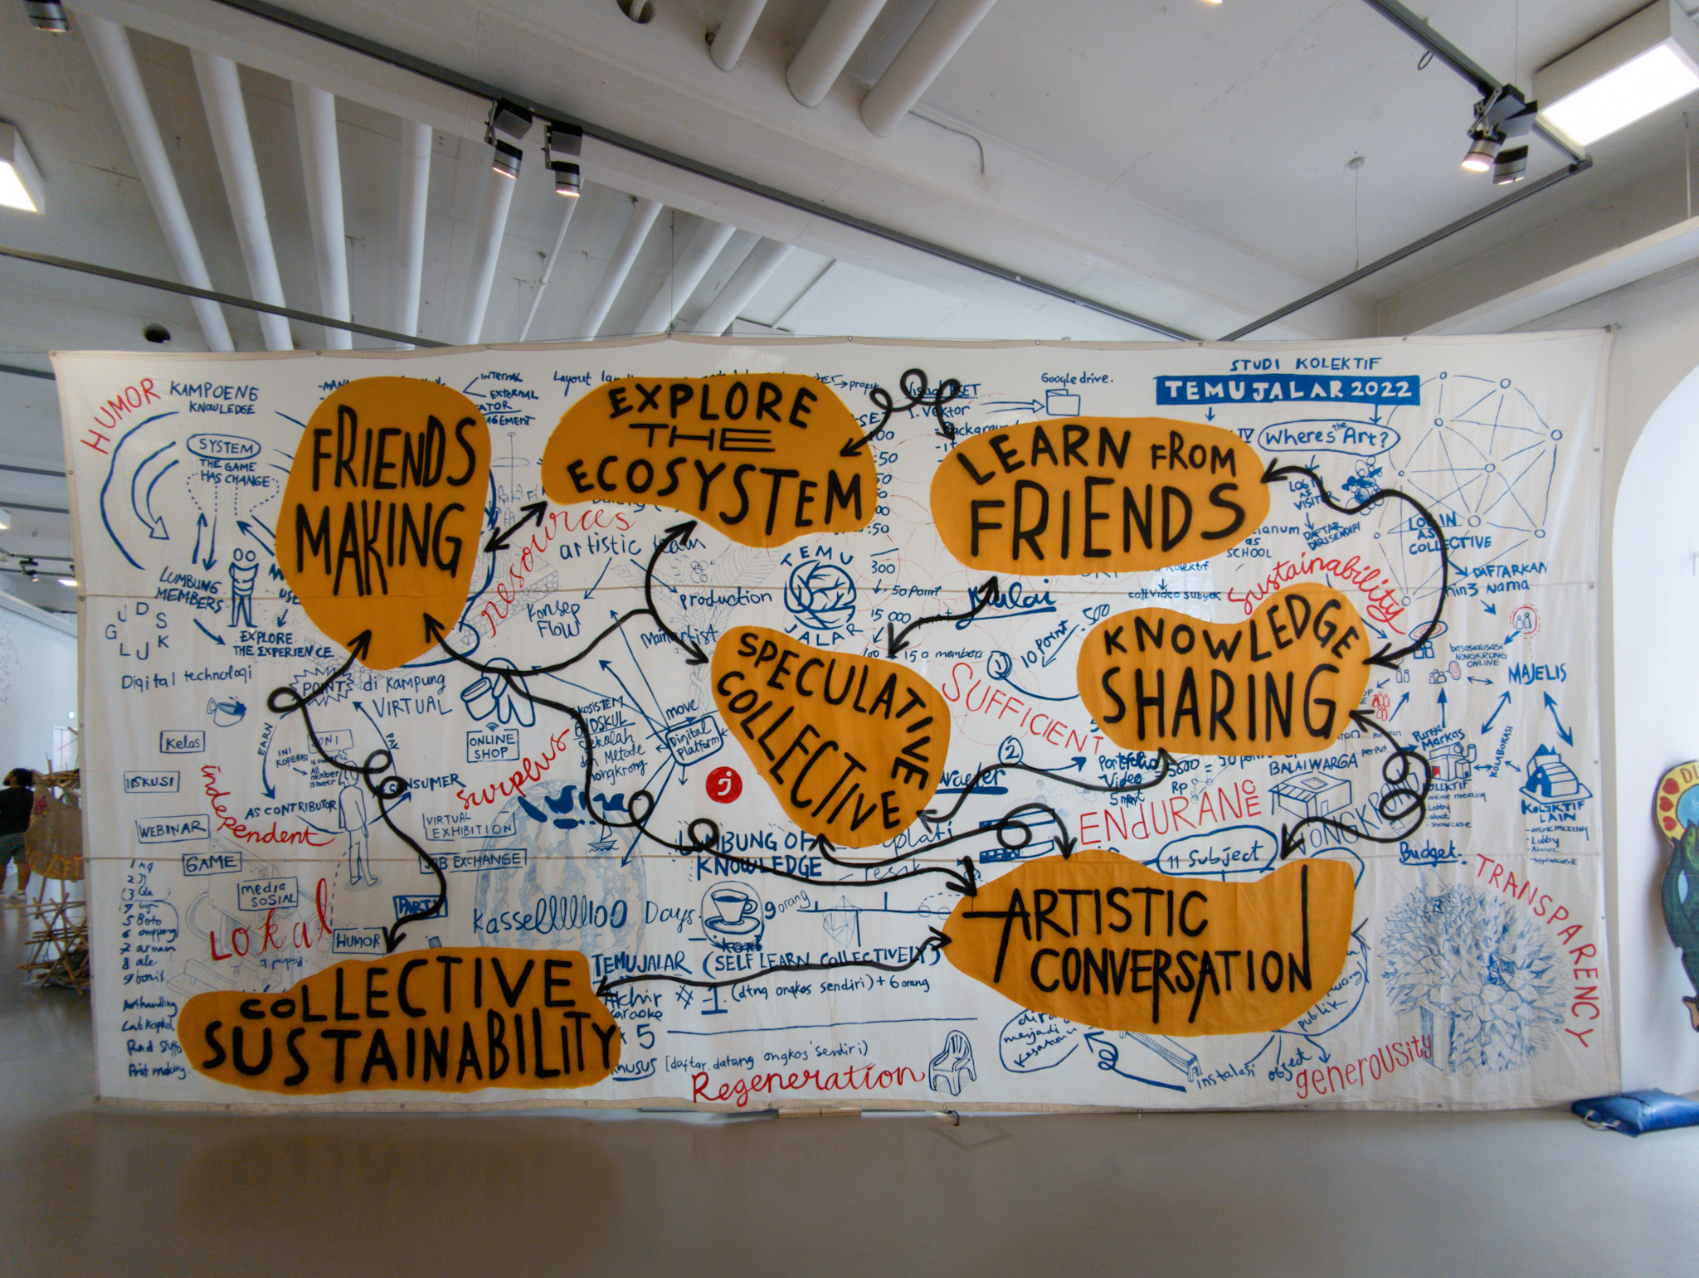 Lumbung chart at documenta fifteen, Kassel, 2022 (photo by Florian Cramer).
When technology is correspondingly engineered as social design (as in most Internet platforms and even long before by way of architecture), it becomes difficult to draw the line between technology and other forms of poiesis. For example, is experimental community building with socially and politically activist tendencies –as in squats, communes and experimental living communities — a technology? Experimental platform and community building, along with their various overlaps and intersections in utopian-dystopian projects, have already existed within hacker culture, artists’ retreats, and contemporary art collectives for quite some time. Think of Monte Verità in the early twentieth century, the Otto Muehl commune from the 1970s, and even the lumbung ekosistem of the 2022 Documenta Fifteen exhibition. Many occult, spiritualist, and magical practices have also described their ways of working as technology. This includes shamanism, meditation, spectral communication, practical kabbalah, and modern gnostic movements such as Scientology. But beyond exposing hopelessly romantic visions of being where community building art practices may also be confused with proto-forms of social design, the emphasis on coincidence and accident distinguishes planned, technological inventions in design or accidental technological discoveries in science and engineering from art and life otherwise in practice.

Lens 4: Coincidental but not Accidental
In his essay “Infrastructures Work on Time,” Timothy Mitchell introduces the challenge to consider delay and postponement as an alternative measure by which to consider large-scale infrastructure projects, perhaps something akin to environmentalists’ call for degrowth. This so-called reversal, with its cringe-worthy tint of romanticism, would cause upon anyone and anything not on board with continued modernization to blush. However, the slowed time of which Mitchell speaks actually refers to both the material durability of built infrastructure like railroads and highways and the durational temporality by which “the present extracts wealth from the future” via investment, credit, and accumulated interest. As such, the waiting time of accrued revenue is just as much a desired variable of the mandates for growth, conquest, and development as any luddite’s call to slow things down.
The temporality of the accident, however, is not necessarily about slowing down or speeding up; it nestles within the gaps between past and future — rips in a planned timeline of the experiment which alter the trajectory of otherwise hypothesized futures. A French chemist clumsily knocks over a flask and inadvertently invents safety glass. World War I nurses appropriate particular cellulose bandages meant for wounded soldiers, unintentionally launching the disposable menstrual pad industry. Scientists answering the US government’s calls for synthetic rubber in light of shortages during World War II fail with a too-malleable silicone polymer, which later goes on to become the classic children’s fidget toy Silly Putty. The nature of “accident” in these examples of great technologies that have revolutionized our world are each tonally distinct. The ensuing invention may be the result of accident, but the manner by which each have come about varies — from literal mishap to astute, reappropriated use to a failed experiment that begets a new commercially-viable twist. By virtue of these diversions in the timeline, those who manage to grasp hold of the resources to control the technology and production of accidents secure long, profitable futures. Magically, what had been an unforeseen glitch becomes part of the mandate for development, efficiency, and managed space-time.
What we are interested in here though, perhaps has less to do with such historically repeated conquests and more with the temporality of the unrepeatable — that which cannot be so readily scaled up. For what sets the precedent of military/state and corporate handshakes is precisely the grip upon resources which turns accidents into #products, the disenfranchised into the #revitalised, and disuse into #innovation. Scientific and technological accidents easily become the planned use of time, space, and other resources because they often occur as fissures within institutional practice and are therefore easily co-opted: Humvee becomes Hummer; chest pain medication becomes Viagra; treatment for crossed eyes becomes Botox.
The mandate for “originality” in art and its affiliated hope for uniqueness is an underlying foundation of the Western art realm (poiesis). Already a paradox, the repeatable is traditionally undesirable, and since modernism this has indirectly lead to a question about artists’ relations to institutions, which have in turn mechanized and systematized production for stratified and repeatable forms of output and representation. In the case of both museums and funding organizations, administration monitors and manages the flow of resources from private and state sectors, setting sanctioned barometers for what art is and what “good artists” are in the eyes of the corporation and nation. In this sense, the wielding of resources occurs in a way similar to the mass-industrial complex of which we spoke before. If we are to try to cull something from art and the accident with a bit more liberatory potential, however, it could be useful to examine what separates them from other realms more carefully. So, in a temporal sense, if accidents could be made less productive or less repeatable, what would they be?
Let us now embark upon a thought dérive, to consider the difference between accident and coincidence. It is the premise of this essay that the two are not one and the same. Their appearances within the realm of art have been conflated and must therefore be distinguished.
Like the accident, coincidence is a relation of time and space, stemming, however, from the medieval Latin coincidentia meaning “occupation of the same space” — also from co-, “together with” and incidere, “fall upon or into.” What overlaps here is the confluence of the spatial and the interpersonal at an intersection with the temporal. This may at first not seem dissimilar to the accident, but the temporal vector form of the accident, from the verb accidere (ad- meaning “towards, to” and cadere “to fall”) bears a subtle difference with the stop-time of coincidence. Accidents move; they propel futures and premeditate an ensuing sequence of events that occur by virtue of the transformatory nature of the accident. The coincidence, on the other hand, merely “happens”; things, people, and circumstances come together, and there is no connotation of a better or worse future in relation to what was prior to the coincidence. This approaches something like 緣 yuán, a Chinese concept most often translated as “fate” or “destiny.” The Western reading of this sounds fixed in the sense of ordained trajectories of time, but we may argue here that yuán merely gives a logical (hence, temporal) lens with which to view things that “merely happen.” The character 緣 yuán is composed of a web of relations: 糸 sī (meaning “silk or thread”) with 彖 tuǎn, from 彖辞 tuàncí (meaning “to determine”) and representing the first two sections of the “Ten Wings” (十翼 shí yì) commentaries on The Book of Changes (易經 Yìjīng). In consideration of the Yijing as a tool of prophecy, coincidence must be conceived as a space of subjective perspective that allows for the constancy of change despite the supposed fixity of predetermined futures and the will of fate. Time plays out as a series of coincidences. We fall together in spite of ourselves, and the futures coincidences beget are not to be grasped but perhaps simply the playing out of a sequence of events. This is not to deny the efficacy of efforts towards change, especially sociopolitical change, but perhaps there may be a subtle shift of perception here which could offer otherwise possibilities of thought and praxis.
If we consider not the repeatability of the accident within art but the singularity of manifestations of coincidence as a form of non-utile accident, then perhaps, in the spirit of Adorno, we could claim the uselessness of art as its very usefulness in society. We do not dismiss the need for aesthetic tools to strengthen other realms, but perhaps we must also not dismiss the potency of realms of the unpredictable, the irreplicable, and the ineffable. Under the regime of the all-devouring divider of capitalism, coincidence may be a much needed respite from mandates for control.
Rather than stopping at Adorno, however, let us find neural coincidence in the fact that more than 2,000 years prior to Adorno, Daoist philosopher Chuang-Tzu had already upended distinctions between usefulness and uselessness. Beyond autonomy and fait social, the idiom 無用之用 wúyòngzhīyòng, or “the usefulness of the useless,” points towards liberation from deadlocked conclusions of any form of the aesthetic, ultimately resisting recupération (or hijacking, to use Situationist terminology) and gentrification as well as prototyping into apps or other capitalist business models. As such, coincidence — where it can be salvaged from the scene of the accident — may offer a glimmer beyond current resignation and cultural pessimism.
Departing then from the idealist aesthetics penned by the likes of thinkers from Kant to Adorno, let us look to another “realist” perspective grounded in the epistemology of the Cantonese language. The character 係 hai⁶ stems from the radical 人 rén, or “person,” along with the sound word 系 xì, meaning “system,” and is the colloquial Cantonese equivalent to “to be, is, and are.” This inextricable relationship between the human and their role in “the system” — for Cantonese speakers — simply is. What may appear to the Western ear as a form of resignation in acceptance, for Eastern thought may simply be an acknowledgement not only of our implications within larger systems but also the potential to affect them. Also of note, the word 關係 gwaan¹ hai⁶ (guānxì in Mandarin), or “relations and connection,” is a combined word from the above guān (to close) and 係 hai⁶. May we infer from coincidence, therefore, the close intimations of human relations — the interaction between people and the systems they create? If not useless, then perhaps the refusals to co-opt from what is to what may be are precisely what distinguishes coincidence from the accident.

Lens 5: Accidents and Open Systems
What if, in art, there were technologies designed to create coincidence (even when they end up producing accidents)?
While it would be oversimplifying to generally and sweepingly attribute coincidental and accidental technologies to art, to say the opposite, that art non-accidentally develops technology, is also true. Science fiction literature, for example, has historically served as a direct inspiration to R&D departments, especially in the fields of digital technology and artificial intelligence. Computer hackers and engineers are known to be among the most ardent readers and viewers of science fiction literature, movies, and television. Science fiction has often functioned as an elaborate, systematically crafted blueprint for the future — prosaic inspiration for certain technologies.
There is also non-accidental, hands-on technology development in the arts themselves — for example by way of research-oriented electronic and computer music — where composition includes the development of matching hardware and software instruments as well as the development of community media tools. Examples of the latter include video and democratic television activism from 1970s artist collective Raindance Corporation, and today’s development of Open Source community tools by artist collectives like Lifepatch, varia, and Hackers & Designers.
This more optimistic lens on coincidence as the technological poiesis of artists is equally countered by aesthetic accidents as prosaic or even catastrophic failure. The Otto Muehl commune, which began as a socio-artistic experiment and ended with criminal convictions for systematic sexual abuse, is perhaps the most striking example of such a catastrophe in recent art practice. But it remains debatable whether such catastrophe was really due to the commune’s social technology and design.
The previously mentioned example of Mail Art, which had emerged from the same 1960s counter-cultural performance art scene as the Muehl commune, experienced numerous structural problems at the level of its network infrastructure and protocols. Its prototyping of Internet social media happened partially by accident, because its original goal was not to create a system for alternative mass communication but a self-organized, non-hierarchical, and inclusive alternative to the curatorial art system of museums and galleries. When Mail Art became The Eternal Network and gradually dissociated itself from art, it prototyped not only Internet social media but also its operational issues. Spam became a problem in Mail Art as early as the 1970s. Many of its participants later testified that they had given up because of the vast amounts of junk mail, most of which came from people who used Mail Art as a low-threshold system to become part of publications and exhibitions. The Eternal Network was therefore effectively re-appropriated as a vehicle for self-promotion, most blatantly by the Italian businessman Guglielmo Achille Cavellini, who used Mail Art to disseminate his individual brand in the form of stickers ubiquitously promoting his art career.
Since Mail Art artists had made a commitment to never reject any submission, there was no structural solution to this problem. In addition, open participation and a free-speech ethos sometimes led to questionable submissions being accepted and disseminated, among them a series of anti-Semitic caricatures bearing a striking visual resemblance to today’s anti-Semitic “Happy Merchant” meme, first published in a 1975 issue of the famed San Francisco Mail Art zine VILE. Also part of The Eternal Network were transgressive projects such as British mail artist Pauline Smith’s Adolf Hitler Fan Club, perceived as tongue-in-cheek by fellow artists in its time, but the motives of which seem more dubious when one reads further into Smith’s comments on Hitler.
In retrospect, spamming, trolling, and political subcultures like the Alternative Right (alt-right) were prefigured at the margins of The Eternal Network. In his 2001 book Networked Art, Craig A. Saper characterized Mail Art practice as “intimate bureaucracies” by which artists effectively became administrative network operators — or, in today’s terminology, sysadmins. Network administration is about managing accidents and disasters in real time, especially when — as with Mail Art or Internet social media — the network is both the information carrier and, at least to some degree, the information itself. Pauline Smith’s apartment was raided by police in 1976, the same year that her London colleague and fellow mail artist Genesis P-Orridge was placed on trial for having put pornographic images on postcards. In both cases, it is difficult to say whether the pre-digital social networks of The Eternal Network caused accidents or were themselves the accident.
This question became even harder to answer after network bureaucracies became algorithmic regimes — when The Eternal Network operators like Mieko Shiomi and others, designing and dispatching prompts and aggregating feedback, were replaced by bots. In March 2016, Microsoft’s research division introduced Tay, an AI chatbot on Twitter. Unlike most other commercial software based on machine learning, this bot had not completed its training before it went to market, but it used all chat interactions as input for its continued machine learning. The launch coincided with Donald Trump’s first successful presidential campaign and the militant support he received from the extreme right in meme and troll forums. After word got out about Tay on /pol, the “politically incorrect” subforum of 4chan and main alt-right hangout at the time, user interactions re-trained the chatbot to be aggressively racist, fascist, and Holocaust-denying in the span of a few hours. Sixteen hours after its premiere, Microsoft took Tay offline.
Tay does not seem to fit into a linear cause-and-effect logic by which technologies either cause their own accidents and disasters (such as the invention of the automobile, which has led to about 1.3 million car accident deaths per year and another estimated 385,000 premature deaths from air pollution), or the inverse, where accidents and disasters give birth to new technologies. As radically open feedback systems that process their own networks in largely unprotected ways, both Tay and Mail Art could be said to be the simultaneous causes and effects of accidents. Their constructions are recipes for disaster, to the point where it becomes impossible to distinguish what exactly is technology and what is accident. In the case of Mail Art (but not of Microsoft), this recipe and its possible consequences were even consciously chosen by artists as radical experiments that can be traced back, via John Cage and other composers, to Fluxus, or even the aleatoric compositions of Kircher.
Other open works (to use a term made known by Umberto Eco), including the aforementioned Spatial Poems or Tristan Tzara’s 1920 instruction to create a Dadaist poem by cutting out and randomly combining the words of any newspaper article, could be similarly scaled up to create catastrophic dynamics in real life. A series of Fluxus pieces titled Danger Music — including Takehisa Kosugi’s 1964 instruction to “scoop out one of your eyes 5 years from now and do the same with the other eye 5 years later” — embarked upon a similar path. The example of Tay and 4chan suggests that contemporary Danger Music features more in digital technology than in the arts. 4chan itself is perhaps the best example of a catastrophic cybernetic heir to Dada — technology as catastrophe and catastrophe as technology.

Lens 6: Aestheticized Technology
Even the less extreme example of TikTok illustrates how, since the Internet boom of the 1990s, technology has become aesthetic to the point that distinctions between art and technology blur and the pre-modern notion of ars (or technē) may, for better or worse, make a comeback. Both Fluxus’s program to abolish fine art and replace it with “art-amusement” and “vaudeville art” and the Situationist (Johan Huizinga-inspired) concept of ludic urbanism replacing functionalist urbanism ended up as, sometimes literal, blueprints for “gamification” design in today’s creative industries.
The Situationist International anticipated this risk in its own concept of recupération. But few concepts and practices developed in the speculative arts were so thoroughly hijacked as those of the Situationists, especially those of playful urbanism. Another question that arises, therefore, is whether such ideas do not bear a problematic dialectic from the moment they are coined.

A Near-Sighted Post-Script
The subject of technological accidents and their role in the arts prompts the question of what we defined as “accidents” and what we define as “technology.” In the arts, accidents have often been credited for poiesis (and in some cases such as dystopian science fiction, also aisthesis). Our earlier differentiation of accident and coincidence narrows their scope. With chance operations, Danger Music, psychogeographies and hauntologies, we have aimed to zoom in on the least ambiguous examples of coincidental and accidental poetics and technology in the arts. Both historically and when taking newer theories and philosophies of technology into account (for example, Gilbert Simondon), the line between artists’ experimentation and technological discovery is blurry, if not arbitrary and artificial. Such distinctions are ultimately based upon a differentiation of practices and domains of knowledge introduced during the late seventeenth to early eighteenth century paradigm shifts in science, when art(es) was divided into art versus science versus technology versus craft.
Such divisions have often and routinely been deplored in technology-oriented arts (like new media art, art/science, and related disciplines), but looking more carefully at accidental technology and art practices, we argue that often, the accidental invention of technologies occur in art practices that are not technologically driven and primarily think of themselves as social and cultural experiments.
In other words, communal-experimental inventions of everyday technologies, such as “practices of everyday life” can be fully manual and offline technologies but also automated and operationalized any time. It may not be upscaling that is the most problematic, but rather hitherto unacknowledged issues, glossed-over conflicts, and hidden dark sides that, when amplified in this process, metastasize into catastrophes. Since no imagination can be dystopian enough, we would not be surprised if one day someone launched a crypto-LumbungCoin on the blockchain, or if documenta fifteen artists continued their ekosistem as real estate development projects. With the distinction between the concept of the accident from that of coincidence, we hope to reach an alternative imagination of the productive use of resources.
The appropriation, mainstreaming, and commodification of artists’ accidental technologies must be mentioned but may only lead to a fatalistic impasse. Artists have served as cultural hackers and unintentional trendsetters for extractive capitalism, gentrification, new capitalist business models, and the like, since the Situationist International of the 1950s-’60s. In neoliberal times, this seismographic function of art is its only remaining justification. Both anarchist sociologist Jacques Ellul and cultural theorist Marshall McLuhan privileged artists in the anticipation of socio-technological developments. While our examples seem to support this hypothesis, the double-edged sword of a romanticist aesthetic ideology still haunts the tempo-spatial horizon.
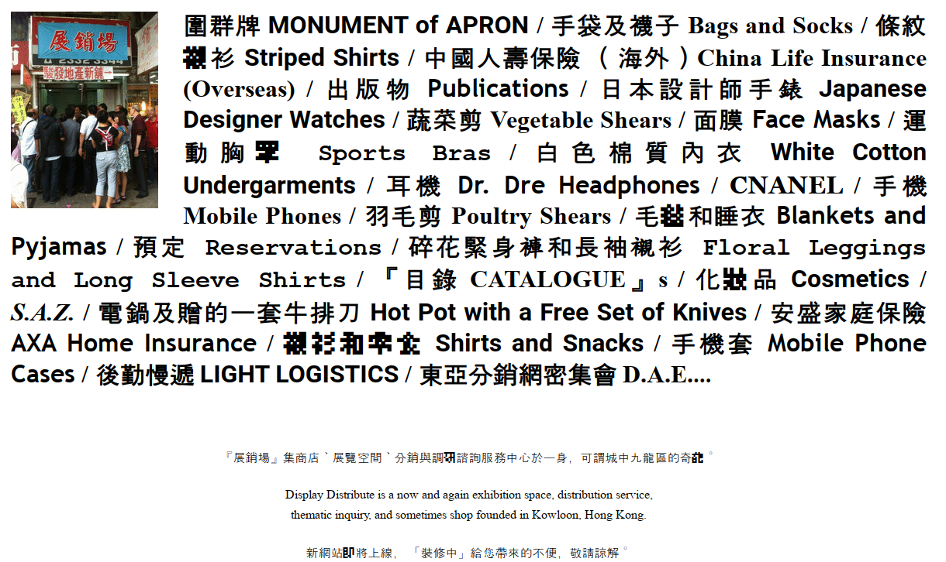
The homepage of Hong Kong-based collective Display Distribute, exemplifying one approach of art as everyday life/practice/technology.
The real question is whether the artificially separated realm of the arts should not be taken out of the sandbox and reintegrated into everyday life and social practices. This would partially render the question of whether or not art should let itself be hijacked obsolete. Since the semantics of hijacking still implies that art is an autonomous realm separate from the rest of society, we are presented with an aesthetic and political conundrum about the integration of art and everyday life. If such divisions between art, technology, research, and society — where signals transmute into carriers and vice versa — were once again to become disputed, their relations need to be renegotiated. Such astigmatism may thus become a newly appreciated temporal near-sightedness.

David Brewster, A Treatise on the Kaleidoscope (Edinburgh: Archibald Constable & Co. and London: Longman, Hurst, Rees, Orme, & Brown and Hurst, Robinson, & Co., 1819), 6, https://archive.org/details/b29295440/page/6/mode/2up.
The cat piano is described in Athanasius Kircher, Musurgia Universalis, Book 6 (Rome, 1650), 519, https://imslp.org/wiki/Musurgia_Universalis_(Kircher,_Athanasius. When the philologist Gustav René Hocke and others later called these devices and sciences “mannerist,” they were employing a twentieth-century modernist perspective and framing. In Kircher’s own time, his books were a recognized part of humanistic science and scholarship. See: Gustav René Hocke, Die Welt als Labyrinth: Manier und Manie in der europäischen Kunst (Hamburg: Rowohlt, 1957).
Psychogeography — roaming cities and other environments — was central to the anti-functionalist “unitary urbanism” of the Situationist International from the 1950s to the 1970s; durational performance became a common practice in the body and performance art of the early 1970s (by, among others, Ulay and Marina Abramovic); deep listening was first developed by composer and musician Pauline Oliveros as a mindful way of listening; nongkrong (Indonesian) roughly translates as chit-chatting and aimlessly hanging out in a group of people, and became a working principle of Indonesian artists’ collectives and of Documenta Fifteen, Kassel, in 2022.
“Problems in the World (1)” is the first track of the self-released album Problems by artist Lai Yu Tong, also known under his musician moniker The Cosmologists. From his description: “While I was about to mix the first song from the album, I recalled I hadn’t listened to what Elaine had sent me on Facebook some days back. Her recording played automatically after I had downloaded it on my computer. It played in the background, entering halfway through the first song I was in the midst of mixing.” Lai Yu Tong, “Problems in the World (1),” track 1 on Problems, 25 September 2019, online release accessible at https://cosmologists.bandcamp.com/album/problems.
See further in: Aymeric Mansoux, “Sandbox Culture: a study of the application of free and open source software licensing ideas to art and cultural production” (PhD diss., Goldsmiths, University of London, 2017).
Reprinted in, among others: Carolee Schneemann, Correspondence Course: An Epistolary History of Carolee Schneemann and Her Circle (Durham, NC: Duke University Press, 2010), 106.
Reprinted in, among others: Tatiana Bazzichelli, Networking: The Net as Artwork (Aarhus: Aarhus University, 2009), 41.
This diagram exists in many variants. Its first version appeared in Baran, Paul. “On distributed communications.” The RAND Corporation (1964). .
To use examples of what is conventionally and undisputedly called technology, i.e., engineered utilities. We will propose a broader definition of technology later in this essay.
Text reprinted in Sophie Lissitzky-Küppers, ed., El Lissitzky: Life, Letters, Texts (London: Thames and Hudson, 1968), 359.
Extensively covered in: Cornelia Sollfrank, net. art Generator (Nuremberg: Verlag für Moderne Kunst, 2004).
Today’s non-European futurisms, such as Afrofuturism and Sinofuturism, are further removed from military imaginaries but intensify speculation.
While it is true that research funding for Arpanet came from budget of the American Ministry of Defence, which back then funded most technology research at American universities, Arpanet itself was not, as common myth perpetuates, a military-purpose project to withstand a nuclear strike. See Katie Hafner and Matthew Lyon, Where Wizards Stay Up Late (New York: Simon & Schuster, 1996).
The Indonesian word lumbung corresponds to the English word (and notion of) the commons.
Timothy Mitchell, “Infrastructures Work on Time,” e-flux Architecture (January 2020), https://www.e-flux.com/architecture/new-silk-roads/312596/infrastructures-work-on-time/.
The concepts of the constancy of change and “change bringing continuity” also stem from the Yijing verse “窮則變，變則通，通則久,” which can be roughly translated as “Poverty begets the desire for change, change begets flow, flow begets continuity.”
Most notably illustrated in Chuang-Tzu’s anecdote of the “useless tree,” Fung Yu-lan, ed., Chuang-Tzu: A New Selected Translation with an Exposition of the Philosophy of Kuo Hsiang (Berlin, Heidelberg, and Beijing: Springer China Academic Library, 2016), 31.
Theodor W. Adorno, Aesthetic Theory, trans. and ed. Robert Hullot-Kentor (London: Continuum, 2004), 6.
Ironically, 系 xì only exists in contemporary Chinese in the simplified form, a logic which could in an extravagant sense be extrapolated to imply that the human has been taken out of considerations of the system and human relations in modern China.
Since many of its core practices have been continued in other communities such as ZEGG (Center for Experimental Cultural Design, near Berlin) which, to date, are not known for abuse.
In some cases, Mail Art communities were direct precursors to online social media — for example in electronic dial-up computer systems (BBSs) that existed in the 1980s and ’90s, and via Mail Art discussion boards on proto-Internet dial-up social media, such as the US computer discussion boards EchoNYC (New York) and The Well (San Francisco). The history of The Well, created in the 1980s by Stewart Brand’s Whole Earth Catalogue publishing company, was written in Howard Rheingold’s 1993 best-selling book The Virtual Community. This book likely inspired the designs of later, larger-scale social networks like AOL and Facebook.
“I was struck by the way Hitler’s description of decadent Austrian democracy prior to WWI could equally well suit the last few British governments. In 1971 ruthless destruction of the community in which I lived was being carried out by commercially minded people whilst those who had the power to stop this happening stood by like reeds in the wind.” Pauline Smith, “Corpse Club,” in About VILE, ed. Anna Banana (Vancouver: Banana Productions, 1983), 59.
Elaborated in: Craig J. Saper, Networked Art (Minneapolis: University of Minnesota Press, 2013), 67.
Along similar lines, work from author Elaine W. Ho’s participation with collective Display Distribute describes their catalogue and logistics projects as “content conflated with its own means of circulation.” See in Display Distribute, 『目錄 CATALOGUE』 No. 2 (Hong Kong: Display Distribute, 2017).
Extensive documentation of Tai’s launch has been compiled at: RandomMan and Kevinvq2, “Tay AI,” Know Your Meme (2016–2019), https://knowyourmeme.com/memes/sites/tay-ai.
Susan Anenberg et al., “A global snapshot of the air pollution-related health impacts of transportation sector emissions in 2010 and 2015,” International Council on Clean Transportation (Washington, DC, 2019).
The latter can be historically documented via modern information and computer technology that emerged from British and American defense against Nazi Germany and in the high-tech innovations of water management by Dutch Delta Works after the floods in the Netherlands in 1953.
Umberto Eco, The Open Work, trans. Anna Cancogni (Cambridge, MA: Harvard University Press, 1989).
The score is reproduced, among others, in: Ken Friedman, ed., The Fluxus Reader (London: Academy Editions, 1998), 122.
The manifesto is reprinted, among others, in: George Maciunas, “Fluxmanifesto on Art Amusement,” in Fluxus etc: The Gilbert and Lila Silverman Collection, exhibition catalogue (Bloomfield Hills, MI: Cranbrook Academy of Art, 1981), 8.
See, for example: Bill Gaver, Tony Dunne, and Elena Pacenti, “Design: Cultural Probes,” Interactions 6, no. 1 (1999): 21–29.
As mentioned at the beginning of this essay, ars and artes stem from the Latin and can be understood as synonymous to the Greek technē.
We do not, however, dismiss the contributions of technology-bent art practices of practitioners like varia, Hackers & Designers, Winnie Soon, and Lifepatch.
The influence of Certeau’s concepts of “the practice of everyday life” upon artistic/activist strategies such as “tactical media” is notable. See Michel de Certeau, The Practice of Everyday Life (Minneapolis: University of Minnesota Press, 1998).
See, for example, Airbnb and the case of the New York Correspondence School versus Facebook/Meta, or the British mail artist Stephan Kukowski who, in 1973, created a proto-search engine called Blitzinformation, a “free art service which replies to your enquiries in the most artistic way possible.” Michael Crane and Mary Stofflet, Correspondence Art: Source Book for the Network of International Postal Art Activity (San Francisco: Contemporary Arts Press, 1984), 269. Kukowski, now named Stephan Shakespeare, later became co-founder and CEO of the British polling company YouGov.
See also collective practices such as those featured during Documenta Fifteen. Additional reading at: John Dewey, Art as Experience (New York: Penguin, 2005 [1934]).

