A Near-sighted Falling into Technology:  
Through the Looking Glass of Art Practice as Human Self-Experimentation, Accidents, and Coincidence

Florian Cramer & Elaine W. Ho

## an **astigmatic** prologue

Several diffracting lenses offer a productive distortion by which to view accidental technologies in the arts. We shall attempt a kaleidoscope of thought here, in the words of ‘accidental’ inventor of the kaleidoscope Sir David Brewster, in the name of “the highest service in all the ornamental arts, [...] for the purposes of rational amusement” (Brewster 6).

### LENS 1: *aestheticization*

Ever since the western enlightenment episteme divided the Latin *ars* and its Greek predecessor *technē* into the separate domains of ‘art’, ‘science’, ‘technology’, ‘craft’, and ‘skill,’ investigations of accidental technical invention, especially with the sphere of the arts, seem to be imbued with a modern-era unfashionable sort of spirituality, if not a moot sense of romanticism.

While ‘art’ in its contemporary meaning provided a refuge for non-empirical, speculative, and even irrational practices and knowledge, it also quarantined them into the domain of the aesthetic. Accidental, random, absurdist, pataphysical, and haunted technologies were effectively sanitized in this way. Athanasius Kircher’s fantastic contraptions, such as the *katzenklavier* (cat piano), were still part of mainstream science and technology in the 17th century.[1] Some of them, such as the megaphone, even became common devices in the centuries that followed.

In the 20th and 21st centuries, a great deal of objects, devices, and technologies (including social technologies such as psychogeography, durational performance, deep listening, and *nongkrong*) created by artists have occurred accidentally and exist outside of established science and technology.[2]

### LENS 2: *art as design prototyping*

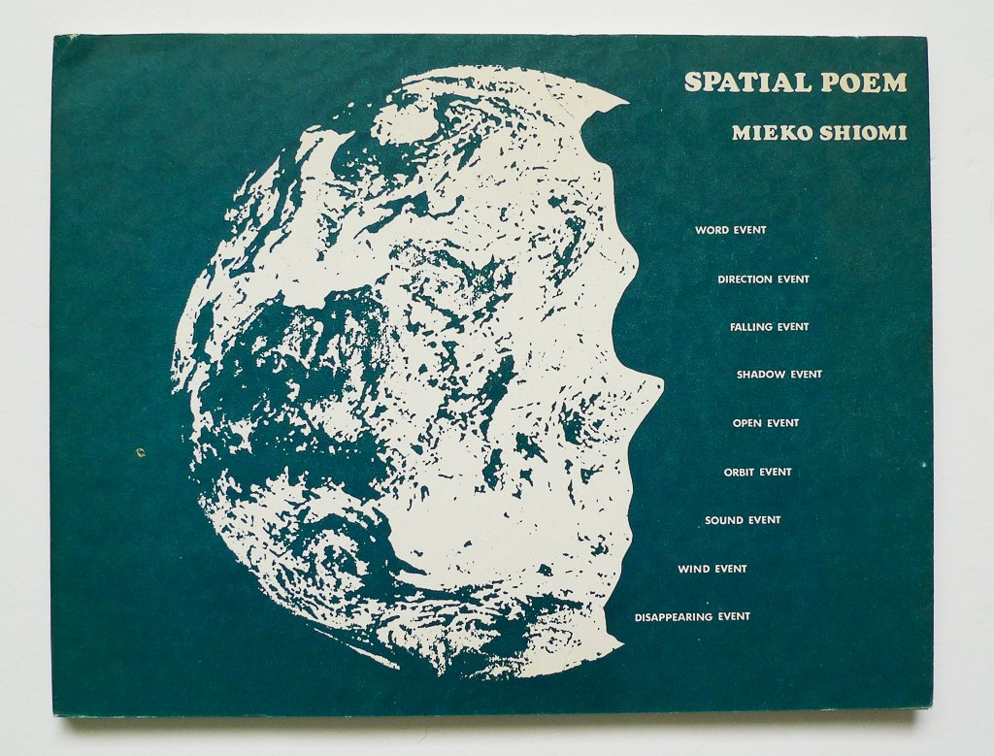

From 1965 to 1975, Japanese Fluxus artist Mieko Shiomi created a series of nine Spatial Poems that consisted of prompts for simple actions, like the following:

*SPATIAL POEM no. 3 will be the record of your intentional effort to make something fall, occurring as it would, simultaneously with all the countless and incessant falling events.*

*Please write to me how and when you performed it, as we are going to edit them chronologically.[3]*

These instructions were sent to Shiomi’s network of friends and fellow artists, and she then compiled their responses—that is, the executed prompt—and assembled them into poem objects. It was her way of keeping in touch with other Fluxus artists after her visa had expired in 1965, and she had to leave New York for her home country.

With this work, Shiomi is often credited with having co-initiated Mail Art. In the 1970s and 1980s, Mail Art developed into a global communication ecosystem that, according to coinage by Fluxus artist Robert Filliou, called itself “The Eternal Network.” The extent to which it anticipated the internet and its social networks by way of the medium of postal mail can be seen in a 1983 diagram by Italian mail artist Vittore Baroni—effectively a schematic for a distributed, peer-to-peer network architecture:[4]

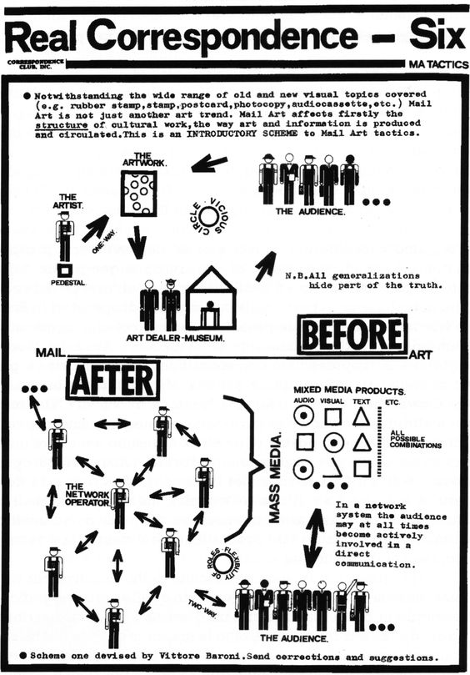

For visual comparison, this is an often-used diagram of today’s digital network architectures:[5]

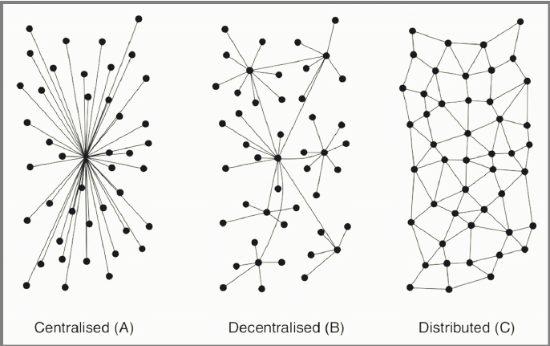

From today’s perspective, Shiomi’s *Spatial Poems* also constitute what could be called a ‘small data’ operation : networked data mining, mapping, and data visualization.

Moreover, there is a striking similarity between Shiomi’s prompts and minimalism with a social medium that is wildly popular at the time of writing this essay (to the point of being considered the defining audiovisual and social medium of contemporary youth): the Chinese website 抖音 Douyin, known elsewhere as TikTok. The enormously addictive social media platform consists of very short (usually 10-15 second) videos, most of which have been recorded by TikTok users themselves with their mobile phones. TikTok has also became known for its viral challenges in which certain dance choreographies or (sometimes dangerous) stunts are performed in front of the camera. Such delight in ‘difference from sameness’ is seen in both Shiomi’s less than viral poetry as well as on the TikTok #FYP (For You Page). In retrospect, one could call Shiomi’s *Spatial Poems* a perfect pre-Internet, TikTok prototype.

Other such lines of connection from experimental arts to mainstream technology may be drawn, of which Fluxus alone provides many examples. From Nam June Paik’s video art (especially notable being his 1973 piece *Global Groove*) as a prototype of 1980s and 1990s MTV music videos to George Maciunas’ Fluxhouse cooperatives (1967) as an ‘accidental’ prototype for today’s co-working spaces, we can witness the cooptation of emergences in art ‘*oops*, co-opted again’ by commercial interests. It was, in fact, the Fluxhouse cooperatives which helped initiate the transformation of New York’s SoHo neighborhood, thus transforming an originally communist *kolkhoz* project into a blueprint for ‘creative class’ gentrification.

Other examples of technologies[6] prototyped in art include: tile mosaics as precursors to pixel graphics (including Bayer filter technology used for digital photography and videography); player pianos by actress Hedy Lamarr and composer George Antheil to support the U.S. Army in 1941 World War II, later invented as wireless frequency hopping; El Lissitzky’s 1925 manifesto *Topography of Typography* demanding the realization of an *Electro Library*;[7] Dadaist collage, photomontage and Cornelia Sollfrank’s 1999 *net.art generators—*the latter a work that involved complex considerations of authorship and the copyright implications of algorithms—anticipating AI text prompt image generators;[8] a project of design students that grew into vacation rental platform Airbnb; the prescient self-fashioning of Cindy Sherman’s staged photographic self-portraits of the 1980s becoming today’s Instagram; and the visual works of John Heartfield and Barbara Kruger anticipating today’s internet memes.

Under this lens, the (relative) autonomy of art—or its (limited) license to speculate and experiment—allows it to develop radical prototypes for what may one day become mainstream technology. This capitalist-realist scenario also provides an albeit cynical answer to the relationship between accident and technology—that such accidents are actually supposed happen in the arts rather than in any other domain, including technological design and engineering. Since the arts, which has at some point lost its traditional functions of mimesis and representation, operates as a socially, politically, and economically sanctioned niche and playground for speculative work and thinking, the accident can, when made techno, be produced repeatably and at larger scale. But are those forms of invention in art actually accidents?

### LENS 3: *accidental scientific and technological invention*

This artistic and ultimately romantic understanding of the arts seems, however, to be contradicted by two facts: planned, technological invention in the arts and accidental technological discoveries in science and engineering.

While artistic research practices such as pataphysics, psychogeography, and *nongkrong* make accidentality their programme, there are also the counter-examples of art modeled from military and industrial invention, including: Italian Futurism, the case of Lamarr and Antheil, highly institutionalised forms of research laboratory art, as well as the very notion of *avant-garde*. They could be seen counter-appropriation: as opposed to military-industrial complexes hijacking ideas and practices from the arts, artists steal from the military.

Italian futurism, though visually modeled on the military, was highly speculative and experimental. It could be said that Boccioni, Balla and others ‘stole’ out of an aestheticist fascination for the accidents and catastrophe inflicted by military technology. Today’s non-European futurisms, such as Afrofuturism and Sinofuturism, are further removed from military imaginaries but advance speculation.

Conversely, the invention of many technologies by scientists and engineers did not follow a programme or plan but were incidental:

* X-rays were discovered accidentally by Wilhelm Röntgen when he was testing whether cathode rays could penetrate glass;
* Pennicillin was discovered by Alexander Fleming, who found that a mould had accidentally killed bacterial cultures in his hospital laboratory;
* Vulcanized rubber was discovered by Charles Goodyear, who accidentally dropped rubber mixed with sulfur onto a hot stove;
* Microwaves as a heating technique were discovered by the engineer Percy Spencer, who found that a magnetron had caused his chocolate snack to melt;
* The pacemaker was invented by engineer Wilson Greatbatch, who really just wanted to record the rhythm of the heartbeat;
* Sildenafil/Viagra was originally developed by Pfizer to treat cardiovascular disease until test patients found it worked as a sexual potency drug;
* The safety pin was accidentally invented by Walter Hunt while playing around with a piece of wire;
* Arpanet/Internet was originally developed to more efficiently share the computational resources of time-sharing computers in research institutes, but ‘civilianised’ shortly after its introduction because of the proliferating uses of e-mail.[9]

In the above examples of accidental discovery in engineering and science, technological invention had always been the goal, but the resulting purposes and products differed from those originally intended. In the arts, on the other hand, one might assume that poetic inventions have perchance become technological visions. From Lissitzky’s *Electro Library* to Shiomi’s *Spatial Poems* and Sollfrank’s *net.art generator*, art may be only originally intended as an unpredictable project—accidentally and consequentially becoming, as mentioned via lens one, a prototype for commercially viable technologies. But this assumption only works if one narrows the scope of art and ignores that these art practices (especially in the examples from Dada, Fluxus, and cyberfeminist Net Art) also saw themselves as real experiments with alternative life potential. Today, this ambition has not diminished, and we may even say that the desires for ‘life otherwise’ have actually intensified. Thinking of contemporary, multidisciplinary artist collectives from often neglected world regions—such as those that participated in documenta fifteen in 2022—art practice is also a speculative but practical form of community work and experimentation for more sustainable ways of living.

If art thus becomes a manner of human self-experimentation, and if the ‘self’ is increasingly collectivised and extended to entire communities, how does it differ from martial invention and biopolitical experiments except in terms of political-economic power?

The distinctions between artistic practice and techno-social practice are in all of the previously mentioned examples difficult or even arbitrary. And here we come to the elephant in the room: the definition of technology. While *The Oxford English Dictionary* conventionally defines technology as a “branch of knowledge concerned with the mechanical arts and applied sciences”, cybernetics, general systems theory, media theory, and philosophers such as Gilbert Simondon have complicated its definition by taking it out of the nature/culture dichotomy and into more complex techno-social dynamics.

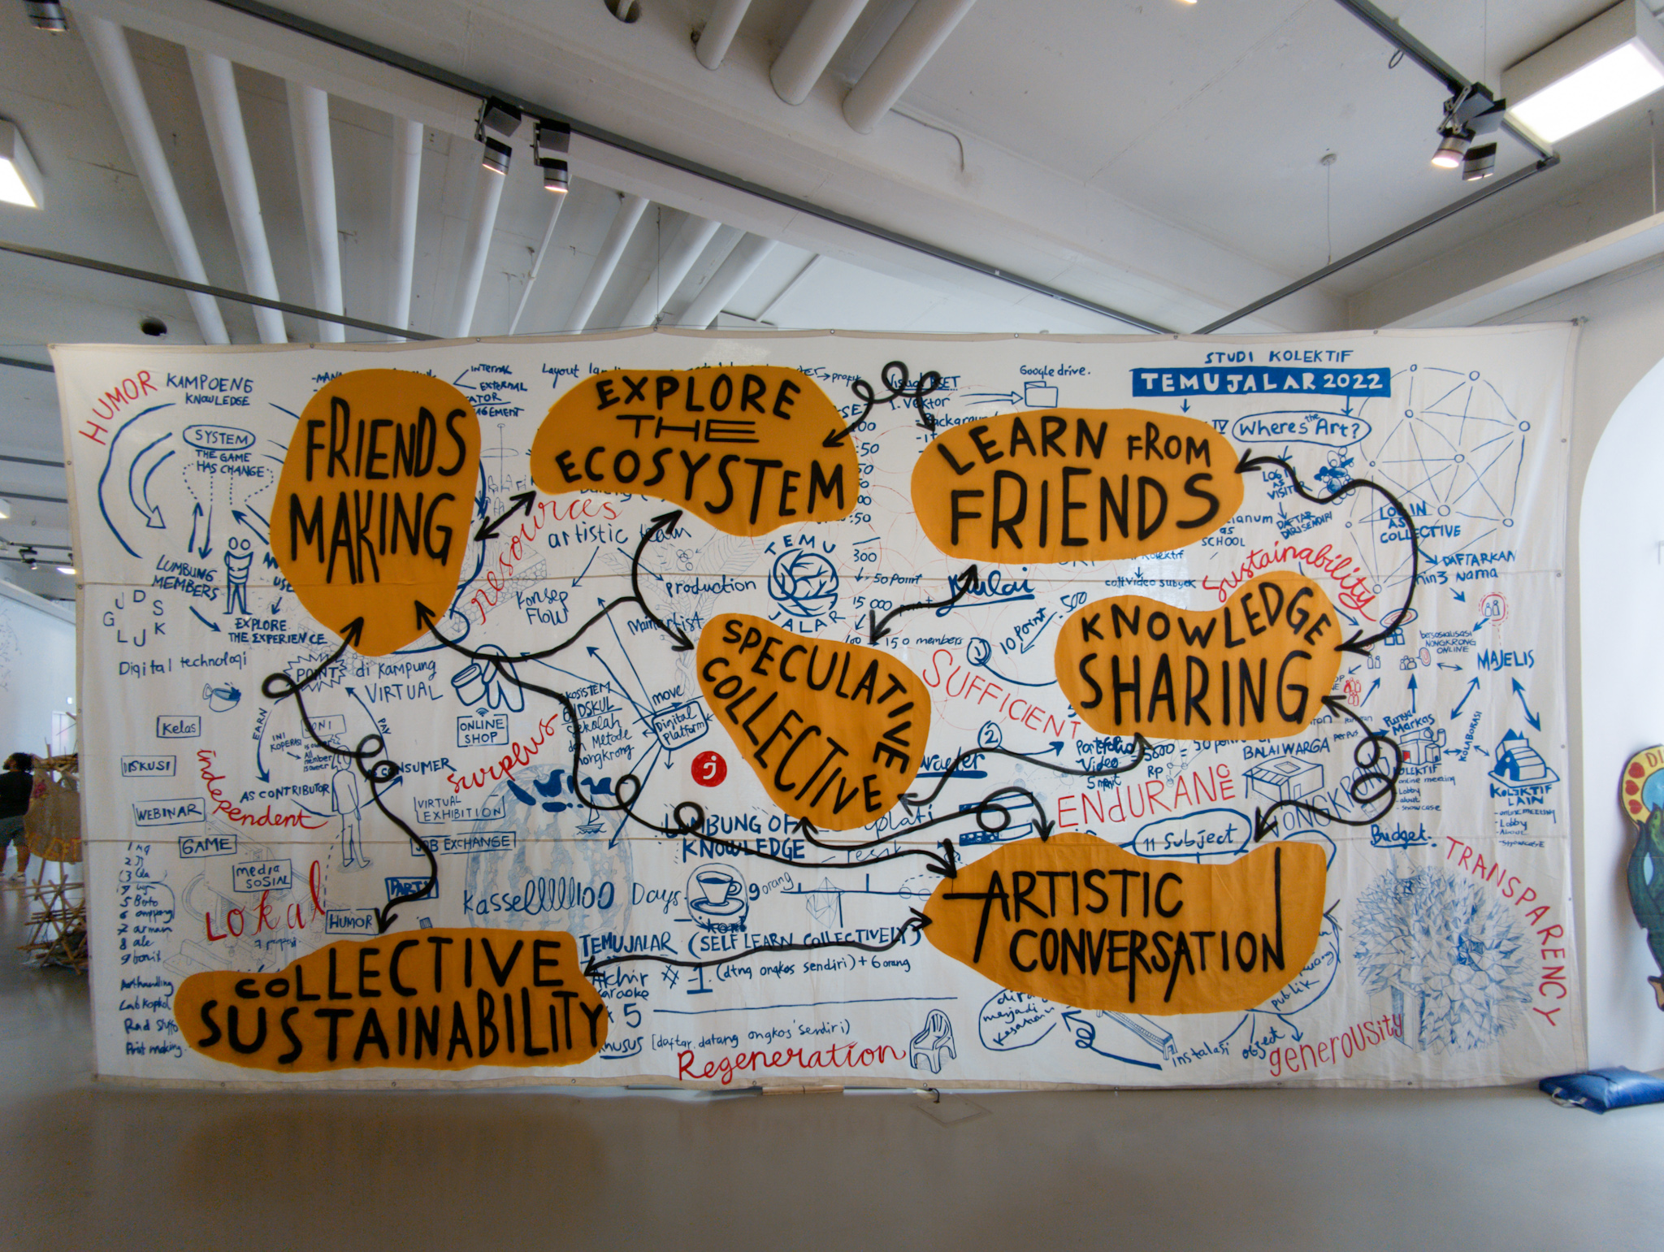*Lumbung* chart at *documenta fifteen*, Kassel, Germany, 2022

When technology is correspondingly engineered as social design (as in most Internet platforms and even long before by way of architecture), it becomes difficult to draw the line between technology and other forms of *poeisis*. For example, is experimental community building with socially and politically activist tendencies—such as squats, communes and experimental living communities—a technology? Experimental platform and community building, along with their various overlaps and intersections in utopian-dystopian projects, have existed within hacker culture, artist retreats, and contemporary art collectives for already quite some time. Think of Monte Verità in the early 20th century, the Otto Muehl commune from the 1970s, and even the *lumbung ecosistem* of the 2022 *documenta fifteen* exhibition.[10] In actuality, many occult, spiritualist, and magical practices have described their ways of working as a kind of technology. This includes shamanism, meditation, spectral communication, practical kabbalah, and modern gnostic movements such as Scientology.

Could these, beyond exposing hopelessly romantic visions of being, then be categorised as planned, technological inventions in the arts—or, accidental technological discoveries in science and engineering?

### LENS 4: *coincidental but not accidental*

In his essay “Infrastructures Work on Time”, Timothy Mitchell introduces the challenge to consider delay and postponement as an alternative barometer by which to consider large-scale infrastructure projects, perhaps something akin to environmentalists’ call for degrowth. This so-called reversal is what blushes the cringe-worthy tint of romanticism upon anyone and anything that is not on board with continued modernisation, yet the slowed time of which Mitchell speaks actually refers to both the material durability of built infrastructure like railroads and highways, as well as the durational temporality by which “the present extracts wealth from the future” via investment, credit, and accumulated interest.[11] As such, the waiting time of accrued revenue is just as much a desired variable of the mandates for growth, conquest, and development as any luddite’s call to slow things down.

The temporality of the accident, however, is not necessarily about slowing down or speeding up; it nestles within the gaps between past and future—rips in a planned timeline of the experiment which alter the trajectory of otherwise hypothesised futures. A French chemist clumsily knocks over a flask and inadvertently invents safety glass. World War I nurses appropriate particular cellulose bandages meant for wounded soldiers, unintentionally launching the disposable menstrual pad industry. Scientists answering to the U.S. government’s calls for synthetic rubber in light of shortages during World War II fail with a too-malleable silicone polymer, which later goes on to become the classic children’s fidget toy Silly Putty. The nature of ‘accident’ in these examples of great technologies which have revolutionised our world today are each tonally distinct. The ensuing invention may be the result of accident, but the manner by which each have come about varies—from literal mishap to astute reappropriated use to a failed experiment which begets a new commercially-viable twist. By virtue of these diversions in the timeline, long, profitable futures are had by those who manage to grasp hold of the resources to control the technology and its production. Magically, what was before an unforeseen glitch in the present becomes once again part of the mandate for development, efficiency, and predictable space-time.

What we are interested in here, though, has perhaps less to do with such historically repeated conquests but the temporality of the unrepeatable—that which cannot be so readily scaled-up. For what sets the precedent of military and state with corporate handshakes is precisely the grip upon resources which turn accidents into #products, the disenfranchised into the #revitalised, and disuse into #innovation. Scientific and technological accidents easily become managed uses of time, space, and other resources because they often occur as fissures *within* institutional practice, therefore easily co-opted: Humvee becomes Hummer; chest pain medication becomes Viagra; treatment for cross-sightedness becomes Botox.

For however much the mandate for ‘originality’ in art can be argued, to speak about accidents in art has more to do with the hope for uniqueness by which the art realm has been historically established (*poeisis*). The repeatable is traditionally undesireable, and this indirectly leads to a question about artists’ relations to institutions, the latter of which mechanise and systematise production for stratified and repeatable forms of output and representation. In the case of both museums and funding organisations, administration monitors and manages the flow of resources from private and state sectors, setting sanctioned barometers for what art is and ‘good artists’ are in the eyes of the corporation and nation. In this sense, the wielding of resources occurs not so dissimilarly from the mass-industrial complex of which we spoke before. If we are to try to cull something from art and the accident with a bit more liberatory potential, however, it could be useful to hone in on what separates them from other realms. So, in a temporal sense, if accidents could be made less productive or less repeatable, what would they be?

Let us now embark upon a thought *dérive*, to consider the difference between accident and coincidence. It is the premise of this paper that the two are not one and the same. Their conflated appearances within the realm of art must therefore also be distinguished.

Like the accident, coincidence is also a relation of time and space, the latter stemming however from the medieval Latin *coincidentia* meaning ‘occupation of the same space’—also from *co-*, ‘together with’ and *incidere*, ‘fall upon or into’. What overlaps here is the confluence of the spatial and the interpersonal at an intersection with the temporal. This may at first appear not so dissimilar to the accident, but the temporal vector form of the accident, from the verb *accidere* (*ad-* meaning ‘towards, to’ and *cadere* ‘to fall’) bears a subtle difference with the stop-time of coincidence. Accidents move; they move futures and premeditate an ensuing sequence of events which occur by virtue of the transformatory nature of the accident. The coincidence, on the other hand, merely ‘happens’; things, people, and circumstances come together, and there is no connotation of a better or worse future in relation to that which was prior to the coincidence. This approaches something like 緣 *yuán*, a Chinese concept most often translated as ‘fate’ or ‘destiny’. The western reading of this sounds fixed in the sense of ordained trajectories of time, but we may argue here that *yuán* merely gives a logical (hence, temporal) lens to view things that ‘merely happen’. The character 緣 *yuán* is composed of the web of relations: 糸 *sī* (meaning ‘silk or thread’) with 彖 *tuǎn*, from 彖辞 *tuàncí* (meaning ‘to determine’) and representing the first two sections of the “Ten Wings” (十翼 *shí yì*) commentaries on *The Book of Changes* (易經 *Yìjīng*). In consideration of the *Yijing* as a tool of prophecy, coincidence must be conceived as a space of subjective perspective which allows for the *constancy of change* despite the supposed fixity of predetermined futures and the will of fate.[12] Time plays out as a series of coincidences. We fall together in spite of ourselves, and the futures they beget are not to be grasped but perhaps simply accepted as a sequence of events. This is not to deny the efficacy of efforts towards change, especially sociopolitical change, but perhaps there may be here a subtle shift of perception which could offer otherwise possibilties of thought and praxis.

If we consider not the repeatability of the accident within art but the singularity of manifestations of coincidence as a form of *non-utile* accident, then perhaps, in the spirit of Adorno, we could claim the uselessness of art as its very usefulness in society. This is not to dismiss the need for aesthetic tools to strengthen other realms, but, perhaps we must also not dismiss the potency of realms of the unpredictable, the irreplicable, and the ineffable. Under the regime of the all-devouring divider of capitalism, coincidence may be a much needed respite from mandates for control.

Rather than stopping at Adorno, however, let us find neural coincidence in the fact that more than 2,000 years prior to Adorno, Daoist philosopher Chuang-Tzu had already upended distinctions between usefulness and uselessness.[13] Beyond autonomy and *fait social*,[14] 無用之用 *wúyòngzhīyòng*, or ‘the usefulness of the useless’, points towards liberation from deadlock conclusions of any form of the aesthetic, ultimately resisting *recupération* (to use Situationist technology) and gentrification, prototyping into apps or other capitalist business models. As such, coincidence—where it can be salvaged from the scene of the accident—may offer a glimmer beyond current resignation and cultural pessimism.

Departing then from the idealist aesthetics penned from the likes of Kant to Adorno, let us look to another ‘realist’ perspective grounded in the epistomology of the Cantonese language. The character 係 *hai6* stems from the root 人 *rén*, or ‘person’, along with the sound word 系 *xì*, meaning ‘system’, and is the colloquial Cantonese equivalent to ‘to be, is, and are’. This inextricable relationship between the human and his/her role in ‘the system’—for Cantonese speakers—simply *is*. What may appear to the western ear as a form of resignation in acceptance, for eastern thought may simply be an acknowledgement of both our implications within larger systems but also the potential to affect them.[15] Interestingly, the word 關係 *guānxì*, or ‘relations and connection’, is a combined word from the above *guān* (to close) and 係 *hai6*. May we think, therefore, of coincidence as the close intimations of human relations—the interaction between people and the systems they create? If not useless, then perhaps the refusals to co-opt from *what is* to *what may be* are precisely what distinguishes coincidence from the accident.

### LENS 5: *accidents and open systems*

What if, in art, there were technologies designed to create coincidence (even when they end up producing accidents)?

While it would be oversimplifying to generally and sweepingly attribute coincidental and accidental technologies to art, to say the opposite, that art non-accidentally develops technology, is also true. Science fiction literature, for example, has historically served as a direct inspiration to R&D departments, especially in the fields of digital technology and artificial intelligence. Computer hackers and engineers are known to be among the most ardent readers and viewers of science fiction literature, movies, and television. Science fiction has often functioned as an elaborate, systematically crafted blueprint for the future—prosaic inspiration for certain technologies.

There is also non-accidental, hands-on technology development in the arts themselves—for example by way of research-oriented electronic and computer music—where composition includes the development of matching hardware and software instruments as well as the development of community media tools. Examples of the latter include video and democratic television activism from 1970s artist collective Raindance Corporation and today’s development of Open Source community tools from artist collectives such as Lifepatch, varia, and Hackers & Designers.

But what if one does not look optimistically at coincidence as the technological *poiesis* of artists and rather at accidents as a sense of prosaic or even catastrophic failure? The Otto Muehl commune, which began as a socio-artistic experiment and ended with criminal convictions for systematic sexual abuse, is perhaps the most striking example of such a catastrophe in recent art practice. But it remains debatable whether such catastrophe was really due to the commune’s social technology.[16]

The previously mentioned example of Mail Art, which had emerged from the same 1960s counter-cultural, performance art scene as the Muehl commune, experienced numerous structural problems at the level of its network infrastructure and protocols. Its prototyping of Internet social media happened partially by accident, because its original goal was not to create a system for alternative mass communication but a self-organised, non-hierarchical, and inclusive alternative to the curatorial art system of museums and galleries. When Mail Art became “The Eternal Network” and gradually dissociated itself from art, it not only prototyped Internet social media but also its operational issues.[17] Spam became a problem in Mail Art as early as the 1970s. Many of its participants later testified that they had given up because of the vast amounts of junk mail, most of which came from people who used Mail Art as a low-threshold system to become part of publications and exhibitions. “The Eternal Network” was therefore effectively re-appropriated as a vehicle for self-promotion, most blatantly by the Italian businessman Guglielmo Achille Cavellini, who used Mail Art to disseminate his individual brand in the form of ubiquitous stickers promoting his artist career.

Since Mail Art artists had made a commitment to never reject any submission, there was no structural solution to resolve the above problem. In addition, open participation and a free speech ethos sometimes led to questionable submissions being accepted and disseminated, such as a series of anti-Semitic caricatures bearing a striking visual resemblance to today’s anti-Semitic “Happy Merchant” meme, first published in a 1975 issue of the famed San Francisco Mail Art zine *VILE*. Also part of “The Eternal Network” were transgressive projects such as British mail artist Pauline Smith’s “Adolf Hitler Fan Club”, perceived in its time as tongue-in-cheek by fellow artists but whose motives seem more dubious when one reads further into Smith’s comments on Hitler.[18]

In retrospect, spamming, trolling, and political subcultures such as the “Alternative Right” (Alt-Right) have been prefigured in margins of “The Eternal Network”. In his 2001 book *Networked Art*, Craig A. Saper characterised Mail Art practice as “intimate bureaucracies” by which artists effectively became administrative network operators—or, in today’s terminology, sysadmins.[19] Network administration is about managing accidents and disasters in real time, especially when—as with Mail Art or internet social media—the network is both the information carrier and at least to some degree the information itself.[20] Pauline Smith’s apartment was raided by police in 1976, the same year that her London colleague and fellow mail artist Genesis P-Orridge was placed on trial for having put pornographic images on postcards. In both cases, it is difficult to say whether the pre-digital social networks of “The Eternal Network” caused accidents or were the accident itself.

This question became even harder to answer after network bureaucracies became algorithmic regimes—when “The Eternal Network” operators like Mieko Shiomi and others, designing and dispatching prompts and aggregating feedback, were replaced by bots. In March 2016, Microsoft’s research division introduced Tay, an AI chatbot on Twitter. Unlike most other commercial software based on machine learning, this bot had not completed its training before it went to market, but it used all chat interactions as input for its continued machine learning. The launch coincided with Donald Trump’s first successful presidential campaign and the militant support he received from the extreme right in meme and troll forums. After word got out about Tay on ‘/pol’, the ‘politically incorrect’ subforum of 4chan and main alt-right hangout at the time, user interactions re-trained the chatbot to be aggressively racist, fascist, and Holocaust-denying in the span of a few hours. Sixteen hours after its premiere, Microsoft took Tay offline.

Tay does not seem to fit into a linear cause-and-effect logic by which technologies either cause their own accidents and disasters (such as the invention of the automobile, which has led to about 1.3 million car accident deaths per year and another estimated 385,000 premature deaths from air pollution[21]), or the inverse, where accidents and disasters give birth to new technologies.[22] As radically open feedback systems that process their own networks in largely unprotected ways, both Tay and Mail Art could be said to be simultaneous causes and effects of accidents. Their constructions are recipes for disaster, to the point where it becomes impossible to distinguish what exactly is technology and what is accident. In the case of Mail Art (but not of Microsoft), this recipe and its possible consequences were even consciously chosen by artists as radical experiments that can be traced back to Fluxus, via John Cage and other composers, or even the aleatoric compositions of Kircher.

Other ‘open works’ (to use a term made known by Umberto Eco), including the aforementioned *Spatial Poems* or Tristan Tzara’s 1920 instruction to create a Dadaist poem by cutting out and randomly combining the words of any newspaper article, could be similarly scaled-up to create catastrophic dynamics in real life. A series of Fluxus pieces titled *Danger Music*—including Takehisa Kosugi’s 1964 instruction to “[s]coop out one of your eyes 5 years from now and do the same with the other eye 5 years later”—embarked upon a similar path.[23] The example of Tay and 4chan suggests that contemporary *Danger Music* now features more in digital technology than in the arts. 4chan itself is perhaps the best example of a catastrophic cybernetic heir to Dada—technology as catastrophe and catastrophe as technology.

### LENS 6: *aestheticized technology*

Even the less extreme example of TikTok illustrates how, since the Internet boom of the 1990s, technology has become aesthetic to the point that distinctions between art and technology blur and the pre-modern notion of *ars* (or *technē*) may, for better or worse, make a comeback. Both Fluxus’ programme to abolish fine art and replace it with ‘art-amusement’ and ‘vaudeville art’[24] and the Situationist (Johan Huizinga-inspired) concept of ludic urbanism replacing functionalist urbanism ended up as, sometimes literal, blueprints for ‘gamification’ design in today’s creative industries.[25]

The Situationist International anticipated such risk in its own concept of *recupération* (hijacking). But few concepts and practices developed in the speculative arts were so thoroughly hijacked as those of the Situationists, especially those of playful urbanism. Another question that arises, therefore, is whether such ideas do not bear a problematic dialectic from the moment they are coined.

## a near-sighted post-script

The subject of technological accidents and their role in the arts prompts the question of what we define as ‘accidents’ and what we define as ‘technology’. In the arts, accidents have often been credited for *poeisis* (in some cases, such as dystopian science fiction, also *aisthesis*). Our earlier differentiation of accident and coincindence narrows their scope. With chance operations, *Danger Music*, psychogeographies and hauntologies, we have aimed to zoom in on the least ambiguous examples of coincidental and accidental poetics and technology in the arts. Both historically and based upon newer theories and philosophies of technology (*eg*, Gilbert Simondon), the line between artist experimentation and technological discovery is blurry, if not arbitrary and artificial. Such distinctions are ultimately based upon a differentation of practices and domains of knowledge introduced during the late 17th-early 18th century paradigm shifts in science, when *art*(*es*)was divided into art *versus* science *versus* technology *versus* craft.[26]

Such divisions have often and routinely been deplored in technology-oriented arts (*eg*, new media art, art/science, *etc*), but looking more carefully behind accidental technology and art practices, we argue that often, the accidental invention of technologies occur in art practices that are *not* technologically driven and primarily think of themselves as social and cultural experiments.[27]

In other words, communal-experimental inventions of everyday technologies, such as “practices of everyday life”[28] can be fully manual and offline technologies but also automated and operationalised any time.[29] It may not be upscaling that is the most problematic but rather hitherto unacknowledged issues, glossed-over conflicts, and hidden dark sides that get amplified in this process metastasise into catastrophic issues. Since no imagination can be dystopian enough, we would not be surprised if one day someone launched a crypto-*Lumbung*Coin on the blockchain, or if *documenta fifteen* artists continued to develop their *ekosistem* as real estate projects. With the distinctions between the concept of the accident from that of coincidence, we hope to reach an alternative understanding of the productive use of resources.

The appropriation, mainstreaming, and commodification of artists’ accidental technologies must be mentioned but may only lead to a fatalist impasse. Artists have served as cultural hackers and unintentional trendsetters for extractive capitalism, gentrification, new capitalist business models, *etc,* since the Situationist International of the 1950s-60s. In neoliberal times, this seismographic function of art is its only remaining justification. Both anarchist sociologist Jacques Ellul and cultural theorist Marshall McLuhan privileged artists in anticipating socio-technological developments. While our examples seem to support this hypothesis, the double-edged sword of a romanticist aesthetic ideology still haunts the tempo-spatial horizon.

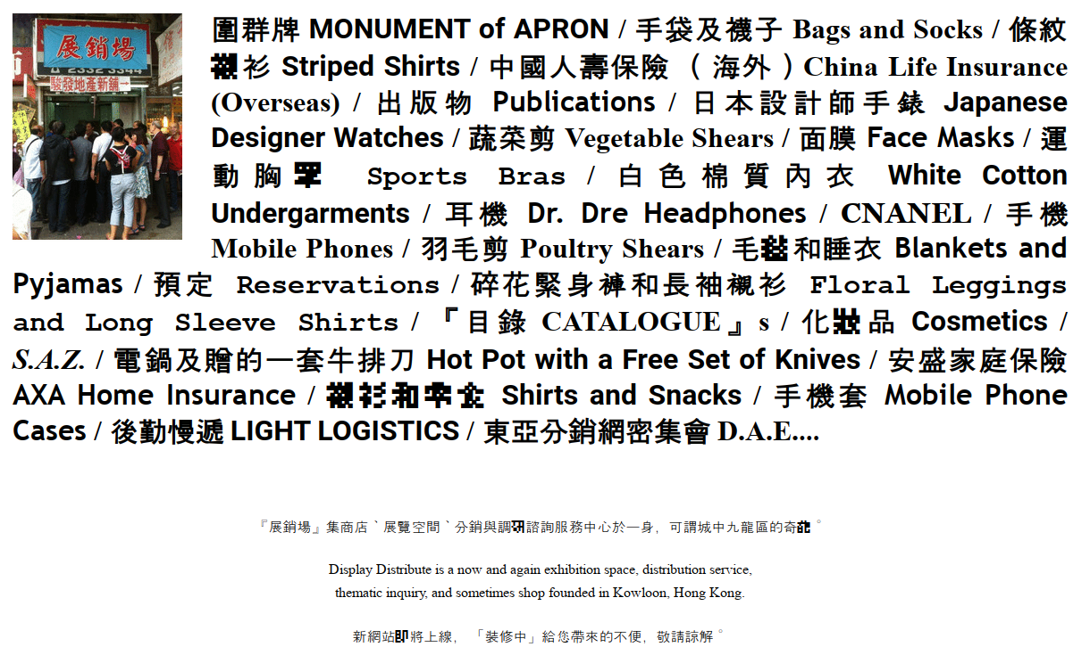

*Homepage of Hong Kong-based collective Display Distribute, exemplifying one approach of art as everyday life/practice/technology.*

The real question is whether the artificially separated realm of the arts should not be reintegrated into everyday life and social practices.[30] This would render the question of whether or not art should let itself be hijacked partially obsolete. Since the semantics of hijacking still implies that art is an autonomous, separated realm from the rest of society, we are presented with an aesthetic and political conundrum about the integration of art and everyday life. If such divisions between art, technology, research, and society—where signals transmute into carriers and vice versa

—could go up once again for dispute, their relations need to be renegotiated from technology in its conventional sense. Such astigmatism may be, thusly, a newly appreciated temporal near-sightedness.

## Works cited

Adorno, Theodor W.. *Aesthetic Theory*, trans. and edited by Robert Hullot-Kentor. London: Continuum, 2004.

Anenberg, Susan, et al. “A global snapshot of the air pollution-related health impacts of transportation sector emissions in 2010 and 2015.” *International Council on Clean Transportation*: Washington, DC, USA (2019).

Bazzichelli, Tatiana. *Networking: the Net as Artwork*. Aarhus: Aarhus University, 2009.

Brewster, David. *A Treatise on the Kaleidoscope*. Edinburgh: Archibald Constable & Co. and London: Longman, Hurst, Rees, Orme, & Brown and Hurst, Robinson, & Co., 1819, p. 6, via Internet Archive, <https://archive.org/details/b29295440/page/6/mode/2up>, accessed 28 December 2022.

Crane, Michael, and Mary Stofflet. *Correspondence Art: Source book for the network of international postal art activity*. Contemporary Arts Press, 1984.

Display Distribute, 『目錄 *CATALOGUE*』No. 02. Hong Kong: Display Distribute, 2017.

Eco, Umberto. *The Open Work*. Harvard University Press, 1989 (1962).

Friedman, Ken, ed. *The Fluxus Reader*. London: Academy Editions, 1998.

Fung Yu-lan (ed.), *Chuang-Tzu. A New Selected Translation with an Exposition of the Philosophy of Kuo Hsiang.*  Berlin, Heidelberg and Beijing: Springer (China Academic Library), 2016

Gaver, Bill, Tony Dunne, and Elena Pacenti. "Design: cultural probes." *interactions* 6.1 (1999): 21-29.

Hafner, Katie, and Matthew Lyon. *Where Wizards Stay Up Late*. New York: Simon & Schuster, 1996.

Hocke, Gustav René. *Die Welt als Labyrinth: Manier und Manie in der europäischen Kunst*. Hamburg: Rowohlt, 1957.

Kevinvq2, and RandomMan. “Tay AI.” *Know Your Meme*, 2016-2019, <https://knowyourmeme.com/memes/sites/tay-ai>, accessed 28 December 2022.

Kircher, Athanasius, *Musurgia Universalis.* Book 6, Rome: 1650, p. 519, <https://imslp.org/wiki/Musurgia_Universalis_(Kircher,_Athanasius>), accessed 28 December 2022.

Lissitzky-Küppers, Sophie, *El Lissitzky: Life, Letters, Texts.* London: Thames and Hudson, 1968.

Maciunas, George. "Fluxmanifesto on art amusement." *Fluxus etc: The Gilbert and Lila Silverman collection*. Exh. cat. Cranbrook Academy of Art, 1981.

Mitchell, Timothy, “Infrastructures Work on Time”. *e-flux Architecture*, New York, USA (2020), <https://www.e-flux.com/architecture/new-silk-roads/312596/infrastructures-work-on-time/>, accessed 28 December 2022.

Saper, Craig J. *Networked Art*. Minnesota: University of Minnesota Press, 2001.

Schneemann, Carolee. *Correspondence Course: An Epistolary History of Carolee Schneemann and Her Circle*. Duke University Press, 2010.

Smith, Pauline. “Corpse Club”, in: Anna Banana. *About VILE.* Vancouver: Banana Productions, 1983, pp. 59-60.

Sollfrank, Cornelia (ed.). *Net.Art Generator: Programmed Seduction*. Nuremberg: Verlag für moderne Kunst, 2004.

1. The cat piano is described in (Kircher 519). When [the philologist Gustav René] (Hocke) and others later called these devices and sciences ‘mannerist’, they were employing a 20th century modernist perspective and framing. In Kircher’s own time, his books were a recognized part of humanistic science and scholarship.
2. Psychogeography—roaming in cities and other environments—was central to the anti-functionalist ‘unitary urbanism’ of the Situationist International from the 1950s to the 1970s; durational performance became a common practice in the body and performance art of the early 1970s (by, among others, Ulay and Marina Abramovic); Deep Listening was first developed by composer and musician Pauline Oliveros as a mindful way of listening; *nongkrong* (Indonesian) roughly translates as chit-chatting and aimlessly hanging out in a group of people and became a working principle of Indonesian artist collectives and of documenta fifteen, Kassel, in 2022.
3. Reprinted, among others, in (Schneemann, 106).
4. Reprinted, among others, in (Bazzichelli, 41).
5. This diagram exists in so many variants that it was impossible to trace its historical origin.
6. To use examples of what is conventionally and undisputedly called technology, *i.e*, engineered utilities. We will propose a broader definition of technology later in this essay.
7. Text reprinted in (Lissitzky-Küppers 359).
8. The *net.art generators* are extensively covered in (Sollfrank).
9. While it is true that research funding for Arpanet came from budget of the American Ministry of Defense, which back then funded most technology research at American universities, Arpanet itself was not, as common myth perpetuates, a military-purpose project to withstand nuclear strike. See (Hafner and Lyon).
10. The Indonesian word *lumbung* corresponds to the English word (and notion of) the ‘commons’.
11. (Mitchell), *op. cit.* 
12. The concepts of the constancy of change and “change brings continuity” stems also from the *Yijing* verse “窮則變，變則通，通則久”, which is roughly translated by the author as “Poverty begets the desire for change, change begets flow, flow begets continuity”.
13. Most notably illustrated in Chuang-Tzu’s anecdote of the ‘useless tree’ (Fung 31).
14. To quote (Adorno 6).
15. Ironically, 系 *xì* only exists in contemporary Chinese in the simplified form, a logic which could be in an extravagant sense be extrapolated to imply that the human has been taken out of considerations of the system and human relations in modern China.
16. Since many of its core practices have been continued in other communities such as ZEGG (Center for Experimental Cultural Design, near Berlin) which, to date, are not known for abuse.
17. In some cases, Mail Art communities were direct precursors to online social media—for example in electronic dial-up computer systems (“BBS”s) that existed from the 1980s to 1990s and via Mail Art discussion boards on proto-Internet dial-up social media such as the U.S. American computer discussion boards *EchoNYC* (New York) and *The Well* (San Francisco). *The Well*, created in the 1980s by Stewart Brand’s *Whole Earth Catalogue* publishing company, was historicised in Howard Rheingold’s 1993 best-selling book *The Virtual Community*. This book likely inspired the designs of later, larger-scale social networks such as AOL and Facebook.
18. “I was struck by the way Hitler’s description of decadent Austrian democracy prior to WWI could equally well suit the last few British governments. In 1971 ruthless destruction of the community in which I lived was being carried out by commercially minded people whilst those who had the power to stop this happening stood by like reeds in the wind” (Smith, 59).
19. Elaborated in (Saper, 3-67).
20. Along the same lines, work from author Elaine W. Ho’s participation with collective Display Distribute describes their catalogue and logistics projects as “content conflated with its own means of circulation”. See further in (Display Distribute).
21. According to (Anenberg, *et al*).
22. The latter can be historically documented via modern information and computer technology that emerged from British and American self-defense against Nazi Germany, as well as in the high-tech innovations of water management by Dutch Delta Works after floods in the Netherlands in 1953.
23. The score has been reproduced, among others, in (Friedman 122).
24. The manifesto has been reprinted, among others, in (Maciunas 8).
25. Such as in (Gaver et.al.).
26. *Ars* and *artes* from Latin, synonymous with the Greek *technē*.
27. We do not, however, dismiss the contributions of technology-bent art practices of practitioners like varia, Hackers & Designers, Winnie Soon, and Lifepatch.
28. See further in *The Practice of Everyday Life* by Michel de Certeau, and note also the influence of such concepts on artistic/activist strategies such as ‘tactical media.’
29. See for example Airbnb and the case of the New York Correspondance School versus Facebook/Meta, or the British mail artist Stephan Kukowski who in 1973 created a proto-search engine called Blitzinformation, a “free art service which replies to your enquiries in the most artistic way possible” (Crane and Stofflet 269). Kukowski, now named Stephan Shakespeare, later became co-founder and CEO of the British polling company YouGov.
30. See also John Dewey, *Art as Experience,* andcollective practices such as those by Display Distribute and during *documenta fifteen*.