Research practices of self-organized collectives versus managerial visions of artistic research

artist-run research
Since at least the early 20th century, artists groups have called their work “research”. Canonized examples include the “Bureau des recherches surréalistes” (“Bureau of Surrealist Research”) founded in Paris by André Breton and fellow Surrealists in 1925 and the Situationist International which, from 1957 to 1972, operated under the moniker of a research group and whose periodical had the form of a research journal. Since then, artist-run research groups and projects have only grown in number and increasingly involved non-art practitioners next to professional artists. The Free International University founded by Joseph Beuys is another such textbook example, as is the research-based “Institutional Critique” from the Art Workers Coalition in the 1970s to contemporary feminist, queer and PoC artist-activist collectives.
Today, transdisciplinary art/research collectives seem to be more common as a contemporary art practice in non-Western regions than in Western countries where art systems are more institutionalized. At the time of this writing, self-organized artist-research collectives are still mostly known to people working in, or in close neighborhood to, art practice; not to wider audiences. This may change with the forthcoming documenta 15 in 2022 that will, for the first time, be curated by an art/research group, the Indonesian ruangrupa collective. Documenta 15’s preliminary participant list, published in summer 2020, almost exclusively lists transdisciplinary collectives that work at the boundaries of art, research and community organizing: “Fondation Festival Sur Le Niger (Ségou, Mali), Gudskul (Jakarta, Indonesia), INLAND (various locations, Spain), Jatiwangi art Factory (Jatiwangi, Indonesia), Question of Funding (Jerusalem, Palestine), Más Arte Más Acción (MAMA) (Nuqui, Choco, Columbia), OFF-Biennale (Budapest, Hungary), Trampoline House (Copenhagen, Denmark), and ZK/U – Zentrum für Kunst und Urbanistik (Berlin, Germany)”. Is the practice of these artist-run collectives and projects identical to artistic research as it has been discussed since the 1990s, typically in the context of (European) higher art education?
While this question might have been purely academic ten years ago, it has become political and epistemological in a time where, on the one hand, artistic research is being more firmly institutionalized – among others, through PhD programs -, and where on the other hand the definition of Western contemporary art has narrowed down, even in art theory, to curatorial white cube art.
For the sake of simplicity, I would like to focus on the work of two contemporary artist-research collectives – the aforementioned Jatiwangi art Factory (Indonesia) and 展銷場 Display Distribute (Hong Kong) – by contrasting their research practices with artistic research as it has been institutionally defined in the “Vienna Declaration on Artistic Research” from 2020. To clarify my own position, I need to mention that I worked with those two collectives in the research project ‘Bridging Art, Design and Technology through Material Practices’ and its public conference ‘Making Matters II’ that took place in November 2020 at Het Nieuwe Instituut in Rotterdam, The Netherlands. The Vienna Declaration on Artistic Research has been authored by, among others, the European art school umbrella organization ELIA of which my art school is an active member and in whose research conferences I have participated. Therefore, any incompatibility between artists’ and institutional concepts of artistic research creates a dilemma for my own work, as a researcher working at an art school.
Jatiwangi art Factory and 展銷場 Display Distribute are part of a larger global phenomenon of self-organized, commons- and community-oriented collectives whose respective practices are highly specific to their own local environment while, at the same time, being internationally networked. These collectives consist of people with mixed or overlapping backgrounds as artists, researchers, theorists, activists, journalists and community organizers. They often focus on one specific material practice – “tanah”/clay in the case of Jatiwangi art Factory, publishing and logistics in the case of 展銷場 Display Distribute – that they turn into a social experiment and artistic-philosophical inquiry.
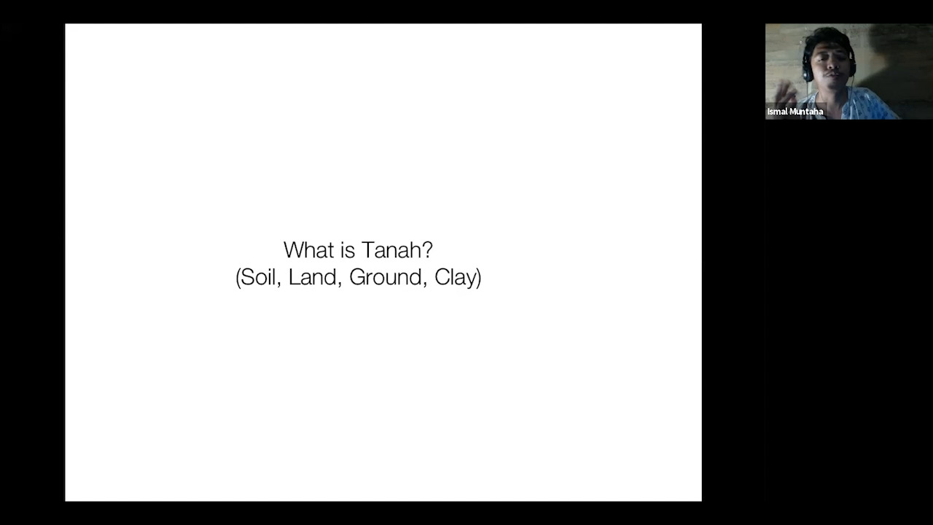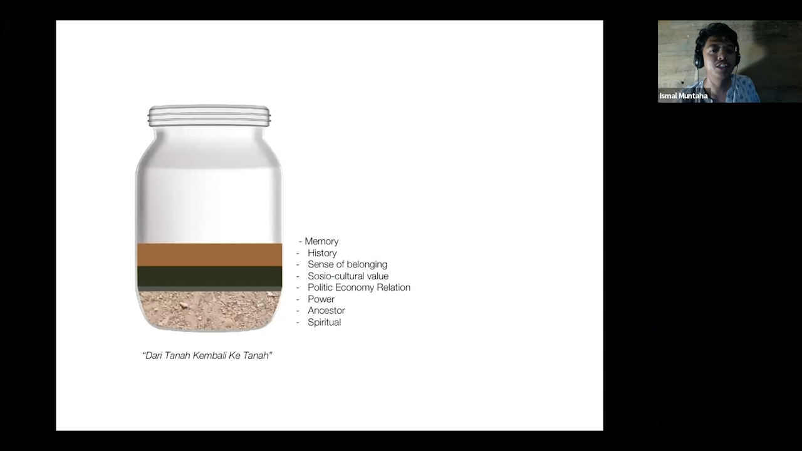
Jatiwangi art Factory (JaF) calls itself a “community-based organization focused on examin[ing] how contemporary art and cultural practices can be contextualized with the local life in [a] rural area, both [in] form [and] ideas”. JaF combines local community activities, including festivals, with an international artist residency program. Ismal Muntaha, a founding member of the collective, explains how the JaF’s activities tie into the history of Jatiwangi, a village 200 kilometers East of Jakarta, as Indonesia’s post-colonial industrial production site for roof tiles. The area’s major natural resource is clay or “tanah”, the Indonesian word for soil, ground and clay. JaF’s work investigates the history and culture of tanah and reactivates it in new forms: “digging again the memories, spiritual value, ritual, proudness, cultivating attitude from our Tanah as local material as a tool of subjectivity”.
Collective activities organized in the village community include a “Zero Point Ritual” whose participants “choose the zero point of Terracotta City as the beginning of a new clay culture, a city based on the people’s desire and their collective agreement”. It involves the creation of a terracotta structure on a piece of land in order to prevent its privatization and keep it as a public community space. JaF also organizes a music festival with community-built clay instruments. All together, JaF’s projects amount to a postcolonial poetics and discourse analysis of tanah and the Jatiwangi region. This research is not published in scholarly papers or textbooks, but through JaF’s public performances and presentations. The research outcomes are not only practical, but also theoretical, as shown in JaF’s diagram of ’Material Subjectivity:
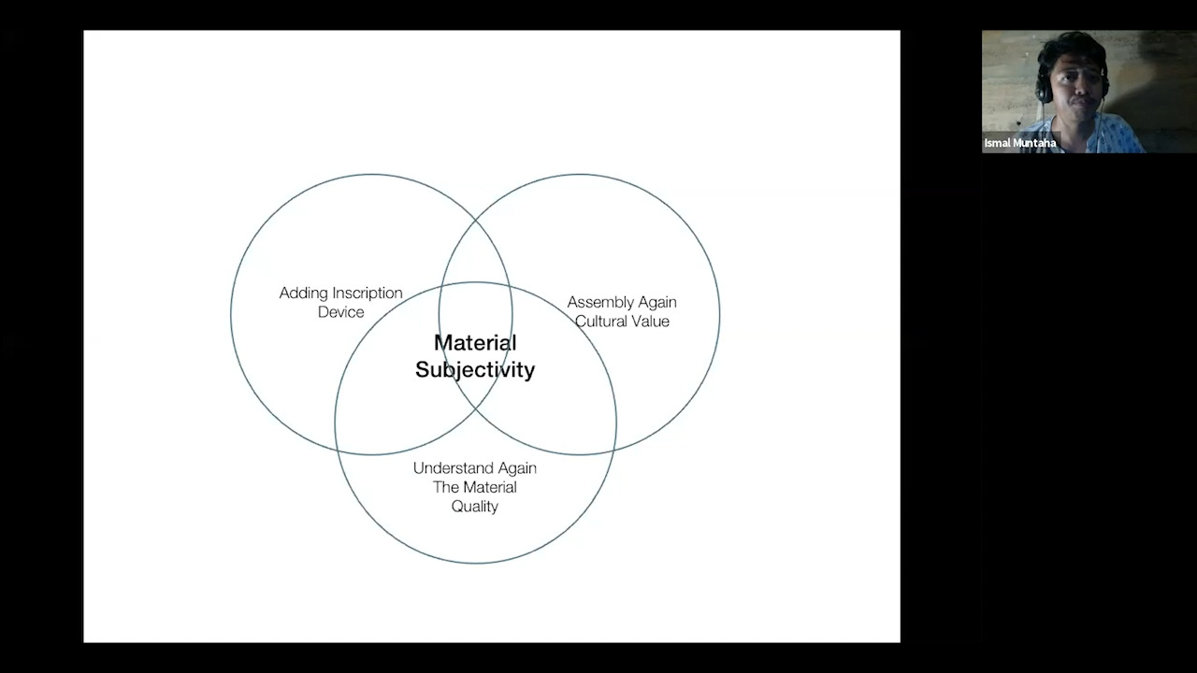
The subjectivity and politics of materials and their communal exchange also characterize the work of the 展銷場 Display Distribute collective in Hong Kong. Its English name is a literal translation of the Chinese “展銷場” (Zhǎnxiāo chǎng), a type of small pop-up store common in Hong Kong whose spaces can be rented from retail estate owners on very short notice, without much paperwork, and for a short period of time. Accordingly, 展銷場 Display Distribute calls itself a “now and again exhibition space, distribution service, thematic inquiry, and sometimes shop in Kowloon, Hong Kong”. Its web homepage lays out the typical stock of such a store (“手袋及襪子 Bags and Socks / 條紋襯衫 Striped Shirts / 中國人壽保險 [海外]China Life Insurance (Overseas) / 出版物 Publications / 日本設計師手錶 Japanese Designer Watches”) and links it to actual pop-up shop manifestations, projects and appearances of the collective.
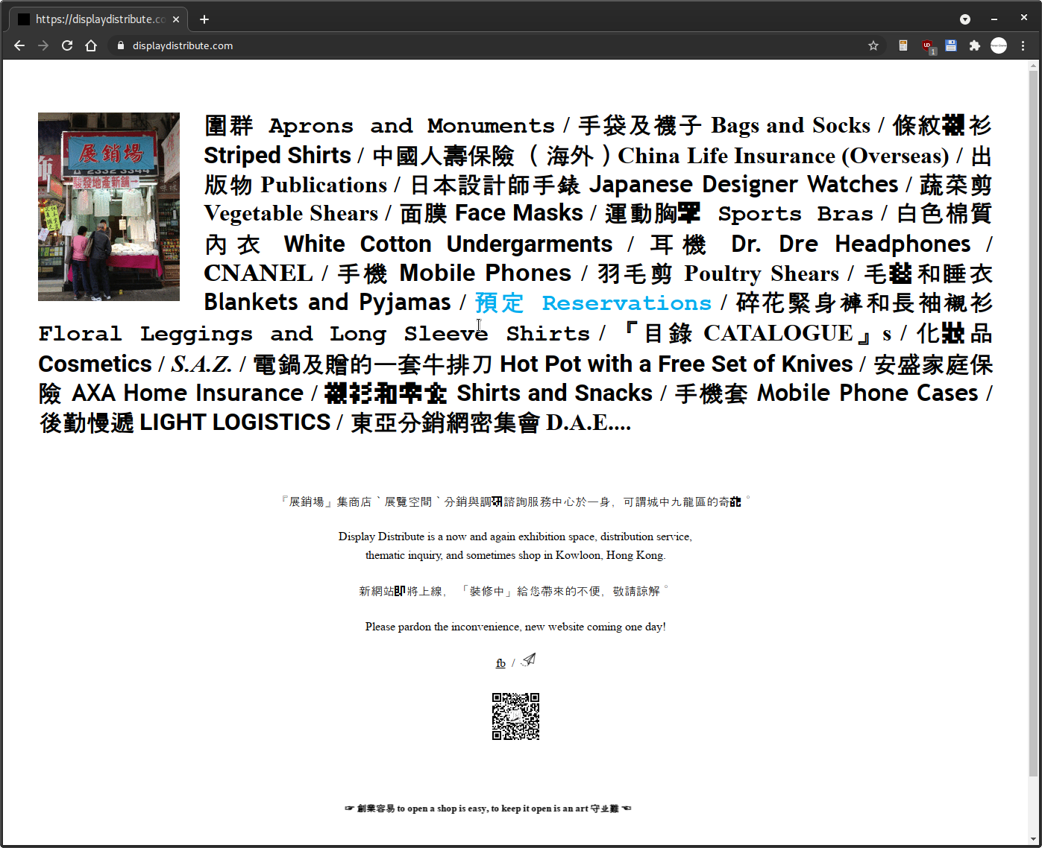
展銷場 Display Distribute, homepage
Never mind the diversity of trades, activities of the collective are focused on artists’ and activist DIY publishing and its communal distribution. 展銷場 Display Distribute’s members conduct many practical, often performative experiments with publishing, retail, distribution and cross-border transport that reflect the political situation of Hong Kong as a simultaneous capitalist experiment and part of the communist People’s Republic of China. The collective experimentally participated in the semi-legal commercial cross-border transportation of retail goods into the PRC, and runs as its most elaborate project a self-organized worldwide courier system “LIGHT LOGISTICS” for DIY publications and other merchandise. It operates on the basis of private travels of volunteer collaborators and is coordinated through 展銷場 Display Distribute’s own tracking-and-tracing bureaucracy. Each shipment is assigned an alphanumeric ID, and its travel is being documented on 展銷場 Display Distribute’s website.
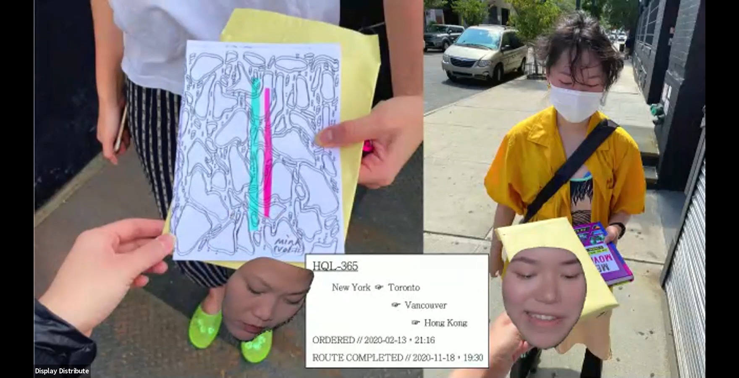
展銷場 Display Distribute, screenshot from ‘Making Matters’ presentation
The above screenshot was taken from the live video performance “Packaging as Propaganda: On circulation, new psychogeographies, and the discursiveness of boxes” that took place in November 2020. By referencing psychogeography, 展銷場 Display Distribute continue an artistic research discipline that was invented in the Lettrist and Situationist International (with forerunners in surrealism and symbolism). When interviewed for a Chinese multi-disciplinary arts magazine and asked about her working definitions of “open platform”, “architectures of commerce” and “documentary gesture”, 展銷場 Display Distribute member Elaine W. Ho replied:
“Together, these questions refer to a socio-politics of syntax informing various paths of artistic research. For example, the LIGHT LOGISTICS project with 展銷場 Display Distribute instigates a series of encounters based around the act of reading. We want to support independent publishers whose work contributes to the discourse on grassroots, radical, and critical practices in East and Southeast Asia. Considering the power of reading as a 1:1 form of exchange, there is still something to be said for kindling these small moments of encounter between individuals with similar interests or that can support by way of coincidental mobility. Setting up this albeit crude infrastructure of a logistical operation makes use of slow couriers’ movement to physically and immaterially transport art, ideas, and practices in ways that may be difficult for independent practitioners otherwise. By playfully highlighting the banal details of this circulation, we want to lay bare the systems of production as they are embedded within the everyday and trace new possibilities for a distributed but self-organized community.”
This fully meets the proposition text for this publication and its characterization of “artistic thinking” as “open-ended, speculative, associative, non-linear, haunting, thinking differently”. In other words, there seems to be no discrepancy between artistic research as defined by artists and as defined by art schools such as the one which initiated this publication. Elaine W. Ho’s statement clarifies and underlines that artistic research does not merely exist as an institutional or higher education discourse, but is claimed by artists as their own, non-institutional practice.

what was research again?
So far, I have dodged the question of how to define research, in the literal sense of drawing boundaries between research and non-research, and between artistic research and art practice. “Research”, like “art”, strikes me as a word whose semantics relies on a superficial social consensus that evaporates upon closer inspection. Even in Western languages and cultures, “research” is not the same thing. To take only the three (geographically and linguistically) neighboring languages and cultures of my daily use, English, Dutch and German, not even the words are related: “research” in English, “Forschung” in German and “onderzoek” in Dutch. Their meanings differ as well.
In German, “Forschung” includes the humanities and effectively everything that a scholar publishes. Not only the interpretation of Shakespeare poems by a literary scholar counts as “Forschung”, but also the publishing of those poems in a critical-philological edition. On top of that, teaching and research are defined as an inseparable “unity”. This humanistic concept of research, which dates back to Wilhelm von Humboldt, has the least incompatibilities with artistic research. One might even argue that some forms of German humanities “Forschung” such as Aby Warburg’s Mnemosyne Atlas and Walter Benjamin’s Arcades Project, were already hybrids of humanities and artistic research.
Unlike German academia and even the German language, Anglophone academia differentiates “research” and “scholarship”. Warburg’s and Benjamin’s projects would likely fall under the latter rather than the former category. This begs the question whether higher-education “artistic research” isn’t a mistranslation, or continental European pidgin English, for a discipline that should rather be called artistic - or creative - scholarship. (The term “artistic research” is still less common in anglophone countries than in continental Europe. I have been told by colleagues from the UK that the word “artistic”, as an equivalent of “artistiek”/“artistique” in Dutch and French or “künstlerisch”/“kunstnerisk” in German and Danish, is much less commonly used in English and even avoided by professional artists.)
In the Netherlands, the word “onderzoek” has a strong semantic bias towards empirical research. Linguistically, it is not differentiated from “investigation” and can also refer to investigative journalism and police work. The empirical bias of “onderzoek” often manifests itself in academic practice, among others in acceptance problems of non-quantitative research as research in Dutch academia and in the requirement of specifying data management in every Dutch research funding application.
In other words: Even before questioning ‘research’ as a Western concept and epistemology, one needs to be aware of the fact that “research” is not even a consistent or unified concept in Western countries. Discussions of whether or not artistic research should have a place in academia, are part of that larger disagreement.
In linguistic terminology, “research” could thus be called a floating signifier; or, using film terminology, a McGuffin: a package that is passed along different parties who may not even have the same idea of what it contains. A McGuffin is an ultimately empty device whose only function it is to tie together a plot. While ‘research’ in its diverse meanings may have McGuffin tendencies (as a device that ties together academia with its very diverse disciplines and epistemologies), artistic research in particular is a word on which two or more parties can reach superficial consensus while having something quite different in mind. It is therefore prone to becoming transactional rather than epistemological, or – to once more use linguistic terminology – defined by its pragmatics rather than by its semantics.
Fernando di Leo’s 1972 semi-famous gangster b-movie Milano Calibro 9 opens with a long McGuffin sequence in which a suitcase is handed from person to person. The suitcase initially contains money but, at the end of the chain, turns out to be a bomb that kills its final receivers. Similarly, artistic research is being understood, among others, as a project-oriented contemporary art practice, as lab science done in collaboration with artists and designers, as art school PhD trajectories, or as academic scholarship whose outcomes are ‘creative’ - audiovisual, performative and/or experimentally written - rather than research papers. But the question is whether the institutionalization of artistic research will marginalize or, in the worst case, kill off some or even most of these understandings.
timelapse of the opening sequence of Milano Calibro 9
Perhaps the first literal mention of “artistic research” is in Asger Jorn’s 1957 Notes on the Formation of an Imaginist Bauhaus, the founding manifesto of a project that eventually became part of the Situationist International. This text was written in Switzerland, first published in French and later translated into English so that it remains unclear whether Jorn departed from the word “forskning” in his native Danish (which is derived from the German word “Forschung”) or from French “recherches”, and to which extent his text reflected the prior use of the word “recherche” in, among others, French Surrealism and post-war experimental music groups such as Pierre Schaeffer’s Groupe de Recherches de Musique Concrète (founded in 1951).
- ☒ - [ ] Even in this early, geographically and culturally limited stage, ‘artistic research’ was a speculative and semi-dubious affair, rooted simultaneously in poetic-absurdist science and laboratory experimentation, and manifesting itself in such artistic research disciplines as ’pataphysics and psychogeography. (Jorn was actively involved in both; in the psychogeographic “atlases” he jointly made with Guy Debord, in his collaboration with the pataphysician Noël Arnaud, and in a critical essay on ’pataphysics as “a religion in the making” for the journal of the Situationist International..)

“A.R.”
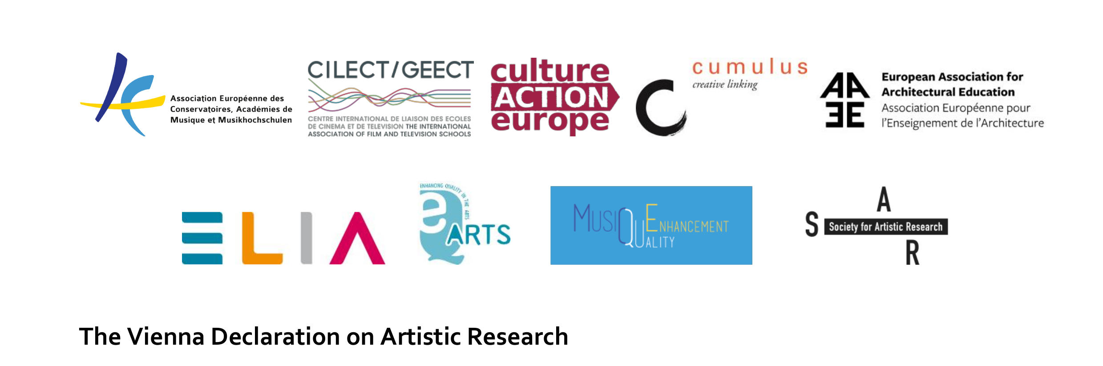
Head of the Vienna Declaration on Artistic Research
Today, however, this type of thinking is no longer what is being expected from artistic research as defined for European higher education. In June 2020, the “Vienna Declaration on Artistic Research” was published by seven European umbrella organizations for higher art education (representing art schools, conservatoires, architecture and film schools), two art school accreditation bodies, the public arts sector organization Culture Action Europe and the Society for Artistic Research (SAR). According to its authors, the Vienna Declaration addresses “political decision makers, funding bodies, higher education and research institutions as well as other organisations and individuals catering for and undertaking AR [artistic research]”. In a critique of the Vienna Declaration I wrote with Nienke Terpsma from the artistic research collective Fucking Good Art, we quoted parts of its text as absurd capitalist-realist poetry:
“Artistic Research (AR) […] has developed rapidly in the last twenty years globally and is a key knowledge base for art education in Higher Arts Education Institutions (HAEIs).” “AR is well suited to inspire creative and innovative developments in sectors such as health and wellbeing, the environment and technology, thus contributing to fulfilling the HEIs’ ‘third mission’. AR must be seen as having a unique potential in the development of the ‘knowledge triangle.’” “Within this frame, AR is aligned in all aspects with the five main criteria that constitute Research & Development in the Frascati Manual.” “HAEIs operate predominately within a research context and have a responsibility to conduct AR. It is also common for HAEIs to interact with related enterprise Research & Development, and to contribute directly to the creation of intellectual property in arts, entertainment and media through research practice.” “This environment requires funding for: educating the next generation of researchers through doctoral programmes; […] building links with business and enterprise in order to stimulate the impact of research.” “AR is validated through peer review covering the range of disciplinary competences addressed by the work. Quality assurance is undertaken by recognised independent, international QA bodies and assures the standards described in the European Standards and Guidelines (ESG 2015) for Quality Assurance in the European Higher Education Area.” “[T]he establishment of AR as an independent category within the Frascati Manual, establishing the opportunity for harvesting research data and statistics from the AR field”.
These quotes may be self-explanatory for my initial diagnosis of artistic research being dead on its institutional arrival. To summarize the core points of our critique: by becoming “AR”, artistic research turns from a speculative and poetic endeavor into a “peer-reviewed” and “validated” affair: “data and statistics” can be “harvested” from it that feed into “enterprise Research & Development”. The Vienna Declaration thus mainstreams artistic research, respectively “AR”, into in almost comically exaggerated neoliberal technocratic agenda, in a way that reminded us of Soviet-era conceptualist poetry – by Vladimir Sorokin, Dmitri Prigov and others – that mimicked and hyperbolized Soviet bureaucratic language.
Most remarkably, the Vienna Declaration does not contain a single mention of “artist” or “artists”. Nienke Terpsma and I therefore read the document as a “land-grabbing” attempt of art schools “to own and define artistic research”. The idea of artistic research as an artist-run, self-organized, non-institutional practice seems to be completely alien to the “A.R.” described in the Vienna Declaration. Instead, the European art school system constructs its own, parallel art world through “A.R.” where artistic research projects are no longer created by artists, but by institutions.
Therefore, “A.R.” perfectly fits the New European Bauhaus project that was announced by the European Commission in 2020/21 and whose logo is the following:
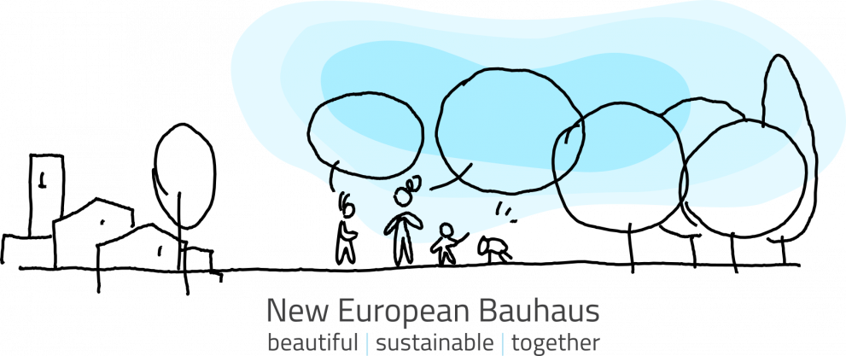
“New European Bauhaus” logo
The verbal and visual languages of “A.R.” and the New European Bauhaus create a stark if not grotesque contrast to practices like those of JaF and 展銷場 Display Distribute. Peer-reviewed and validated “A.R.” seems to have nothing in common any more with artistic research as defined by Elaine W. Ho and its “crude infrastructure […] playfully highlighting […] banal details of […] circulation” in order to “trace new possibilities for a distributed but self-organized community”. If one compares these two understandings and epistemologies of artistic research, the issue is even greater than that of the semantic shifts between “research”, “Forschung” and “onderzoek”: it is no longer an issue of different research cultures, but whether people actually mean the same thing at all when they use the word “artistic research”.
“Artistic research” then almost becomes a riff on John Locke’s inverted spectrum argument, with two people perceiving colors on opposite spectra (one seeing red as green and the other seeing green as red), but still referring to them with the same words, because they have no insight into each other’s sensory perception. I am mentally picturing a sitcom where representatives of an Indonesian DIY collective meet art school managers and, throughout the show, perfectly misunderstand each other talking about artistic research and believing that they mean the same thing. If “artistic research” becomes even more of a McGuffin than “research” already is, it may end up becoming an object, instead of a characterization, of such poetic transactions as 展銷場 Display Distribute’s “LIGHT LOGISTICS”.
Perhaps it’s time for a more fundamental critique. “Research” – which from Jarry’s ’pataphysics to JaF’s tanah research was an emancipatory project for artists and non-artists – may need to be revisited in the same way as other enlightenment and modernist tropes: as concepts that are broken, and in the worst case even “toxic and beyond reappropriation”, to quote Sven Lütticken’s critical revision of the term “autonomy”. Then, the “post-research condition” would become a very literal and practical matter.
From ’pataphysics to LIGHT LOGISTICS, artistic research has, on the other hand, always amounted to a “post-research condition”. When institutions retrofit it into a mainstream academic research epistemology, they may think that they are emancipating the arts. In reality, however, they rather seem to emancipate themselves from them.

Bibliography
AEC, et al. The Vienna Declaration on Artistic Research. 2020, https://cultureactioneurope.org/files/2020/06/Vienna-Declaration-on-AR_corrected-version_24-June-20-1.pdf. Accessed March 1st, 2021.
Cramer, Florian, and Nienke Terpsma. “‘Quality Assurance […] Assures the Standards Described in the European Standards and Guidelines (ESG 2015)’ – and What Else Is Wrong with the Vienna Declaration on Artistic Research.” OPEN!, 2020, https://www.onlineopen.org/what-is-wrong-with-the-vienna-declaration-on-artistic-research. Accessed March 1st, 2021.
Display Distribute. Packaging as Propaganda: On Circulation, New Psychogeographies, and the Discursiveness of Boxes. Het Nieuwe Instituut, 2020, https://research-development.hetnieuweinstituut.nl/en/activities/collective-material-practices-critical-times. Accessed March 1st, 2021.
Frayling, Christopher. Research in Art and Design. Royal College of Art, 1993.
Huang, Jingyuan. “An Invitation to Describe: Elaine W. Ho.” Bajia, no. 2, July 2018, pp. 79–86.
Jatiwangi art Factory. “+ WE ARE.” Tumblr, 2021, https://jatiwangiartfactory.tumblr.com/are. Accessed March 1st, 2021.
Jorn, Asger. “Notes on the Formation of an Imaginist Bauhaus.” Bureau of Public Secrets, 1957, http://www.bopsecrets.org/SI/bauhaus.htm. Accessed March 1st, 2021.
Jorn, Asger, and Guy Debord. Fin de Copenhague. Bauhaus Imaginiste, https://monoskop.org/images/7/75/Jorn_Asger_Fin_de_Copenhague.pdf. Accessed 3 Jan. 2021.
Jorn, Asger. “Pataphysics: A Religion in the Making.” Internationale Situationniste, vol. 6, 1961, https://www.cddc.vt.edu/sionline/si/pataphysics.html.
Leo, Fernando di. Milano calibro 9. Cineproduzioni Daunia 70, 1972.
Lütticken, Sven. “Neither Autocracy nor Automatism: Notes on Autonomy and the Aesthetic.” Cultural Revolution: Aesthetic Practice after Autonomy, Sternberg Press, 2017, pp. 59–86.
Muntaha, Ismal. Jatiwangi art Factory. Het Nieuwe Instituut, 2020, https://research-development.hetnieuweinstituut.nl/en/activities/collective-material-practices-critical-times. Accessed March 1st, 2021.
Osborne, Peter. Anywhere or Not at All: Philosophy of Contemporary Art. Verso, 2013.
vanhoe, reinaart. Also-Space: From Hot to Something Else: How Indonesian Art Initiatives Have Reinvented Networking. Onomatopee, 2017.
Vis, Dirk. Research for People Who Think They Would Rather Create. Onomatopee, 2021.

For an overview of the former, see (vanhoe).
Exceptions include electronic music and architecture with their long, well-documented history of artistic research in collectives. For contemporary art in the more narrow sense, there is practically no overview literature, with perhaps the exception of (Vis).
With (Frayling) being one of its earliest documents.
A prominent example of the latter is (Osborne).
(Jatiwangi art Factory).
(Muntaha), conference abstract.
(Muntaha), conference video recording, 28:55.
(Muntaha), conference video, 22:05.
https://displaydistribute.com, Accessed 3/1/2021.
Ibid.
(Display Distribute).
(Huang 80).
https://www.hku.nl/en/study-at-hku/hku-college/pre-phd-programme/the-postresearch-condition, Accessed March 1st 2021.
See (Jorn and Debord), (Jorn, 1961)
(AEC et al.).
(Cramer and Terpsma).
Ibid.
(Huang, 80).
This would be also a riff on the plot of Johann Peter Hebel’s 1808 short story Kannitverstan.
(Lütticken, 59): “Autonomy has also gotten a bad name in the field of art. In the United States in particular, the association of the concept of autonomy with Clement Greenberg’s restrictive understanding of modernism has made term seem toxic and beyond reappropriation”.

