Artistic research - dead on arrival?

Research practices of self-organized collectives vs. managerial visions of artistic research

abstract
[My lecture will compare the practices of multidisciplinary art/research collectives to the definition of “A.R.” (“Artistic Research”) in the 2020 Vienna Declaration on Artistic Research written by European art schools. The material, cultural and community-oriented research of artist collectives such as Display Distribute and Jatiwangi Art Factory sharply contrast with the “A.R.” that art schools now claim to own and legitimize through standard means of academic validation. Can these two forms of artistic research still be reconciled? - My examples and arguments draw on the NWO research project ‘Bridiging Art, Design and Technology through Material Practices’ and a critique of the “Vienna Declaration” I co-wrote with Nienke Terpsma from Fucking Good Art (to published in OPEN!).]

Intro
My thanks to Henk Slager and BAK for inviting me. I changed the title of my presentation to “Artistic research - dead on arrival?” because this puts the issue more clearly on the table.
I am here because of my involvement in two different and seemingly unrelated efforts. [slide] The first is a four-year research project with Leiden University, Waag Society, Het Nieuwe Instituut and West Den Haag called “Bridging Art, Design and Technology through Material Practices”, which has been funded by the Dutch Research Council NWO as part of its ‘Smart Culture’ program (to which this conference is related). Two months ago, we organized the conference ‘Making Matters’ [slide] with a number of international artist-research collectives, among them the Otolith Group, Feral Atlas, Display Distribute and Jatiwangi Art Factory. I will talk about the work of the last two groups as contemporary artist-run research practice - but also need to clarify here that here and today, I am purely speaking as an individual, not on behalf of our research project.
[slide] Secondly, with Nienke Terpsma from the Rotterdam-based collective Fucking Good Art, I wrote a critical response to a European policy paper on artistic research, the so-called “Vienna Declaration on Artistic Research”. [slide]
These two subjects may seem different yet are profoundly interrelated - since I can’t think of a bigger discrepancy than the one between the concept of artistic research put out in the “Vienna Declaration” versus the practice of, among others, Display Distribute and Jatiwangi Art Factory. (I could also mention the ruangrupa collective here which is now well-known after its appointment as curators of the upcoming Documenta.)

What is research?
But, before I go into these details, please allow me to zoom out and go back to the question of what we are talking about - namely, what is being understood as “research”. “Research”, like “art”, strikes me as the case of a word whose semantics rely on a superficial consensus that evaporates on closer inspection.
[slide] Even when staying only within Western languages and cultures, we’re not speaking about the same thing. If I only take the three neighboring languages and cultures that are my own daily languages, German, English and Dutch, not even the words are the same: “research” in English, “Forschung” in German and “onderzoek” in Dutch. [slide] In German everything that a scholar publishes is “Forschung”. This includes for example interpretations of Shakespeare poems by a literary scholar, but also the mere publishing of those poems in a critical edition. [slide] Anglophone academia differentiates between “research” and “scholarship” (which wouldn’t be differentiated in Germany). [slide] Here in the Netherlands the term “onderzoek” has a strong semantic bias towards empirical research. It can even refer to investigative journalism and police work. This bias among others manifests itself in the fact that you have to specify data management in every Dutch research funding application.
In film terminology, “research” could therefore be called a McGuffin: a package that is passed along and shared between different parties who may not even have the same idea of what its content is. [slide] It is a word on which two or more parties can reach seeming consensus while having something different in mind. It is thus prone to become a subject of transactions rather than of discourse, or of pragmatics instead of semantics. Here I’m thinking of a semi-famous McGuffin sequence in the 1972 Italian gangster b-movie Milano Calibro 9 in which a suitcase is handed from person to person. The suitcase initially contains money but ultimately turns out to be a bomb that kills the last people receiving it. (I made a timelapse of that five-minute sequence as an animated GIF.)

timelapse of the opening sequence of Milano Calibro 9
[slide] The first literal mention of “artistic research” I am aware of is in Asger Jorn’s 1957 Notes on the Formation of an Imaginist Bauhaus. This text was written in Switzerland, first published in French and later translated into English, so we do not know whether Jorn departed from the word “forskning” in his native Danish (which is derived from the German word “Forschung”) or from French “recherches”, and to which extent his text reflected the prior use of the word “recherche” in, among others, the French Surrealism and its ‘Bureau de recherches surréalistes’ in the 1920s, as well as post-war experimental music groups such as Pierre Schaeffer’s Groupe de Recherches de Musique Concrète founded in 1951.
[slide] Even in this early, geographically and culturally limited, stage, ‘artistic research’ was a speculative and semi-dubious affair, with simultaneous roots in poetic-absurdist science and laboratory experimentation, manifesting itself in such artistic research disciplines as pataphysics and psychogeography .

Display Distribute, Jatiwangi Art Factory
If my historical examples have been Eurocentric, this is structurally tied to the linguistic Eurocentrism of the word “artistic research”. (A word, btw., that is a literal Eurocentrism since the term “artistic research” is much less common in anglophone countries than in continental Europe. I have been told by co-workers of mine from the UK that the word “artistic”, as an equivalent of “artistiek”/“artistique” in French and Dutch or “künstlerisch”/“kunstnerisk” in German and Danish, is much less commonly used in English and even avoided by many artists.)
But how could we characterize today’s artist-run research practices? With Jatiwangi Art Factory (from Indonesia) and Display Distribute (from Hong Kong), I am taking two groups as cases, or traces, of a global phenomenon of self-organized, commons- or community-oriented collectives whose practices are highly localized and internationally connected at the same time, often involve people with mixed backgrounds as artists, researchers, activists, journalists, and often focus on specific material practices that simultaneously function as social experiments.
Jatiwangi art Factory (JaF) calls itself a “community-based organization focused on examin[ing] how contemporary art and cultural practices can be contextualized with the local life in rural area, both form [and] ideas”.
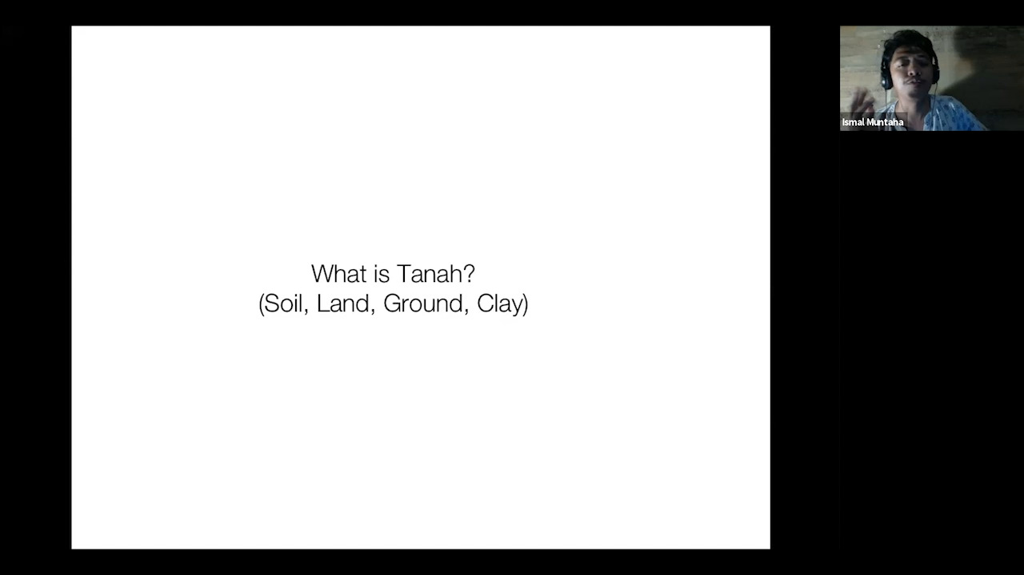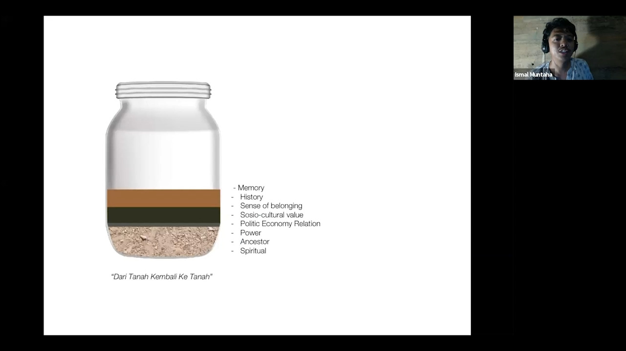
Jatiwangi art Factory combines a residency program with several local festivals. Ismal Muntaha, a founding member of the project, explained at our conference how the JaF’s activities tie into the village’s history as Indonesia’s post-colonial industrial production site for roof tiles, because it is rich with clay or “tanah” which means soil, ground and clay. Jatiwangi art Factory’s work investigates the history and culture of tanah and reactivates it in new forms; “digging again the memories, spiritual value, ritual, proudness, cultivating attitude from our Tanah as local material as a tool of subjectivity”.
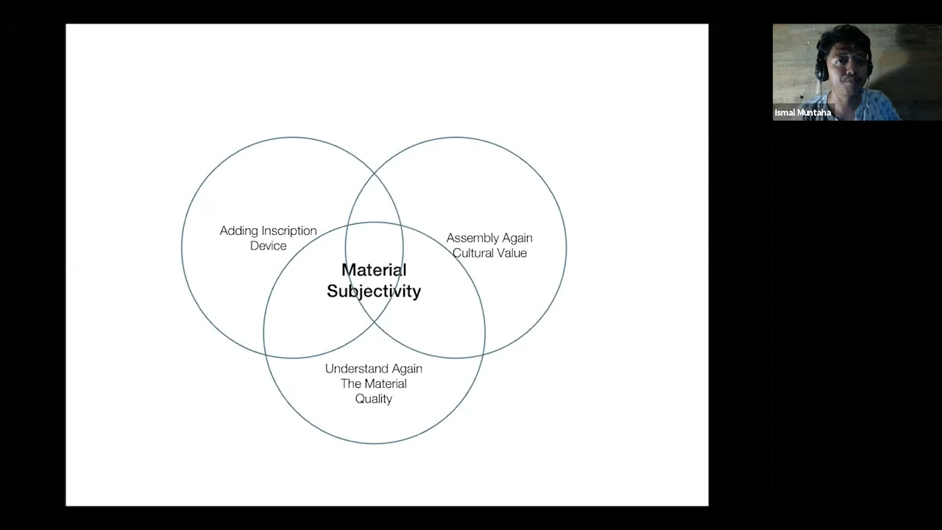
JaF, material subjectivity
[video clip Ismal explaining subproject] - The full video presentation can be seen on the website of Het Nieuwe Instituut in the archive of our conference. [slide]
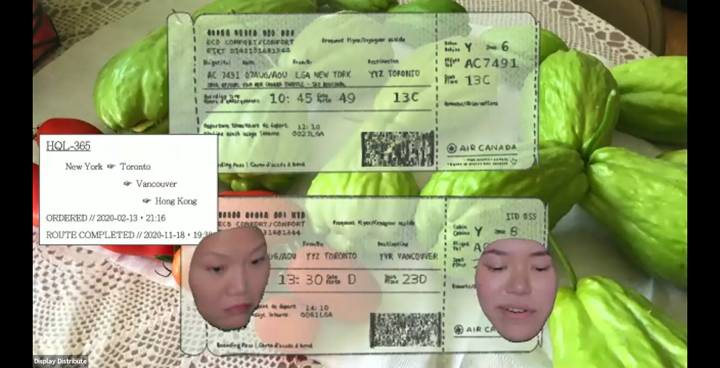
Display Distribute, screenshot from ‘Making Matters’ presentation
Display Distribute calls itself a “now and again exhibition space, distribution service, thematic inquiry, and sometimes shop in Kowloon, Hong Kong”. When interviewed for a Chinese multi-disciplinary arts magazine and asked about her working definitions of “open platform”, “architectures of commerce” and “documentary gesture”, Display Distribute member Elaine W. Ho replied:
“Together, these questions refer to a socio-politics of syntax informing various paths of artistic research. For example, the Light Logistics project with Display Distribute instigates a series of encounters based around the act of reading. We want to support independent publishers whose work contributes to the discourse on grassroots, radical, and critical practices in East and Southeast Asia. Considering the power of reading as a 1:1 form of exchange, there is still something to be said for kindling these small moments of encounter between individuals with similar interests or that can support by way of coincidental mobility. Setting up this albeit crude infrastructure of a logistical operation makes use of slow couriers’ movement to physically and immaterially transport art, ideas, and practices in ways that may be difficult for independent practitioners otherwise. By playfully highlighting the banal details of this circulation, we want to lay bare the systems of production as they are embedded within the everyday and trace new possibilities for a distributed but self-organized community.”
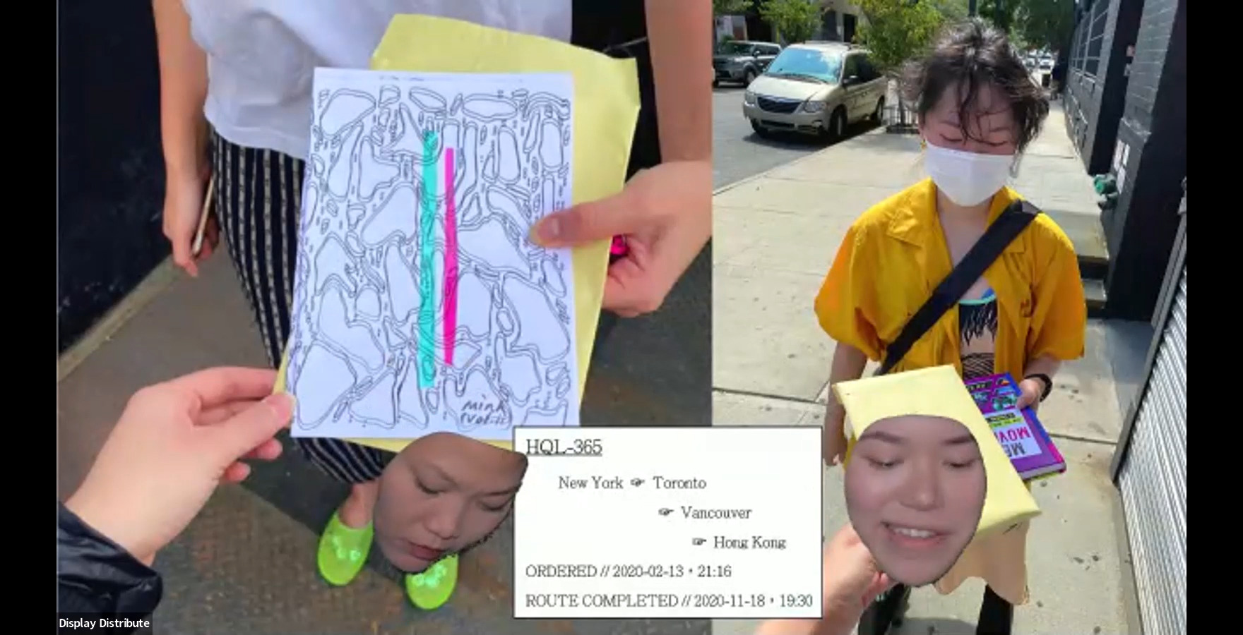
Display Distribute, screenshot from ‘Making Matters’ presentation
This screenshot documents one of the transactions or transports within Display Distribute’s courier system. At our conference, the collective performed a live online theater play “Packaging as Propaganda - On Circulation, new psychogeographies and the discursiveness of boxes”. This video is publicaly available in the conference archive, too, and (as with Jatiwangi art Factory’s presentation) I recommed watching it in its entirety. By literally referencing psychogeography, Display Distribute continue developing the artistic research disciplines that I mentioned before. Their practice is thus also meeting the proposition text for this conference and its characterization of “artistic thinking” as “open-ended, speculative, associative, non-linear, haunting, thinking differently”.

Vienna Declaration
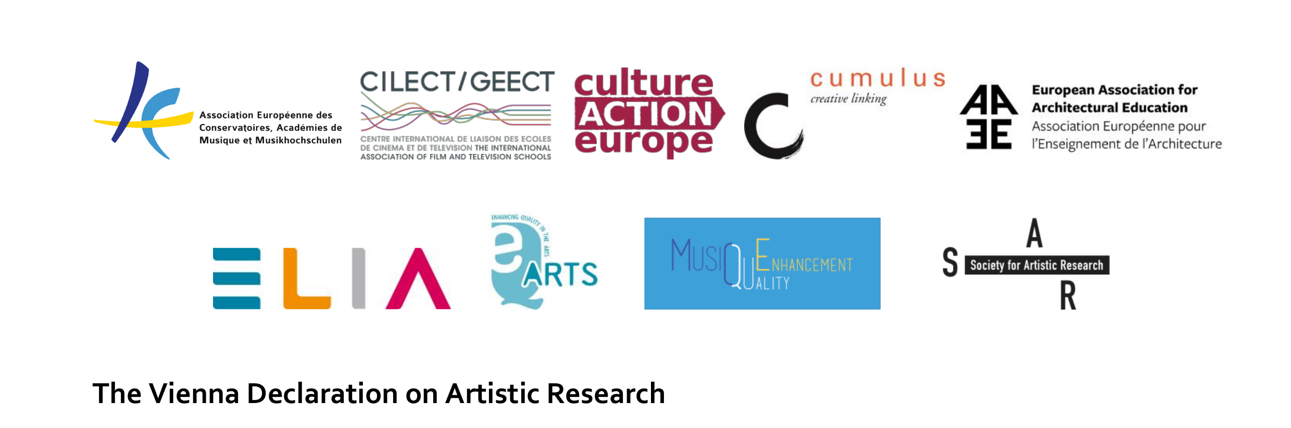
Head of the Vienna Declaration on Artistic Research
Since half a year, however, this type of thinking is no longer what is necessarily being expected from artistic research, at least not if we are speaking about its official framing for European higher education. In June 2020, the “Vienna Declaration on Artistic Research” was published by seven European umbrella organizations for higher art education (representing art schools, conservatoires, architecture and film schools), two art school accreditation bodies, the public arts sector organization Culture Action Europe and the Society for Artistic Research (SAR). According to its authors, the Vienna Declaration addresses “political decision makers, funding bodies, higher education and research institutions as well as other organisations and individuals catering for and undertaking AR [artistic research]”.(footnote: https://cultureactioneurope.org/news/vienna-declaration-on-artistic-research/). Since I don’t have the time to read the “Vienna Declaration” in its entirety - although this would be a worthwhile conceptualist performance of capitalist-realist poetry -, I will just quote a few core passages: [slide]
“Artistic Research (AR) […] has developed rapidly in the last twenty years globally and is a key knowledge base for art education in Higher Arts Education Institutions (HAEIs).” “AR is well suited to inspire creative and innovative developments in sectors such as health and wellbeing, the environment and technology, thus contributing to fulfilling the HEIs’ ‘third mission’. AR must be seen as having a unique potential in the development of the ‘knowledge triangle.’” “Within this frame, AR is aligned in all aspects with the five main criteria that constitute Research & Development in the Frascati Manual.” “HAEIs operate predominately within a research context and have a responsibility to conduct AR. It is also common for HAEIs to interact with related enterprise Research & Development, and to contribute directly to the creation of intellectual property in arts, entertainment and media through research practice.” “This environment requires funding for: educating the next generation of researchers through doctoral programmes; […] building links with business and enterprise in order to stimulate the impact of research.” “AR is validated through peer review covering the range of disciplinary competences addressed by the work. Quality assurance is undertaken by recognised independent, international QA bodies and assures the standards described in the European Standards and Guidelines (ESG 2015) for Quality Assurance in the European Higher Education Area.” “[T]he establishment of AR as an independent category within the Frascati Manual, establishing the opportunity for harvesting research data and statistics from the AR field”.
These quotes may be self-explanatory for my diagnosis of artistic research being dead on its institutional arrival. I mentioned before that Nienke Terpsma and I wrote a critique of this pamphlet that has been published online by the arts journal OPEN!, so I will just summarize our core points: In the Vienna Declaration, artistic research turns into “AR”, and from a speculative and poetic endeavor into a “peer-reviewed” and “validated” affair. “Data and statistics” can be “harvested” from it, which feeds into “enterprise Research & Development”. In other words, the “Vienna Declaration” mainstreams artistic research, respectively “AR”, into in almost comically exaggerated neoliberal technocratic agenda (in a way that reminded us of the Soviet-era conceptualist poetry that exaggerated Soviet bureaucratic language).
Even more importantly, and not coincidentally, the Vienna Declaration does not contain a single mention of “artist” or “artists”. Nienke and I thus read it as “land-grabbing” by art schools “to own and define artistic research”. The idea of artistic research as an artist-run, self-organized, non-institutional practice simply does not exist in the Vienna Declaration. Instead, the European art school system constructs its own, parallel art world through “A.R.” where research projects are no longer defined by artists, but by the institutions themselves. [We wrote that it “reframes artistic research as a top-down practice where projects, subjects and research questions are formulated by academic institutions and artists need to fit into pre-defined projects and calls, forms, formats and methods”.]

Clash of cultures
“A.R.” thus seems to perfectly fit the vision of the New European Bauhaus that has been recently declared by the EU (see images), and whose logo is the following [slide]:
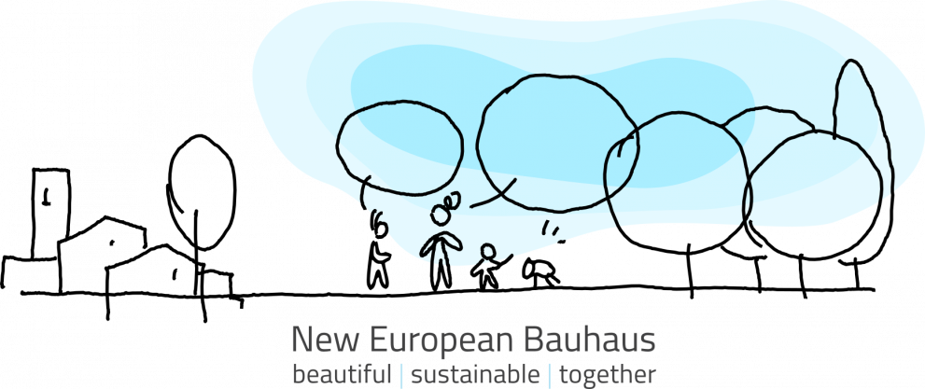
“New European Bauhaus” logo
Both in language creates a stark if not grotesque contrast to the practice of, for example, Display Distribute which defines its artistic research as “crude infrastructure”, “playfully highlighting […] banal details of […] circulation” in order to “trace new possibilities for a distributed but self-organized community”. If we compare the research practice of Display Distribute, Jatiwangi Art Factory and other mixed-disciplinary self-organized collectives with “A.R.” as defined in the “Vienna Declaration”, the question actually is whether we are still talking about the same thing at all.
One could imagine a sitcom with representatives of an Indonesian DIY collective in dialogue with European art school managers, with both perfectly misunderstanding each other while seemingly talking about the same subjects. At this point, not only is “research” a McGuffin. Its subset “artistic research” has turned into a McGuffin, too: a floating and merely transactional signifier (and thus a potential object for, but not longer a characterization of Display Distribute and its “light logistics”).
But on a more fundamental critical level, “research” - which from Jarry’s pataphysics to Display Distribute’s Light Logistics was an emancipatory project for artists and non-artists - now needs to be revisited in the same way as other enlightenment and modernist tropes such as “autonomy”: namely, as concepts that are broken, and in the worst case even “toxic and beyond reappropriation” (to quote from Sven Lütticken’s critical review of the term “autonomy”). Then indeed, the “post-research condition” would become a very practical matter.
On the other, one could argue that from pataphysics to light logistics, artistic research has never constituted anything but a “post-research condition”. When institutions retrofit it into a mainstream research epistemology, they are only pretending to emancipate the arts. In reality, they are busy with emancipating themselves from the arts, because that field has become too small to support them.

Jorn reflected on both, in the psychogeographic “atlases” he jointly made with Guy Debord, and a critical essay on pataphysics as “a new religion in the making” for the journal of the Situationist International.
https://displaydistribute.com/
An Invitation to Describe Elaine W. Ho, Bajia Issue 2, July 2018, p. 80
https://www.hku.nl/en/study-at-hku/hku-college/pre-phd-programme/the-postresearch-condition
https://www.onlineopen.org/what-is-wrong-with-the-vienna-declaration-on-artistic-research
Riffing on the plot of Johann Peter Hebel’s 1808 short story Kannitverstan.
Lütticken, Sven. “Neither Autocracy nor Automatism: Notes on Autonomy and the Aesthetic.” Cultural Revolution, Sternberg Press, 2017, p. 59: “Autonomy has also gotten a bad name in the field of art. In the United States in particular, the association of the concept of autonomy with Clement Greenberg’s restrictive understanding of modernism has made term seem toxic and beyond reappropriation”.

