# What is urgent publishing? - Request for Comments (RFC) in art & design education

## [author]

Florian Cramer, reader/research professor in 20th Century Visual Culture/Autonomous Practices at Willem de Kooning Academy & Piet Zwart Institute, Rotterdam University of Applied Sciences, The Netherlands

## Abstract

Publishing is increasingly being challenged through instantaneous social media publishing, even in the fields of scholarship and cultural, philosophical and political debate. Memetic self-publishers, such as the right-wing ‘YouTube intellectual’ Jordan Peterson and his left-wing counterpart Natalie Wynn, seem to tap into urgent needs that traditional publishing fails to identify and address. Does their practice amount to a new form of urgent publishing? How is it different from non-urgent publishing on the one hand and from propaganda on the other? Which urgencies can be addressed by urgent publishing? What is the role of artists and designers in it?

Tags: publishing, social media, memetics, propaganda, urgency, art, design

## publishing as propaganda

To begin with an example: at the end of 2020, the psychology professor and political influencer Jordan Peterson had 3.3 million YouTube subscribers and up to 6.9 million individual views of his videos.[1] Peterson’s political message could be broadly characterised as traditionalist conservatism that resorts to mythology and its (controversial) use in C.G. Jung’s early twentieth-century psychology[2] to back up its opposition to ‘political correctness’ and ‘postmodernism’ (in Peterson’s own words), or, more generally, to feminism and intersectional politics respectively.[3] He effectively continues a discourse that begun in the late 1980s with Allan Bloom’s book *The Closing of the American Mind: How Higher Education Has Failed Democracy and Impoverished the Souls of Today’s Students*, using the same targets and similar arguments. A good example is the video lecture *Political Correctness and Postmodernism* (Peterson, 2017) in which Peterson explains that “political correctness is a paradoxical amalgam of postmodernism, which originated as a form of philosophy and literary criticism, and Marxism or Neo-Marxism”, and – problematically - identifies Michel Foucault and Jacques Derrida as postmodernism’s intellectual leaders.[4] Peterson’s characterisation of postmodernism as a “nihilistic doctrine” is largely in line with Allan Bloom’s earlier remarks on “deconstruction” and other politically conservative critiques of (what could best be characterized as) the left-wing American academic reception of French poststructuralist theory.[5] However, Peterson reaches a much wider audience than Bloom did. *The* *New York Times* even called him ‘the most influential public intellectual in the Western world right now.’[6] Peterson is also popular among those art school students who reject feminist, de-colonial and intersectional curricula. This was epitomised in a meme created by a teacher at Rotterdam’s Willem de Kooning Academy in May 2020:



From the Instagram account wdka.teachermemes

Both Peterson’s YouTube videos and the meme reactions to them could be characterised as forms, and ways, of publishing that meet existing popular demand. On top of that, they are built on formats and networks outside traditional publishing. Even if one doubts Peterson’s intellectual depth,[7] he is­­—whether one likes it or not—the first global YouTube ‘intellectual’—someone who rose to fame through his self-produced YouTube videos, not print publications. Peterson’s YouTubing does not exist in isolation, but is part of a larger ‘Alt-Right’ discourse and network that includes, for example, the former *VICE* journalist and founder of the militant right-wing street fight organisation Proud Boys, Gavin McInnes. (Among others, Peterson appeared in 2016 on McInnes’ YouTube talk show under the headline ‘Prof. Jordan Peterson: “Bloody neo-Marxists have invaded the campuses”.’[8]) Peterson’s videos take up central Alt-Right talking points—such as the ‘manosphere’ view of traditional gender roles, the conspiracy narrative of ‘cultural Marxism’ and the meme Pepe the Frog—normalise them into mainstream conservative discourse, and give his social media audience the feeling that what they otherwise know only through trolling and meme subculture is scholarly sanctioned.

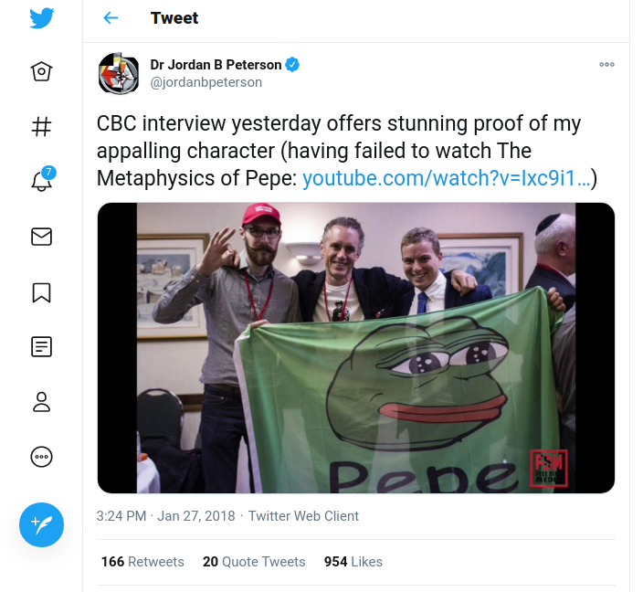

Jordan Peterson (in the middle)

Peterson’s success factors can be summed up as follows:

1. Speed, thanks to the immediacy of YouTube as a publishing medium, in contrast to traditional publishing;
2. Reach, thanks to the ubiquity of YouTube/the internet;
3. Tapping into existing subcultures and popular desires, discourses and concerns (as opposed to scholars, mainstream news media and traditional publishers who are not in touch with them);
4. Partisanship; dividing the audience into either followers or adversaries;
5. Meme-ability; where the quality of a statement lies less in its reasoning or consistency, but its potential to ‘go viral.’

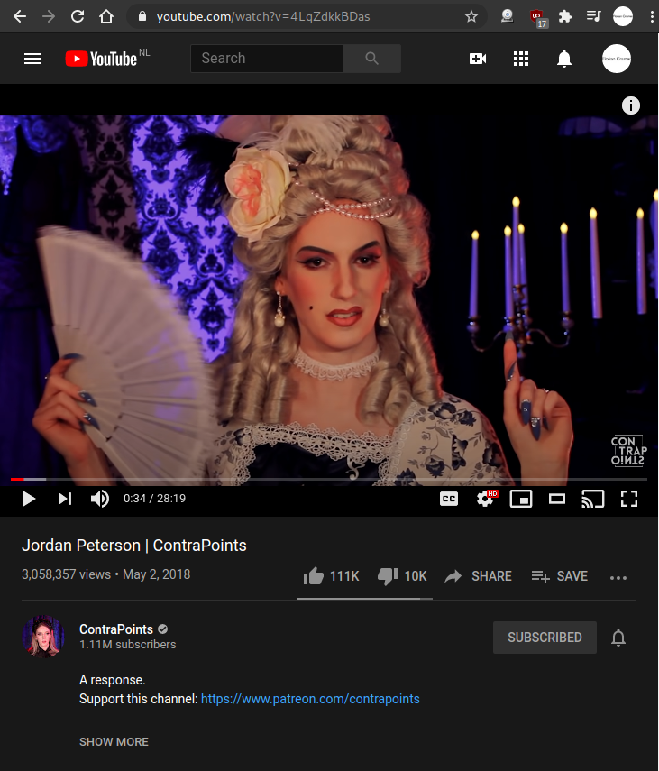

Natalie Wynn, ContraPoints, discussing Jordan Peterson

These success factors also apply to publishers in the opposite political camp, such as the transgender YouTuber Natalie Wynn, who posts her lavishly and elaborately produced videos on issues such as Cancel Culture, gender, and Peterson himself on her channel *ContraPoints*, where they have up to 3.8 Million individual views.[9] From 2017, when the channel was launched, to the end of the 2010s, *ContraPoints* was a rare, if not unique, case of a politically non- and anti-right wing medium using the Internet’s popular visual culture of memes, subcultural slang and social media personalities, in a time when most liberal and left-wing media refused this aesthetic as being propagandistic, “fake news” and tainted by the extreme right. *ContraPoints* thus disproved the popular assumption that “the left can’t meme”.[10]

Do the above five points—speed, reach, tapping into existing subcultures, partisanship, meme-ability—amount to criteria for, or even a definition, of urgent publishing?[11]

All five points are typical characteristics of propaganda—not only the political propaganda of totalitarian regimes but also, for example, anti-Catholic propaganda in the European Reformation age and Counter-Reformation propaganda of the Catholic church.[12] Even visual meme propaganda pre-existed in Reformation and Counter-Reformation propaganda emblems and flyposter caricatures.

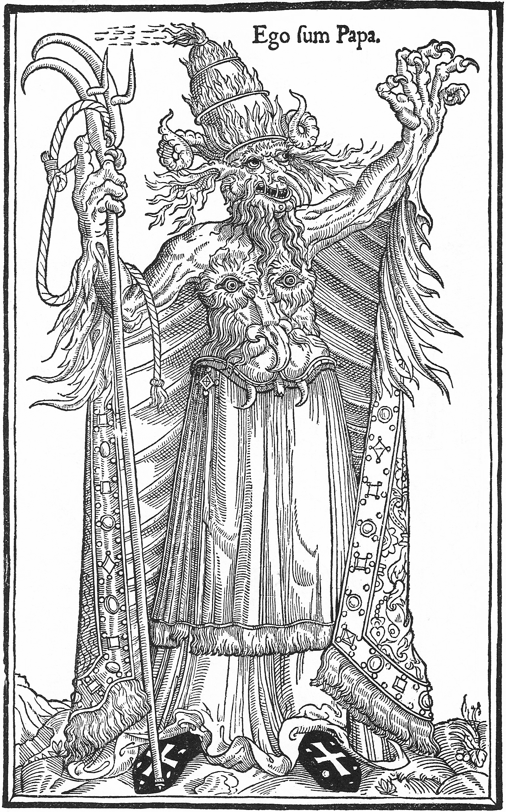

‘I am the Pope.’ -Anti-Catholic meme, sixteenth century.

That the production of propaganda (or counter-propaganda) memes can be a critical publishing practice has been exemplified, among other places, in Berlin Dadaism and John Heartfield’s photomontages of the 1920s:

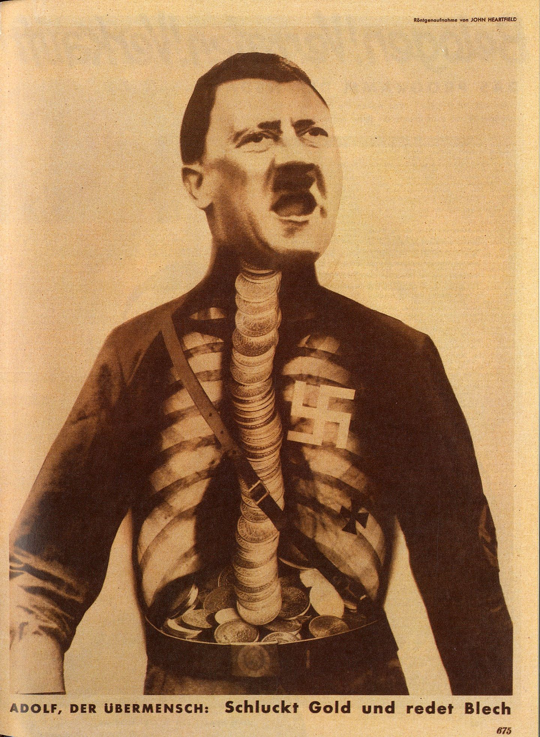

John Heartfield, ‘Adolf, the Übermensch: Swallows gold and talks garbage,’ 1932.

But ultimately, this discussion dates back to the political-philosophical and ethical debate on the validity of rhetoric (as a school of persuasion, seduction and propaganda) versus logic/dialectics (as a school of finding the truth through sound reasoning) that, in Western culture, was first articulated by Plato. In the *Phaedrus*, he concludes that rhetoric can only be justified when it is firmly based on dialectics; when, in other words, it helps to make a logically sound argument more persuasive. Since Plato articulated this position in the period of the decline of Athenian democracy,[13] it has gained new relevance in the present day of globally surging fascist populisms: Is rhetoric, in its contemporary forms of memes and YouTube influencer videos, principally problematic as the language of fake news and “alternative facts”, and is it only acceptable when it helps communicating the truth; a scientific truth that has been established on the basis of logical reasoning by respected authorities? Is democracy being undermined by propaganda, or is it conversely necessary to replace with a regime of experts? These questions have become even more urgent with the Corona crisis, and in that sense, Plato’s questions are surprisingly timely, despite having been articulated 2400 years ago.

This old dispute between dialectics and rhetoric is now being re-enacted, not only as a dispute between traditional politics and publishing media on the one hand and populist politicians and memers/influencers on the other. It also exists in academia as a dispute between analytical philosophy (which continues and radicalizes Plato’s position of logic being the only valid form of argumentation) versus continental philosophy and critical theory (which, in its social-constructivist schools, has rhetoric and subjective experience as its foundations, and argues that truth is never as objective as it seems, but also shaped by social powers). This extends into an opposition of scientific research paper publishing versus popular—and populist—visual culture and social media publishing.

This opposition is most clearly visible in the current societal debate on the Covid-19 pandemic. The (often Alt Right-affiliated) Covid-19 ‘sceptics’ alternatively claim that the virus is not real, that its harmfulness is being exaggerated, that it can be better fought with alternative remedies, and that both quarantine measures and vaccinations are the product of a global conspiracy. Since rational scientific method and logical argumentation seem to be the only way of countering these positions, with rhetoric being—along the lines of Plato—used to support them, the Covid-19 crisis forced continental philosophy and critical theory to either align themselves with analytical and scientific discourse, or to side—like (Agamben)—with the ‘sceptic’ camp and thereby cast doubt on its soundness.[14]

The corresponding question for artists, designers, cultural workers, producers of popular visual culture would be: am I just supposed to create ‘good’ propaganda for knowledge and discourses in whose development I wasn’t involved (but which were created by, among others, virologists and policymakers) in order to amplify, in line with Plato, a given, sound logical argument with persuasive visual rhetoric? Does urgency, and urgent publishing, exhaust itself in that, and thus ultimately boil down to illustration? Will the art schools that educate these visual culture workers and publishers just play their due role in the Dutch and other higher vocational--polytechnical education systems, where they are – according to government policy – supposed to (merely) receive research knowledge from traditional universities and put it into practice, but instead be involved in developing research knowledge themselves?

## rephrasing urgent publishing

To get out of this impasse, and out of being stuck in repeating Plato’s argument, it might help to flip the question of what urgent publishing is: if urgent publishing differs from publishing in general, there must also be non-urgent publishing. But what would be examples and a working definition of non-urgent publishing? And could we use its characteristics to define urgent publishing ex negativo?

The difficulty in answering these questions lies in the nature of urgency: it is neither set in stone nor universal. If one chooses, for example, telephone books as a seemingly evident form of non-urgent publishing, one would overlook the fact that a telephone book may be a literal life-saver for a person in a particular situation (such as: finding an emergency number while having no internet access). Conversely for visual culture producers, receiving a design commission for telephone books may be of critical financial importance.

The non-urgency of a publication can perhaps best be defined as a situation in which the urgency for the creator is not the same as for the reader; where, in other words, no communal urgency defines a publication and the act of publishing. A PhD thesis, for example, always has individual urgency—that of gaining an academic title and qualification—but not necessarily communal urgency, i.e., if the urgency of the thesis exhausts itself in obtaining the title, but otherwise it remains virtually ignored in some university archive. On the other hand, a zine written out of personal urgency (such as, for example, struggling with a queer coming out) and published in an edition of five copies with the hope of finding only one person who shares the publisher’s feelings is defined by communal urgency.

In art and research publishing, most forms of ritualistic publishing are non-urgent in the above sense: while they are urgent for individuals or a project group to retroactively legitimise their work, that urgency is rarely communal in the sense of being shared outside their own project. Publications that are made out of institutional logic and legitimation, but for which there is no wider community urgency, include the majority of catalogues, research papers, conference proceedings, academic journals that primarily serve scholars’ needs to meet ranking and evaluation criteria, as well as showcase, prestige and other PR publications, no matter if these are books, periodicals, blogs, podcasts or YouTube videos.

In unsubsidised commercial publishing, any book or periodical that is primarily a coffee table publication, or any other publication to be shelved away after, at best, a superficial reading, is by definition non-urgent. While non-urgent publications of any kind may still gain urgency in future contexts and circumstances, in most cases they were not developed from and with a larger community and its self-defined urgent issues and articulations.

Therefore, successful propaganda is always urgent publishing; but not all forms of urgent publishing are propaganda.

When revisiting the previous five criteria of speed, reach, tapping into existing subcultures, partisanship and meme-ability with a focus on communal urgency, the picture—and definitions—become more nuanced:

1. While urgency always somehow implies speed, or at least timeliness, the corresponding criterion for communal urgency cannot be quantitative but needs to be qualitatively measured (and could, in some cases and situations, even entail intentional slowdown and delay): in other words, the criterion is *responsiveness* rather than merely speed.
2. Likewise, reach needs to be a qualitative, rather than quantitative, criterion when applied to communal urgency, in the sense of a publication (or an act of publishing) that actually reaches the community for which it is meaningful.
3. Instead of merely tapping into existing subcultures and their desires, the publication and the act of publishing emerges from communities and their needs.
4. While partisanship is not necessarily the criterion or intended effect of a publication in its intended community—or, put differently: reaching a community does not need to mean alienating others—but *identification* remains crucial.
5. Meme-ability, while being helpful as urgency metrics, depends on the particular community and discourse for which the act of publishing and the publication is meant. While a meme that goes viral is urgent publishing by definition, not all forms and acts of urgent publishing are viral memes; but at least they spread ‘peer-to-peer’ within their communities.[15]

To avoid misunderstandings: these five modified criteria do *not* amount to criteria of ethically ‘good’ communal urgent publishing versus ‘bad’ propaganda publishing. For example, both Jordan Peterson’s and Natalie Wynn’s/ContraPoints’ YouTube videos fulfil not only the five criteria of propagandistic urgent publishing but also those of communal urgent publishing through their combination of propaganda-style meme tactics and psychological self-help. Even a crass Neo-Nazi propaganda website like *The Daily Stormer* ticks all the above boxes, which may explain why it has been more successful than more traditional Neo-Nazi websites; the same, of course, is true for image boards like *4chan* and *8chan*/*8kun* and the ‘QAnon’ conspiracy myth that emerged on them.[16] All these examples fulfil all five criteria of propaganda urgent publishing as well as at least two of the five criteria of communal urgent publishing; or, more precisely, they work as propaganda catalysts for communities which further elaborate those stories, visuals and memes in communal acts of urgent publishing.

## the larger picture

In all the above examples, the notion and definition of ‘publishing’ was kept deliberately broad. This is, in my opinion, necessary for opening up space for radical imaginations and re-imaginations of publishing in times of fundamental changes in media, communication and visual culture; re-imaginations in which artists and designers need to play a role. The urgent publishing of the Berlin Dadaists broke with fine art and materially engaged with the urgent publishing media of their time—newspapers and tabloids, which in the 1920s often appeared with three issues per day, and political leaflets—re-imagining these both in form and content. ContraPoints is doing (structurally) the same with today’s YouTube propaganda.

Publishing, then, includes any act of making something public—including street interventions and performances and low-resolution meme images, for example[17]—but one that, in most cases, travels over a distance and can be archived. Aside from these technical characteristics, publishing has informational and educational aspects. This includes the use of internet meme images and YouTube videos as educational resources for self-study,[18] which explains Jordan Peterson’s and Natalie Wynn’s respective success. Major intellectuals and philosophers of the twentieth century, including Walter Benjamin and Hannah Arendt, published mainly in journalistic periodicals after their academic careers had been cut off, which was unfortunate for them personally but not for their readership and for the public role of the humanities. Other philosophers (from Adorno and Heidegger to Slavoj Žižek and Judith Butler) followed suit by lecturing on radio and television and publishing in newspapers, but to date have remained stuck in these classical editorial mass media.

An early example of memetic urgent propaganda publishing were the controversial ‘Zeitgeist’ videos published on YouTube from 2007 to 2011 by the designer and activist Peter Joseph. Originally produced in close neighbourhood to the later Alt-Right personality Alex Jones’ *Infowars* (by reusing entire segments from Jones’ documentary *Terrorstorm*), they spun a conspiracy narrative and ‘post-scarcity’ economic vision that instigated a homonymous ‘Zeitgeist movement.’ In 2011 and 2012, Zeitgeist activists played central roles in the Occupy movement, both in New York and Europe. Zeitgeist may, therefore, be called an early (or perhaps even, the first) example of internet-based theory construction in which memetics and viral success acted as editorial filters and thus replaced peer review.

This form of urgent publishing has created a problem for academics, artists, designers and journalists who have not been educated or trained in this system and logic, but in peer reviews, group critiques, editorial boards and institutional curatorship. The political takeaway of the 2016 Trump elections, that ‘the left can’t meme,’ could at that time be rephrased as ‘artists, designers and academics can’t meme.’ Both are no longer true if one looks at contemporary political activism—with *ContraPoints* being just one example—or, in the Netherlands, at the anonymous meme accounts run by students and teachers of particular art schools, such as ‘wdkamemes’ and ‘wdka.teachermemes’ for The Willem de Kooning Academy Rotterdam (the first picture in this article was taken from the latter) and ‘kabkmemes’ for the Royal Academy of Art, The Hague.

The examples and definitions of urgency I used to this point included societal and political urgency, personal urgency and (in the case of Zeitgeist and Occupy) economic urgency; but they should also include—among others—aesthetic urgency (for which tattoo culture is a good example of an urgent publishing practice) and technological urgency (with, among others, Free/Open Source software as a form of urgent publishing).



Still from René van Zundert’s documentary ‘Thuisprikkers’ (‘Home Tattooers’), showing a self-taught, unlicensed discount tattoo artist running his home studio in Rotterdam’s Tarwewijk.

In both arts and design and in academic research, there is a lack of courage for *not* doing something because it either lacks urgency or addresses an issue in a structurally wrong way. A good example for such courage is, in my opinion, the 2012 social design project ‘WIJkonomie’ (a pun on ‘we-conomy’ and ‘neighbourhood economy’) in Rotterdam’s economically disadvantaged neighbourhood Tarwewijk. The architects Theo Deutinger, Stefanos Filippas, Elisa Mante and Ana Rita Marques had been hired to improve local conditions, but gave up after having researched the area:

‘Four architects spending two months of thinking about Tarwewijk and spending three weeks physically in Tarwewijk does not make any difference. The people of Tarwewijk have seen a lot of people like us come and go. Well-educated groups with high-flying plans, spreading hope for a prosperous future. When they are gone, life in Tarwewijk is more miserable than before. All expectations and trust by the people of Tarwewijk did disappear with the people foreign to the place.

Tarwewijk does not need us to know what to do; Tarwewijk knows exactly what to do. Do it yourself Tarwewijk! We propose a project stop, a concept stop and a subsidy stop for initiatives from outside of Tarwewijk. The people of Tarwewijk know how to do things; they know how to start a business, they know how to work around regulations. We trust in the power of the people in Tarwewijk.’[19]

This example shows how urgency, and one’s true capability of living up to it, is an important self-evaluation criterion. For less experienced people, however, it could also be suffocating. Art and design educators are faced with the dilemma that they want and need to foster urgent work (as opposed to art and design that is, for example, just complacent and decorative), but at the same time need to give room, especially in undergraduate education, for ‘pre-urgency’: the opportunity for students to develop their voice and experiment without urgency as a hard requirement. Correspondingly, there can be ‘post-urgency’ in works of artists and designers. Examples could include Andy Warhol, who—after enabling a queer and underground community in his Factory period and surviving Valerie Solanas’ gun assault—became a high-society artist who factually printed his celebrity portraits as money; or Nam June Paik, who resorted, after having radically deconstructed and re-imagined electronic mass media in the 1960s and 1970s, to building decorative video sculptures, which allowed him a better lifestyle than the unheated lofts that had ruined his health.

The crisis of traditional publishing and media industries may be explained with the high amount of non-urgent publishing it involves, while urgent publishing conversely moved on to other channels (including memes, YouTube, zines). And, to clarify again, ‘urgent publishing’ by itself does not say anything about the quality, let alone the ethics, of a publication or act of publishing; it only describes its performativity.[20] The subject matters and visual-cultural language of YouTube ‘truthers,’ Covid-19 deniers and trolls of any kind are urgent, otherwise they would not find their audiences—and the subscriber numbers of even semi-obscure YouTubers would not exceed those of large newspapers by a factor of ten and more.

When I moved to the Netherlands in 2006, before the financial crisis and the slashing of Dutch public art funding, I subjectively experienced most contemporary Dutch art— particularly what could be seen at art schools graduation shows—as lacking urgency and tending to be visually decorative.[21] The unfortunate and perhaps perverse logic of social, economic and political crisis and divides is that they re-instill urgency into arts and publishing practices, as the aforementioned examples from the Weimar Republic to Trumpist America demonstrate. In these times, the criteria I proposed for a working definition of urgent publishing—responsiveness, reaching intended communities, emerging from communities and their needs, fostering identification, and (to some extent) spreading virally—will hopefully become subject to discussions, critique, improvement and alternatives.

# References

Agamben, Giorgio. “L’invenzione di un’epidemia.” *Quodlibet*, 2020, https://www.quodlibet.it/giorgio-agamben-l-invenzione-di-un-epidemia. Accessed 17 Nov. 2020.

Bloom, Allan. *The Closing of the American Mind: How Higher Education Has Failed Democracy and Impoverished the Souls of Today’s Students*. Penguin Books, 1988.

Brooks, David. “Opinion: The Jordan Peterson Moment.” *The New York Times*, 26 Jan. 2018. NYTimes.com, https://www.nytimes.com/2018/01/25/opinion/jordan-peterson-moment.html. Accessed 17 Nov. 2020.

Cramer, Florian, and Wu Ming 1. “Blank Space QAnon. On the Success of a Conspiracy Fantasy as a Collective Text Interpretation Game.” *GIAP*, Nov. 2020, https://www.wumingfoundation.com/giap/blank-space-qanon/.

Crenshaw, Kimberlé. *On Intersectionality: Essential Writings*. The New Press, 2019.

Deutinger, Theo. “We Don’t Trust You Architects - Review on the WIJkonomie Project for Tarwewijk in Rotterdam.” *TD Architects*, http://td-architects.eu/. Accessed 17 Nov. 2020.

Diederichsen, Diedrich. *Körpertreffer: Zur Ästhetik der nachpopulären Künste*. Suhrkamp Verlag, 2017.

Know Your Meme. “The Left Can’t Meme.” *Know Your Meme*, 2018, <https://knowyourmeme.com/memes/the-left-cant-meme> . Accessed 15 Feb. 2020

Lyotard, Jean-Francois. *Postmodern Condition: A Report on Knowledge*. Translated by G. Bennington and B. Massumi, Manchester University Press, 1984 (1979).

McGowan, Don. *What Is Wrong with Jung?* Prometheus, 1994.

McInnes, Gavin. “Rebel News. Prof. Jordan Peterson: ‘Bloody Neo-Marxists Have Invaded the Campuses’”. 2016. *YouTube*, https://www.youtube.com/watch?v=X_Kfm_qWpN0. Accessed 17 Nov. 2020.

Jordan B Peterson. *Jordan Peterson - Political Correctness and Postmodernism*. 2017. YouTube, <https://www.youtube.com/watch?v=f5rUPatnXSE>. Accessed 15 Feb. 2020

Peterson, Jordan B. *Jordan B Peterson - YouTube*. https://www.youtube.com/channel/UCL_f53ZEJxp8TtlOkHwMV9Q. Accessed 17 Nov. 2020.

Peterson, Jordan, “Q & A 2019 01 January”. 2019. *YouTube*, https://www.youtube.com/watch?v=mXPmLZRAPSo. Accessed 17 Nov. 2020.

Steyerl, Hito. “In Defense of the Poor Image.” *E-Flux Journal*, vol. 10, Nov. 2009, https://www.e-flux.com/journal/10/61362/in-defense-of-the-poor-image/.

“Trendbeheer”. Trendbeheer.com, 2020, https://trendbeheer.com/.

Van Zundert, René. *Thuisprikkers*. *VICE*, 2012, https://www.vice.com/nl/article/ppjv5n/thuisprikkers. Accessed 17 Nov. 2020.

Wynn, Natalie. “ContraPoints.” *YouTube*, Nov. 2020, https://www.youtube.com/channel/UCNvsIonJdJ5E4EXMa65VYpA. Accessed 17 Nov. 2020.

1. According to the view numbers on (Peterson, 2020). More than three million copies of his self-help book *12 Rules for Life* were sold, according to (Peterson, 2019).
2. I.e., Jungian archetypes. For a comprehensive critique of Jung, see (McGowan).
3. Intersectionality is a form of politics that considers racism, sexism, homophobia and other forms of discrimination and suppression being not as isolated from each other but as interrelated. The term was coined and explicated by Crenshaw.
4. This is a questionable characterization, since philosophical postmodernism began in 1979 with François Lyotard, with Wittgenstein (rather than structuralism) as a theoretical foundation. Conversely, neither Derrida nor Foucault used the term “postmodern” in or for their philosophies.
5. Characterized by (Bloom 235) as follows: “The interpreter's creative activity is more important than the text; there is no text, only interpretation”. Curiously, this describes hermeneutics, in its modern schools, better than deconstruction (which was often seen as anti-hermeneutical). Peterson characterizes “postmodernism” in the same way, as a philosophy that considers meaning infinitely interpretable, although Lyotard’s *Postmodern Condition* is not about this subject. Peterson thus conflates poststructuralism and postmodernism.
6. See Brooks 2018.
7. Since, for example, his take on Jacques Derrida’s deconstruction appears to be superficial at best, at worst not even based on first-hand reading, see the footnotes above.
8. McInnes 2016.
9. According to the view numbers on Wynn’s YouTube page.
10. According to (Knowyourmeme.com), “The Left Can't Meme […] is believed to have been created on /pol/ [a subforum of the website 4chan, ed.] and rose to prominence during the 2016 United States Presidential Election”.
11. A historical footnote: in all these five points, Peterson follows the footsteps of another Canadian scholar and political conservative, Marshall McLuhan (only that McLuhan’s electronic medium was television, not the internet).
12. Cross-reference to the previous footnote: not only was McLuhan a devout Catholic, his ‘global village’ was a literal riff, via James Joyce, on the Pope’s annual prayer ‘Urbi et Orbi’ [‘for the city and the globe’].
13. Leaving aside the issue of Athenian democracy not being a democracy, but an oligarchy, by today’s political standards.
14. Giorgio Agamben is a prominent contemporary philosopher whose works – building up on Michel Foucault – analyze how human life is controlled by political powers. From this background, he argued in 2020 that “[i]t is almost as if with terrorism exhausted as a cause for exceptional measures, the invention of an epidemic offered the ideal pretext for scaling them up beyond any limitation”.
15. A good example being El Paquete in Cuba, a 1TB hard drive of popular movies, TV shows and music that is updated every week and gets copied and distributed across Cuba because of the absence of broadband internet.
16. Covered in more detail in Cramer and Wu Ming 1 (2020).
17. For an early reflection on the digital ‘poor image’ as visual culture production, see Steyerl (2009).
18. Years ago, a theory curriculum coordinator of a Dutch art school told me that she prefers learning cultural theory from YouTube videos to reading books.
19. Quoted in Deutinger (2020).
20. Or, to borrow from Peirce via Diederichsen’s (2017) theory of ‘post-popular arts,’ its indexicality.
21. On the popular contemporary Dutch art blog Trendbeheer, many examples of such art can still be found.