Logistics / Dispatch

緩件號碼 DISPATCH № //
HQL-364

內容 CONTENTS //
黑書眾半年多報

Black Book Assembly More-Than-Half-A-Year-in-Review

出發點 START POINT //
安卡拉
Ankara

到達點 END POINT //
香港 Hong Kong
＋
台中 Taichung
經由 VIA
伊斯坦堡 Istanbul
＋
阿姆斯特丹 Amsterdam
＋
羅特丹 Rotterdam
＋
曼谷 Bangkok

E: for now to get back to you about dispatch HQL-364. So if it's okay for you all to get in touch with Amy for a handover, please go ahead and do so. Attached is an image that Amy took for me of the stack of newsletters so you can see the amount. Of course only take what is convenient for Y.! Please share with her my ogistics@displaydistribute.com e-mail address for communication, otherwise give me hers and I will arrange with her about the documentation and her courier codename for updating the route.

LIGHT LOGISTICS is a person-to-person distribution network enabled by the surplus carrying power of couriers. This is a free but not-in-time service; please allow for adequate lead time for your cargo to arrive. If you are interested in becoming a courier and receiving 12% discount on all publications, please scroll to the bottom of the page.

Guangzhou, 2020-11-03
Rotterdam, 2020-11-04

E: The practical question first: For HQL-364, how many copies would you preferably have brought to Taiwan? Y. wants me to forward to you that she expects to have about 3kgs available capacity in her luggage.

F :Are you familiar with Ulises Carrión projected courier system E.A.M.I.S. ("Erratic Art Mail International System") from 1977? It was preceded by an essay "Mail Art and the Big Monster" in which he wrote:

"Mail art uses as support the postal system — a complex, international system of trans-
port, including thousands of people, buildings, machinery, world treaties, and God
knows what.
The proof that the post is not the medium is that to use it, an artist doesn’t need to
understand how it functions. Even in the utopic possibility that the artist reaches
complete understanding of the system, he cannot control it. [...]
What about the mailing? Then we are not free, we are subject to certain rules estab-
lished beforehand. [...]
Seen from this point of view, mail art is no longer something easy, cheap, unpreten-
tious and unimportant. Mail art knocks at the door of the castle where the Big Mon-
ster lives. You can tell the monster anything you like, according to your experiences
and beliefs. But the fact is that the Big Monster lives and oppresses us. [...]
What or who is the monster I am talking about? Do I mean the postmaster? Post office
clerks? Do I mean the minister of communications? Or, do I mean the technology
they use and control? Do I mean those little, colorful pieces of glued paper that we
must buy every time we post something? To tell you the truth, I do not know exactly
what or whom I am talking about. All I know is that there is a Monster, and that by
posting all sorts of mail pieces, I am knocking at his door."

Here's the EAMIS manifesto:

_________________________________________

An alternative to the official Post Offices.
- The E.A.M.I.S will carry messages in any format cards, letters, parcels, etc, and realised in any medium book, cassette, tape, film, etc.
- The message must reach the E.A.M.I.S office by any way other than the official Post Offices. It can be delivered by the author or by any other person.
- The E.A.M.I.S is free of charge. Any piece, however, intended for delivery should be accompanied by a second copy or duplicate. This second copy or duplicate shall be kept in the archives of the E.A.M.I.S after delivery of the original.
- The E.A.M.I.S guarantees delivery of the entrusted pieces by any means other than the official Post Offices. If for any reason a piece remains 3 years undelivered, it will be sent back to the author by any means other than the official Post Office.
- The E.A.M.I.S will keep on its premises, open to any potential receiver, a stock of yet undelivered pieces. On the other hand, it is not necessary to be a potential receiver in order to visit the archives.
- Mail pieces are accepted regardless of size, country of origin and country of destination.
- The E.A.M.I.S is not responsible for fakes and falsifiers. Every piece from the E.A.M.I.S must carry our own stamps and seals.
- By using the E.A.M.I.S you support the only alternative to the national bureaucracies and you strengthen the international artists community.
Ulises Carrión
(Post Master)
_________________________________________

Guangzhou, 2020-11-10
Rotterdam, 2020-11-11

E: no, I did not know about Ulises Carrión's project, very impressive!

F: My collaborator and friend Goodiepal (musician, one-of-a-kind-person and community activist from Denmark, currently having an exhibition here: https://www.smk.dk/en/exhibition/unboxing-the-goodiepal-collection/) runs a similar courier system where people send postal mail to his mother or grandmother [he doesn't have an e-mail address], friends pick it up and physically deliver it to him wherever in the world he is. His collective ("Goodiepal & Pals") now also runs its own courier/smuggling operation to bring refugees over the EU border in Serbia.
I'm also reminded of Thomas Pynchon's novel 'The Crying of Lot 49' and its underground postal system Tristero.

定量信息 QUANTITATIVE DATA //
大概300份
approximately 300 copies

大概21.5公斤
approximately 21.5kg
慢遞人員 COURIER //
官妍廷 KUAN Yen-Ting
＋
Florian CRAMER
＋
Merve BEDIR
＋
Ruud & Jeannette
van MEETEREN
＋
吳索 Amy S. WU
＋
Jock RHEA & Lara van MEETEREN
物流情況 SHIPPING STATUS //
遞送中 IN TRANSIT

慢遞招募發布
ROUTE REQUESTED：
2020-03-03，18:07

“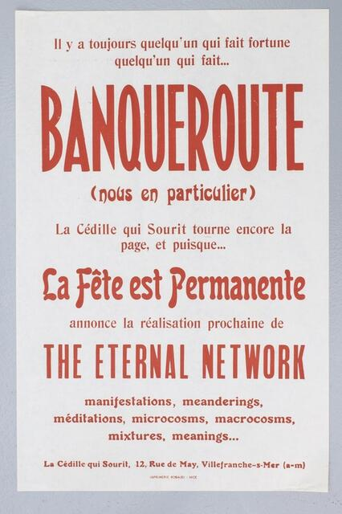

Since the 1970s, Mail Art has been referred to, by its own protagonists, as Mail Art, Correspondence Art, Postal Art and “The Eternal Network”. The latter was a coinage of the French Fluxus artist Robert Filliou from 1961. [... A]“Flux Post” kit designed by George Maciunas, the founder and central organizer of Fluxus [...] included a postcard by Ben Vautier from 1965 on whose sides two different addresses could be entered in order to give the postman the choice of where to send it. (“Postman’s Choice” is also the title of the piece.) In modern terminology, one could call this a network art piece that played with underlying protocols and routing. The first exhibition and catalogue of Mail Art, made in France by the curator Jean-Marc Poinsot in 1971, mostly focused on artists’ individual works that used the postal system as a medium, quite similar to how most video art approached video as an artistic medium.

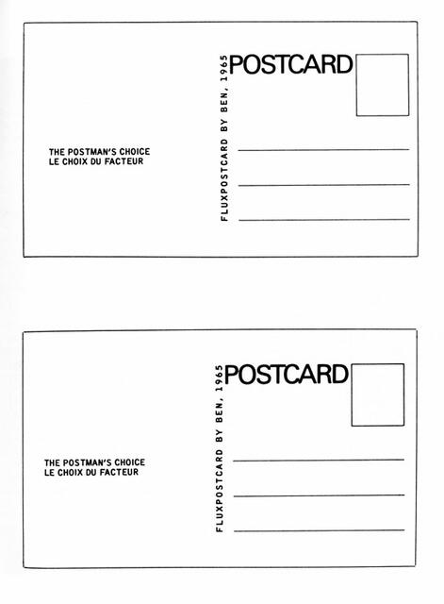
Partly prior, partly in parallel to Fluxus, the artist Ray Johnson maintained a correspondence networks with friends and collaborators, mostly from New York’s contemporary art world. [..] In 1962, the name “New York Correspondence School” was coined for this network. By the early 1970s, it had grown beyond New York and transformed into a larger, international network of artists who primarily worked in and through the medium of postal exchange. [...] From the 1970s onwards, [and through the involvement of such artist collectives as General Idea], the purpose of Mail Art was no longer only experimentation with mail as an artistic medium, but the use of the international postal system for an alternative, self-organized, non-institutional art system that would completely bypass the established art system of the art market, museums, curators, editorial art magazines, criticism and catalog publishing. [...] There was also no distinction between professional artists and non-professional artists, or artists and non-artists: Mail Art was supposed to be a radically democratic system, which is why by the 1980s and 1990s, most of its participants preferred to call it “Eternal Network” (in order to obliterate “art” as a filter and distinction).”

The Eternal Network and its memes, campaigns, spam, trolling, bureaucracies
The main reason why participants left the Mail Art network, however, was not political [in single cryptofascist and antisemitic (ab)uses of its free speech ethos] but “junk mail” as the downside of Mail Art’s radical inclusionism. Many people saw mail art exhibitions and publications as an effortless way of obtaining exposure. Mail Art therefore had a “spam” problem as early in the 1970s that only became worse over the years. [...] Since most Mail Art neither involves any electronic technology, nor any form of automation or formalization of processes, none of the above issues stem from problematic algorithms, biased data sets and resulting discriminatory artificial intelligence. This makes one wonder whether algorithms, filter bubbles and big data aren’t being used as scapegoats for problematic social dynamics.

2020-06-15，16:10 UTC+01：
小型聚會也在荷蘭慢慢恢復，所以慢遞員吳小姐也可以慢慢派送一些給羅特丹本地讀者
As social gatherings return to the Netherlands, small-scale distributions of the last 1/3 of dispatch HQL-364 can be made by courier Ms. WU while in relay in Rotterdam

Guangzhou
Rotterdam
E: that said, much more time to read and dilly dally around in a confined space, so I finally got to read your 'eternal network' paper more carefully, and i guess the main value i can take from this history is to see similar struggles and resonances resulting in similar impulses and tactics, the eternal network here being a kind of affinity ——
F: I am also whether these struggles, resonances and mistakes need to be constantly re-enacted, embodied and repeated by each new generation in order to be fully (i.e. not just in an abstract or disembodied manner) understood; and what could be gained from observing and analyzing both the historical repetitions and differences in those repetitions.

E: though i wonder if it changes anything or similar confines our mail art fandom into the realm of the marginal play... if whatever foresight those projects from the 60s forward have for internet behaviours today, and as you say our pinpointing of AI/algorithms as the evils of the system is misplaced, then how can these intimate and networked actions parasiting off of larger infrastructures really effect anything?

2021-01-19，17:59 UTC+01：
慢遞員CRAMER先生的更新 COURIER Mr. CRAMER's UPDATE：
HQL-364 is currently quarantined in a hotel in Taichung; I hope it's not a major letdown that we have only been able to bag 13 copies because of the bulkiness of Yenting's luggage. My agreement with Amy was that she would give me a large stack of copies and that I would return to her whatever wouldn't fit the luggage. The remaining 62 copies are currently at my home and still need to returned to Amy, who lives nearby. As a special detail, she gave me the copies in a bag of the German drug store chain DM, which was founded and is owned by an anthroposopher (and very popular among Taiwanese tourists visiting Germany, along with the German-made "China-Öl"/"China Oil" remedy on which we both, Yenting and me, are making a zine). Anthroposophy—which was also the belief system and ideology underlying Joseph Beuys' 'social sculpture'—has recently come under closer critical attention since anthroposophers are at the core of the Corona denier movement in Germany and have organized mass protests together with neo-Nazis; I will let you know as soon as the 62 copies have returned to Amy.

F: Maybe that's the problem - that, by focusing on (larger societal) effects, we're unintentionally superimposing growth or impact expectations on these projects while their main value might have been their subjective-collective experience, and functioning as an experiment? (Also in the sense of a radically open experiment with questionable ethical/political outcomes? For example, I was once struck to find the name of Jürgen Elsässer, nowadays the leading extreme right/conspirational/populist publisher in Germany, in a Mail Art anthology from the 1980s.)
E: perhaps this question is naïve and misplaced. anyhow, there are certain murky areas between centralisation and decentralisation that Display Distribute is certainly implicated in... You are right that 'radical inclusivity' does not necessarily garner any momentum, but neither do elitism and the reverse snobbery of oligarchic manoeuvring.

E: And thank you for sharing your paper, have only skimmed it, but the conclusion you end on is quite sad somehow, as in the crux problem of technology as an ideology to improve human life and yet we never solve the real problems of living with one another.

F: This is just based on my own experience of collective projects always failing in the one or the other way. But for me, this still leaves the question how to free oneself from the logic of success vs. failure that ultimately puts such endeavors into deadlocks.

F: [...] In Europe, I also witness the constant failure of artists to truly commit to collective projects and not just use them as platforms for displaying/performing their individual portfolio work.
E: What you mentioned about the failure to really collectivise in Europe is also a problem in Hong Kong and China. When we were invited to participate in the Unlived by What is Seen exhibition in 2014, the curators told us they wanted to include HomeShop as a collective practice because they felt that all the other collectives they saw in China at the time were merely solidarity-for-opportunity kinds of conglomerations, often splitting up when the group becomes famous enough that the individuals can then make their way with solo careers.
So it's no wonder that so many of us have that starry-eyed fascination with the many Indonesian collectives, hahaha, but of course as discussed with my friend Riar in a talk a couple of weeks ago, there are many problems there as well that tend not to get discussed publicly, and that exportation of nongkrong can in some ways be just as much of a selling strategy like anything else.
Re: Yanting (sorry if my romanisation is incorrect, don't have the hang of Taiwanese romanisation, ha), wow, that's really wonderful, thank you so much. What needs to be picked up are the Black Book Assembly newsletters that are currently stationed at Amy's flat, mentioned in our talk, hehe... I think it may be quite a big stack, but of course she doesn't have to take all, just what is convenient for her (anyhow it may not be easy to get them from Taiwan to HK, either, hahah). But if she knows some spaces in Taichung where they may be read, she is also free to distribute a few copies! (a few have been distributed in Taipei earlier this year) We just would like to get a few back in HK at some point because we've already distributed them all out.

2021-01-19，15:21 UTC+08：
慢遞員官小姐更新：「更詳細的信息——我坐了中華航空航班號CL-74，1月10日早上7:02到達台灣；我還是在隔離中，要到25號00:00才被放出來；因為上個星期在台灣有了第一個醫生病例，之後還有他的四個同事也病了，這邊都對於外來的人更謹慎；機場的工作人員都非常有經驗，整個入境過程比較順利——有一個專門的的士安排送從機場來的乘客直接到隔離酒店；酒店處於台中的一本比較中心的位置，離我曾經工作了四年時間（2014-2018）的國立臺灣美術館不遠」
COURIER Mr. KUAN's UPDATE：For more detailed information, I was flying with China airlines flight CL-74 and arrived at Taiwan at 7:02 am, 10th January. Indeed I'm still quarantined and will be free on 25th midnight. As the first doctor got COVID-19 a week ago, and 4 more colleagues of his were later infected, people here are more cautious with travellers from abroad, who are more likely to bring back the virus. The airport staff were all experienced and well-trained regarding the whole arrival processes. I went back to Taichung directly by a special taxi which only takes travellers from the airport to quarantine hotels. The hotel is located in a busy area in Taichung, not too far from the National Taiwan Museum of Fine Art, where I had worked for more than 4 years from 2014 to 2018.
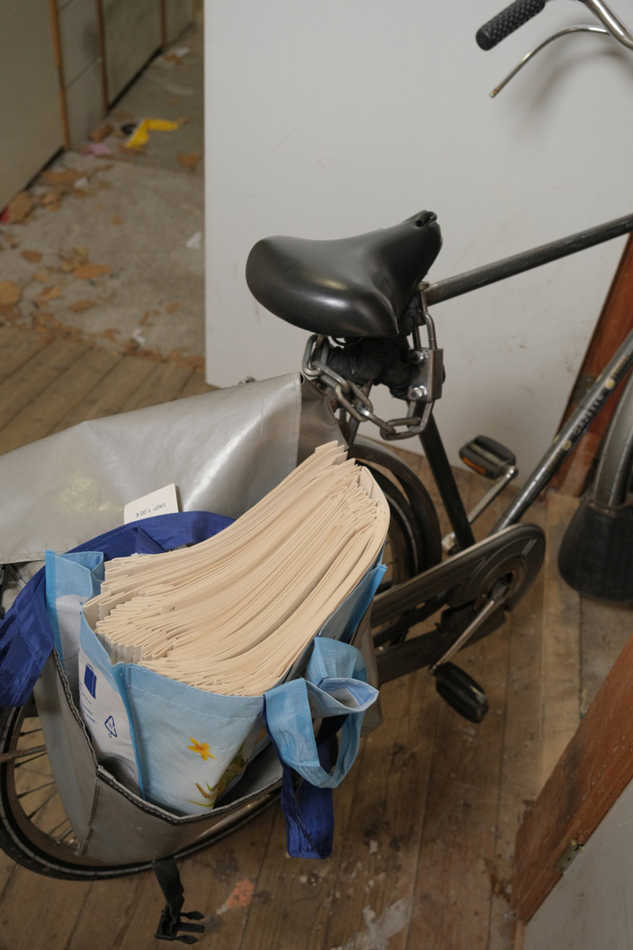

F: Most of the zines from HQL-364 went back to Amy today. I'm enclosing my visual documentation of the transfer (a distance of 1.6km)
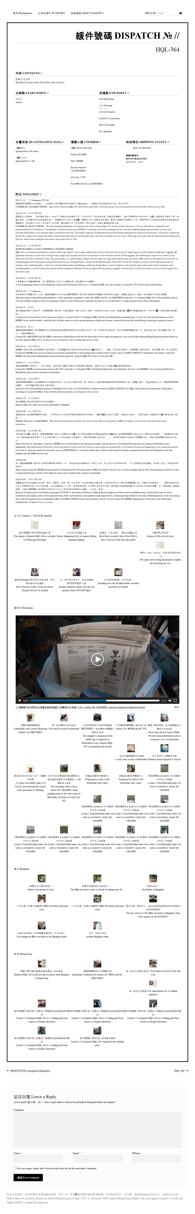
Guangzhou
Rotterdam

E: today i had an interesting conversation with members of the Laboratory of Insurrectionary Imagination and a few others, and JJ mentioned about how when they were doing interventions in the finance district in NY, i think in the early 2000s, and he wanted to learn all about finance as a way to learn how to dismantle the system, but later he changed his mind to think that you don't need to understand the system if you really want to smash it, because it goes beyond reform, that they would want to build up something completely other...

i don't necessarily agree with this thought, though the degree of how much one should understand what one wants to infiltrate, rework, dismantle, etc. needs to be addressed. it's quite interesting that Carrión also premises the ignorance of the artist as part of the premise.

F: Yes, and it is interesting to see how that work that he didn't want to do ended up being done by hacker activists since the 1980s, but not with better results. This, btw., was the logo of the (semi-legendary, still existing) German hacker association Chaos Computer Club:



...a riff on the logo of the German Postal Service:


E: there was a period in my logistics fervour that i wanted to take online courses in industrial logistics in order to understand better, hahaha...
F: I understand that Kate Rich is now doing just that - pursuing a PhD in economics (if I remember correctly; after yesterday night, I don't trust my head any more). Her contribution to the conference next week will be 1:1 business consultations!

E: but perhaps intuitively the scale didn't reach me down in the shadows of our realm... but i have done some cross border parallel trading of cosmetics and milk powder, though!
I guess this is related to the concerns in HK about contaminated milk powder produced in the PRC?
E: is it still the thought that this exchange should find its way into keywords and such? let me know what is still possible or already way beyond the deadline...?



Rotterdam 2020-11-18
Guangzhou 2020-11-17

F: While reading "Getting a Move On: A Logistics of Thought towards Print and Publics", I was also reminded of a discussion on piracy with Raqs Media Collective ca. 15 years ago that taught me about my (and generally Western) biases in perspectives on piracy. Back then, piracy was largely discussed in the context of download culture (with The Pirate Bay, Library.nu/LibGen, aaaaarg & WaReZ servers as the standard examples), but Raqs brought in the perspective of pirated software and DVDs sold on street markets. [I wonder whether that culture and economy still exists. When I moved to my neighborhood in Rotterdam, it was still normal that when you went to a hairdresser, mobile vendors of pirated DVDs would come by and sell you the newest Hollywood films.] Back then, I largely shared the view of the Free Software/Open Source movement that intellectual property should be ended, but that piracy of commercial software ultimately had the effect of keeping the software industry in business, and prevented a mainstream success of Free Software. Raqs, however, argued in favor of considering pirate's work as a form of community care, and addressing real community needs, which then made me rethink my position. (All the more now as Free Software is fully entangled with the big software industry, and has questionable libertarian heritage on top of that.) Nevertheless, I'm still torn on this issue. If one just sticks to the example of digital piracy, then one could argue that The Pirate Bay paved the way for Netflix, LibGen paved the way for Amazon Kindle, and WaReZ servers paved the way for App Stores; not only conceptually or in their user interface design, but also in the 'content' they provided. (I.e. The Pirate Bay offers pretty much the same kind of mainstream films that are offered by Netflix, etc.)

I find it excellent how Display Distribute shifts this whole perspective, and often deadlocked and tired debate, to the question: "‘Who will read it?’". Today, I wrote a paper with an attempt to define "Urgent Publishing", as a wrap-up of a research project of my school in which Clara Balaguer was also involved, and made an attempt to first define urgency through propagandistic-memetic success [taking the example of Jordan Peterson and Natalie Wynn/ContraPoints], and then partly toss this definition, redefine it through communality [i.e. roughly: what is the communal urgency of a publication, as a pact and shared interest between readers and publishers? - with the following proposed five criteria: reponsiveness, reaching one's community, emerging from this community and its needs; creating identification; spreading - perhaps virally - within the community].

E: In a similar way, Stevphen Shukaitis—whom I mention in the Book Society text—is a Marxist anarchist who has been embedded within an Organisation Studies department of the Essex Business School for some years, and he has recently decided to embark upon a second PhD in sports studies to further think through forms of collaboration and organisation that are, in terms of the sports industrial complex, inherently imbricated within corporate sponsorship, spectacle, and media.
I am familiar with his work with Penny Rimbaud (from, among others, Crass)!

Granted, I think there are very few people who can manage to work 'undercover' in this way and not find themselves co-opted by the systems which they were supposed to infiltrate. That's the idealism of politics, isn't it?

F: Yes, and I must say that I am rather disillusioned in this respect, often even appalled by fellow academics. I would prefer (tenured) academics to reflect on their co-optation and complicity, and not to pretend to have an autonomous position. It's rather easy to take a moral high ground if your position is secure.

What I forgot to mention - since you brought up "total football" (originally a Dutch concept from the 1970s, "totaalvoetbal", coined by Johan Cruyff - I should also translate his most
memorable quotes, because they might be inspiring for Display Distribute:
"Every disadvantage has its advantage."
"You're not going to see it until you've figured it out."
"The good cause is not your own cause."
"Football is a game of mistakes. The team that makes the least is the best."
"Football is simple. What is difficult is simple football."
"If you aren't anywhere, you're either too early or too late."
"Coincidence is logical."
"The truth is never exactly the way you think it will be."
"I'm against everything, until I make a decision. Then I'm for it.")

...so what I actually forgot to mention is three-sided-football, which was supposedly thought up by Asger Jorn, but actually practiced by a number of situationist-inspired people in 1990s Britain and later.

2021-02-22，下午 afternoon UTC+08：
慢遞員CRAMER先生的更新：「之前拿的大部分HQL-364的報紙今天還給Amy了；在羅特丹走的路線是1.6公里，照片在附件」
COURIER Mr. CRAMER's UPDATE：Most of the zines from HQL-364 went back to Amy today. I'm enclosing my visual documentation of the transfer (a distance of 1.6km)

F: I'm sorry to write that there's now uncertainty about HQL-364. Y. needed to return home early than planned, on the 9th instead of the 19th, because of tightened quarantine and immigration policies in Taiwan and the uncertainty whether flights will be cancelled (after all flights from the UK to Taiwan got cancelled by the government). I wrote Amy asking her whether she may be back home before the 9th.

E: but thank you for the reminder, as i have to tell myself again and again in so many arenas, to focus upon 'subjective-collective experience, and functioning as an experiment', rather than the unintentional but hard to escape notions of 'superimposing growth or impact expectations', as you say...
F: Yes, but you could also criticize that as a petty-bourgeois hobbyist self-limitation that gives up on the larger picture... All the best, and my apologies for the logistical complications.

