# DIY

## A time machine

The term and concept “Do-It-Yourself” has been (re-)invented several times throughout the 20th and 21st century, retroactively applied to the past, and projected onto the future.

In its most conventional meaning, DIY is a North American term for home improvement, in use since the 1950s. Its close cousin is the French “bricolage” both in its literal, quotidian sense (of “bricolage” hardware shops) and in its wider application to culture.[1]

The most literal meaning of DIY is that of a material practice done by someone without professional training, typically in makeshift (or even crude) ways. In more recent and widened understandings of term, DIY stands for an alternative poetics and aesthetics to industrial capitalism and its products.

## travel b[l]ack

“We was singing in the penitentiary you know  
Singing away the years  
One time we sung the same song for five years  
Next thing I knew, I was home back in the projects”[2]

The song/track/poem *DIY Time Machine* by the Afrofuturist punkexperimental musician and poet Moor Mother (Camae Ayewa) likely originated in the zine and workshop series “Do-It-Yourself Time Travel” of The Afrofuturist Affair/Black Quantum Futurism, an artist project consisting of herself and of speculative science fiction writer and civil rights lawyer Rasheedah Phillips. The zine relates time travel to “Key Features of Time in African Cultural Traditions”, with their concepts of “cyclical” time and of time only becoming “meaningful at the point of the event”,[3] as opposed to Western linear understanding and quantitative measuring of time. With cyclical time, time travel becomes an “everyday” activity naturally present in such activities as “Astrology and Tarot, Mirrors, Thought, Language, Dreams, Music”.[4] Workshop participants are asked to “[r]ecall a memory, then get inside of the memory to actually re-experience it”, to place “‘future’ thoughts, ‘past’ thoughts, and ‘present’ thoughts” in their imagination in order to “[t]ake one of the future thoughts that you have reversed and build up a memory of it” and leave a “message for [one’s] past self”.[5]

This is what also seems to happen in the lyrics of *DIY Time Machine*. The creation of one’s own technology and science outside of what is institutionally recognized as technology and science not only yields a poetic epistemology, but also a poetic-activist tool set. The complete lyrics of the song reflect on slavery and its continuation in wars, inner-city ghettos, wars on drugs and the prison system, through a DIY time machine travel that weaves together different pasts and presents as well as ancestors and present-day people.

In the work of Black Quantum Futurism, time travel - in whatever forms and manifestations, including participatory → workshops - becomes an artistic research method.

## traveling further back & forth

Amy Spencer’s 2005 book “DIY: The Rise of Lo-Fi Culture” begins its long - retrofitted - history of DIY with zines, i.e. photocopied or cheaply printed, non-professionally made, personal micro publications. Their history began in 1930 with the American science fiction zine “The Comet”, a DIY medium in many respects: with hand-drawn covers, typewritten text and inexpensive (low-quality) stencil press printing, and above all Science Fiction stories self-written by fans instead of professional writers (whose short stories were published, in that time, in popular Science Fiction periodicals).

However, zines were not described as a culture of their own before the late 1990s,[6] and not identified with DIY before the punk movement of the late 1970s.[7] The idea that everyone could be a musician by playing only three guitar chords, and that anyone - no matter the skill level - could be a writer, graphic designer, printer, bookbinder and publisher by typewriting, collaging, photocopying and stapling their zine, that any punk was their own fashion designer,[8] turned DIY from only a poetics (in the literal sense of poiesis as → “making”) into a simultaneous poetics, aesthetics and politics.

Precursors of DIY existed in the 19th century Arts and Crafts movement where William Morris not only opposed the industrial revolution in words, but also as a self-taught designer, constructor, typographer and printer. “Do it yourself” became a common term and slogan in 1960s/1970s counter-culture where activists and artists practiced it as a form of social intervention. For example, *Survival Chapbooks* of UK artist/musician/activist Stefan Szczelkun taught how to build one’s own shelter, grow one’s own food and generate one’s own energy. His DIY poetics was straightforwardly continued by the UK artists heath bunting and Kate Rich in the 1990s and has its contemporary equivalent zine series *Self-Reliance Library* made by the Chicago-based Temporary Services collective. Around the turn of the 1960s and 1970s, the artist collective Raindance Corporation turned video art into social activism. Its journal *Radical Software* covered self-made electronics for television broadcasting both on the level of technological equipment-building and contemporary art discourse.

While these examples stand for DIY as an alternative culture outside or next to that of commercial home improvement and DIY superstores, alternative DIY became commodified as early as in the 1970s with the *Whole Earth Catalogue*, its concept of DIY as a lifestyle and product range, and its later transition in the 1980s to home computing, early electronic social media and ultimately the Californian Internet economy.[9] Today, Internet corporations such as Facebook, Twitter and Google have perfected the idea of “user-generated content”, or self-made cultural production, as a source of large-scale revenue and basis of → platform capitalism.

## to 2016

On December 2, 2016, a fire broke out in the *Ghost Ship*, a warehouse building collectively used and inhabited by artists and musicians in Oakland, California. It eventually killed 36 people. Both American news media and residents referred to *Ghost Ship* as a “DIY space”. After the fire, DIY spaces throughout the USA were under scrutiny for their safety. Extreme-right supporters of president Donald Trump on the anonymous web forum *4chan* compiled online lists of these spaces to have them reported and shut down.[10]

As opposed to the more established terms ‘artist-run space’ and ‘artists collective/initiative’, “DIY space” implies no clear-cut separation between artists and non-artists, professionals and non-professionals. The term includes artists of all trades, musicians, community organizers, political activists, squatters, bohemians, artists as well as their audience. “DIY culture” at large has the same connotation: of cultural work that blurs the boundaries between these disciplines and roles, and which can no longer be firmly placed under the moniker “art”, or at least doesn’t fit the concept of fine art.[11]

## time capsule: 1979

The earliest connection between punk and DIY that I could find was made in the British music magazine *Sounds* in early 1981.[12] A possible influence was the album *Do It Yourself* by the punk-influenced rock band Ian Dury & the Blockheads that had been released in 1979.[13] The LP’s cover design used flowery wallpapers as its backdrop, alluding to the fact that the songs were written at Dury’s home.

In punk and other countercultures that preceded it, DIY thus constitutes a poetics and aesthetics, and most importantly, an ethos, of unalienated production and community; ultimately, of removing the difference between “production” and “consumption”. This ethos characterizes the internal contradictions of punk culture which was not only a DIY phenomenon but, since the Sex Pistols, also an industry product and self-declared “swindle” designed by their (Situationism-influenced) manager Malcolm McLaren and fashion designer Vivienne Westwood. The structural struggle of any DIY movement against incorporation into a (creative) industry were thus laid bare in punk.

The DIY ethos suggest that the historical origins of DIY lie in romanticism, particularly the kind of 19th century romanticism that glorified folk culture and, later in Arts and Crafts, self-making as resistance against capitalism and industrial commodification. The close ties between romanticism and nationalism conversely paint DIY as an ethos and politics that may just as well apply to cultural phenomena like militant settlers, colonists and homesteaders and contemporary fascist “sovereign citizen movements” that claim to run their own micro states. A famous blueprint for DIY homesteading is Henry David Thoreau’s 1854 book *Walden; or, Life in the Woods* that inspired anarchist-leaning artists such as John Cage and Jonas Mekas[14] and the “Unabomber” Ted Kaczynski. The latter modeled his life in a cabin after Thoreau’s book. His letter-bombings of high-tech scientists could be interpreted as militant DIY.

The main difference between post-punk DIY and DIY culture from Arts and Crafts to the 1970s is an aesthetic one. While the latter strove for craft and beauty, punk-DIY is post-industrial rather than anti-industrial in its collaging (like Dada in the 1920s) of industrial products, disregard of crafts and skill, and embracing ugliness and crudeness.

## forward to the early 1990s

However, the word “DIY” did not seem to be commonly associated with punk culture until the emergence of the Riot Grrrl movement in the early 1990s on the US-American North West Coast. In Riot Grrrl, music and zine making were - arguably - for the first time equally important, without zines serving the secondary purpose of covering music. In her book *The Archival Turn in Feminism - Outrage in Order*, Kate Eichhorn reconstructs how archiving became a vital part of the movement as well and thus a third pillar of DIY culture. She portrays the initial struggles of its protagonists to come to terms with archiving while identifying as “anti-institutional, DIY, fuck the institution”.[15]

Archiving projects that often exist on the fringes or in violation of intellectual property, exist today as DIY Internet culture. Examples include the websites *Ubuweb*, *Monoskop*, *Memory of the World*, *aaarg*; Kenneth Goldsmith describes their poetics in his 2020 book *Duchamp Is My Lawyer*.[16] Often, these digital DIY archiving projects apply principles of Free Software/Open Source to culture. In this context, Eichhorn points out a discrepancy in cultural capital accumulated by mainstream Open Source software development and Riot Grrrl, although both phenomena began in the same decennium: “Riot Grrrl, which opted out of established publishing and recording venues to embrace a DIY approach marked by a parallel anti-economic mandate, did not necessarily benefit financially or in terms of cultural prestige from its decisions”.[17]

Histories of DIY that focus on its punk legacy, such as Amy Spencer’s, tend to omit hip hop whose early music production technology of scratching vinyl records was born out of poverty and DIY improvisation. The white bias of DIY becomes even more problematic as soon as one doesn’t limit one’s perspective to Western or industrialized countries. Here the question is whether DIY, as a concept, even makes sense in geographical areas and cultures where self-making and makeshift improvisation is not an exception but the rule of everyday life and thus does not make a meaningful difference.

## jump to 2021

The Indonesian artist collective ruangrupa has been characterized as being driven by “a strong DIY ethos”, born out of the necessity of creating one’s own structures in post-dictatorship Indonesia and affinity and vicinity to “punk and street cultures”.[18] Other Indonesia art collectives, such as Wok the Rock, do even more clearly identify with punk culture and political anarchism.[19]

This would not be the first link between contemporary art and DIY. Amy Spencer retrofits the self-publications of Dadaism, Situationism, Fluxus and Mail Art into her history of DIY. In the book *The DIY movement in Art, Music and Publishing*, Sarah Lowdnes goes even farther and extends the notion of DIY culture to include, among others, contemporary art scenes of European cities such as Cologne and Glasgow. This arguably overstretches the term since the local scenes she covers are mostly made up of professionally educated artists, commercial galleries and art institutions. At the same time, it is difficult to differentiate “DIY” from “non-DIY” for an artisanal, non-industrial practice like studio art as long as one only considers its modes of material production and leaves aside other aspects such as education, funding, presentation and distribution.

A radical DIY practice is thus: self-taught, self-built, self-funded, happening in self-organized spaces using self-built infrastructure, with self-organized communication and distribution; where the “self” can be an individual, a collective or a community.

This ultimately makes DIY a practice that is concerned with autonomy. “Autonomy”, when translated literally from Greek to English, means “self-governance”. In the context of artists’ DIY, autonomy therefore describes a poetics instead of an aesthetics, and hence an categorically different concept of autonomy than that of aesthetic philosophy from Kant and Schiller to Adorno and Rancière. Rather than an idealist concept, autonomy becomes a material practice. Or perhaps more precisely: in DIY culture, autonomy is being actively created - and permanently negotiated - in and through the material practice of its community members. Re-applied to art, this means, to quote David Teh’s characterization of ruangrupa, to further “autonomy of artists, singular or plural, but not necessarily that of the artwork”.[20]

## leap into a parallel universe

Between the two extremes of DIY as (a) counterculture and (b) home improvement superstores exists the technological DIY of hacker and ‘maker’ culture. With the boom of fab labs and maker spacers, “DIY” in this particular sense has become its own industry (where, as in the American gold rush, equipment suppliers make most profit).

Hacker/maker culture has traditionally blurry boundaries to countercultural and artists’ DIY on the one hand and to industries on the other hand. For example, the DIY technology instructions of the Raindance Corporation in the 1970s and of Temporary Services in the 2000s could just as well find their home in hacker and maker spaces. But more often, hacker and maker spaces serve as ‘incubators’ for industrial products and commercial spin-offs, or even as a model for small-scale industries. The smaller parts of the Chinese electronics industries in the special economic zone (and world capital of electronics manufacturing) Shenzhen, work in the manner of DIY makerspaces.[21]

This is where → Critical Making enters the scene. In some of its variants, it can mean the reinsertion of a counter-cultural (and even anti-capitalist) DIY ethos into maker culture.

## a trip back to aesthetics

In the different times and spaces we traveled, DIY has been alternatively characterized as a poetics and aesthetics, or even as a poetics instead of an aesthetics.

Although DIY literally describes doing/making/poiesis, a strong DIY aesthetic does, perhaps paradoxically, exist. In order for something to be seen as DIY, it typically must have recognizable outer attributes, such as, in punk fashion, a recycled piece of clothing or a badge, in DIY publishing, handwriting or collage combined with cheap printing processes and uneven hand-binding/stapling, in DIY spaces, recycled and repurposed furniture (which became a fatal fire hazard in the “Ghost Ship’) and industrial ruins, to name only a few (stereo)typical examples. These attributes also explain the inclusion of Dada, Situationism, Fluxus and Mail Art into Amy Spencer’s history of DIY. Fluxus could even be retroactively called a DIY movement if one focuses on George Maciunas’ manifestos for a radically democratic”non-elite, non-parasitic" participatory art, his early focus on cheaply sold, hand-made multiples and typewritten artists booklets, his various attempts of founding artists cooperatives as an alternative economy, and his FluxHouse project that, in the words of Craig Saper, was “entrepreneurial communism” and “functioned like a DIY development corporation”,[22]: two run-down, self-maintained warehouses in New York that provided communal housing and work spaces for artists.

If DIY thus amounts to a poetics of the makeshift and non-expertly self-made, aesthetic imperfection becomes its most recognizable attribute and a defining criterion.

The aesthetic of imperfection in DIY however still differs from older and more established aesthetics of imperfection:

* DIY imperfection differs from the romanticist poetics and aesthetics of the fragment (such as in the works of Friedrich Schlegel and Novalis, and the later gothic romanticism of ruins), in that DIY culture neither understands imperfection as a philosophical reflection of an absolute ideal, nor as an expression of autonomy in the sense of absence of rules for the artist.[23]
* DIY imperfection also differs from the traditional Japanese aesthetic concept of Wabi Sabi - which finds beauty in what seems to be run down or is worn. According to the 20th century novelist and aesthetic theoretician Junichiro Tanizaki, Japanese and Chinese aesthetics does not have an ideal of imperfection, but a different concept of perfection: “As a general matter we find it hard to be really at home with things that shine and glitter. The Westerner uses silver and steel and nickel tableware, and polishes it to a fine brilliance, […] we begin to enjoy it only when the luster has worn off, when it has begun to take on a dark, smoky patina. […] When new it resembles aluminum and is not particularly attractive; only after long use brings some of the elegance of age is it at all acceptable. Then, as the surface darkens, the line of verse etched upon it gives a final touch of perfection”.[24]

Using the terminology of Clement Greenberg and Rosalind Krauss, DIY practices are simultaneously “medium-specific” and medium-unspecific. On the one hand, they are always based on the practical engagement with a specific medium or material (such as: zines/publishing, fashion, music, or a specific technology such as computing in the case of hacker-cultural DIY). On the other hand, DIY practices do not strive for mastery or perfection - as soon as a DIY practice has become mastery, it ceases to be DIY. This in turn differentiates DIY from amateur cultural and artisanal production which typically imitates professional role-models and strives for the level of crafts and perfection found in professional art and creative industries productions.[25] Examples would include amateur remakes of movies like Star Wars, and thus also early zines like *The Comet* that imitated mainstream cultural products. (One could therefore argue that zines became DIY culture only when they stopped being “fanzines”.)

## simultaneous quantum travel to Cologne, 1920, and Berlin, 1982

If Dada and (post-)punk could, retroactively, be seen as two 20th century stations in between 19th century Arts and Crafts and 21st century DIY, then it might be worth to look into a term promoted at its fringes: the “dilettante”, or in its 1982 punk misspelling, “dilletante” (literally meaning “dill aunt” in German):

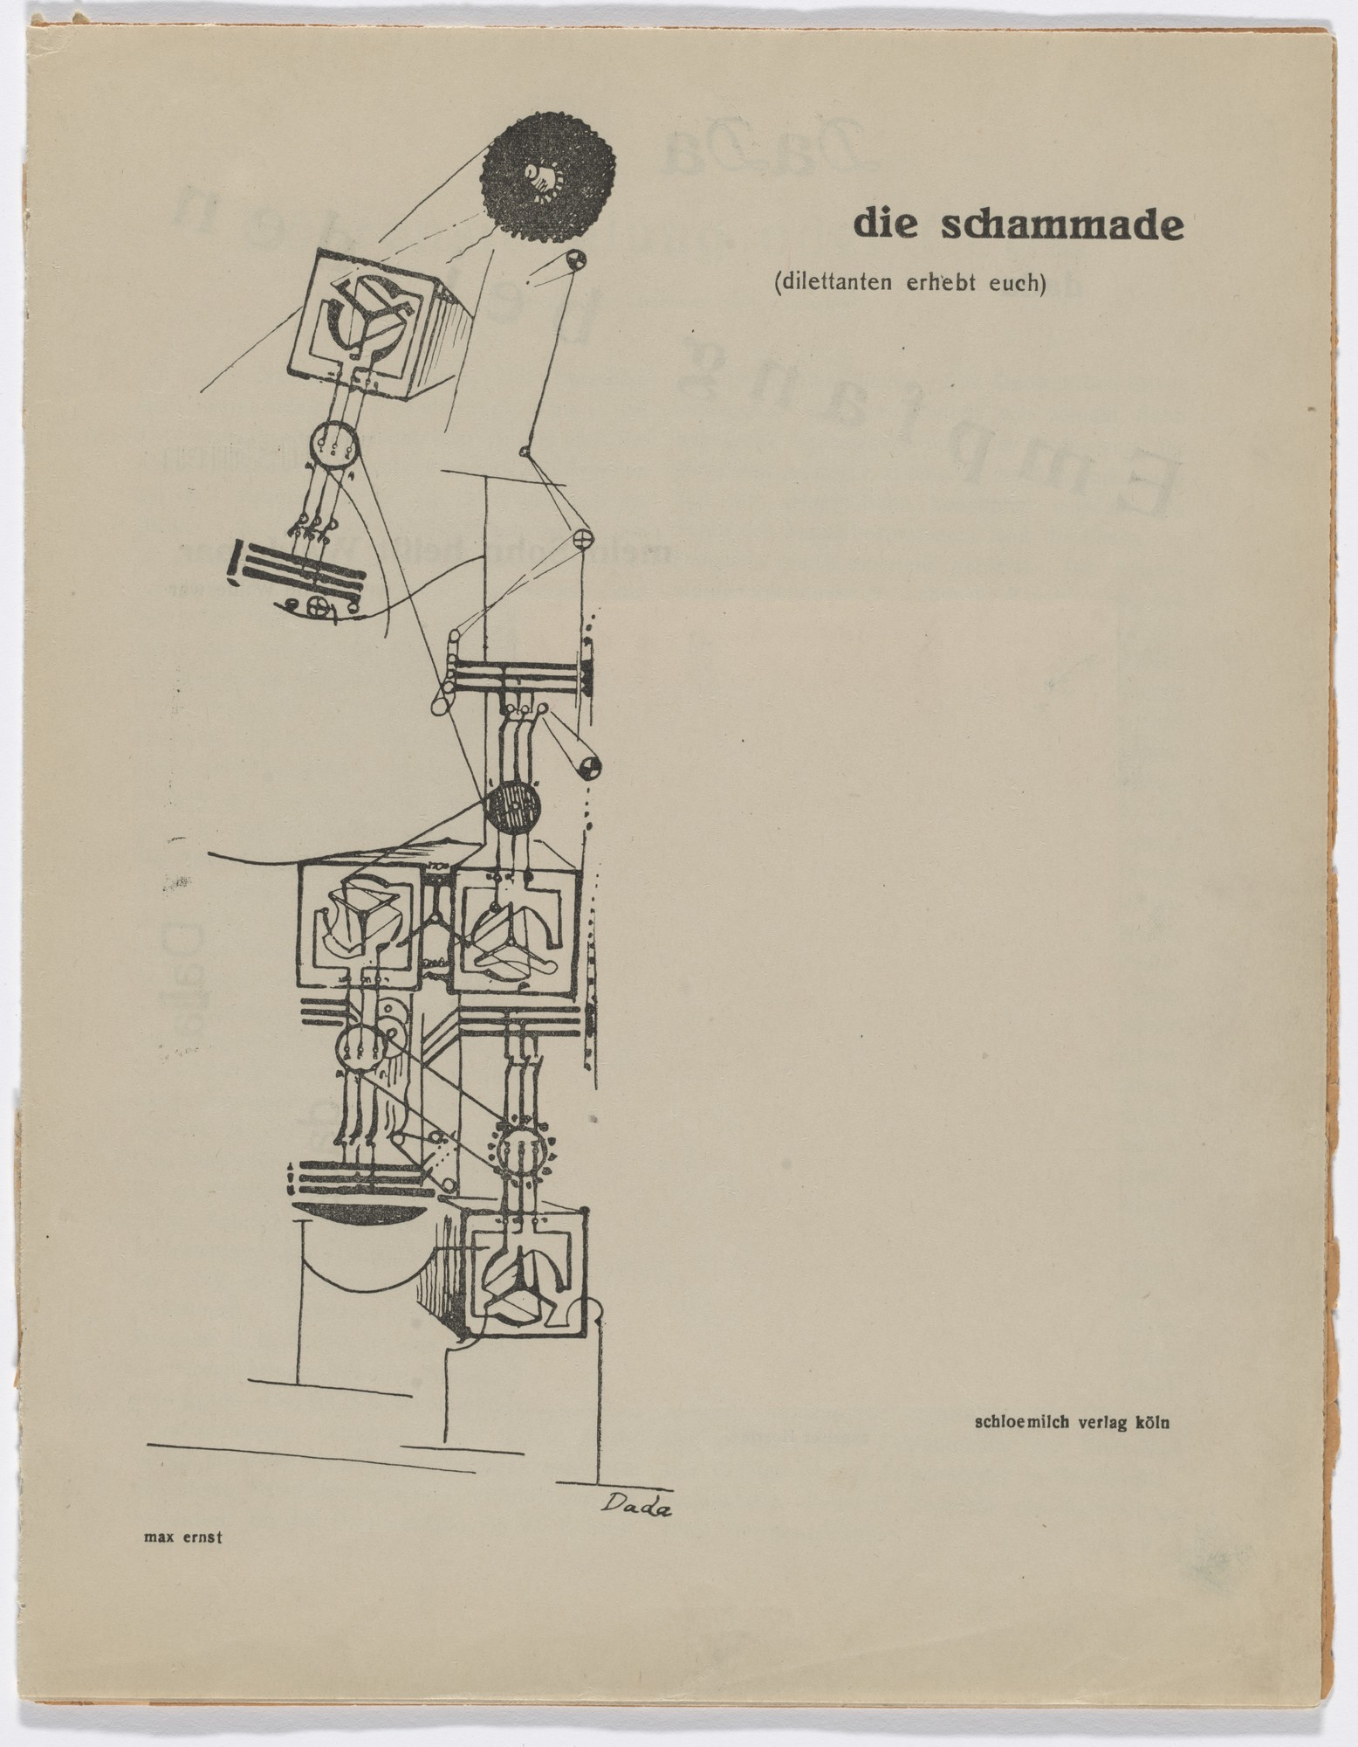

“Die Schammade: Dilettanten erhebt euch”, magazine published by Max Ernst and Johannes Theodor Baargeld, 1920

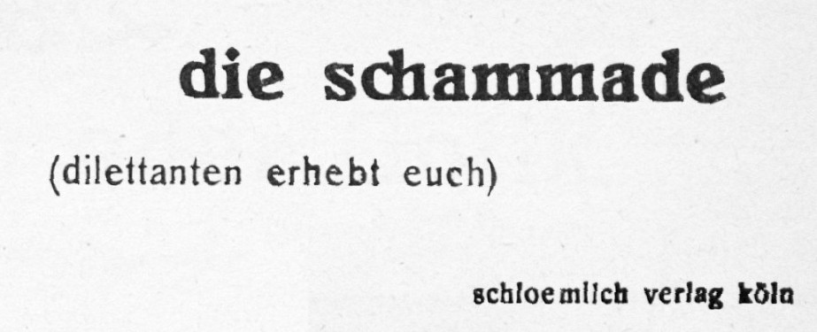

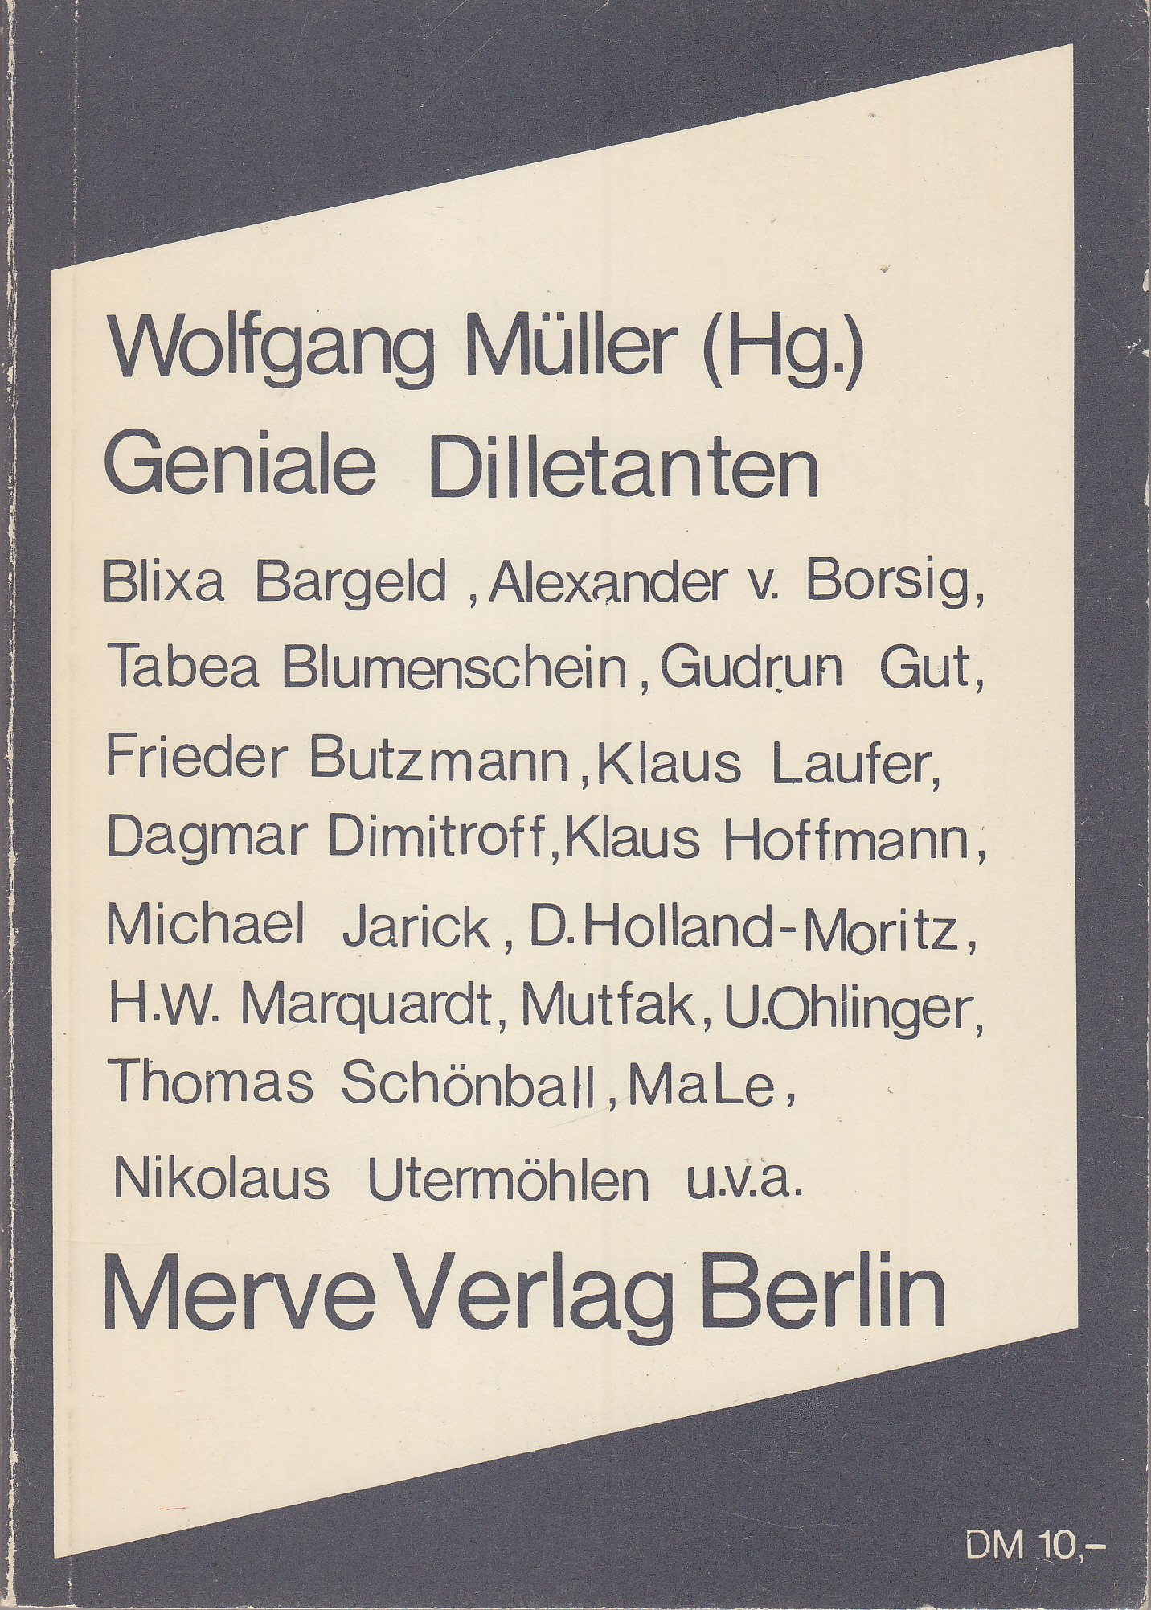

“Geniale Dilletanten”, book edited by Wolfgang Müller, 1982

“Geniale Dilletanten” (“Brilliant Dilettants/Dill Aunts”) was a coinage of the artist and member of the queer performance collective Die Tödliche Doris, Wolfgang Müller. It became a comprehensive moniker for the experimental parts of West-Berlin’s 1980s post-punk subculture.[26] The book edited by Múller in 1982 includes Blixa Bargeld as a contributor, who had picked his stage name from the Cologne Dadaist Johannes Theodor Baargeld who had co-edited *Die Schammade*. Unlike its English equivalent, the German “dilettant” doesn’t have a neutral connotation, but means a both unskilled and inept person that botches the job given to them. If “amateur” merely signifies non-professional status, and “DIY” gives this status an ethical spin, “dilettant” is an insult that Dadaists and punks turned into their humorous badge of honor.

By labeling its products as worthless, the “dilettante” addresses an inherent trap of DIY programs that continue the tradition of Arts and Crafts. While Arts and Crafts began as a socialist movement of non-alienated economic production for its self-organized, classless village communities, it ended up producing luxury items for the wealthy few. Fluxus, whose self-published pamphlets and multiples are now fine art collector’s items, fell into the same trap.

## back to the present

Building upon the legacy of Arts and Crafts, DIY culture is typically based on an explicit or implict critique of disembodied and alienated industrial or institutional production for which it creates concrete alternatives. This critique and practice can have Marxist, left-anarchist, religious-spiritual, green-ecologist, conservative, liberal, libertarian and extreme right-wing ideological underpinnings. Racist organic farmers, for example, neofascist squatters, Nazi rock bands, motorbike repair shops of outlaw biker clubs, religious cult communes and Alt-Right meme collectives are among those who practice and make up radical DIY culture. This renders political-ethical claims for DIY culture just as dubious as any other fundamental political-ethical claim for subculture, let alone any romantization of minorities on the pure grounds of their minority position.

(“Dilletanten” poetics and aesthetics might be a more honest or charming alternative to DIY in this respect, since it does not make any moral or political claims.)

## I will open my Quantum Time Capsule on:

Dates(s):

Time(s):

Location(s):[27]

1. Such as the concepts of philosophical “bricolage” in (Lévi-Strauss) and (Derrida).
2. Moor Mother, DIY Time Machine, *Fetish Bones*, 2016
3. (Afrofuturist Affair).
4. Ibid.
5. Ibid.
6. (Gunderloy)
7. (Sounds)
8. (Westwood)
9. (Diederichsen and Franke), (Turner)
10. https://hyperallergic.com/355219/from-texas-to-dc-artists-and-diy-spaces-struggle-with-permits-and-trolls/ ; the archive of the online art magazine *Hyperallergic* includes more than ten articles on American DIY Spaces.
11. Although, historically, many contemporary art careers have been made from DIY collectives. Examples include Gordon Matta Clark who was part of the FOOD restaurant collective in the early 1970s and Sherry Levine and Jenny Holzer who were part of *Colab* from the late 1970s to the mid-1980s (Colab).
12. “Karl had warped out the the DIY punk ethic”, *Sounds*, January 24th, 1981. A similar claim was made for American punk in the 1983 book *Hardcore California*: “when *Search & Destroy* dismantled itself he was out of a fanzine. So, in the DIY tradition of punk, he created *Damage* magazine” (Davis and Belsito, 173).
13. (Dury).
14. (Cage), (Mekas).
15. (Eichhorn, 104)
16. (Goldsmith)
17. (Eichhorn, 120)
18. (Teh), https://www.afterall.org/article/who-cares-a-lot-ruangrupa-as-curatorship
19. Such as in Wok the Rock’s project *Trash Squad* that is “inspired by the debate about anti-capitalism discourse in punk communities in Indonesia”, https://www.woktherock.net
20. (Teh).
21. Luisa Mengoni, *From Shenzhen: Shanzhai and the Maker movement*, Victoria & Albert Museum Blog, 2015, https://www.vam.ac.uk/blog/international-initiatives/from-shenzhen-shanzhai-and-the-maker-movement
22. Craig S. Saper/dj readies, *Intimate Bureaucracies: A Manifesto*, Punctum Books, 2012, 2.
23. “Die romantische Dichtart ist noch im Werden; ja das ist ihr eigentliches Wesen, daß sie ewig nur werden, nie vollendet sein kann. Sie kann durch keine Theorie erschöpft werden, und nur eine divinatorische Kritik dürfte es wagen, ihr Ideal charakterisieren zu wollen. Sie allein ist unendlich, wie sie allein frei ist, und das als ihr erstes Gesetz anerkennt, daß die Willkür des Dichters kein Gesetz über sich leide.”, Friedrich Schlegel, Athenäums-Fragment 116, 1798.
24. (Tanizaki, 10)
25. (Deren) described this dilemma and limitation of amateur culture as early as in 1959, taken amateur filmmaking as her example.
26. (Müller, 1982), (Müller, 2014).
27. © The Afrofuturist Affair/Black Quantum Futurism, *Do-It-Yourself Time Travel (mini zine)*