# Critical Making

On its most simple level, Critical Making is a contraction of “making” and “critical thinking”.[1] According to its inventor Matt Ratto, Critical Making “signals a desire to theoretically and pragmatically connect two modes of engagement with the world that are often held separate — critical thinking, typically understood as conceptually and linguistically based, and physical ‘making,’ goal-based material work”.[2] Critical Making thus fuses theory and practice, idea and matter; domains that were traditionally separated in Western culture.

Critical Making has a cultural and material affinity to maker culture and accessible digital technologies for “→ DIY citizenship”.[3] In Critical Making, the technologies are not only being used to bridge thinking and making, but also to bring elements of design education into university social sciences.

Critical Making knows at least three definitions, schools, and iterations:

1. Social science Critical Making developed and practiced at University of Toronto by Matt Ratto and his research team;
2. Critical Making as socially engaged maker culture, practiced by Garnet Hertz and his research team at Emily Carr University in Vancouver;
3. Critical Making as a design ethos, proposed and practiced among others at the Rhode Island School of Design.

# Critical Making in social sciences

The following is heavily based on information by ginger coons who completed her PhD research in the Critical Making Lab of University of Toronto:

Critical Making, in this school, is a practical study and research method for students and scholars with no art, design or engineering background to do their classroom study through material experimentation instead of merely reading and discussing texts.

For such curricula, “maker”, Open Source and Internet technologies dramatically lower the threshold for non-experts to build something - an object, a piece of technology, an application - to serve as a temporary, experimental and discursive device for studying and exploring a concept or theory.

A cultural studies or feminist theory class, for example, could use Critical Making as a classroom method to study and discuss Audre Lorde’s claim that “The Master’s Tools Will Never Dismantle the Master’s House”,[4] by practically experimenting with the possibilities and limitations of using corporate social media platforms such as YouTube and Instagram for social activism.

# Critical Making as socially engaged maker culture

“Maker spaces” became a mainstream phenomenon with the creation of the first “Fab[rication] Lab” at the Massachusetts Institute of Technology in 2001 and the launch of *Make:* magazine in 2005. From the perspective of digital media artists, however, “maker culture” boiled down to a mainstreaming and commercialization of radical technological →DIY that had existed from Nam June Paik’s self-constructed video synthesizer in the 1960s to, among others, artists’ experiments with self-built radio and tv infrastructures in the 1970s and 1980s, and the “tactical media” movement of the 1990s.

This difference in politics is epitomized by a cover of “Make:” magazine and its parody, “Made:” by the designer and artist Garnet Hertz:

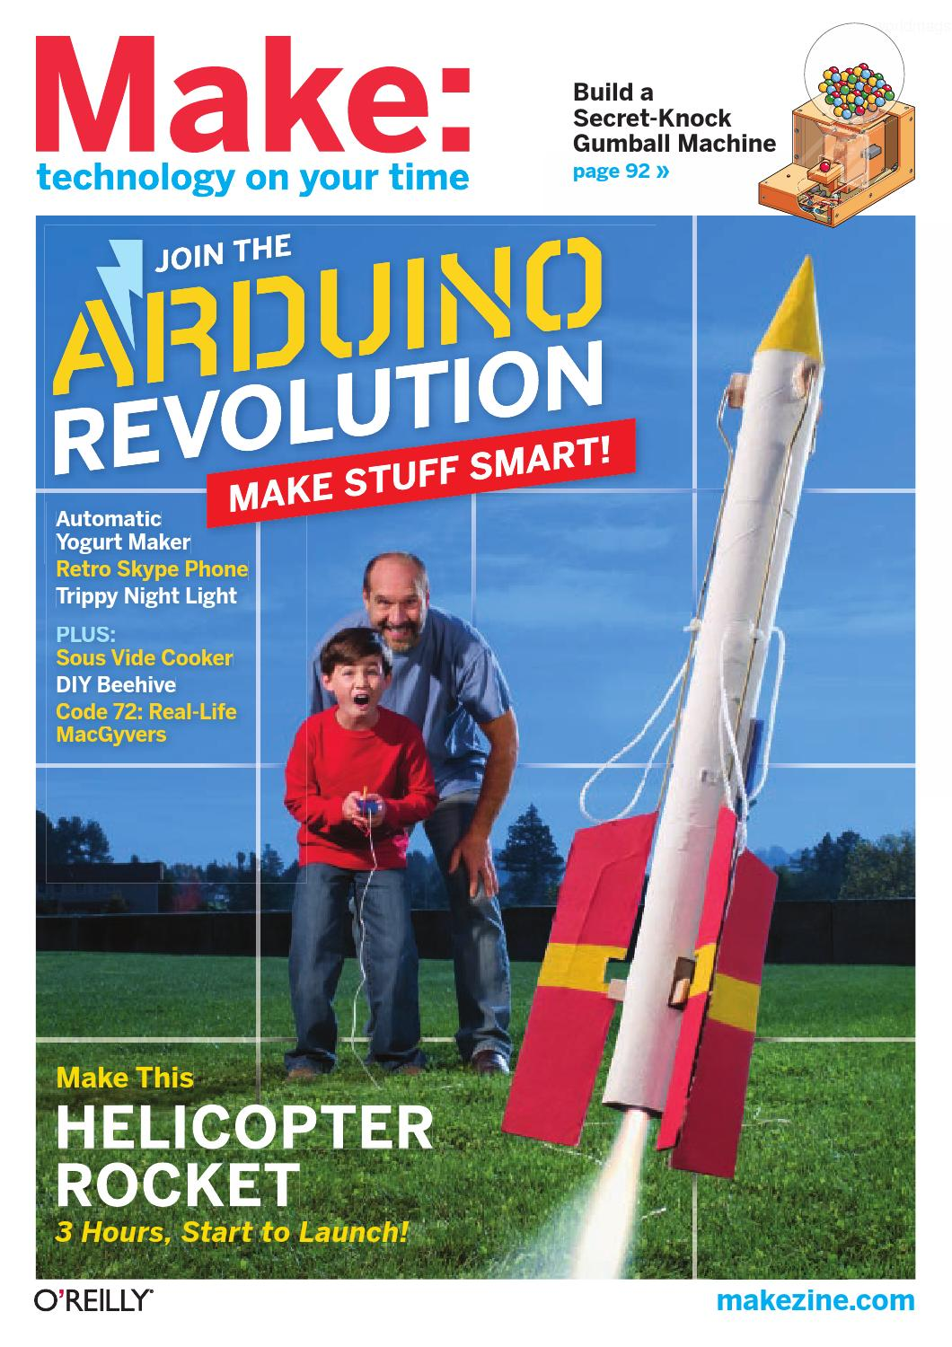

*Make:*, vol. 25, 2011

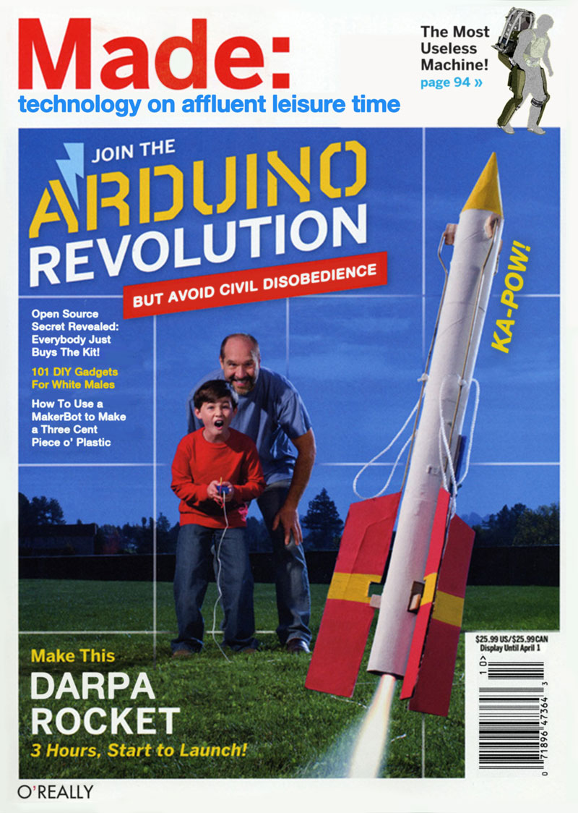

*Made:*, Garnet Hertz, 2012

A series of freely distributed and freely downloadable Critical Making zines produced by Hertz positions Critical Making as an umbrella term for any art and design that experiments with technology in critical or non-mainstream ways: from the post-punk robotics of the 1980s Californian *Survival Research Labs* collective to ‘tactical media’ art as it has existed since the 1990s, the ‘critical engineering’ of the homonymous collective around Danja Vasiliev and Julian Oliver, to the *critical design* of Anthony Dunne and Fiona Raby (which (Ratto) differentiates from his own concept of Critical Making).

# Critical Making as a design ethos

Design educators often fail to see a difference between Critical Making and design education as it has been practiced in art schools for many decades, since design classes often involve concepts from critical theory explored in experimental design projects. In Ratto’s concept of Critical Making, however, objects made by students are not design projects, but merely makeshift devices that get discarded at the end of the class.

It is hence not surprising that design educators reclaim “Critical Making” for their practice in broadest terms. An example of this is the 2013 book *The Art of Critical Making* by the Rhode Island School of Design in which the school refers to its entire curriculum as Critical Making.

# Epilogue

In 2019, a temporary bankruptcy of *Make:* magazine marked an end of over-optimistic expectations for maker culture. Still, the term has stuck and makes it difficult to use “Critical Making” for practices outside maker spaces.

# References

Bogers, Loes and Chiappini, Letizia, eds. *The Critical Makers Reader*. INC Reader 12. Amsterdam: Institute of Network Cultures, 2019. https://research.hva.nl/en/publications/fe892f5e-c7b9-4a1a-9b76-1674562d56f0.

Boler, Megan, and Matt Ratto. *DIY Citizenship: Critical Making and Social Media*. MIT Press, 2014.

Hertz, Garnet. *Critical Making*. Canada: Telharmonium, 2012.

Hertz, Garnet. “Two Terms: Critical Making + D.I.Y.” *conceptlab.com*, 2020. http://conceptlab.com/2terms/pdf/hertz-2terms-202011181901.pdf.

Lorde, Audre. *The Master’s Tools Will Never Dismantle the Master’s House*. London: Penguin, 2018.

Maeda, John. *The Art of Critical Making: Rhode Island School of Design on Creative Practice*. Edited by Rosanne Somerson and Mara Hermano. Hoboken, New Jersey: Wiley, 2013.

Ratto, Matt. “Critical Making: Conceptual and Material Studies in Technology and Social Life.” *The Information Society* 27, no. 4 (2011): 252–60.

1. (Hertz, 2020
2. (Ratto, 2011, 254)
3. (Ratto, 2014).
4. (Lorde, 2018).