# Critical Making

On its most simple level, Critical Making is a contraction of “making” and “critical thinking”. As its coiner Matt Ratto explains, the “use of the term critical making to describe our work signals a desire to theoretically and pragmatically connect two modes of engagement with the world that are often held separate — critical thinking, typically understood as conceptually and linguistically based, and physical ‘making,’ goal-based material work”.[1] It thus combines, and even short-circuits, domains that have been separated in Western culture since Platonic philosophy: theory and practice, idea and matter. In this respect, it has common ground with all material practices covered in this book, but it nevertheless is more specific.

This specificity lies in its affinity to maker culture, respectively digital technologies for, as Ratto puts it, “→ DIY citizenship”, from blogging to Open Source Software and inexpensive programmable hardware. It originated in the early 2010s, shortly after the Occupy movement and the so-called “Facebook revolution” of the Arab spring (Ratto, 2014, 3). Ten years later, many of these media are being rather associated with Silicon Valley → platform and surveillance capitalism,[2] which relativizes this notion of DIY, and the underlying optimism concerning these technologies. Nevertheless, the participatory technological aspect is crucial for Critical Making to achieve its goal of breaking through disciplines and modes of critique that separated theoretical reflection from material engagement; or, in educational terms, that separate classical university social sciences and humanities from art and design education.

Critical Making knows at least three definitions, schools, or iterations, which I would characterize as follows:

1. Social science Critical Making developed and practiced at University of Toronto by Matt Ratto and his collaborators;
2. Critical Making as socially engaged hacker and maker culture overlapping with (new media) art and design, practiced by Garnet Hertz and his collaborators at Emily Carr University in Vancouver;
3. Critical Making as a design ethos, as proposed and practiced among others at the Rhode Island School of Design.

# Critical Making in social sciences

The following account is heavily based on information by ginger coons, who completed her PhD research in the Critical Making Lab of University of Toronto.

Critical Making, in this school, manifests itself as a practical study and research method that is based on having students and scholars who have no art, design or engineering background, to develop their study and discussion through material experimentation, rather than merely through language. The idea is that “maker”/fab lab, Open Source and Internet technologies dramatically lower the threshold for non-experts to build something - an object, a piece of technology, an application - that can serve as a temporary, experimental and discursive device for studying and exploring a concept or a theory.

To use an example close to the ones given by ginger coons: Bruno Latour’s actor-network theory, which thinks of society as being made up of human and non-human actors that perform comparable functions, could be studied simply by reading and discussing his essay _From Realpolitik to Dingpolitk in which the mechanical device of the door stopper is being described as being equivalent to the social function of a door person.[3] In a Critical Making class, participants would experiment with building door stopping devices with various degrees of automation and manual operation, as well as with door stopping performances that combine human and technological agency. Through their self-built devices, they could critically explore the concept of human and non-human agency and gain richer insights through this material engagement than through purely theoretical reflection.

As opposed to a (critical) design class, the designs themselves that were made by the participants don’t matter, and all self-built objects are discarded at the end of the class (so that they don’t even serve as prototypes for more refined designs). In this sense, Critical Making is a method of bringing artistic and design research into traditional academic sciences, and opening it up for non-artists. In the case of the University of Toronto, this is the department of information/library sciences of which Ratto’s Critical Making Lab is a part. The approach can be potentially extended to any other academic discipline. A cultural studies or feminist theory class, for example, could apply Critical Making as a classroom method to study Audre Lorde’s claim that the “The Master’s Tools Will Never Dismantle the Master’s House”,[4] for example, by practically experimenting with the possibilities and limitations of YouTube, Instagram and Facebook as activist tools.

In an article co-authored with Garnet Hertz, Matt Ratto reminds readers that the “term critical making highlighted the importance of the material in conceptual and analytic processes, a point that has been an increasingly dominant trope in social theories – the so-called ‘material turn’ that has been noted in a range of disciplines”.[5]

# Critical Making as socially engaged hacker and maker culture

“Maker spaces” became a mainstream phenomenon with the launch of *Make:* magazine in 2005. This was preceded by the “Fab[rication] Lab” at the Massachusetts Institute of Technology in 2001, and the employment of new types of machines such as 3D printers, CNC machines, machines for etching microprocessors and laser cutters, with the promise of potentially manufacturing anything - any material object - at comparatively low cost, in comparatively small spaces, using product designs and blueprints shared as Open Source, and thus turning manufacturing into a form of →DIY, at least in comparison to traditional large-scale industrial fabrication. What the Open Source movement had promised for software, Maker Spaces thus seemed to promise for material goods.

From the perspective of (digital media) artists and activists, however, “Maker culture” was the mainstreaming and commercialization of radical technological →DIY that had existed from Nam June Paik’s self-constructed video synthesizer in the 1960s to, among others, artists’ experiments with self-built radio transmitters and self-built robots in the 1970s and 1980s, to the *Dorkbot* series of informal events organized in various cities on four continents in the 2000s which were advertised as “people doing strange things with electricity”, and which mostly involved artists and technological tinkerers demonstrating their experiments to an interested public.

The new, mainstreamed maker culture and the older “tactical media” art of such collectives as The Institute of Applied Autonomy (which built graffiti robots that can cross police lines) and the Yes Men (whose earliest projects included the swapping of voice chips between GI Joe and Barbie dolls in toy stores),[6] differed from each other in their politics. This difference is epitomized by a cover of “Make:” magazine and its parody, “Made:” by Garnet Hertz:

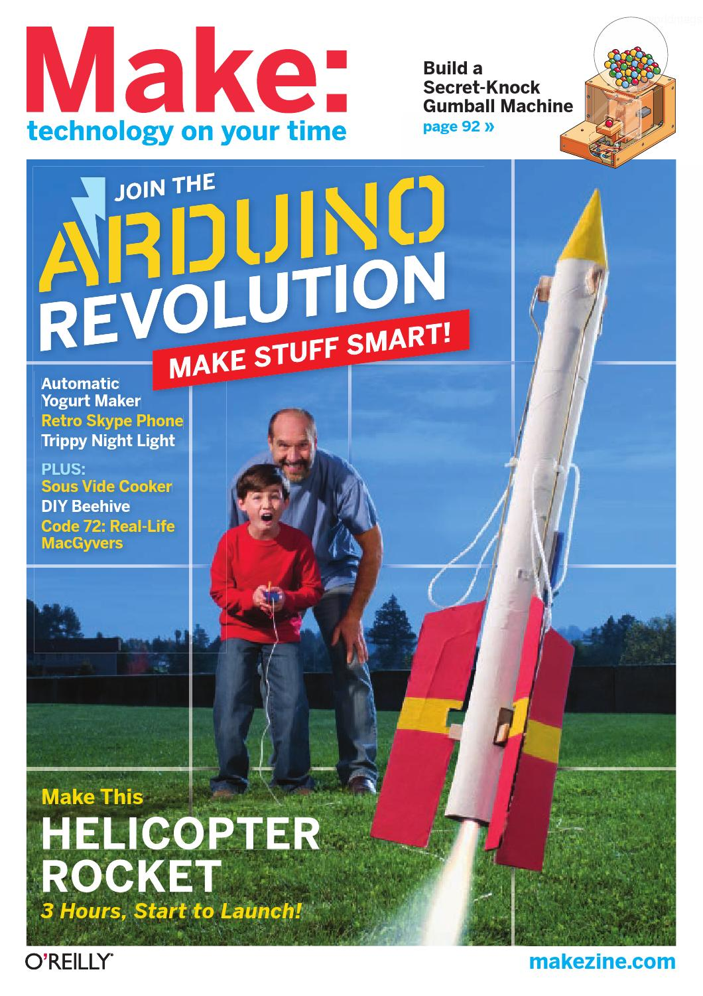

*Make:*, vol. 25, 2011

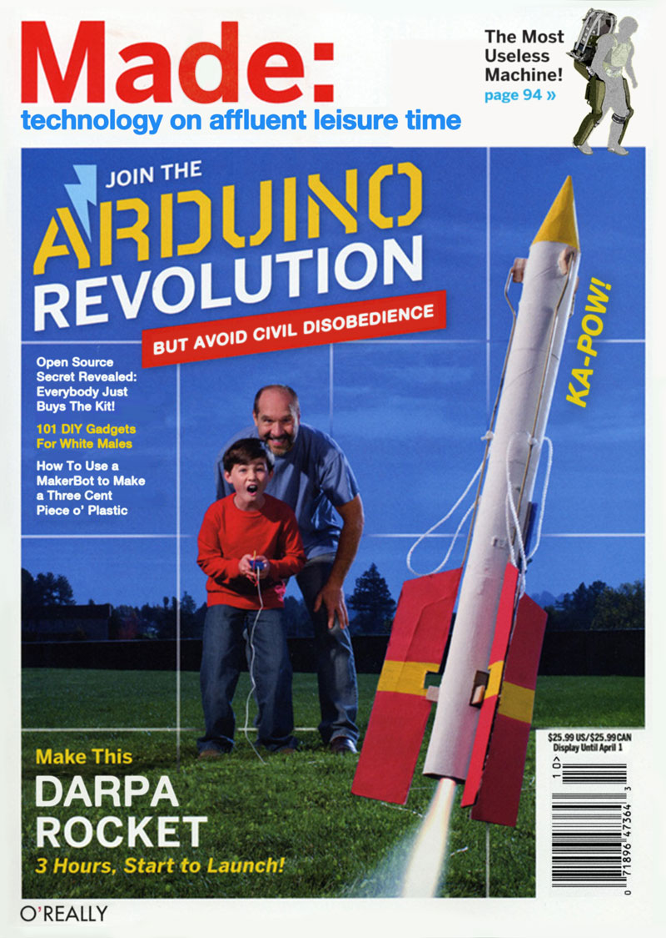

*Made:*, Garnet Hertz, 2012

Garnet Hertz, a designer and digital media artist appropriated the term Critical Making from Matt Ratto and University of Toronto Critical Making Lab, to give it a second, perhaps even more literal meaning: Critical Making as politically critical Maker culture. In this version, Critical Making restores the proto-Maker culture of *Dorkbot*, of which Hertz had been a long-time participant, and brands it “Critical Making” to rescue it from marginalization. A series of freely distributed and freely downloadable Critical Making zines produced by Hertz position Critical Making as an umbrella term for any art and design that experiments with technology in critical or non-mainstream ways: from the post-punk robotics of the 1980s Californian *Survival Research Labs* collective to ‘tactical media’ art as it has existed since the 1990s, the ‘critical engineering’ of the homonymous collective around Danja Vasiliev and Julian Oliver, to the *critical design* of Anthony Dunne and Fiona Raby (which (Ratto) differentiates from his own concept of Critical Making).

Hertz’ concept of Critical Making is taken up and continued in the *Critical Makers Reader* edited by Loes Bogers and Letizia Chiappini for Institute of Network Cultures in Amsterdam, which positions its discourse as a social, environmental and political critical corrective to unbridled techno optimism in (mainstream) Maker culture.

# Critical Making as a design ethos

Design educators often do not see any difference between Critical Making as it is being practiced at the University of Toronto’s Critical Making Lab to design education as it has been practiced in art schools for many decades - since the method of taking concepts from critical theory and having students explore them in design projects, is a staple of almost any Bachelor- and Master-level design study program. The only difference is that, in the original concept of Critical Making, the objects made by students are merely makeshift devices, not actually considered design projects and being discarded instead of further developed.

One could thus argue that for art and design education, Critical Making does not constitute or contribute anything new, or that Critical Making in its first sense boils down to bringing elements of design curricula into social sciences and humanities. However, in its 2013 book *The Art of Critical Making*, the Rhode Island School of Design refers to its entire curriculum as Critical Making.

In the words of its director John Maeda: “Every stone, speck of dirt, and atom of oxygen must be turned over and examined in the light of the day in its present, past, and future. It is this kind of intensity that makes our unique brand of ‘critical making’ so relevant to this day and age.[7] Later in the book, Critical Making is generally defined as”a philosophy, perspective, or sensibility particular to RISD [Rhode Island School of Design]“, as”transforming the ordinary into something meaningful" and “giving form to ideas”.[8] This factually contradicts Ratto’s original concept of Critical Making where the object made does not have any lasting meaning. In its positioning of “critical making” as design with a poetic or fine art ethos somewhat similar to Arthur C. Danto’s *Transfiguration of the Commonplace* and lack of techno-social specificity,[9] it has little to nothing in common with Hertz’s concept of Critical Making.[10]

If at all, then this particular school intersects with the earlier schools of Critical Making in the concept of material thinking, or thinking-through-matter, although language such as “giving form to ideas” in the end reinforces the division of ideas and matter.

# Epilogue

In 2019, the temporary bankruptcy of *Make:* magazine marked an end of a fifteen-years boom of maker culture. Its initial promises and hopes to bring low-cost fabrication technology to every household (in similar ways as personal computing had brought computers and printers to nearly every household of the First World) have failed, mainstream adoption of digital fabrication technology has shifted to small and large-scale industries, “maker spaces” have remained, for the most part, educational facilities, and most items fabricated in them are experiments and prototypes. It is rather doubtful whether one can still speak of a “maker movement”.

However, the terms “maker” and “maker space” have stuck to the degree that it has proven difficult to use “Critical Making” for practices that do not necessarily involve maker space technologies (such as 3D printing).

# Literature

[to be completed]

Bogers, Loes and Chiappini, Letizia, editors. *The Critical Makers Reader*. Institute of Network Cultures, 2019, https://research.hva.nl/en/publications/fe892f5e-c7b9-4a1a-9b76-1674562d56f0.

Boler, Megan, and Matt Ratto. *DIY Citizenship: Critical Making and Social Media*. MIT Press, 2014.

Danto, Arthur C. “The Transfiguration of the Commonplace.” *The Journal of Aesthetics and Art Criticism*, vol. 33, no. 2, 1974, pp. 139–48.

Hertz, Garnet. *Critical Making*. Telharmonium, 2012.

Oliver, Julian, et al. *The Critical Engineering Manifesto*. 2016 2011, https://criticalengineering.org/.

Ratto, Matt. “Critical Making: Conceptual and Material Studies in Technology and Social Life.” The Information Society, vol. 27, no. 4, 2011, pp. 252–60.

Latour, Bruno. “Where Are the Missing Masses? The Sociology of a Few Mundane Artifacts.” *Shaping Technology - Building Society. Studies in Sociotechnical Change*, edited by Wiebe Bijker and John Law, MIT Press, 1992, pp. 225–59.

Maeda, John. *The Art of Critical Making: Rhode Island School of Design on Creative Practice*. Edited by Rosanne Somerson and Mara Hermano, Wiley, 2013.

1. (Ratto, 2011, 254)
2. (Zuboff).
3. (Latour).
4. (Lorde).
5. (Bogers and Chiappini, p. 19).
6. (Raley).
7. (Maeda, 7).
8. (Maeda, p. 87, 32, 98)
9. (Danto).
10. Neither Matto nor Hertz are credited or quoted by (Maeda) and his co-authors.