The Eternal Network: System administration, spam and trolling in the 1970s and 1980s

Florian Cramer @Simon Frazer University, Vancouver, Oct. 30th 2019

# Introduction

First off, I am talking about “Mail Art” as in “m-a-i-l”, not “m-a-l-e”. I first thought that it was only me as a non-native speaker who couldn’t properly pronounce the two words so that people knew which one I meant; until pronunciation sound files of the Cambridge Dictionary taught me that the two words are indeed identically pronounced both in British and American English,. 0 But this linguistic confusion actually brings me closer to my topic: Although Mail Art departed from a radically democratic, inclusive ethos and was one of the art currents (or subcultures) of the 1970s that prominently included feminist and queer positions, I want to propose a contemporary reading of its “Eternal Network” as both an anticipation to today’s Internet-based social networks, both the corporate and self-organized ones; so my reading is explicitly not historical but through a contemporary lens.

Who am I to speak about this subject? As a teenager part of 1980s post-punk subculture, zinemaking and DIY cassette music, interconnections through second-/third-generation mail artists like Vittore Baroni and my friend Graf Haufen; part of (the Canadian-founded network of) Neoism since 1988, maker/publisher of SMILE magazines until the early 1990s (whose heritage goes back to General Idea’s FILE magazine - more on that later).

My lecture will have three parts:

1. A brief historical overview of Mail Art and its “Eternal Network”, since I do not presume that everyone here is familiar with it, plus pointers to a number of select resources
2. A more in-depth look at the network dynamics of Mail Art, using a number of examples, and focusing on similarities to contemporary network culture.
3. Tentative conclusions to be drawn both for media studies and media critique of contemporary networks, and for the self-organized arts practices.

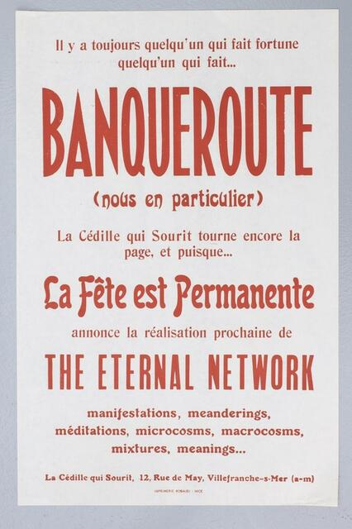

eternal_network

# Brief history of Mail Art

Mail Art has been alternatively referred to, by its own protagonists, as Mail Art, Correspondence Art, Postal Art and “The Eternal Network”. The latter was a coinage of the French Fluxus artist Robert Filliou from 1961. Leaving aside uses of artists’ postcards and international networking in early 20th century Dadaism, Fluxus was in many respects a precursor to the Mail Art network of the 1970s. Fluxus had departed from a concept of non-elitist, performative, everyday and inexpensive creativity outside fine art, and in the course of its existence included several experiments of co-op economics and lifestyle. Part of this was a “Flux Post” kit designed by George Maciunas, the founder and central organizer of Fluxus. It included a postcard by Ben Vautier from 1965 on whose sides two different addresses could be entered in order to give the postman the choice of where to send it. (“Postman’s Choice” is also the title of the piece.) In modern terminology, one could call this a network art piece that played with underlying protocols and routing. The first exhibition and catalogue of Mail Art, made in France by the curator Jean-Marc Poinsot in 1971, mostly focused on artists’ individual works that used the postal system as a medium, quite similar to how most video art approached video as an artistic medium.

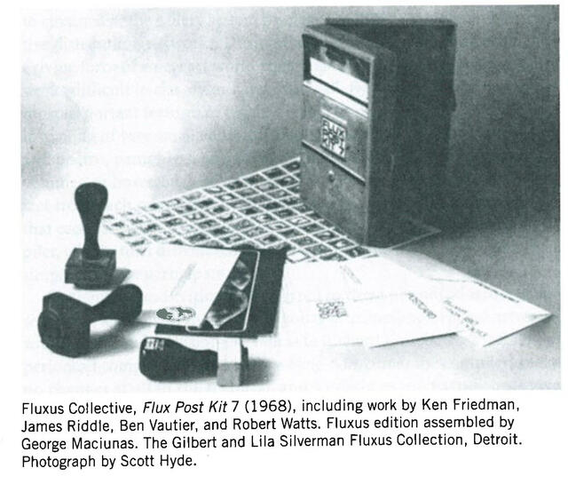

fluxus-1

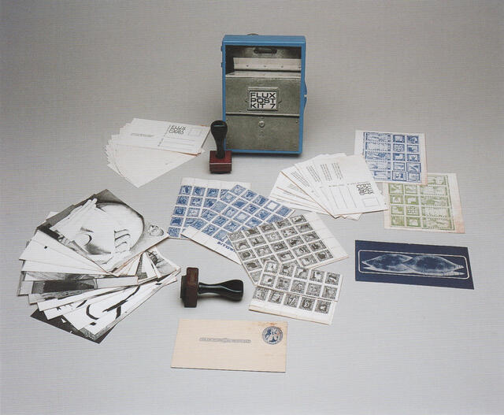

fluxus-2

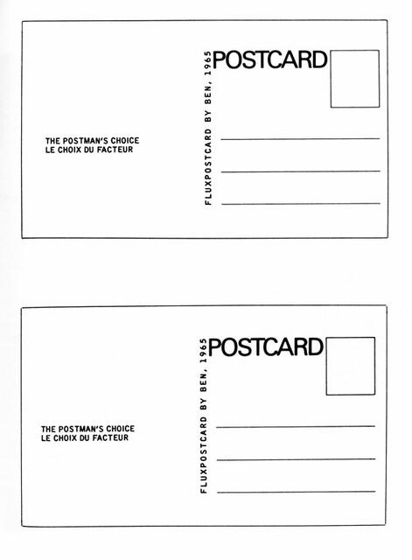

fluxus-3

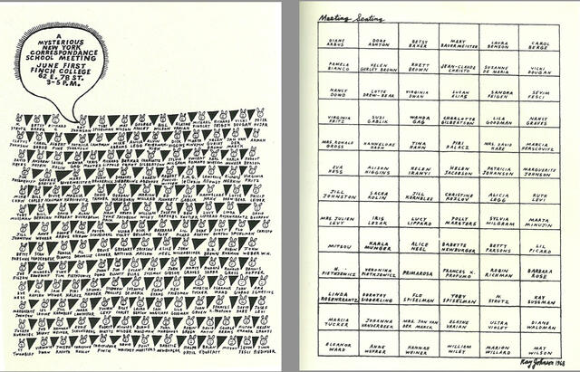

ray_johnson-nycs-1

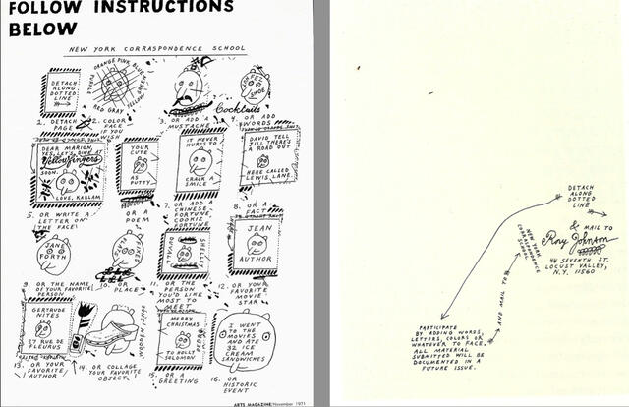

ray_johnson-nycs-2

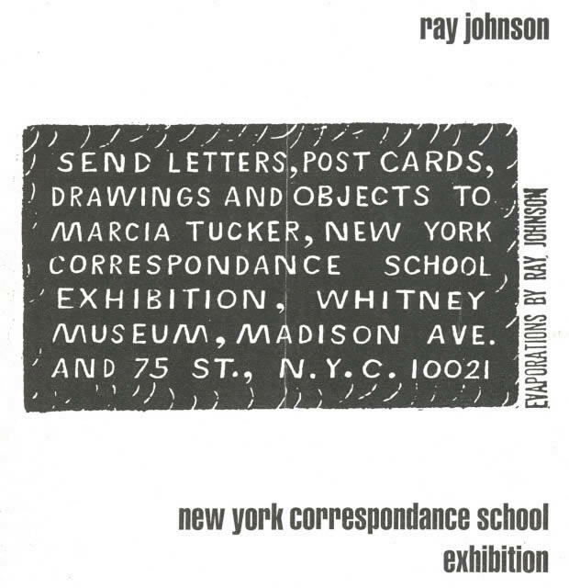

ray_johnson-nycs-3

Partly prior, partly in parallel to Fluxus, the artist Ray Johnson maintained a correspondence networks with friends and collaborators, mostly from New York’s contemporary art world. Johnson had studied at the Black Mountain School and was friends with among others Andy Warhol, Robert Rauschenberg and Lucy Lippard. From the 1960s on, his ephemeral drawings and writings for his correspondence network became his main art practice. In 1962, the name “New York Correspondence School” was coined for this network. By the early 1970s, it had grown beyond New York and transformed into a larger, international network of artists who primarily worked in and through the medium of postal exchange.

Canada played a particular role in the Mail Art network of the early 1970s, ostensibly through artist collectives like General Idea (Toronto), Image Bank and Western Front in Vancouver and Vehicule Art in Montréal. In this context, Mail Art was a central component of artist-run media and infrastructures, which also included artists’ books (through spin-offs like Art Metropole, later Printed Matter in New York), what we nowadays would call zines, self-organized shows, and work with performance and video.

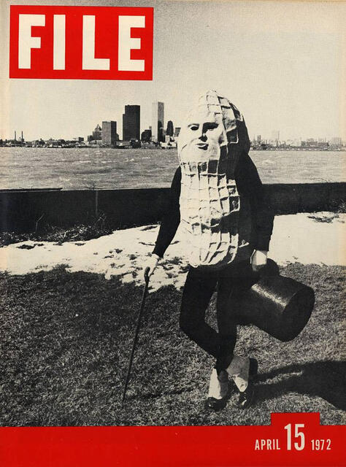

file_-_1

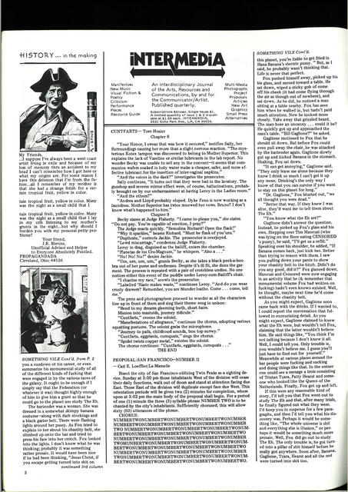

vile-4

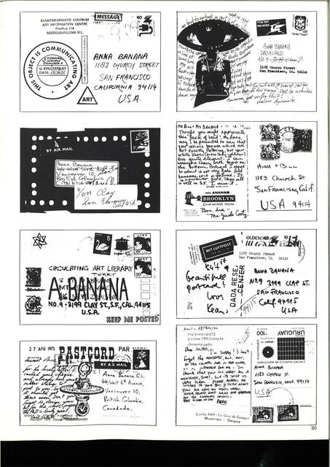

vile-5

A good example for this networking are the early issues of General Idea’s magazine “FILE”, such as the first issue from 1972. If we just take the cover, there are all kinds of interesting details - including methods of media appropriation and Vancouver’s local history - that I would like to leave aside for a moment and touch upon later. Re-reading the magazine is now possible thanks to a complete facsimile reprint of FILE from 2008. It becomes immediately clear that the early, Mail Art-centric issues of FILE were not classical editorial publications, but for the most part unredacted contributions sent by correspondents in General Idea’s Mail Art network. In this way, Mail Art publications resembled Internet forums much more than typical contemporary art catalogs or magazines.

At this point, the purpose of Mail Art was not experimentation with mail as an artistic medium, but the use of the international postal system for an alternative, self-organized, non-institutional art system that would completely bypass the established art system consisting of the art market, museums, curators, editorial art magazines, criticism and catalog publishing.

These working principles became Mail Art’s ethos and unwritten law: A Mail Art show and/or publication could be announced by *anyone* through an open (often thematic) call spread through the Mail Art network and its publications; *all* submissions had to be accepted, no curatorial selection would take place, and all participants would receive free copies of the publication or documentation of the exhibition or event. There was also no distinction between professional artists and non-professional artists, or artists and non-artists: Mail Art was supposed to be a radically democratic system, which is why by the 1980s and 1990s, most of its participants preferred to call it “Eternal Network” (in order to obliterate “art” as a filter and distinction).

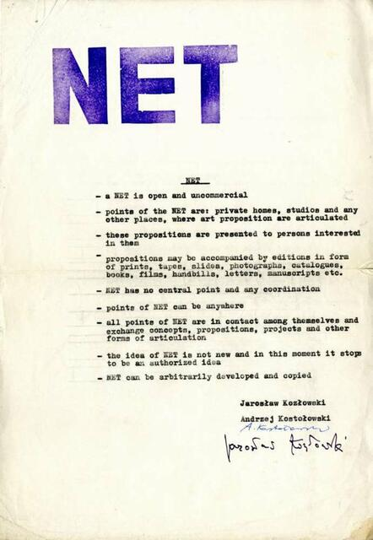

kozlowski_kostolowski-net

The Mail Art network spanned most if not all continents, but most prominently involved participants from North and South America, Western and Eastern Europe and Japan. In Eastern Europe, it was closely related to Samizdat and underground art, and partly had its own parallel developments. In 1971, the Polish artist Jarosław Kozłowski sent the following manifesto to 350 correspondents:

"NET

* a NET is open and uncommercial
* points of the NET are: private homes, studios and any other places, where art proposition are articulated
* these propositions are presented to persons interested in them
* propositions may be accompanied by editions in form of prints, tapes, slides, photographs, catalogues, books, films, handbills, letters, manuscripts etc.
* NET has no central point and any coordination
* points of NET can be anywhere
* all points of NET are in contact among themselves and exchange concepts, propositions, projects and other forms of articulation.
* the idea of NET is not new in this moment it stops to be an authorized idea
* NET can be arbitrarily developed and copied"

(The stamp was a subversive means of giving the letter an official appearance and make it slip through censorship. But it didn’t work, and like many Eastern European artists, Kozłowski got factually banned from publicly showing his work.)

What is clear here is that the idea of, to use contemporary terminology, free, open and peer-to-peer network culture did not originate in the 1990s with the popularization of the Internet, but was fully conceptually developed in the correspondence arts of the early 1970s. (Personal note: This is why the early net culture and net.art manifestations around 1997 annoyed me, because they seemed to reinvent the wheel, repeat the same mistakes and perform historical revisionism.) - I will cover this in more detail.

While Mail Art in the 1970s must be seen in larger context of artist-run infrastructures, and next to groups like General Idea also involved artists like Genesis P’Orridge and Cosey Fanny Tutti, John Armleder and Ulises Carrión who became known through other work and in other contexts, it paradoxically became more self-centered by the 1980s when it had fully embraced the concept of networking over that of art.

The following is a diagram by the Italian mail artist, musician and publisher Vittore Baroni, who embodies a shift of Mail Art from 1970s artist-run practices to 1980s DIY subculture, where Mail Art operates in close vicinity to zine culture and cassette tape labels for DIY post-punk and industrial music.

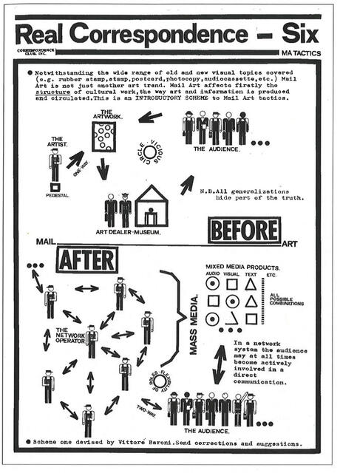

baroni-real_correspondence-1981

The communication model sketched by Baroni in 1981 is essentially the same as that for top-down mass media communication versus bottom-up network communication, or for centralized versus peer-to-peer network services. Remarkable is that Baroni insists on communication *structure* versus superficial appearance (mail art, rubber stamps etc.) of “real correspondence”. His statement that “[i]n a network system the audience may at all times become actively involved in a [sic] direct communication” could just as well come from early Internet activism, or from contemporary advocacy for federated social networks like diaspora and Mastodon.

Even the notion of a world wide web was anticipated in subcultures that originated Mail Art such as Neoism, whose activities in the early 1980s mostly consisted of self-organized festivals that took place in apartments and for which a 1983 manifesto reads as follows:

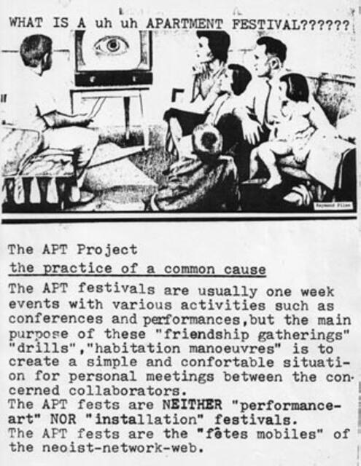

neoist

“The APT fests are NEITHER ‘performance-art’ NOR ‘installation’ festivals. The APT fests are the”fêtes mobiles" of the neoist-network-web".

Even the notion of “copy-left” existed in Mail Art before it was used for Free and Open Source software. This open-participation Mail Art magazine was published by the Swiss mail artist Manfred Vänçi Stirnemann, and first appeared in 1983, two years before Richard Stallman’s GNU Manifesto:

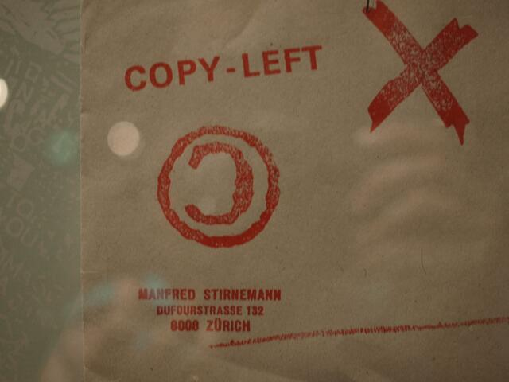

copy-left-0

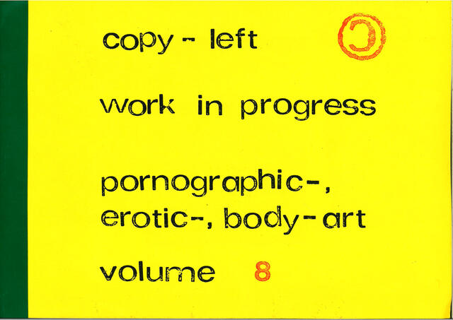

copy-left-1

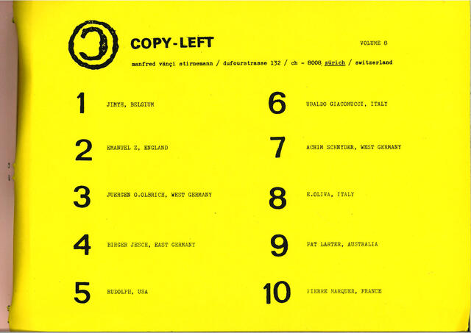

copy-left-2

As early as in 1973, the British artist Stephan Kukowski created an artist’s search engine called *Blitzinformation*, a “free art service which replies to your enquiries in the most artistic way possible”. Kukowski today goes by the name Stephan Shakespeare and is the co-founder and CEO of the British Internet polling company YouGov.

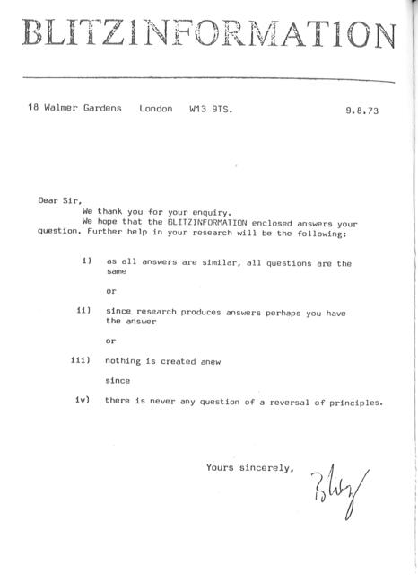

blitzinformation

[Pete Horobin, DATA project]

By the late 1980s, several Mail Artists experimented with modem dial-up electronic bulletin board systems, both self-run such as Ruud Janssen’s TAM in the Netherlands, Mail Art boards on San Francisco *The Well* (run by Carl Eugene Loeffler, the publisher of the first seminal source book on Mail Art) and on the Echo NYC electronic bulletin board.

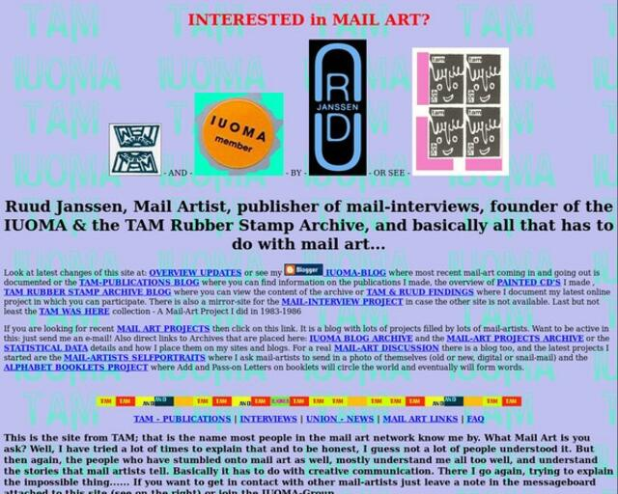

janssen_-_tam-2

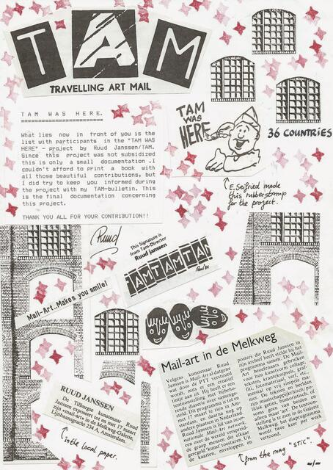

janssen_-_tam

The Mail Art or Eternal Network and community *still* exists, people like Vittore Baroni are still active in it, although less visibly so than in earlier decades and with aging participants.

It struck me that when I first gave a public presentation on this topic, in the form of a workshop at the art space ODD in Bucharest, I received very negative feedback a person who had been involved in Mail Art in the past, but retrospectively considers it a waste of time and story of disappointments. (The same is probably true for many Internet activists.) So it’s time to talk about network administration bureaucracies, censorship wars, spam and trolling in Mail Art.

# Resources

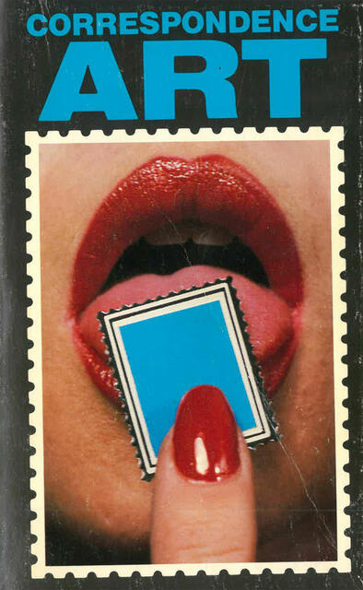

crane-stofflet-1

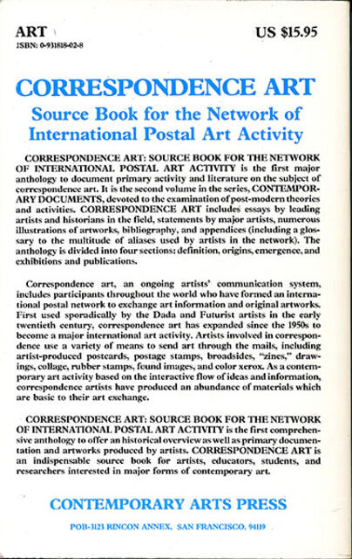

crane-stofflet-2

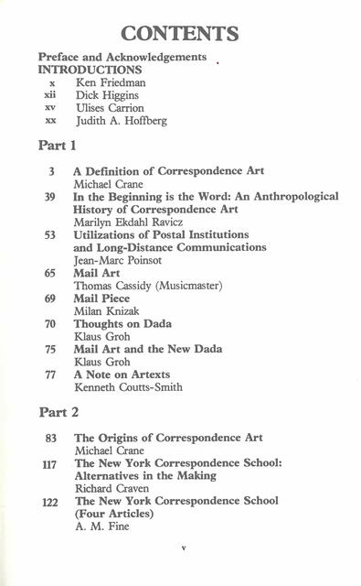

crane-stofflet-3

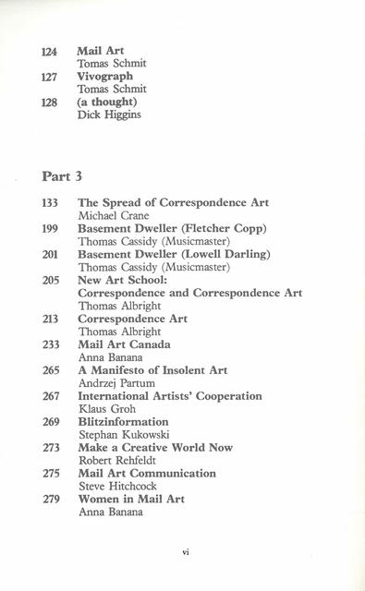

crane-stofflet-4

Stofflet/Crane, Correspondence Art (published by Art Metropole), 1984 - in my view, still the best source book on Mail Art

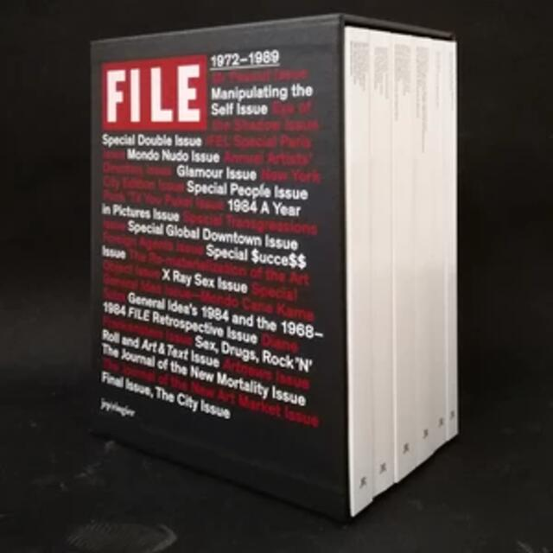

file-ringier

FILE magazine reprint, ironically by Ringier, the Swiss Murdoch

# The Eternal Network and its memes, campaigns, spam, trolling, bureaucracies



file

## FILE, VILE, BILE, SMILE:

To go back to FILE magazine: The magazine parodied the title and visual identity of LIFE magazine, while being just the opposite in its editorial policy. In that sense, and in its use of the catchy title image, it has a similar strategy to that of contemporary memes and imageboards that also (a) rely on open, pseudo- or anonymous participation while (b) recycling and parodying mass media visuals. In other words, the early issues of FILE could be seen as a forerunner to imageboards like 4chan, in their early years, before they got taken over through the extreme right. Just as 4chan fostered other chan boards, FILE became the point of reference departure for a number of other mail art magazines, VILE published in San Francisco by the Mail Artist Anna Banana:

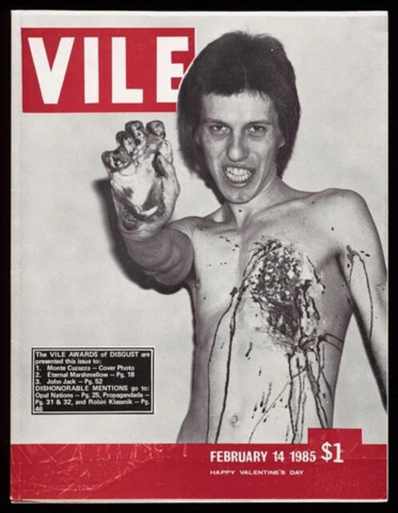 This issue featured the Californian performance artist and Industrial musician Monte Cazzaza, and was not the only issue of VILE that used grotesque and pornographic visuals both on the cover and inside the magazine; another parallel to imageboards.

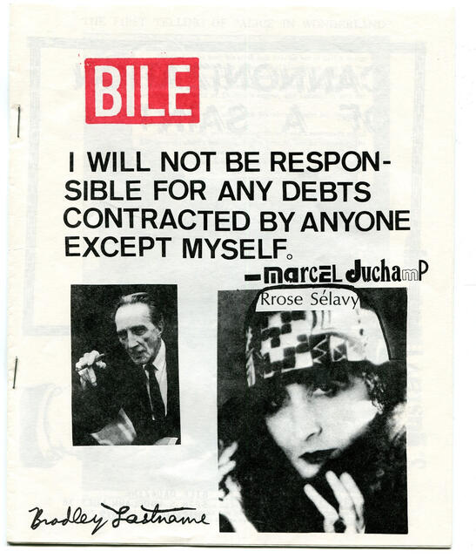

bile

VILE conversely fostered BILE by the mail artist Bradley Lastname (the pseudonyms are another parallel to Internet culture).

In the 1980s, they were followed by SMILE (first published by Stewart Home in London) which became a multiple-use zine title that anyone could use, but was most popular within Neoism:

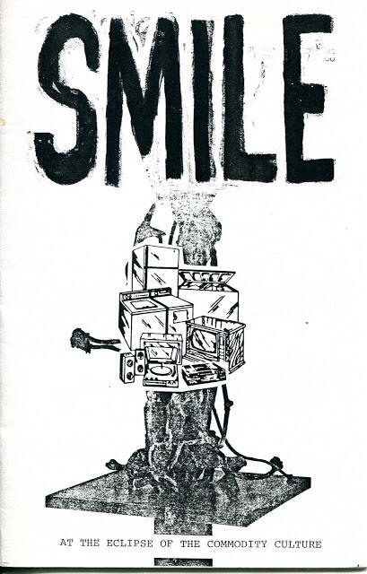

smile_zine-1

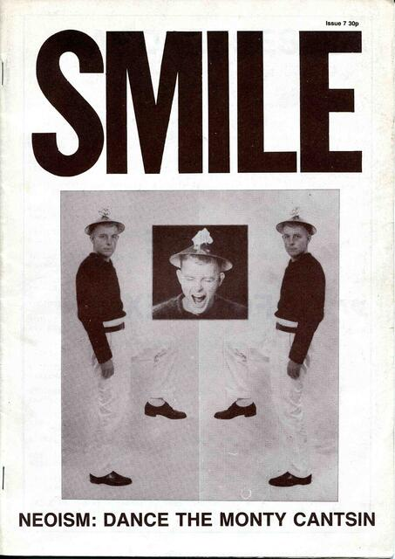

smile_zine-2

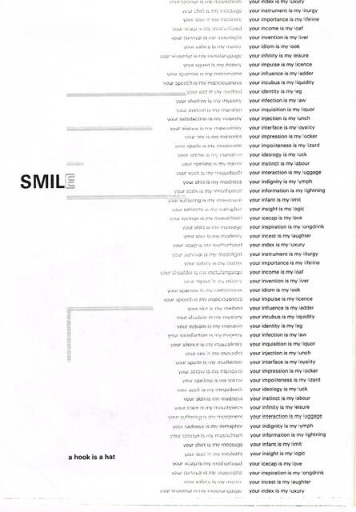

smile_zine-3

On the cover of the first FILE issues is the artist Vincent Trasov in his persona and costume as “Mr. Peanut”. In 1974, he ran for mayor of Vancouver in an artist-run campaign:



file

(newsreel on Trasov’s/Mr. Peanut’s election campaign for mayor of Vancouver)

In 2019, we of course watch this video with another perspective. In retrospect, it seems to be historically located right in between the Berlin Dadaist satirical-political campaigns, amongst others in the German parliament, protesting the pre-fascist tendencies in the Weimar Republic; and contemporary populist political spectacles such as those of the Five Star movement in Italy around the comedian Beppo Grillo, and to some degree also of Donald Trump in the U.S.. I state this not as a critique, but simply as an observation, proving that the Vancouver artists of 1974 anticipated a later zeitgeist; which proves McLuhan’s (in my opinion: correct) observation that artists are “antennas” of social, cultural and technological developments. The Eternal Network of Mail Art is a very good proof of that hypothesis.

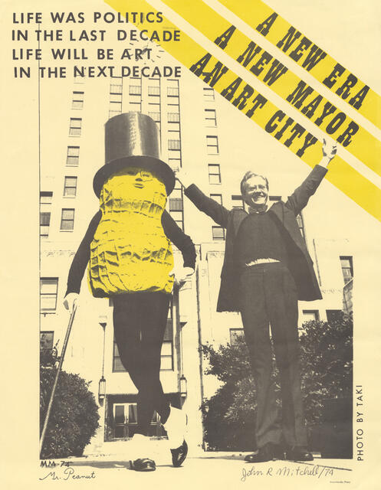

trasov-1

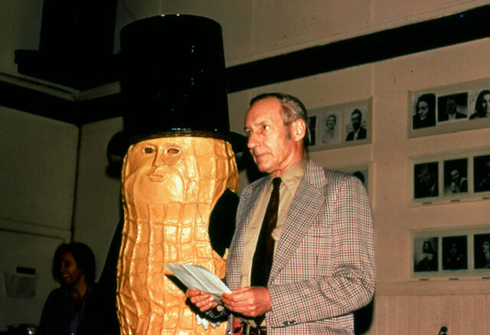

trasov-2

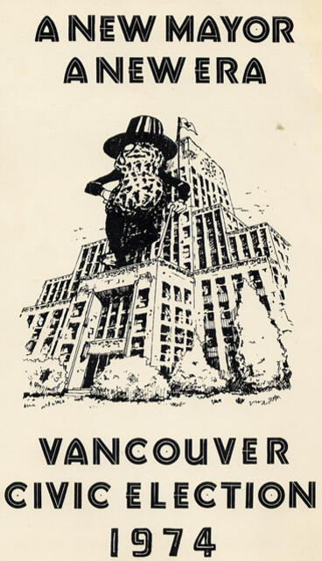

trasov-3

## Genesis P’Orridge & Ulises Carrión

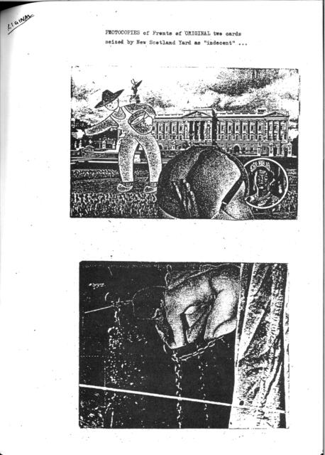

gpo-1

In 1976, Genesis P’Orridge got into legal trouble for having made and sent out two Mail Art postcards that were confiscated by the British postal service and deemed obscene. Genesis P’Orridge is now better known as a founding figure of Industrial Music with the band Throbbing Gristle (followed by Psychic TV) and today as a transgender body artist. At that time, he and his partner Cosey Fanny Tutti were the nucleus of the artist collective COUM Transmissions, the forerunner of Throbbing Gristle, that caused a public scandal with the exposition “Prostitution” in the ICA London, which featured among others documents of Cosey Fanny Tutti’s work in the sex industry.

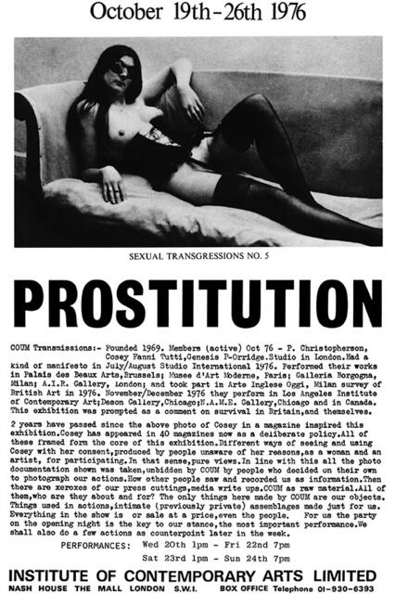

coum

During the legal prosecution, P’Orridge started a “Mail Action” of soliciting public support letters from artist friends (including William S. Burroughs) and correspondents in the Mail Art network; a factual anticipation of contemporary crowdsourcing and online petition campaigns.

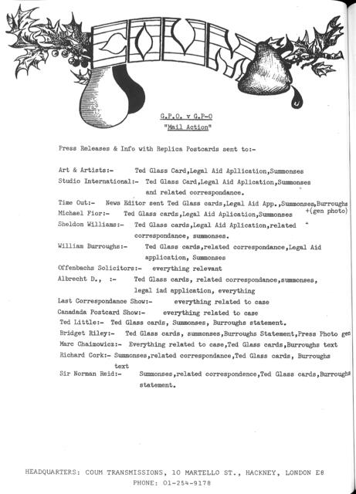

gpo-2

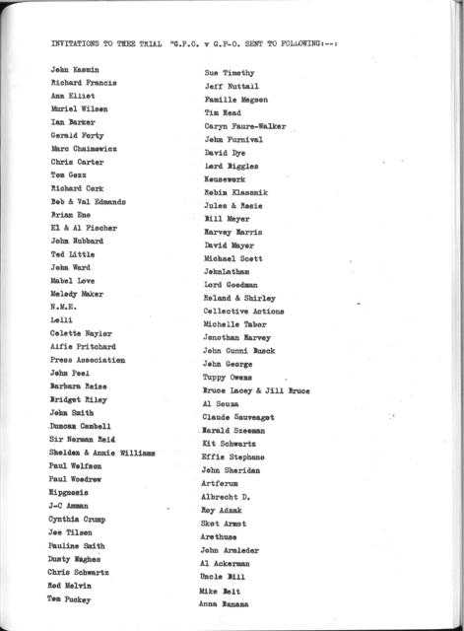

gpo-3

Most significantly, the postcard affair exposed the vulnerability of the “Eternal Network” being dependent on national and international postal systems out of the participants’ control. The structural dilemma was, I’d argue, the same as in today’s use of the Internet through artists and political activists: dependency on a hybrid corporate and state system whose governance is not democratic, and the use of censorship and content filtering and infringement of communication privacy within that system (be it postal employees or employees of content filtering agencies working for Facebook and company).

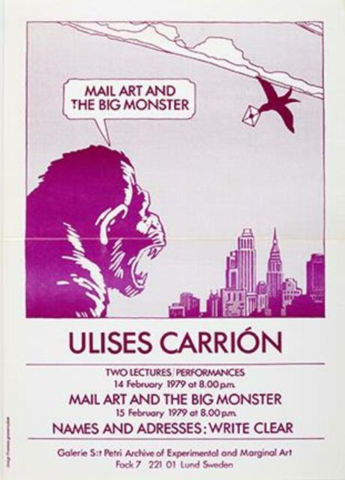

carrion-monster

In 1977, the Mexican-born poet, artist’s book practitioner and theoretician and mail artist Ulises Carrión (by now a well-known name, back then a little-known artist) gave a lecture “Mail Art and the Big Monster” which is reprinted in *Correspondence Art* and prescient of contemporary criticism of the Internet:

Mail art uses as support the postal system — a complex, international system of transport, including thousands of people, buildings, machinery, world treaties, and God knows what.

The proof that the post is not the medium is that to use it, an artist doesn’t need to understand how it functions. Even in the utopic possibility that the artist reaches complete understanding of the system, he cannot control it. […]

What about the mailing? Then we are not free, we are subject to certain rules established beforehand. […]

Seen from this point of view, mail art is no longer something easy, cheap, unpretentious and unimportant. Mail art knocks at the door of the castle where the Big Monster lives. You can tell the monster anything you like, according to your experiences and beliefs. But the fact is that the Big Monster lives and oppresses us. […]

What or who is the monster I am talking about? Do I mean the postmaster? Post office clerks? Do I mean the minister of communications? Or, do I mean the technology they use and control? Do I mean those little, colorful pieces of glued paper that we must buy every time we post something? To tell you the truth, I do not know exactly what or whom I am talking about. All I know is that there is a Monster, and that by posting all sorts of mail pieces, I am knocking at his door.

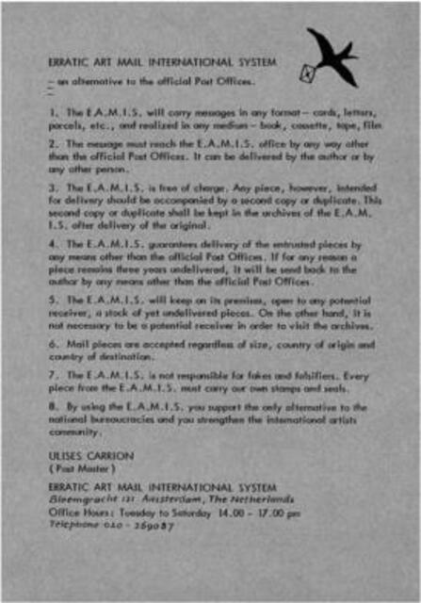

carrion–eamis

Carrión’s solution for that dilemma was the same that activists for peer-to-peer and federated networking use the same: The creation of an alternative, artist-run postal distribution system outside the institutional postal system, which he called E.A.M.I.S. (“Erratic Art Mail International System”); a variation of it is being practiced today by the Danish musician, artist and activist Goodiepal.

## VILE & Pauline Smith

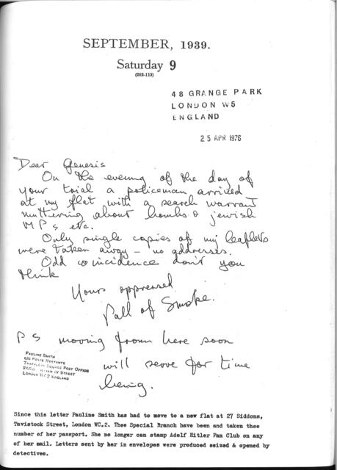

gpo-4

Genesis P’Orridge was not the only Mail Artist whose correspondence was intercepted and led to legal prosecution. P’Orridge’s “Mail Action” booklet includes a letter by the London-based Mail Artist Pauline Smith who writes:

"On the day of your trial a policeman arrived at my flat with a search warrant muttering about bombs & Jewish MPs etc.

Only single copies of my leaflets were taken away - no addresses".

P’Orridge adds a note that “Since this letter Pauline Smith has had to move to a new flat […] Thee Special Branch have been and taken thee number of her passport. She no longer can stamp Adolf Hitler Fan Club on any letter”.

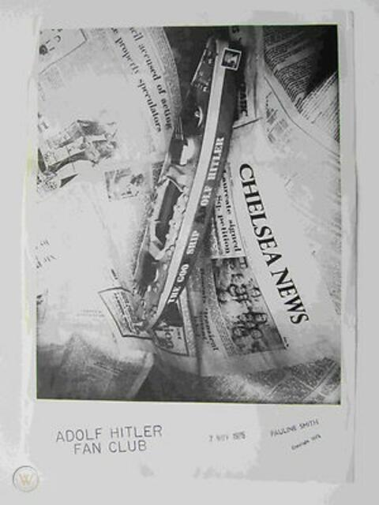

pauline-smith-1

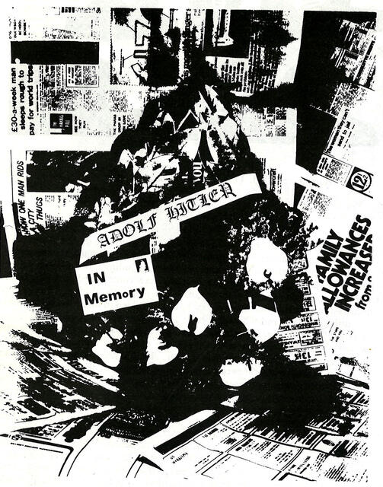

pauline_smith-1

The *Adolf Hitler Fan Club* was Pauline Smith’s art project at that time. It was widely perceived as pre-punk style provocation and testing of the limits of free speech, much like P’Orridge’s later work. However, reading Smith’s own statements, doubts are in order:

“The ADOLF HITLER FAN CLUB was intended to be an analogy for the week-kneed British Governments since 1945 and was stimulated by local Chelsea politics regarding landlords/tenants/development/tourism, in which I was interested in the early seventies. The country is a mess and nothing gets any better. […] For the immediate present I am preoccupied with Adolf Hitler’s involvement in the occult, the mediumistic nature of his public speaking and the mystery of his charismatic appeal to the multitudes. He may have been a bad man but he knew very well that people do not live by bread alone.”

(“I did not read *Mein Kampf* until 1971. At that tie I was struck by the way Hitler’s description of decadent Austrian democracy prior to WW1 could equally well suit the last few British governments. In 1971 ruthless destruction of the community in which I lived was being carried out by commercially minded people whilst those who had the power to stop this happening stood by like reeds in the wind.”)

It’s probably fair to say that Smith’s motives were dubious and quite comparable to the contemporary resurgence of esoteric fascism and anti-semitic anticapitalism. But even if this was merely an artistic research experiment or an early example trolling (the same sort of ambiguity we encounter in today’s imageboard and meme culture), it was embedded in a larger radical free speech ethos of the Eternal Network at large. This is obvious in the covers of San Francisco-published VILE, which appeared in close geographical and historical proximity to the Berkeley free speech movement:

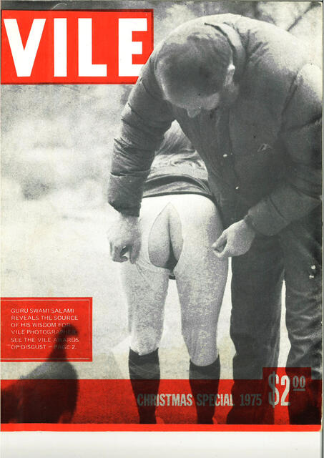

vile-1

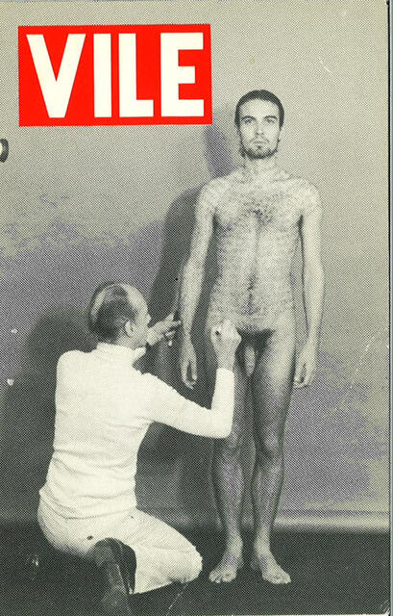 Scanning this cover for this lecture, I re-read the whole issue and found this sent-in contribution on its pages:

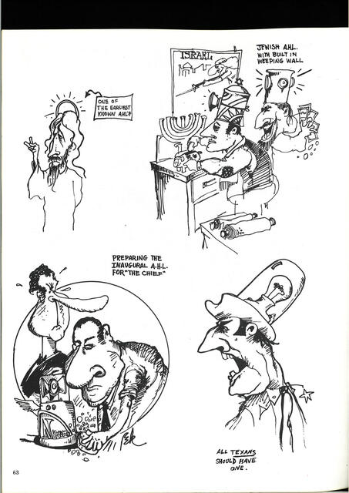

vile-6

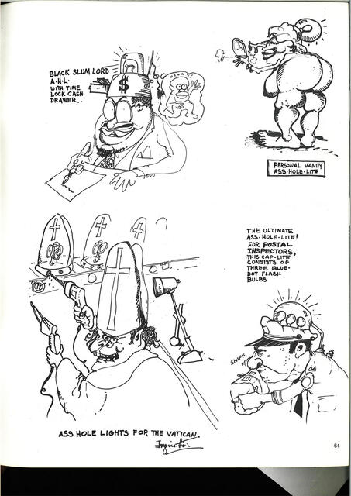

vile-7

Obviously, the above is an antisemitic caricature. On top of that, the drawings have a great visual similitude to the now-popular antisemitic “Happy Merchant” meme that is a staple in Neonazi and Alt-Right Internet culture, and originated (like most popular memes) on the 4chan image board.

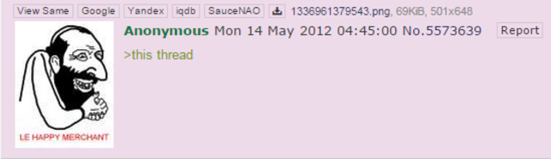

happy_merchant



happy_merchant

While, VILE itself and the Mail Art network at large tended to be on the political left, the principle of no curatorship, radical democracy and radical inclusion opened it up for such contributions, a phenomenon that repeated itself in practically every free-speech subculture, including punk and post-punk in the 1980s and Internet culture since the 1990s, with either libertarianism or anti-capitalism providing the glue between the left and the extreme right. (Seen this in contemporary art as well; recent examples include Nina Power and, apparently, Emma Sulkowicz who got red-pilled.)

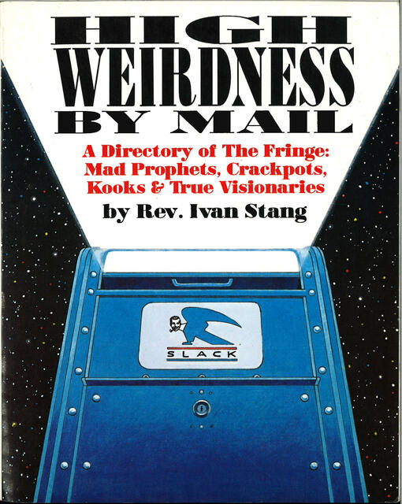

stang-high_weirdness-01

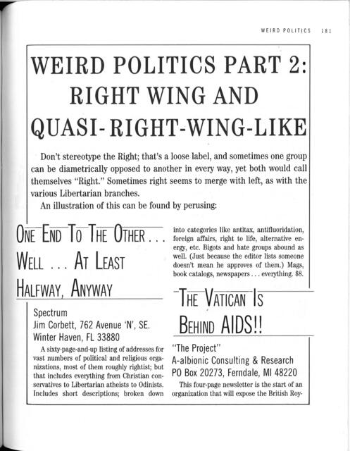

stang-high_weirdness-02

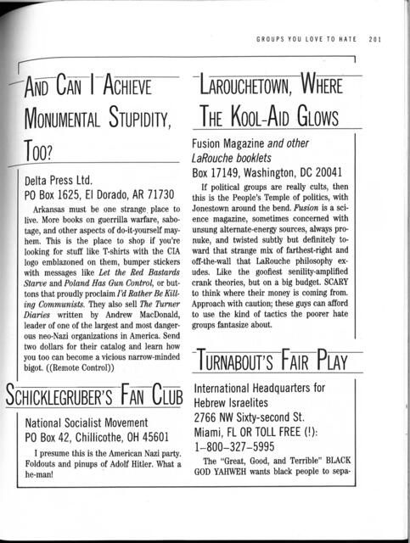

stang-high_weirdness-03

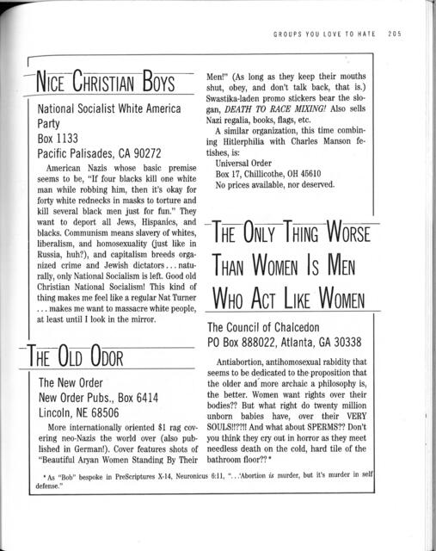

stang-high_weirdness-04

Another example for this inclusionism in pre-digital network culture is the book *High Weirdness by Mail* by Ivan Stang, the founder and head of the (satirical) Church of SubGenius. Published in 1988, it reads like a precursor of an Internet directory of fringe culture, only that the organizations and individuals listed corresponded by postal mail. Neonazi and other extreme right organizations were included in this directory, both out of a free speech ethos and for amusement. Three decades later, campy fascism has become a fully integrated propaganda tactic of the extreme right.

# Cavellini + junk mail

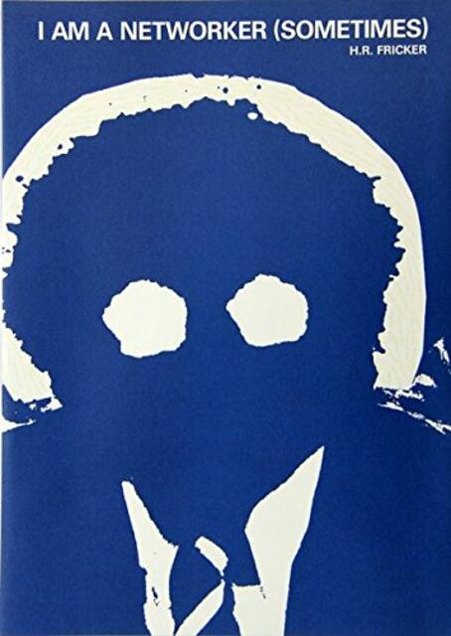

fricker

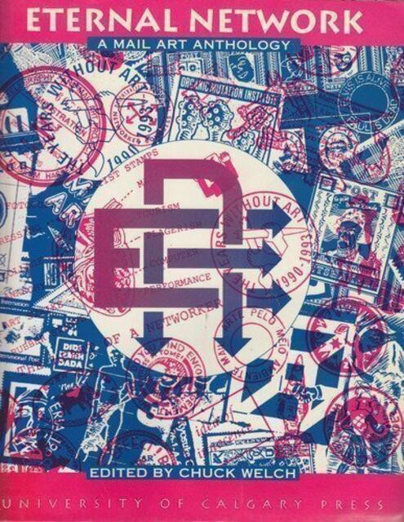

welch-eternal_network

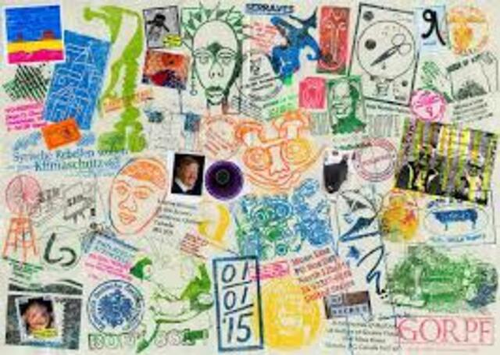

braincell

The main reason why participants left the Mail Art network, however, was not political, but “junk mail” as the downside of Mail Art’s radical inclusionism. Many people saw mail art exhibitions and publications as an effortless way of obtaining exposure. Mail Art therefore had a “spam” problem as early in the 1970s that only became worse over the years. Parallel to that, one can observe in Mail Art publications an increasing preoccupation with the network, its structure and administration as such. By the 1980s, Mail Art - or The Eternal Network - became less and less an infrastructure for and paralleling other artist-run initiatives, but a system mostly preoccupied with itself. Every Mail Artist, or networker, ultimately became a post master or even post office, or in modern terms: a systems administrator - which is best visible in the boom of rubber stamp art as a subgenre within Mail Art. (In his 2001 book “Networked Art”, which is actually about mail art, not Internet art, the US-American critic and scholar Craig Saper calls these “intimate bureaucracies”.)

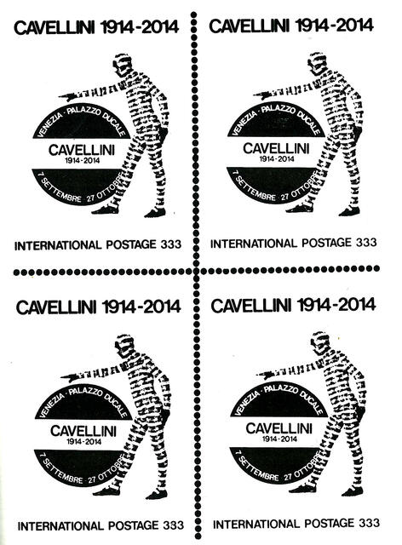

cavellini-2

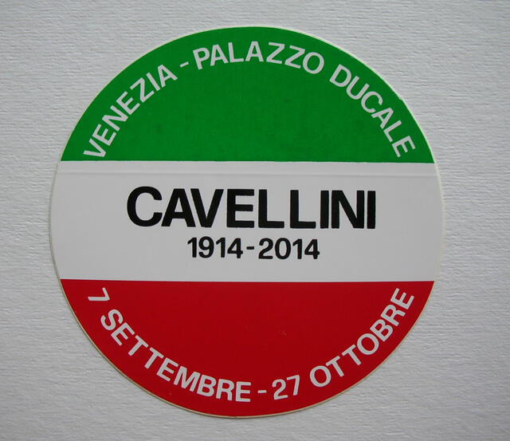

cavellini-sticker

The Mail Art network actually happened to be used for art-commercial spamming and yielded its own spam artist, the Italian Guglielmo Achille Cavellini, the son of a rich industrialist family and unsuccessful artist, who used Mail Art to as a promotional vehicle for himself, with mass-produced and mass-spread stickers advertising his future museum retrospective as a self-fulfilling prophecy. Since this was done as a conceptual artwork, the “eternal network” was defenseless against this self-marketing campaign, and Cavellini stickers were a staple of 1980s Mail Art.

The definition of mail art as an “eternal network” and its peer-to-peer “real correspondence” topology (as sketched by Vittore Baroni) ultimately lead to the same problems as in the Internet when E-Mail became a common good in the 1990s.

# Conclusion: It’s not the algorithm, stupid

While my narrative has admittedly framed Mail Art in the terminology and through the lens of contemporary Internet culture, I do insist that this parallel is not coincidental, but that both the Eternal Network of Mail Art and the Internet expose structural issues of *any* networked communication, regardless the technology that is being used: the problem of ownership and governance of the infrastructural apparatus, with the issues of “monsters” rising from ostensibly decentralized structures, issues of both censorship and laissez-faire politics including crypto-fascism and esoteric politics, issues of growing bureaucracy and system administration, issues of commercial and vanity abuse, issues of spectacle and populism. Mail Artists, in that sense, were indeed experimenters, “antennas” or even literally an avant-garde of contemporary networked culture, and perhaps that quality of the “Eternal Network” can now be more clearly seen and appreciated. (Whereas in the past, Mail Art was frequently criticized for allegedly being an inferior copy of Dada and Fluxus.)

Conversely, for contemporary media studies of the Internet, the lesson to be learned from Mail Art can be summed up with the sentence: It’s not the algorithm, stupid. Since most Mail Art neither involves any electronic technology, nor any form of automation or formalization of processes, none of the above issues stem from problematic algorithms, biased data sets and resulting discriminatory artificial intelligence. This makes one wonder whether algorithms, filter bubbles and big data aren’t being used as scapegoats for problematic social dynamics.