Does DIY mean anything? - a DIY attempt (= essay)

Florian Cramer, 7-2019

originally commissioned for [Anrikningsverket Journal #1](https://norbergfestival.com/anrikningsverket-journal) by Norbergfestival, Sweden

  
*The DIY space Ghost Ship, Oakland, USA, burned down in 2016*

# diy experience

When writing about Do-it-yourself culture, one practically needs to have experienced it first-hand, in the same way in which one needs literacy for reviewing literature, or at least rudimentary singing or instrumental practice in order to understand music. Most of those identifying with DIY culture would probably agree that any part of DIY culture (such as DIY publishing, squatting, food coops, punk culture, hacking, self-organized libraries, alternative arts spaces…) is best understood from within, since it includes personal involvement and entanglement. This brings the messy element of autobiography into this essay. I am writing from the perspective of a person who has been involved - like some of my colleagues and peers (out of my head: Craig Saper, Anna Poletti and Johanna Drucker) - in two rather opposite cultures: (a) academic humanities, (b) practices such as zine and printmaking, postal networking (a.k.a. Mail Art), DIY music publishing and the running of self-organized spaces, all which weren’t and still aren’t by themselves recognized as “art”. The overarching label “DIY culture” seems to have been slapped on to them only recently; or, as Frida writes in her introduction, these fields now seem to converge.

My work as a reader at an art school involves the introduction of practices from both (a) and (b) into an institution that traditionally stood somewhere in between these two, but has always been grounded on the idea of a professional-institutional arts practice. The basis of that practice has become fragile and up for renegotiation in times where public institutions are being dismantled, infrastructures privatized and professions deprofessionalized, and where DIY production and sharing conversely has been appropriated as the business model of Internet platforms. In neoliberalism and other systems with fragile institutions and infrastructures, “DIY” has become the norm. As early as in 1986, the British cultural studies scholar Stuart Hall described this as “what Thatcherism regards as the new, vital forces of capitalism: the small businessmen, the do-it-yourself conveyancers” (Stuart Hall, No Light at the End of the Tunnel, *Marxism Today*, December 1986, 15).

As a result, DIY experience has often become cultural capital for those moving from classical DIY organization into institutions or companies. When I made my first zine in 1982, as a 13-year-old, I wouldn’t have thought that I would be brought into an art school, first to bring in Internet expertise, later to run zine workshops there (at age 50).

# note

  
*in 1982, taken in the time when I made my first zine*

I normally don’t write in an autobiographical style but this subject seems to demand it, as explained in the beginning. My apologies if this text sounds self-indulgent. It is not only subjective, but - like something written for a zine - willfully opinionated, and therefore inviting disagreement.

# beginnings and endings of diy

A co-worker of mine, Renee Turner, once pointed out to me that my writing amounts to an extended meditation on Fluxus. Since then, I’ve smuggled Fluxus anecdotes into most of my published essays. Fluxus was in many respects a precursor of contemporary DIY culture, with its founder George Maciunas rejecting art in favor of a radically democratic, “non-elite, non-parasitic” practices he called “art-amusement”. One of the first participants of the early 1960s European Fluxus festivals (which Maciunas financed through his day job as a graphic designer for the U.S. Army) was the German artist tomas schmit. Tomas soon fell out with Maciunas because of the latter’s populist tactics, which included the use of Vaudeville typography and selling funny gadgets in Fluxus stores. In his late life, tomas worked at an artists’ bookstore in Berlin (now Galerie Barbara Wien) which stocked an extensive amount of DIY publications by former Fluxus artists, including tomas’ own. It was first located in a neighborhood where tomas was mostly busy preventing junkies from stealing the cash register. Once, a customer who actually had come for the books picked one of tomas’ self-published booklets. Tomas happened to be person at the counter on that day and offered him to sign it. The customer, being unaware whom he was talking to, hastily declined, thinking that he was dealing with a mad person.

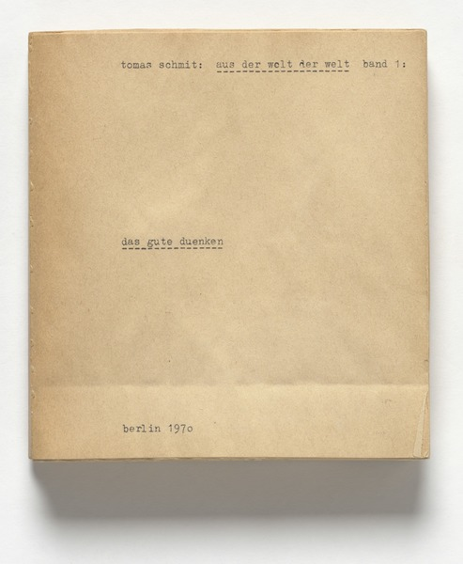  
*DIY book by tomas schmit*

Maciunas would have likely disapproved of signing the book, an act of giving it collector and art market value. While Fluxus Editions, the self-publishing house run by Maciunas, *did* sell signed and numbered booklets and multiples, it did so only as a compromise with the participating artists (most of whom didn’t subscribe to Maciunas’ communist politics) and economic survival necessities. The ideal of Fluxus Editions would thus have been cheap industrial mass production. Yet individual signatures and non-mass production were precisely what made their products “DIY”. In that sense, the autographs of white cube gallery art (which Fluxus was opposed to) are arguably more “DIY” than Fluxus serigraphs. Yet the book store customer’s anxiety was anxiety of DIY: that a mad person, or anyone else who’s not *author*-ized, could deface or damage the commodity he just bought, similar to having one’s newly bought car scratched by a random street artist with their signature tag.

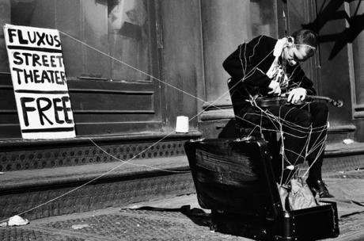  
*Fluxus as street art in the 1960s*

Authorship is a contentious issue in DIY: The Fluxus anecdote exemplifies how DIY can both be attributed to extreme romantic subjectivity, including romanticist notions of authorship and authenticity, and its opposite of radical collective and commons practices that give up classical authorship in favor of sharing. (No matter the practice or technology; and including even phenomena like Wikipedia which, despite its reach and popularity, remains a DIY encyclopedia.)

# diy and its other

Imagine a future scenario in which *all* printed matters will be DIY products because all mass media have become electronic. Then Maciunas’ anti-art politics wouldn’t have worked. Publishing artists’ books and multiples would not be a means of radically rethinking and democratizing the art market, but of contributing to a culture of craftiness and exclusivity. This is what factually happened to artist-made books today, as they are shown at the NY Art Book Fair and elsewhere, including the Fluxus booklets and multiples that have become collector’s items; a development anticipated in the 19th century when the socialist Arts and Crafts movements advocated hand-made goods for the masses against industrial capitalism, but ended up making luxury items for the few. DIY, in other words, has an inherent *Arts and Crafts trap*, next to the Facebook, Instagram, Google and Airbnb trap of participation platform capitalism (more on that later).

  
*William Morris’ science fiction novel News from Nowhere, a socialist manifesto for Arts & Crafts*

However, if Arts and Crafts’ ambitions would have been realized, or if one does not merely consider industrialized cultures and societies, then the following is true: wherever things are always self-made, the term *do-it-yourself* makes no sense, since it no longer describes a difference. Conversely, it makes no sense to call the making of things in pre-, non- or weakly industrialized eras and areas “DIY” unless one simply views them through the lens of industrialization. Self-organization in areas lacking infrastructures and institutions is only “DIY” when one takes the existence of such infrastructures and institutions for granted.

DIY thus only exists through its other: an industrial economy. It can only be identified through an industrial-colonial gaze.

# diy vs. art

Movements like Dada and Fluxus adopted work methods from musical performance and political activism and drew on non-Western cultures (questionably in Dada with its “negro chant” poetry performances, more consequential in Fluxus as an American-Southeast Asian movement) to revolutionize art. Today’s contemporary art system included these impulses superficially but watered them down to what fits a white cube. While art is thus content with being “fine art” again, DIY cultures conversely seem to be less interested than in the past in alternatives to the art system. While “art” (in its difference to both “crafts” and everyday popular “culture”) has become an increasingly questionable, dated, either commercial or institutional, Western-specific concept, DIY culture has become more indifferent about art than in the past.

Art in this modern Western sense only existed since the mid-18th century when the Latin word “ars” and its modern European equivalents ceased to generally refer to arts, crafts and sciences. It is very possible that those two-and-a-half centuries, in merely one world region, will remain the historical exception. But if “art” should revert to its older meaning of arts, crafts, sciences and technique, then “DIY culture” will no longer describe a meaningful difference to institutional art.

# apparatus

Neither does *DIY* make sense when a certain practice does not require any complex institutional or technological apparatus. Good examples include writing - which, with its minimal dependency on production technology, is “DIY” by definition - and (a-capella) singing: As long as artificial intelligence bots haven’t taken over writing (and industrialized staff writing is the exception rather than the norm in the overall volume of what is getting written every day) and as long as Autotune and speech synthesis haven’t taken over singing, the notions of “DIY writing” and “DIY singing” are redundant and rather incomprehensible.

# romanticism & reaction

Traditionally, DIY culture departs from a critique of disembodied and alienated industrial or institutional production for which it envisions an autonomist alternative. This critique exists in Marxist, left-anarchist, religious/spiritual, conservative and extreme right-wing ideological forms. A common epistemological origin, for Western culture, lies in 19th century romanticism as a counter-reaction to the industrial revolution. If the lineage of DIY practices goes at least as far back as to Arts and Crafts and extends to contemporary alternative cultures and collapsologies, then DIY has always been conservative *and* anti-conservative at the same time, depending on which concepts and practices it either rejected or sought to preserve. It even is *reactionary* if one clings to the literal meaning of that word.

# left & right

Today, DIY culture is the overcoupling moniker for squat-style art centers and spaces as they were targeted for shutdown by an [extreme right/‘Alt-Right’ meme war operation in 2016](https://knowyourmeme.com/memes/events/4chan-safety-squad-raids) *and* for the doomsday prepper activism of people who might have been involved in that same operation, and even for the websites - the anonymous, participatory, low-tech *4chan* and *8chan* imageboards - on which the operation was launched. Both *Ghost Ship* (the Oakland DIY space that burned down in 2016) and *4chan*/*8chan* are two sides of contemporary DIY culture.

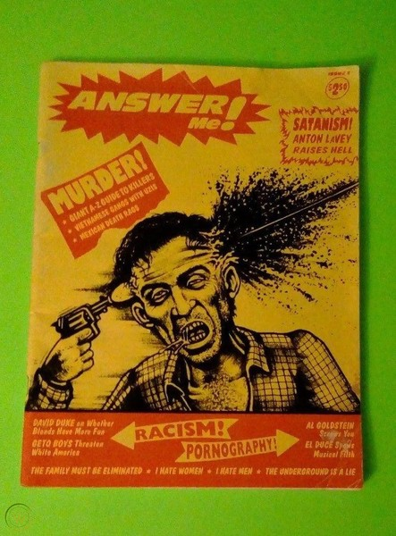  
*Second issue of Answer Me!, an early 1990s underground zine that included the extreme right in its narrative of transgression and whose editor has become an icon of the ‘Alt-Right’*

This was just as true in the past. DIY has historically included actors from the extreme left and the extreme right, with both fighting institutions and industrial capitalism. Radical DIY movements and subcultures from punk (including Crass as well as Skrewdriver) and zine making, noise music (involving Throbbing Gristle as well as Boyd Rice) to Internet meme warfare (involving Anonymous and the ‘Alt-Right’ on *4chan*) always involved actors from both political camps.

# collapsology vs. diy super stores

DIY is a survivalist strategy, both in the sense of emotional survival (such as in queer and people of color communities and self-help zines) and physical survival. The latter is becoming more pronounced in times of impeding ecological catastrophe and collapse of civilization. It unites different political factions, too.

The document *Alternatives to the Singularity*, collectively written by a network of futurologists in 2011, includes the “Hexayurtularity” as one of its 82 dystopian futurological visions. The Hexayurtularity unites the left and right, digital and non-, post- or anti-digital DIY cultures: “global currency collapse meets DARPA sponsored DIY state regeneration projects led by Scottish Burning Manstyle collapsitarian gurus. Your future made of plywood. Scythe-wielding Afghan poets and wobble bass.” (The document has been archived [on the Monoskop website](https://monoskop.org/images/0/03/Alternatives_to_the_Singularity_2011.pdf).)

This scenario points to two manifestations and aspects of contemporary DIY: factual extremist DIYers such as the Unabomber and, as their opposite, *Home Depot* shoppers, i.e. the consumers (or “prosumers”) of the kind of stores that are commonly called “DIY Superstores” in America.

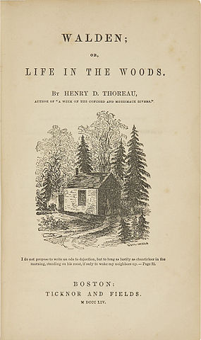  
*First edition of Henry David Thoreau’s Walden*

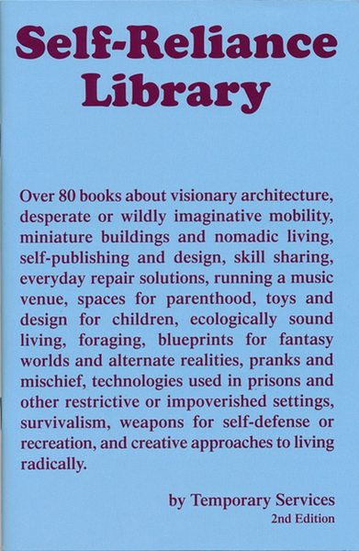  
*DIY zine by Temporary Services, Chicago*

The Unabomber could be seen as the radicalization, Home Depot as the mainstreaming and commodification of a DIY mythology created in Henry David Thoreau’s 1854 book *Walden*, an autobiographical account of leaving civilization and living an autonomist life in the woods. Although many other (non-American, non-Western, and older) sources could be pulled into a cultural history of DIY, the name and its associated culture remains American at its core, linked to a history that prominently includes Thoreau and his concept of “civil disobedience” as well as the (often right-wing and Christian-fundamentalist) homesteader movement.

# poetics

the writing machine is for everybody do it yourself until the machine comes here is the system according to us (William S. Burroughs, Brion Gysin, *The Third Mind*, 1977)

An immediate forerunner of DIY manuals are *poetics* books from the antiquity to the Renaissance. The *Poetic Funnel* (*Poetischer Trichter*) of the 17th century German poet and scholar Georg Philipp Harsdörffer promised to funnel the art of poetry into anyone. It is factually a DIY manual for literary writing (heavily based on Julius Caesar Scaliger’s 1561 *Poetices*).

Considering the meaning of the Greek word *poeisis*, making, DIY amounts to a poetics in the most literal sense. In the 18th century, Western art theory largely abandoned poetics in favor of the newly-coined aesthetics, in an act of shifting the definition of art from making to perception (*aisthesis*). The expulsion of making from art - that is still very much in place wherever art is defined as conceptual, post-conceptual or more recently “post-contemporary” - conversely opened up a space for DIY as poetics.

In a European context, DIY cultural strategies are more commonly associated with self-publishing and its historical origins in the reformation age, political pamphletism and literary writing since the 18th century (as documented by Craig Dworkin, Simon Morris and Nick Thurston in the sourcebook *Do or DIY*, Information as Material, 2012).

In the arts, DIY thus not only stands for anti-institutionalism, outside either white cubes or creative industries. It also implies anti-aestheticism wherever it frames itself as technical practices that can be picked up by everyone.

The characteristics of the punk movement - “DIY politics, DIY organisation, DIY publishing and printing […] all linked together” (quoted from the book *Ripped, Torn and Cut. Pop, politics and punk fanzines from 1976*, Manchester University Press, 2018) - effectively applies to every radical DIY movement.

# mainstreamed diy

The 1960s/70s US-American *Whole Earth Catalog* marked the convergence of proto-“Maker Culture”, Thoreau-inspired counterculture and DIY superstores. As both a manual and a product catalog, it gave “access to tools” (its motto) for squatters as well for homesteaders. Its publisher, Stewart Brand, went on to become a Silicon Valley entrepreneur. The 1980s, San Francisco-based social network *WELL* ("Whole Earth ‘Lectronic Link"), a conceptual forerunner of Facebook, marked the transition from 1960s countercultural entrepreneurship to ’New Economy’ startup capitalism. (This history has been documented among others in Lutz Dammbeck’s 2004 documentary film *The Net* and Fred Turner’s 2006 book *From Counterculture to Cyberculture*.)

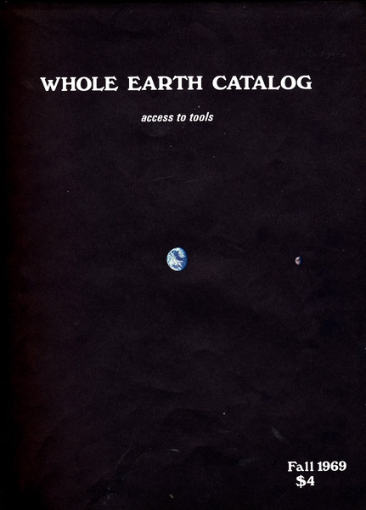  
*First issue of the Whole Earth Catalog*

Craig Saper observed a similar tendency in Fluxus. Starting in 1967, Maciunas tried to convert two Manhattan houses into an artist-run housing project: “George Maciunas’s FluxHouse project functioned like a DIY development corporation, but with cooperative and social capitalists motivations. Maciunas referred to it as entrepreneurial communism, but now the phrase social entrepreneurs describes similar projects like the Kiva or Kickstarter projects.” (Craig S. Saper/dj readies, *Intimate Bureaucracies: A Manifesto*, Punctum Books, 2012, 2.)

The transition from DIY to the so-called “New Economy” is best embodied by hacker culture which applied counter-cultural and autonomist DIY principles 1:1 to technological systems. Today, this also includes techno-utopian and transhumanist movements that believe in total makeability. The 2014 Xenofeminist manifesto, for example, suggests that “we [can] stitch together the embryonic promises held before us by pharmaceutical 3D printing (‘reactionware’), grassroots telemedical abortion clinics, gender hacktivist and DIY-HRT forums, and so on, to assemble a platform for free and open-source medicine”.

Applications of DIY to science and high technology expose an internal contradiction within DIY movements: between (a) categorical rejections of complex technologies and complex systems from which DIY seems to offer rescue, and (b) applications of the DIY principle to such systems themselves.

This begs the question whether DIY is still a useful term at all, or whether it doesn’t rather serve to gloss over, obscure, sugarcoat and create fake common sense around extremely opposite philosophical-political agendas and forces.

# postscript / scrap buffer / leftovers

The above differences become blatantly visible as soon as two opposing camps reclaim DIY for themselves: Silicon Valley companies for their “participatory” social networks as opposed to zine and DIY print makers who have come to understand their medium as a counter-practice to these systems. (Which seems to have replaced art as the frame of reference: where Mail Art and zine making might have been alternative art practices in the 1970s and 1980s, they are now seen as alternative social networking practices. This development already manifested itself with the terminological shift from “Mail Art” to “Eternal Network” in the 1980s/1990s.)

However, these DIY alternative practices tend to have their own blind spots: lack of intersectionality, despite claims to the contrary; high dependency on mainstream social media platforms in community organization; DIY spaces being a driver of gentrification in their cities (including privatization of public spaces); involuntary execution of neoliberal agendas that shift public services and responsibilities to DIY private initiatives (which the king of the country where I live praised as the “participation society” in his inauguration speech to the throne). The old blind spots of both political activism and contemporary art thus carry over into contemporary DIY culture.

Instead of Maciunas’ “entrepreneurial communism”, these contemporary clusters of neoliberal and communitarian agendas - no matter whether they’re perpetuated by self-organized communities, municipalities or companies - result in something that may be called “platform communitarianism”.

It still remains to be seen whether the alternative social networking of contemporary DIY culture will eventually amount to post-digital repetitions of 1990s digital culture mistakes: whether contemporary DIY culture will eventually yield its own (non-digital) Whole Earth Catalogues, Apples, Ubers and Airbnbs.